FOR IMMEDIATE RELEASE

Ken Burns and Lynn Novick’s HEMINGWAY to Premiere
April 5, 2021 on PBS

Filmmakers & Special Guests Explore the Writer’s Art and Legacy in Conversations on Hemingway Virtual Event Series Prior to Premiere

Voice Actors Include Jeff Daniels as Hemingway; Meryl Streep, Keri Russell, Mary-Louise Parker and Patricia Clarkson as Hemingway’s Four Wives

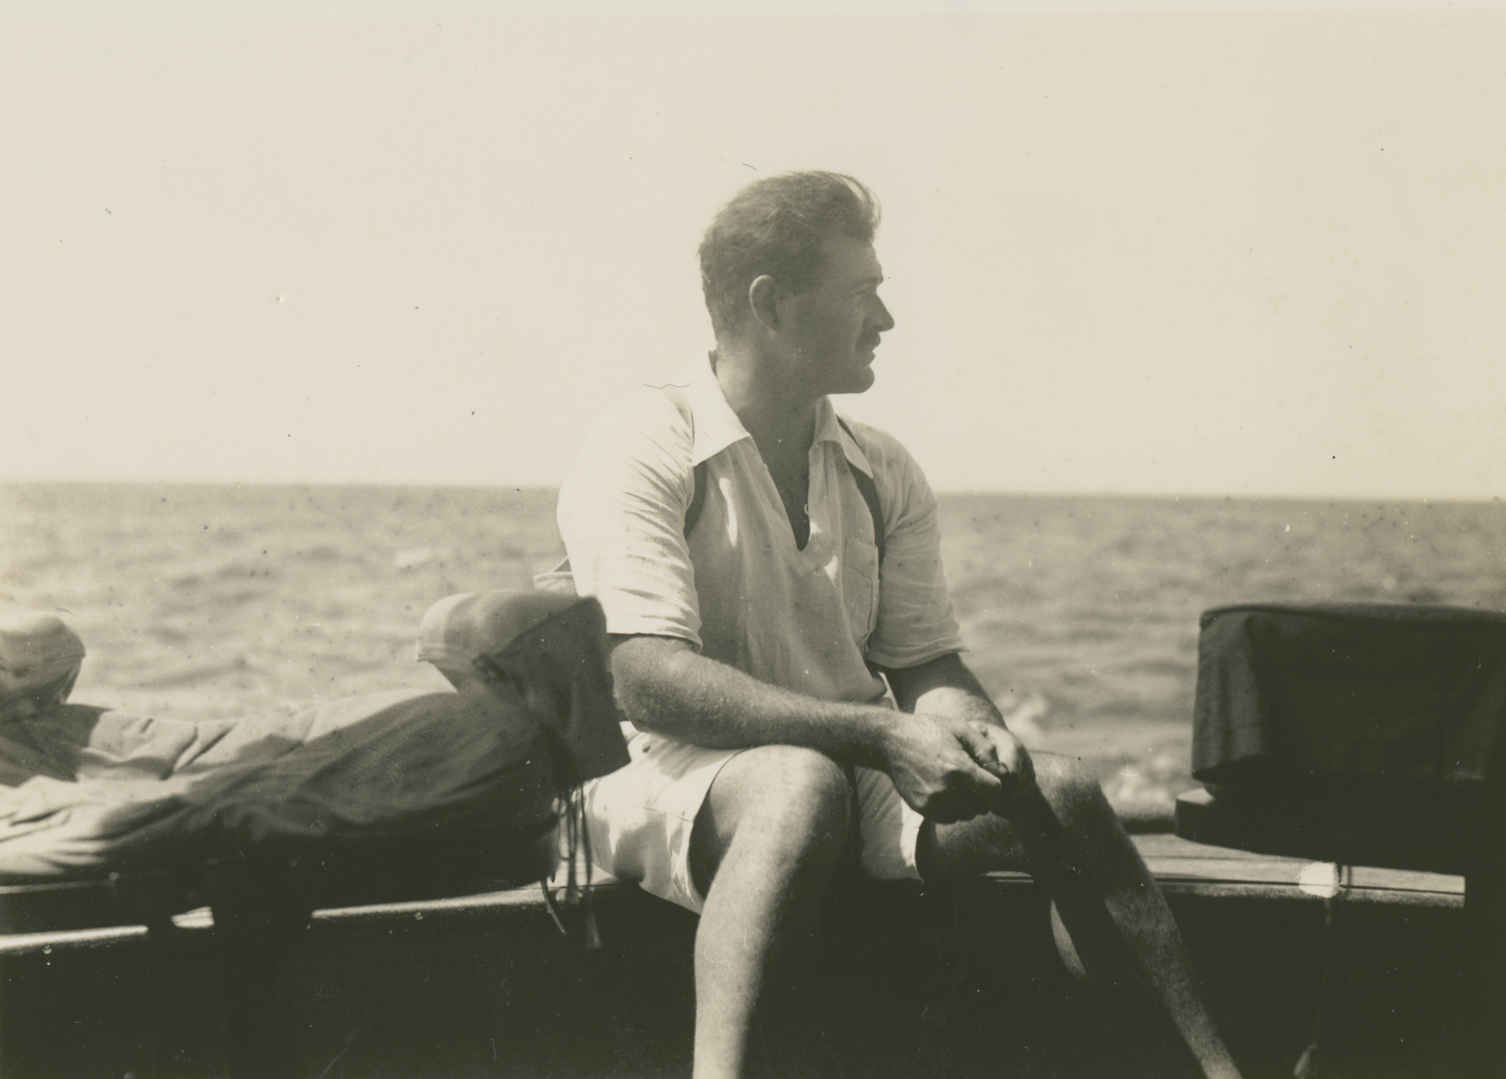
Ernest Hemingway on the fishing boat Anita circa 1929. Courtesy of Ernest Hemingway Photograph Collection, John F. Kennedy Presidential Library and Museum, Boston.
Arlington, VA – February 2, 2021 – Ernest Hemingway, the iconic literary figure considered one of the greatest American writers and among the first to live and work at the treacherous nexus of art and celebrity, is the subject of an upcoming three-part, six-hour documentary series directed by award-winning filmmakers Ken Burns and Lynn Novick (THE VIETNAM WAR, PROHIBITION, THE WAR, FRANK LLOYD WRIGHT) coming to PBS April 5-7, 2021, 8:00–10:00 p.m. ET (check local listings). A trailer for the series is available here.

HEMINGWAY paints an intimate picture of the writer—who captured on paper the complexities of the human condition in spare and profound prose, and whose work remains deeply influential around the world—while also penetrating the myth of Hemingway the man’s man, to reveal a deeply troubled and ultimately tragic figure. The film also explores Hemingway’s limitations and biases as an artist.

The filmmakers, who were joined by actor Jeff Daniels, who reads the voice of Hemingway in the film at PBS’s portion of the 2021 Winter Television Critics Association Press Tour, announced Conversations on Hemingway, a series of virtual events with leading writers and scholars in the weeks prior to the broadcast. The nine-part conversation series is open to the public and will take place remotely, creating a unique opportunity for people throughout the country to participate. People can register for one or more of the events at pbs.org/hemingwayevents.

HEMINGWAY–written by Geoffrey C. Ward and produced by Sarah Botstein, both longtime collaborators of Burns and Novick–interweaves a close study of the biographical events of the author’s life with excerpts from his fiction, nonfiction and short stories, informed by interviews with celebrated writers, scholars and Hemingway’s son, Patrick. The filmmakers explore the painstaking process through which Hemingway created some of the most important works of fiction in American letters, including novels The Sun Also Rises, A Farewell to Arms, For Whom the Bell Tolls and The Old Man and the Sea; short stories “Hills Like White Elephants,” “The Short and Happy Life of Francis Macomber,” “Up in Michigan,” “Indian Camp” and “The Snows of Kilimanjaro;” as well as the nonfiction works Death in the Afternoon and A Moveable Feast.

“HEMINGWAY is both an intimate, turbulent family saga and an examination of some of the greatest works of American literature in the 20th century,” said director Ken Burns. “The documentary attempts to go beyond prevailing assumptions about Ernest Hemingway and his writing. At the same time, we are unsparing in our inquiry into less well-known aspects of his character and writing. Our intent is to offer viewers an honest portrayal of a complex and conflicted writer who left an indelible mark on literature.”

“In an era when Americans are re-evaluating so many icons, Hemingway is a particularly compelling figure to revisit," said director Lynn Novick. "He was hugely complicated, deeply flawed, and he truly revolutionized the art of writing. One of the great revelations of this project was sitting down with renowned writers from around the world—Mario Vargas Llosa, Edna O’Brien, Abraham Verghese, Leonardo Padura, Mary Karr—and hearing share their insights into Hemingway's work and why he is still important today.”

“One of the great challenges of this project,” said producer Sarah Botstein, “was finding ways—visually, cinematically—to show how Hemingway honed his craft and how he used words to such extraordinary effect. In collaboration with our editors, we deployed all the tools in our filmmaking toolbox—graphic effects, archival footage and photographs, live cinematography, sound effects—to make Hemingway’s work come fully alive on screen.”

“While many of us studied Ernest Hemingway in school, the true significance of his work was perhaps never fully appreciated. Through this extraordinary film, Ken, Lynn and Sarah have shed new light on the contributions and complexity of one of America’s most influential writers,” said Paula Kerger, President and CEO of PBS. “Public television continues to be a destination for thoughtful and thought-provoking biographies, and we are uniquely positioned to bring these important stories into the classroom through PBS LearningMedia.”

Ernest Hemingway “loved being in love,” the writer Michael Katakis says in the film. He married four times over the course of his tumultuous life and had three sons. His relationships with women—his mother, sisters, wives and the World War I nurse who broke his heart—profoundly affected his work. Yet for all his bravado and hyper-masculine posturing, Hemingway wrote about relationships between men and women with sensitivity, nuance and clarity. As writer Edna O’Brien says on camera, he was able to put himself “inside the skin” of the other.

Narrated by long-time collaborator Peter Coyote, the series features an all-star cast of actors bringing Hemingway (voiced by Jeff Daniels), his friends and family vividly to life. Through letters to and from his four wives—voiced by Meryl Streep, Keri Russell, Mary-Louise Parker and Patricia Clarkson—the film reveals Hemingway at his most romantic and his most vulnerable, grappling at times with insecurity, anxiety and existential loneliness.
“I’ve always admired Hemingway’s writing,” said Daniels. “The power of his simplicity changed literature. Reading his published work along with his unpublished letters gave me new insight into his impact as an artist and the ultimate tragedy of his life.”
In three two-hour episodes, HEMINGWAY tracks the meteoric rise and tragic fall of the author who, in his final years, suffered from chronic alcoholism, traumatic brain injuries and serious mental illness. In 1961, at the age of 61, Hemingway died by suicide, leaving behind an unparalleled body of artistic work and a complicated emotional legacy for those closest to him.

The filmmakers were granted unusually open access to the treasure trove of Hemingway’s manuscripts, correspondence, scrapbooks and photographs housed at the John F. Kennedy Presidential Library in Boston. Interviews with renowned biographers and scholars, including Mary Dearborn and Marc Dudley, shed new light on the man and his work; and well-known writers around the world—including Edna O’Brien, Abraham Verghese, Mario Vargas Llosa, Mary Karr, Tim O’Brien, Akiko Manabe, Leonardo Padura and Tobias Wolff—deepen the film’s exploration of Hemingway’s oeuvre. It also includes moving commentary from Hemingway’s surviving son, Patrick, and from the late Senator John McCain, whose lifelong role model was not Hemingway, but Robert Jordan, the protagonist of For Whom the Bell Tolls.

Conversations on Hemingway will take place virtually via Zoom on Tuesday and Thursday nights beginning on February 23 and continuing through March 18. A final event, focused on Hemingway and Women, in partnership with the New York Review of Books, will take place on Wednesday, March 24. The events will each cover a theme in Hemingway’s work and life and include a discussion with the filmmakers and leading writers and scholars. The schedule is as follows (note all events are 7:00 p.m. ET except Los Angeles, which is 8:00 p.m. ET):

Feb. 23 Hemingway and Childhood, in partnership with WTTW and Chicago Public Library (Guests include writers Verna Kale and Tim O’Brien)

Feb. 25 Hemingway, Journalism and War, in partnership with Kansas City PBS and the Kansas City Star (Guests include Kansas City Star editorial writer and columnist Melinda Henneberger and Hemingway scholar Alex Vernon)

March 2 Hemingway and the Natural World, in partnership with Idaho Public Television and The Community Library/Hemingway House (Guests include writer Terry Tempest Williams)

March 4 Hemingway and Celebrity, in partnership with PBS SoCal and the Los Angeles Times (Guests include Los Angeles Times columnist Patt Morrison and writer Lesley M.M. Blume)

March 9 Hemingway, the Sea and Cuba, in partnership with South Florida PBS, FIU’s Casa Cuba, and The Ernest Hemingway Home and Museum (Guests include writer Cristina Garcia and author/journalist Brin-Jonathan Butler)

March 11 Hemingway, Gender and Identity, in partnership with The WNET Group
and the Center for Fiction (Guests include writers Mary Karr and Marc Dudley and journalist Lisa Kennedy)

March 16 Hemingway the Author, in partnership with GBH, the John F. Kennedy Presidential Library and Museum, and the National Archives (Guests include writer Tobias Wolff and writer and physician Abraham Verghese)

March 18 Hemingway and Biography, in partnership with WETA and Georgetown University (Guests include writers Amanda Vaill, Howard Bryant and Paul Elie)

March 24 Hemingway and Women, in partnership with The New York Review of Books (Guests include writers Joyce Carol Oates, Francine Prose and Edward Mendelson)

PBS LearningMedia, a free service that includes thousands of contextualized learning materials aligned to state and national standards, will offer a host of educational offerings related to HEMINGWAY for middle and high school teachers. Resources will include video clips, activities, discussion questions and lesson plans focusing on a range of topics relevant to English Language Arts, social studies, media literacy and health teachers, and include suggestions for incorporating these materials into remote learning environments. PBS and WETA will also offer virtual professional learning opportunities for educators to help them navigate the resources and build the skills to bring topics related to Hemingway’s life and writing to life in their classrooms.

PBS Books, a multi-platform initiative celebrating the love of reading, has built a robust, nationwide outreach plan to complement the film and engage communities in partnership with thousands of libraries and their local PBS stations. Activities will include a virtual exhibition showcasing the most beloved articles in the Hemingway collections of libraries and individual readers, an aggressive social media campaign on Facebook and Twitter, a National Book Club conversation with the filmmakers on Thursday, April 8, a variety of Hemingway-themed booklists, and more to help foster discussion about this iconic American writer and his continuing impact today.

HEMINGWAY will be available to stream for free on all station-branded PBS platforms, including PBS.org and the PBS Video App, available on iOS, Android, Roku, Apple TV, Amazon Fire TV, Android TV, Samsung Smart TV and Chromecast. PBS station members can view the documentary via PBS Passport, as part of a full collection of Ken Burns films. For more information about PBS Passport, visit the PBS Passport FAQ website.

HEMINGWAY is a production of Florentine Films and WETA Washington, D.C. Directed by Ken Burns and Lynn Novick, written by Geoffrey C. Ward, and produced by Sarah Botstein, Lynn Novick and Ken Burns. The film was co-produced by Salimah El-Amin and Lucas Frank, with associate producers Vanessa Gonzalez-Block and Jonah Velasco. Original music produced by Johnny Gandelsman, with additional music created by longtime Florentine collaborator David Cieri. The executive in charge for WETA is John F. Wilson.

Corporate funding for HEMINGWAY was provided by Bank of America. Major funding was provided by the Annenberg Foundation, The Arthur Vining Davis Foundations, and by ‘The Better Angels Society,’ and its members John & Leslie McQuown, the Elizabeth Ruth Wallace Living Trust, John & Catherine Debs, The Fullerton Family Charitable Trust, the Kissick Family Foundation, Gail M. Elden, Gilchrist & Amy Berg, Robert & Beverly Grappone, Mauree Jane & Mark Perry; and by the Corporation for Public Broadcasting and PBS.

About WETA
WETA is the leading public broadcaster in the nation’s capital, serving Virginia, Maryland and the District of Columbia with educational initiatives and with high-quality programming on television, radio and digital. WETA Washington, D.C., is the second largest producing-station of new content for public television in the United States, with productions and co-productions including PBS NEWSHOUR, WASHINGTON WEEK, THE KENNEDY CENTER MARK TWAIN PRIZE, THE LIBRARY OF CONGRESS GERSHWIN PRIZE FOR POPULAR SONG, LATINO AMERICANS, ASIAN AMERICANS and documentaries by filmmaker Ken Burns and scholar Henry Louis Gates, Jr. Sharon Percy Rockefeller is president and CEO. More information on WETA and its programs and services is available at www.weta.org.

About PBS
PBS, with more than 330 member stations, offers all Americans the opportunity to explore new ideas and new worlds through television and digital content. Each month, PBS reaches over 120 million people through television and 26 million people online, inviting them to experience the worlds of science, history, nature and public affairs; to hear diverse viewpoints; and to take front row seats to world-class drama and performances. PBS’ broad array of programs has been consistently honored by the industry’s most coveted award competitions. Teachers of children from pre-K through 12th grade turn to PBS for digital content and services that help bring classroom lessons to life. Decades of research confirms that PBS’ premier children’s media service, PBS KIDS, helps children build critical literacy, math and social-emotional skills, enabling them to find success in school and life. Delivered through member stations, PBS KIDS offers high-quality educational content on TV – including a 24/7 channel, online at pbskids.org, via an array of mobile apps and in communities across America. More information about PBS is available at www.pbs.org, one of the leading dot-org websites on the internet, or by following PBS on Twitter, Facebook or through our apps for mobile and connected devices. Specific program information and updates for press are available at pbs.org/pressroom or by following PBS Pressroom on Twitter.

– PBS –

MEDIA CONTACT: HemingwayDKC@dkcnews.com

For images and additional up-to-date information on this and other PBS programs, visit PBS PressRoom at pbs.org/pressroom.

