THE RISE AND FALL OF THE BROWN BUFFALO
Premieres Friday, March 23, 2018, on PBS

A Look at the Unorthodox Life and Complex Legacy of Oscar Zeta Acosta: The Chicano Movement’s Forgotten Activist Hero, Attorney and Literary Celebrity

THE RISE AND FALL OF THE BROWN BUFFALO is a fresh and genre-defying film about the life of radical Chicano lawyer, author and countercultural icon Oscar Zeta Acosta — the basis for the character Dr. Gonzo in Fear and Loathing in Las Vegas, written by his friend, legendary journalist-provocateur Hunter S. Thompson. Filmmaker Phillip Rodriguez brings Acosta to life by employing a cinematic style as unorthodox as his subject: weaving archival footage and images with dramatized portrayals of Acosta, Thompson, and other key figures and moments of the era. The script is culled from Acosta and Thompson’s writings and interviews, as well as letters and journalistic and personal accounts. The resulting film brings narrative style to documentary filmmaking and paints a portrait of a fascinating, complex and enigmatic man. THE RISE AND FALL OF THE BROWN BUFFALO premieres Friday, March 23, 2018, 9:00-10:00 p.m. ET (check local listings) as a VOCES special on PBS.
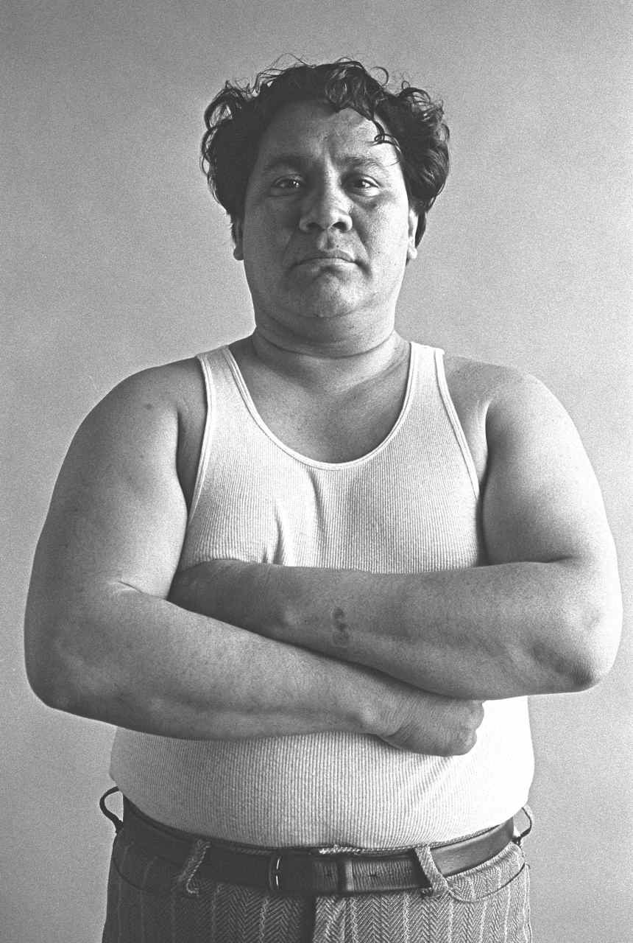
Credit: ©Annie Leibovitz

Acosta’s powerful literary voice, brash courtroom style and notorious revolutionary antics made him a revered figure within the Chicano movement of the 1960s and 70s, and offered one of the most brazen assaults on the status quo and white supremacy seen at the time. Yet Acosta, author of two groundbreaking autobiographical novels, is known more for his turn as Thompson’s bumbling sidekick in Fear and Loathing in Las Vegas than for his own work exposing racial bias, hypocrisy and repression within the California justice system.

Channeling the spirit of the psychedelic 60s and the joyful irreverence of “Gonzo” journalism, THE RISE AND FALL OF THE BROWN BUFFALO shows Acosta’s personal and creative evolution playing out against the backdrop of a society in turmoil. From his origins in segregated rural California to his stint as a Baptist missionary in the jungles of Panama, to his radicalization in the Chicano movement of the late 60s and finally to his mysterious disappearance off the coast of Mexico in 1974, director Rodriguez offers a vision of a complex figure at once wholly unique and emblematic of a generation.

Channeling Acosta’s own extravagant mythmaking — the man was known for his enormous ego as well as his prodigious appetites for drugs and alcohol — Rodriguez draws upon Acosta’s writings, legal transcripts and other archival materials, combined with striking visuals and animation, to explore Acosta’s larger-than-life story. Actors Jesse Celedon and Jeff Harms portray Acosta and Thompson, while an ensemble of performers inhabits a collection of friends, foes and fellow travelers in a series of playful recreations that go beyond a mere presentation of facts, pointing toward a deeper truth.

“I feel it is a storyteller’s obligation to shine new light on stories, such as Acosta’s, that have been systematically neglected or distorted by mainstream culture,” said Rodriguez. “In a society where the Chicano experience is so often reduced to caricature, a sensitive, nuanced rendering of this complex brown man was long overdue.”

Relevant now more than ever, THE RISE AND FALL OF THE BROWN BUFFALO explores issues of racial identity, criminal justice, politics and media representation while revealing the personal story of a troubled and brilliant man coming to terms with his identity and finding meaning in the struggles of his people.

Major funding for THE RISE AND FALL OF THE BROWN BUFFALO provided by the Corporation for Public Broadcasting. Additional funding provided by Latino Public Broadcasting and California Humanities. The film is produced by Rodriguez’s Los Angeles-based production company, City Projects, LLC.

CREDITS

Director/Producer/Writer  Cinematographer/Editor/Animator  Writer  Producer |  | PHILLIP RODRIGUEZ  CLAUDIO ROCHA  DAVID VENTURA  ALISON SOTOMAYOR
Associate Producer |  | RICARDO LOPEZ
Original Music by |  | ALEJANDRO COHEN &  AARON DRAKE

About the Filmmaker
Phillip Rodriguez (Director/Producer/Writer) is an award-winning documentary filmmaker and veteran content provider for PBS. His films bring to light the complexities of Latino culture, history and identity at a time when our nation’s demographics reflect unprecedented growth in the Latino community and the concomitant demand for relevant storytelling. Rodriguez’s investigative documentary, Ruben Salazar: Man in the Middle, explores the life and mysterious death of the pioneering journalist and won Best Documentary at the 2014 San Antonio CineFestival and the 2014 Denver XicanIndie Festival. RACE 2012: A Conversation About Race and Politics in America was awarded a 2013 CINE Golden Eagle Award in the Best Televised News Division – Informational/Current Issue category. Latinos ’08 received a 2009 CINE Golden Eagle Award for Best News Analysis. Brown Is the New Green: George Lopez and the American Dream was awarded the 2008 Imagen Award for Best TV Documentary. Rodriguez’s other critically acclaimed films include Los Angeles Now, Mixed Feelings: San Diego/Tijuana, Manuel Ocampo: God Is My Copilot and Pancho Villa & Other Stories.

In 2006, Rodriguez received the first annual United States Artists Broad Fellow Award. This award honors the country’s most accomplished and innovative artists. A graduate of U.C. Berkeley, he holds an M.A. in Latin American Studies (Honors) and an M.F.A. in Film and Television from UCLA. His fellowships have included Senior Fellow at The Dorothy Leavy Center for the Study of Los Angeles at Loyola Marymount University, Fellow for Documentary Filmmaking at the Institute for Justice and Journalism at the USC Annenberg School for Communication and Journalism, and Senior Fellow at the USC Annenberg School for Communication and Journalism.

About VOCES
Produced by Latino Public Broadcasting, VOCES is PBS’ signature Latino arts and culture documentary showcase and the only ongoing national television series devoted to exploring and celebrating the rich diversity of the Latino cultural experience. The series is supported in part by the National Endowment for the Arts.

About Latino Public Broadcasting
Latino Public Broadcasting (LPB) is the leader in the development, production, acquisition and distribution of non-commercial educational and cultural media that is representative of Latino people, or addresses issues of particular interest to Latino Americans. These programs are produced for dissemination to public broadcasting stations and other public telecommunication entities. Latino Public Broadcasting provides a voice to the diverse Latino community throughout the United States and is funded by the Corporation for Public Broadcasting. Latino Public Broadcasting produces the series VOCES, PBS’s signature Latino arts and culture documentary showcase and the only ongoing national television series devoted to exploring and celebrating the rich diversity of the Latino cultural experience. Between 2009 and 2016, LPB programs won over 85 awards, including the prestigious George Foster Peabody Award as well as two Emmys, two Imagen Awards and the Sundance Film Festival Award for Best Director, Documentary. In addition, LPB has been the recipient of the Norman Lear Legacy Award and the NCLR Alma Award for Special Achievement – Year in Documentaries.
###

Press Contacts:
After Bruce PR
Tracy Nguyen-Chung, tracy@afterbruce.com
Eseel Borlasa, eseel@afterbruce.com
For images and additional up-to-date information on this and other PBS programs, visit PBS PressRoom at pbs.org/pressroom.

