10 BUILDINGS THAT CHANGED AMERICA
PREMIERES SUNDAY, MAY 12, 2013, 10:00 P.M. ET ON PBS

Travel Across America With Host Geoffrey Baer to Explore 10 Buildings
That Changed How We Live, Work and Play

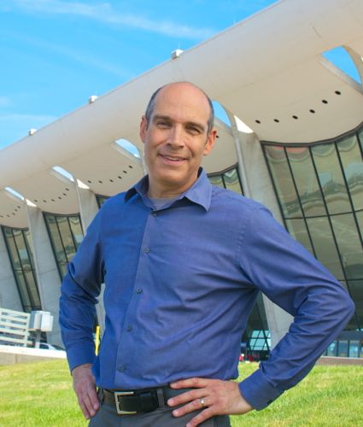
Host Geoffrey Baer at Dulles Airport.
Credit: Courtesy of WTTW
CHICAGO – 10 Buildings that Changed America, a new PBS special about ten influential American buildings that changed the way we live, work, and play, premieres on Sunday, May 12, 2013 at 10:00 p.m. ET (check local listings). Written and produced by Dan Protess and hosted by Geoffrey Baer, the program was shot on location from Massachusetts to Los Angeles, and features rare archival images, distinctive animation, and interviews with some of the nation’s most insightful historians and architects, including Frank Gehry and Robert Venturi.

“You may not have heard of all of these ten buildings, but their influence is all around you,” says Baer. “There’s a good chance that these revolutionary works of architecture inspired your local city hall or library, the mall where you shop, the office building or factory where you work, and maybe even your own house,” he added.

10 Buildings that Changed America is a journey that takes viewers inside these groundbreaking works of art and engineering and reveals the shocking, funny, and even sad stories of how these buildings came to be. From the glorious Trinity Church, designed as “an envelope” for the voice of Rector Phillips Brooks (best known today as the writer of “O Little Town of Bethlehem”) to the Highland Park Ford Plant, designed by Jewish architect Albert Kahn, whose partnership with Henry Ford flourished despite Ford’s anti-Semitic writings, the program explores how their construction had consequences — some unintended — on cities and communities across the country. Ultimately, the program is a journey inside the imaginations of a group of architects who dared to create these influential structures.

The ten buildings in chronological order are:

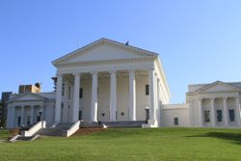Virginia State Capitol, Richmond, VA (1788) – Designed by Thomas Jefferson, it marked the beginning of the American tradition of modeling government buildings on Roman and Greek temples.
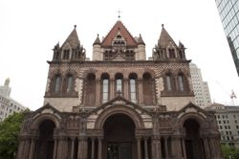
Trinity Church, Boston, MA (1877) – Created by architect H.H. Richardson, Trinity was the first example of the/his Richardsonian Romanesque style, which was later used in churches, city halls and county courthouses across America.

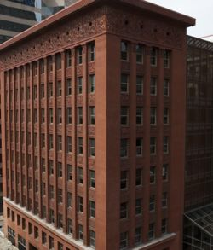Wainwright Building, St. Louis, MO (1891) – Louis Sullivan’s Wainwright Building was not the first skyscraper, but it gave the modern, steel-frame skyscraper its form. Historian Tim Samuelson said it “taught the skyscraper to soar.”

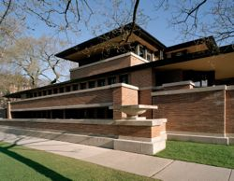Robie House, Chicago, IL (1910) – Considered a masterpiece of Frank Lloyd Wright’s prairie style, it transformed the American home and even inspired the ranch houses of the mid-20th century.

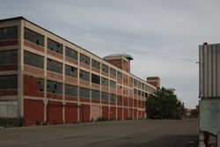Highland Park Ford Plant, Highland Park, MI (1910) – The first home of Henry Ford’s revolutionary moving assembly line, Albert Kahn’s “daylight factory” design revolutionized industrial architecture.

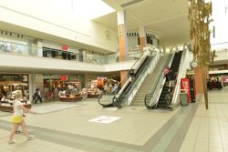Southdale Center, Edina, MN (1956) – America’s first fully enclosed, indoor regional shopping mall, it established the formula that all indoor malls followed for decades. Its architect, Victor Gruen, was a socialist who ironically thought shopping malls would cure suburban sprawl.
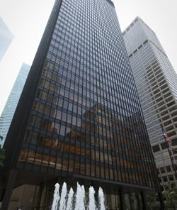

Seagram Building, New York, NY (1958) – Mies van der Rohe’s tower on Park Avenue was the model for modernist skyscrapers built across the country in the mid-20th century: a dark glass box, set back on an open plaza.

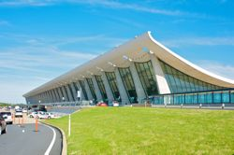
Dulles International Airport, Chantilly, VA (1962) – Designed by Eero Saarinen, this was the first airport in the world created expressly for jets.

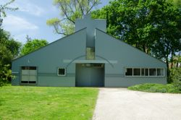
Vanna Venturi House, Philadelphia, PA (1964) – Considered by many to be the first “postmodern” building. In an age of austere glass boxes, Robert Venturi dared to design a home that looked like a child’s typical drawing of a house.
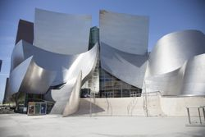
Walt Disney Concert Hall, Los Angeles, CA (2003) – Frank Gehry’s swooping stainless steel design was a radical departure from the traditional, even stuffy, idea of a concert hall. It inspired other architects to set their imaginations free.

Accompanying the broadcast is a robust companion website, wttw.com/10buildings, a mobile-optimized online destination packed with rich media content including text, photos, video, animation and interactive features that bring the stories of American architecture to life. The site will feature the stories of the ten buildings covered in the program, ten more buildings exclusive to the web, and ten trends in architecture. Visitors to the site will also have the opportunity to share their own picks. Also included will be a curriculum designed for grades 6-12 which will include five lesson plans, focusing on five different subjects: art, English, mathematics, science, and social studies.

Geoffrey Baer is known for his masterful storytelling, conversational style, and contagious enthusiasm. Nationally, Geoffrey has hosted documentaries on the acclaimed architects Michael Graves and Robert A. M. Stern, and Saved from the Wrecking Ball, a documentary about Mies van der Rohe’s all-glass Farnsworth House. Geoffrey is familiar to Chicago viewers as the host and writer of eighteen extraordinarily popular feature-length WTTW specials about Chicago architecture and history. The programs took viewers on “TV tours” of the city’s lakefront, the Chicago River by boat, the city’s neighborhoods by “L” train, the boulevards by bike and virtually all of the region’s suburban areas. He also ate his way through Chicago’s diverse communities in The Foods of Chicago: A Delicious History, which was nominated for a James Beard Award. Geoffrey appears regularly on WTTW’s flagship nightly newsmagazine program Chicago Tonight, answering viewers’ questions about Chicago architecture and history in a segment called Ask Geoffrey. He has been a docent for the Chicago Architecture Foundation since 1987. He has won multiple Emmy awards, the CPB Gold Award from the Corporation for Public Broadcasting, and awards from the Society of Architectural Historians, the New York Festivals, the U.S. International Film and Video Festival, and the Chicago Headline Club.

Dan Protess has been producing and writing critically-acclaimed television programs and films for two decades. His work has appeared on PBS, ABC, C-SPAN, and at film and video festivals across the country. Dan has produced or written 14 documentaries for WTTW Chicago, including the award-winning A Justice That Heals, Biking the Boulevards, and The Foods of Chicago: A Delicious History, which earned him an Emmy, and a James Beard Award nomination. He won a coveted Peter Lisagor Award for his work on WTTW’s nightly newsmagazine program Chicago Tonight.

10 Buildings that Changed America is produced in partnership with the Society of Architectural Historians. Major funding is provided by The Negaunee Foundation, ITW, Robert & Joan Clifford, and BMO Harris Bank. Additional funding is provided by the Joseph & Bessie Feinberg Foundation, Rande & Cary McMillan, Richard & Mary L. Gray, The Robert Thomas Bobins Foundation, Alexandra & John Nichols, Patrick & Shirley Ryan, The Walter E. Heller Foundation, in memory of Alyce DeCosta, and Nicor Gas. Funding is also provided by Harriet K. Burnstein, Ken Norgan, Peter Kelliher II, Millennium Properties, Perkins+Will, USG Corporation, Neil G. Bluhm, and other generous donors (as of 3/13/13).

10 BUILDINGS THAT CHANGED AMERICA is available on DVD and Blu-Ray from PBS Distribution: ShopPBS.org; 800-PLAY-PBS, 24 hours a day, 7 days a week. A 144-page hardcover companion book is also available at ShopPBS.org.

About WTTW National Productions
WTTW National Productions is a premier producer and presenter of original, high-quality television programs for both public and commercial television broadcast. WTTW National Productions is a division of Window to the World Communications, Inc., the parent company of WTTW Chicago. For more than 50 years, WTTW and WTTW National Productions have introduced a wide array of ground-breaking television programming – reflecting the world’s rich and diverse arts and entertainment scene as well as education, politics, public affairs, business, and religion – to a national audience. Its landmark innovative series and original productions include the critically-acclaimed performance showcases Soundstage, Legends of Jazz with Ramsey Lewis; Proclamation of Hope, and David Broza at Masada: The Sunrise Concert; cultural series, MEXICO—One Plate at a Time with Rick Bayless, Grannies on Safari, Ebert Presents At the Movies and The Artist Toolbox; the business series CEO Exchange; the documentary series Retirement Revolution; the transmedia online educational children’s properties Mission to Planet 429 and UMIGO, and the award-winning animated children’s series WordWorld. For more information, please visit www.wttw.com/national.

About PBS
PBS, with its over 350 member stations, offers all Americans the opportunity to explore new ideas and new worlds through television and online content. Each month, PBS reaches nearly 120 million people through television and nearly 28 million people online, inviting them to experience the worlds of science, history, nature and public affairs; to hear diverse viewpoints; and to take front row seats to world-class drama and performances. PBS’ broad array of programs has been consistently honored by the industry’s most coveted award competitions. Teachers of children from pre-K through 12th grade turn to PBS for digital content and services that help bring classroom lessons to life. PBS’ premier children’s TV programming and its website, pbskids.org, are parents’ and teachers’ most trusted partners in inspiring and nurturing curiosity and love of learning in children. More information about PBS is available at www.pbs.org, one of the leading dot-org websites on the Internet, or by following PBS on Twitter, Facebook or through our apps for mobile devices. Specific program information and updates for press are available at pbs.org/pressroom or by following PBS Pressroom on Twitter.
# # #

CONTACT:
CaraMar Publicity
Mary Lugo 770-623-8190 lugo@negia.net
Cara White 843-881-1480 cara.white@mac.com
Abbe Harris 908-233-7990 abbe@caramar.net

For downloadable images, visit pbs.org/pressroom/

