10 HOMES THAT CHANGED AMERICA
PREMIERES TUESDAY, APRIL 5, 2016 AT 8:00 PM ET ON PBS

First Episode of New Three-Part 10 THAT CHANGED AMERICA Series
Visits Ten Homes That Transformed the Way We Live

CHICAGO – 10 HOMES THAT CHANGED AMERICA, the first episode of the new three-part series 10 THAT CHANGED AMERICA, premieres Tuesday, April 5, 2016 at 8:00 pm ET (check local listings) on PBS. Hosted by Geoffrey Baer, 10 HOMES THAT CHANGED AMERICA, presented nationally by WTTW Chicago, highlights ten homes that transformed residential living, from grand estates such as Thomas Jefferson’s Monticello and Frank Lloyd Wright’s Fallingwater, to the pueblos of Taos, New Mexico, and the tenements of 19th century New York. Featuring interviews with architecture critic Paul Goldberger, historian Peter Onuf, and others, 10 HOMES THAT CHANGED AMERICA offers a primer in residential architecture and a fascinating lesson in the history of American domestic life, as the evolving design of these homes over time reveals our changing relationship with nature, technology, and each other.

The ten homes, featured in chronological order, are:
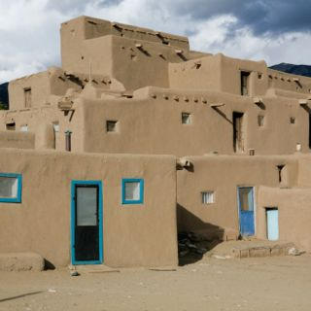
Taos Pueblo, New Mexico (c. 15th century)
America’s first “green buildings,” the pueblos of the Taos Indians of New Mexico were built with adobe (mud), which kept the dwellings cool during the day and warm at night. Their closely-packed design fostered a sense of community and offered protection against enemies.

Monticello - Albemarle County, Virginia (1809)

Thomas Jefferson called Monticello his “essay in architecture.” Inspired by the work of Italian architect Andrea Palladio, Jefferson broke with convention by setting his plantation home on a hilltop instead of along a river. The interior was designed for the enlightenment of his guests, and as a comfortable sanctuary for its owner.

Lyndhurst - Tarrytown, New York (1842)
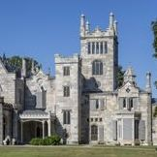
Shocking when it was built, Lyndhurst is a gothic castle on the Hudson River built by former New York City mayor William Paulding as a retreat from the industrialized city. The work of architect A. J. Davis, Lyndhurst’s irregular style complemented its rugged, picturesque setting, and proved highly influential as other wealthy Americans strove to create grand houses that expressed their individuality and connected them with the land.
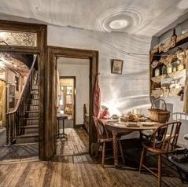
Mid-19th Century Tenement - New York
As New York’s Lower East Side swelled with immigrants, landlords converted every inch into rental space, creating cramped apartments in tenement buildings often five or more stories high. A visit to New York’s Tenement Museum provides a firsthand look at the families whose American dream began in these dank spaces without bathrooms, electricity, or running water.
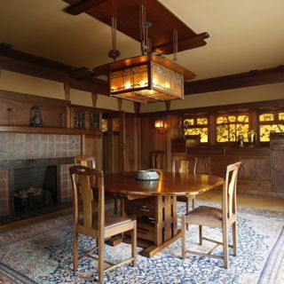
The Gamble House - Pasadena, California (1908)
The California retreat of the wealthy Gamble family of Cincinnati, the Gamble House, built by architects Charles and Henry Greene, is a prime example of an American Craftsman bungalow. The house and furnishings were handcrafted in the Arts and Crafts style, and helped inspire a bungalow-building boom as the style became synonymous with the American Dream.

Langston Terrace Dwellings - Washington, D.C. (1938)
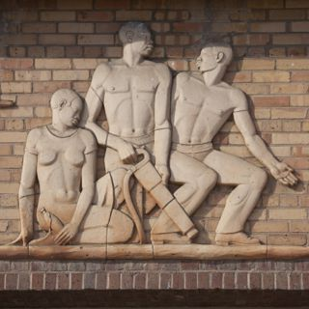
A bold re-thinking of “public housing,” Langston Terrace offered residents — primarily African Americans who had fled the South during the Great Migration — stylish homes and a ticket out of the tenements. Built by African American architect Hilyard Robinson, who believed strongly in the power of architecture to transform lives, the modernist Langston Terrace featured open green spaces, courtyards, and play areas.

Fallingwater - Mill Run, Pennsylvania (1937)
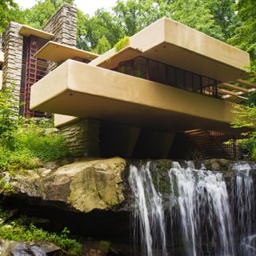
Often considered the greatest triumph of America’s greatest architect, Frank Lloyd Wright’s masterwork was built for Pittsburgh department store owner Edgar Kauffmann. Using a cantilever structure, Wright’s creation descends in layers like the waterfall that graces the site, taking the concept of integrating a home into its landscape to its ultimate extreme. The house would change our perception of how a home could be integrated with its environment, and resuscitate the career of a great American architect.

Eames House - Pacific Palisades, California (1949)
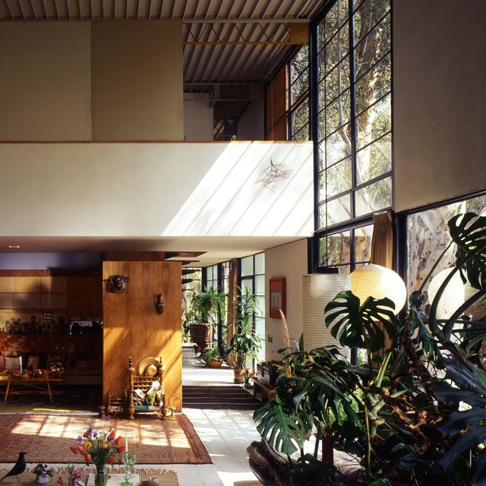
In 1945, the publisher of Arts and Architecture Magazine challenged a handful of architects to design modern, affordable housing that could be easily replicated. Among those to answer the challenge was the husband-and-wife team of well-known furniture designers Charles and Ray Eames. Despite being created from a wide variety of prefabricated materials, the Eames House showed that a factory-made home could still have style and personality.
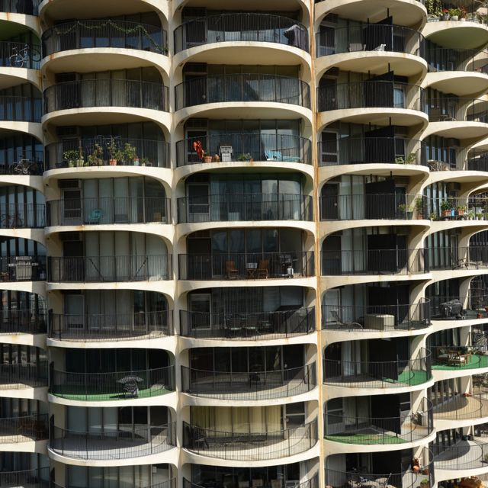
Marina City - Chicago, Illinois (1962)
At a time when people were fleeing cities for the suburbs, Chicago’s Marina City made urban living look glamorous again. Bankrolled by the janitors’ union in hopes of revitalizing the city’s downtown with a development for the middle class, Marina City was designed by architect Bertrand Goldberg. A three-acre complex with hardly a right angle in sight, Marina City’s uniquely shaped high rises offered a new vision for struggling urban downtowns across the county.

Glidehouse - Novato, California (2004)
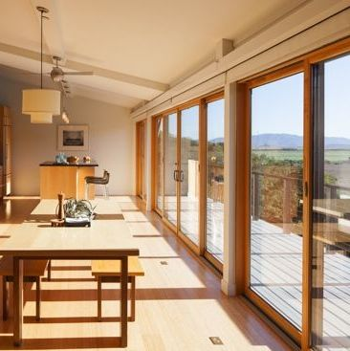
Michelle Kaufmann’s pre-fabricated, environmentally-friendly homes popped up in communities across the country. Modest in size, packed with “green” features, and factory-made, these “Glidehouses” are only the latest example of American designers’ quest to solve some of our greatest challenges with innovative design.

Other episodes in the 10 THAT CHANGED AMERICA series are 10 PARKS THAT CHANGED AMERICA (Tuesday, April 12, 2016), the story of ten innovators who took open canvases of land and transformed them into serene spaces that offer city dwellers a respite from the hustle and bustle of urban life, and 10 TOWNS THAT CHANGED AMERICA (Tuesday, April 19, 2016), a look at ten “experimental” towns that did not evolve organically over time, but instead were designed (or redesigned) from the ground up by architects, corporations, and citizens who sought to change the lives of residents using architecture, design, and urban planning.

Accompanying each episode and the three-part series are immersive websites (wttw.com/tenthatchanged) where visitors can explore and learn more about the homes, parks, and towns; discover additional landmark places and spaces; and join the discussion. Featuring additional narrative content, exclusive video, stunning photography, animated and interactive features, activities, and more, the sites bring the stories introduced in the television specials to life. Visitors to the site will have the opportunity to suggest their own homes, parks, and towns for consideration by the online audience. The digital platform also localizes the experience so users can explore their own built environment with content drawing on the rich narrative and video assets from the television productions; interactive maps guide users to drill down to attractions near the homes, parks, and towns; and the sites feature quizzes, timelines, and a peek inside the technical and artistic achievements of each of the subjects. There will also be an educational curriculum that can be used in schools.

10 HOMES THAT CHANGED AMERICA is produced by Dan Protess and hosted by Geoffrey Baer. Executive Producers are Dan Soles and V.J. McAleer. 10 THAT CHANGED AMERICA is available on DVD and Blu-ray from PBS Distribution: ShopPBS.org; 800-PLAY-PBS, 24 hours a day, 7 days a week.

GEOFFREY BAER (Host) is an Emmy-winning producer, writer and host known for his masterful storytelling, conversational style, and contagious enthusiasm. Nationally, Geoffrey hosted the acclaimed 2013 production 10 Buildings that Changed America as well as documentaries on architects Michael Graves and Robert A. M. Stern, along with Saved from the Wrecking Ball, about Mies van der Rohe’s Farnsworth House. Geoffrey is also familiar to Chicago viewers as the host and writer of numerous extraordinarily popular feature-length WTTW “TV tours” of the Chicago area’s architecture and history, which he has conducted by boat, by ‘L’ train, by bicycle, by car, through a magical “time machine,” and on foot. His special The Foods of Chicago: A Delicious History was nominated for a James Beard Award. Geoffrey appears regularly on WTTW’s flagship nightly newsmagazine program Chicago Tonight, answering viewers’ questions about Chicago architecture and history in a segment called “Ask Geoffrey.” He has been a docent tour guide for the Chicago Architecture Foundation since 1987.

DAN PROTESS (Series Producer) was the producer and writer of 10 Buildings that Changed America. His work has been seen nationally on PBS, ABC, C-SPAN, and at film and video festivals across the country. Dan’s other recent productions include the
feature-length architecture and history specials Chicago Time Machine, Chicago’s Loop: a New Walking Tour, Biking
the Boulevards and Chicago’s Lakefront. He wrote and produced the Emmy-winning, James Beard-nominated The
Foods of Chicago: A Delicious History. He has also produced candidate forums and feature stories for Chicago Tonight, WTTW’s nightly newsmagazine program, for which he has received the prestigious Peter Lisagor Award. He began his career at WTTW in 1999 as an associate producer of arts and architecture programming, and soon after served as the associate producer
and writer of A Justice That Heals, a documentary about a teenage murderer and his young victim that was shown on
ABC’s Nightline. In 2013 he was selected to attend the CPB/PBS Producers Academy at WGBH in Boston. He began
his career at public television station WHA-TV in Madison, Wisconsin.

10 THAT CHANGED AMERICA is made possible, in part, by The Joseph & Bessie Feinberg Foundation. Major funding is also provided by Joan and Robert Clifford, The Walter E. Heller Foundation, and others. A complete list is available from PBS.

About WTTW Chicago
WTTW Chicago presents a wide array of ground-breaking content for the national public media system, with series and specials on education, politics, public affairs, science, business, arts and entertainment, health, and religion. WTTW Chicago’s landmark series include Soundstage, featuring concerts by top pop and rock artists in an intimate concert setting; the popular cooking series, MEXICO — One Plate at a Time with Rick Bayless; and the new animated series Nature Cat, a co-production with Chicago’s Spiffy Pictures which premiered nationwide in November 2015. WTTW Chicago has also served as the national presenting station for such programs as 1916 - The Irish Rebellion, inCommon with Mike Leonard, Curious Traveler, Dream of Italy, Islands Without Cars, Speakeasy, Vintage, the educational children’s properties Mission to Planet 429 and UMIGO, the award-winning children’s series WordWorld, and many others. For more information, please visit wttw.com/national.

About PBS
PBS, with 350 member stations, offers all Americans the opportunity to explore new ideas and new worlds through television and online content. Each month, PBS reaches more than 103 million people through television and over 33 million people online, inviting them to experience the worlds of science, history, nature and public affairs; to hear diverse viewpoints; and to take front row seats to world-class drama and performances. PBS’ broad array of programs has been consistently honored by the industry’s most coveted award competitions. Teachers of children from pre-K through 12th grade turn to PBS for digital content and services that help bring classroom lessons to life. PBS’ premier children’s TV programming and its website, pbskids.org, are parents’ and teachers’ most trusted partners in inspiring and nurturing curiosity and love of learning in children. More information about PBS is available at www.pbs.org, one of the leading dot-org websites on the Internet, or by following PBS on Twitter, Facebook or through our apps for mobile devices. Specific program information and updates for press are available at pbs.org/pressroom or by following PBS Pressroom on Twitter.

# # #
CONTACT: CaraMar Publicity
Mary Lugo 770-623-8190 lugo@negia.net
Cara White 843-881-1480 cara.white@mac.com
Abbe Harris 908-244-5516 abbe@caramar.net

For downloadable images, visit pbs.org/pressroom/

