10 PARKS THAT CHANGED AMERICA
PREMIERES TUESDAY, APRIL 12, 2016 AT 8:00 PM ET ON PBS

Second Episode of Three-Part Series 10 THAT CHANGED AMERICA
Visits Ten Parks That Transformed Urban Living

CHICAGO – 10 PARKS THAT CHANGED AMERICA, the second episode of the new three-part series 10 THAT CHANGED AMERICA, premieres Tuesday, April 12, 2016 at 8:00 pm ET (check local listings) on PBS. 10 PARKS THAT CHANGED AMERICA, presented nationally by WTTW Chicago, highlights visionaries who transformed open canvases of land into serene spaces that offer city-dwellers a respite from the hustle and bustle of urban life. While European cities were traditionally defined by their private squares and royal hunting grounds, American cities were often built around these democratic, public spaces. From the elegant squares of Savannah, Georgia, to a park built over a freeway in Seattle, to the more recent High Line in New York, each story introduces us to the heroes who brought these parks to life. Featuring landscape architects and historians, the show uncovers the evolution of our nation’s city parks and the history of landscape architecture — an art form in which human beings try their best to mimic nature.

The ten parks, featured in chronological order, are:

The Squares of Savannah - Georgia
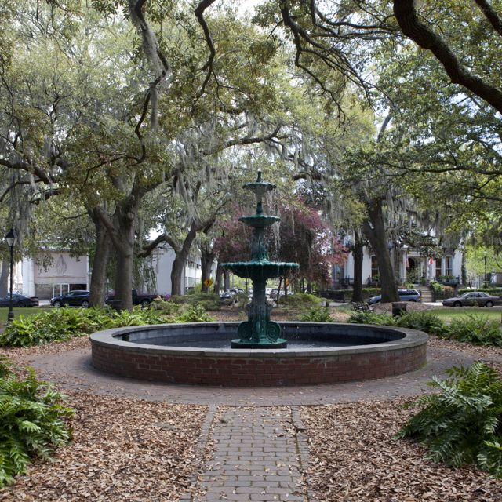
When James Oglethorpe led a group of poor laborers and tradesmen from England to Georgia in 1732, he set out to form an egalitarian colony. He designed a city of equal-sized neighborhoods centered on a public square that would serve as a place for citizens to gather water, bake bread, attend public meetings, and simply enjoy the outdoors.

Fairmount Park - Philadelphia, Pennsylvania
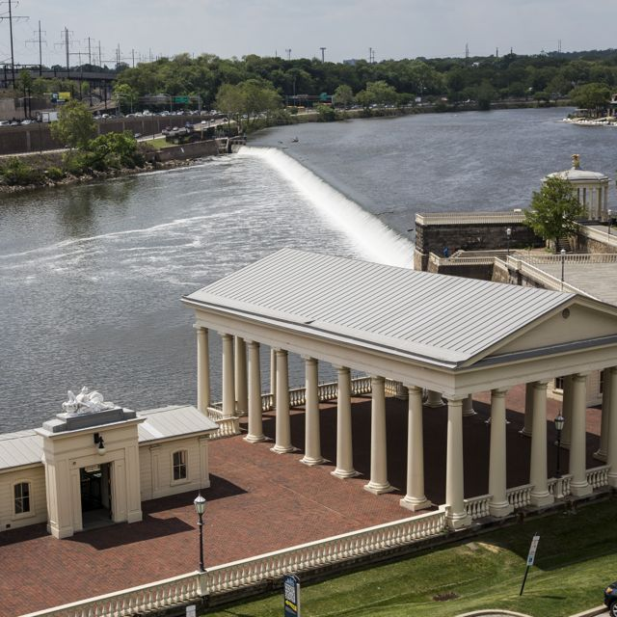
Fairmount Park was created to save a much-needed resource: water. After yellow fever claimed thousands of lives in 1793, the city reclaimed the Schuykill River waterfront as a public park that would serve as a water source, and act as the “lungs” of the ever-more industrialized city.

Mt. Auburn Cemetery - Boston, Massachusetts
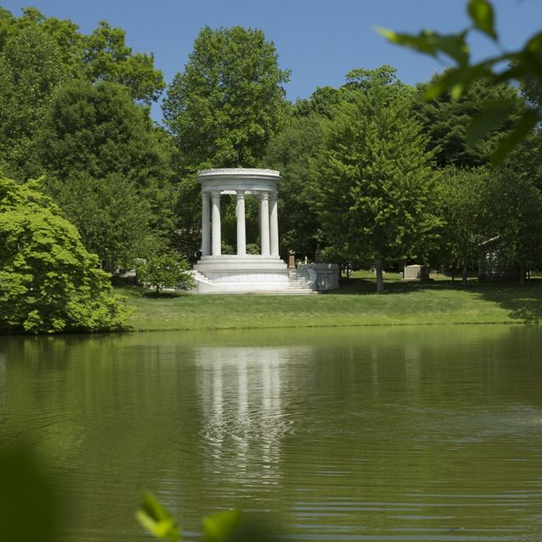
Before Mt. Auburn, most burial grounds were overcrowded and unsanitary. But in 1825, Dr. Jacob Bigelow of Harvard had a new idea — a “cemetery” that would dignify the dead in a serene setting while serving the living as a green respite from the city. Mt. Auburn was designed by Henry Dearborn, whose craft soon became known as “landscape architecture.”

Central Park - New York City
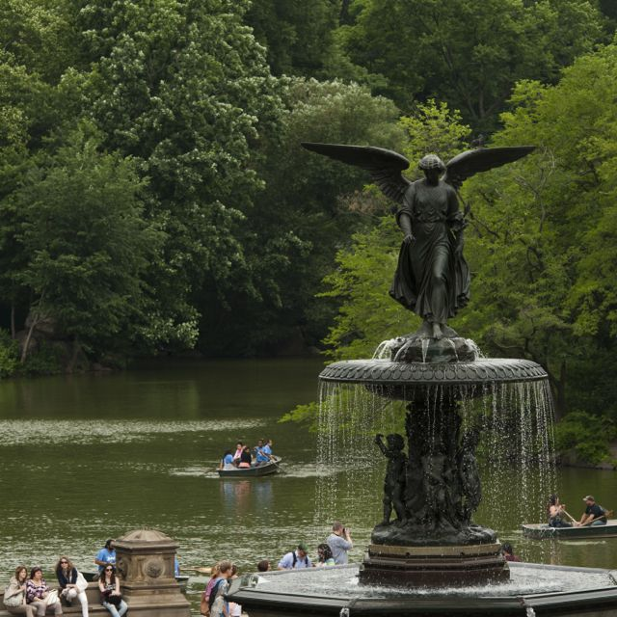
In 1858, Frederick Law Olmsted and Calvert Vaux won a competition to design Central Park. Their goal was to provide all New Yorkers, from tenement dwellers to titans of industry, a natural refuge from the crowded city and a place where the social classes could come together on equal footing.

Chicago’s Neighborhood Parks - Illinois
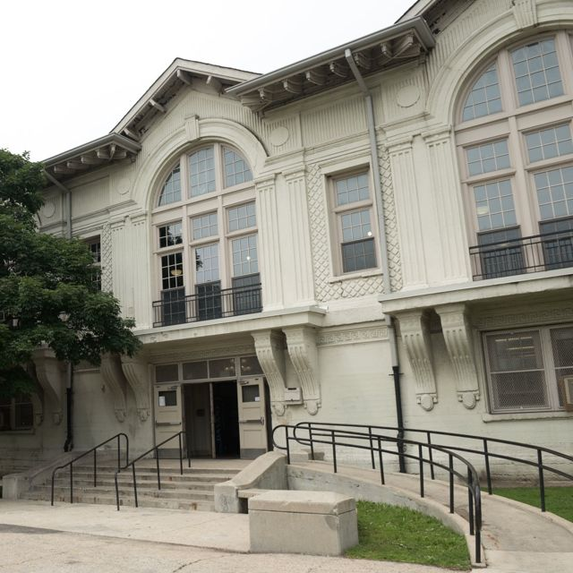
Following the success of Central Park, a progressive Chicago park superintendent named J. Frank Foster took the idea one step further. Chicago’s neighborhood parks, designed by Olmsted’s sons John Olmsted and Frederick Law Olmsted, Jr., would address the very real needs of the city’s immigrants by providing a place to bathe and play sports, get free healthcare, and take a variety of classes.

San Antonio’s River Walk - Texas
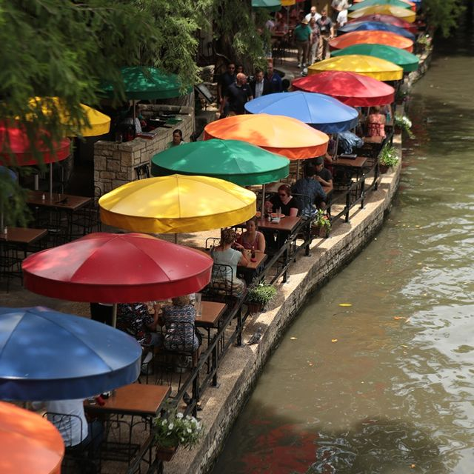
The San Antonio River had been always prone to flooding; in 1921, more than 50 lives were claimed. But 27-year-old architect Robert Hugman transformed the flood-ravaged banks into a Spanish Revival promenade that would serve as a commercial district with elegant shops and cafes. The River Walk not only transformed San Antonio, but showed other American cities the possible economic upside of urban parks.

Overton Park - Memphis, Tennessee
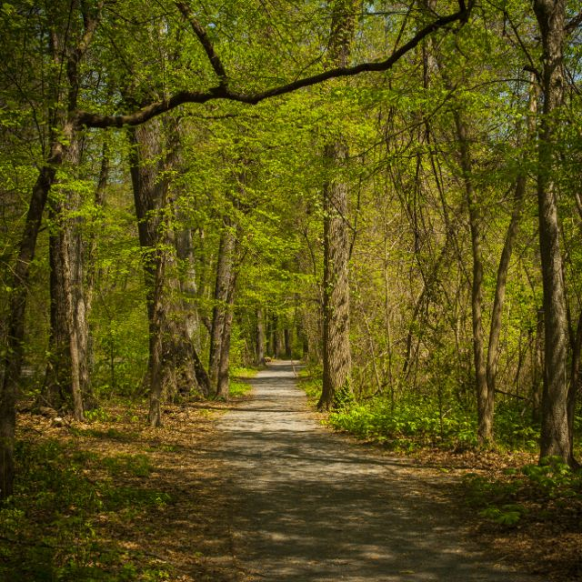
In 1957, it was announced that a six-lane freeway would plow through Memphis’s Overton Park — a fate that had already disfigured other American parks as the interstate highway system cut through the country. But a group of mostly middle-class homemakers led a campaign to save the park, ultimately succeeding in preserving not only Overton Park, but cherished green spaces around the country.

Freeway Park - Seattle, Washington
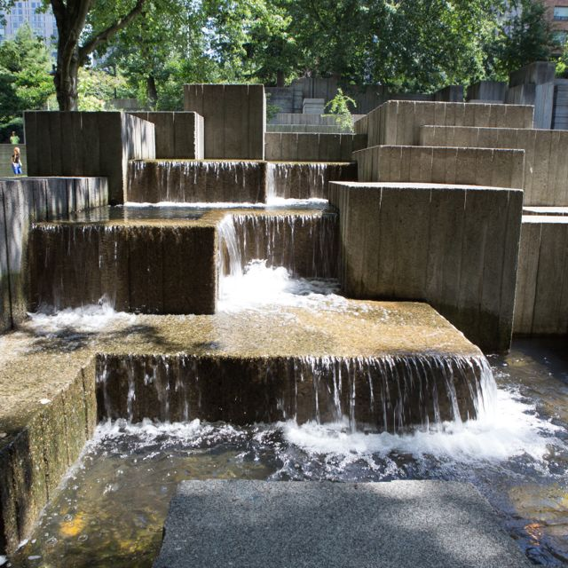
In Seattle, the damage was already done when a freeway cut the city in half in 1966. But landscape architect Lawrence Halprin would heal the wound with a new kind of park built on top of the freeway, embracing both nature and the changing face of the city.

Gas Works Park - Seattle, Washington
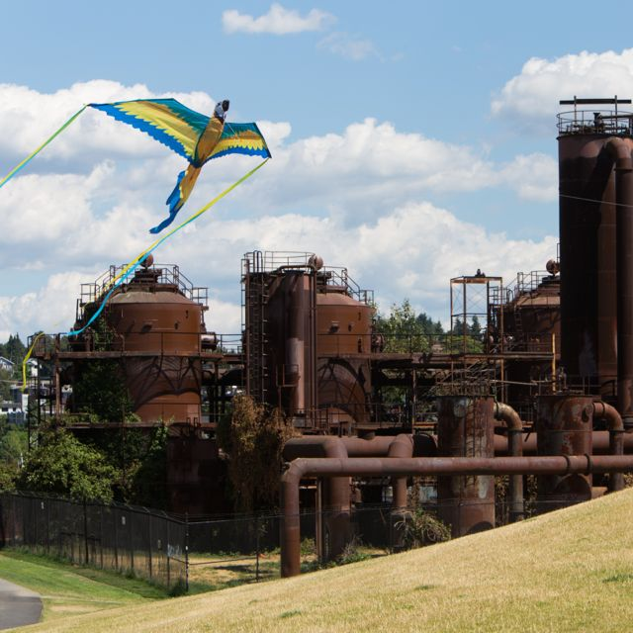
A toxic waste site is an unlikely place for a park. Yet in the mid-1970s, landscape architect Richard Haag designed a park that celebrated the hulking ruins of the Gas Works that had poisoned the site. Using the new science of bioremediation to clean the soil, Haag transformed one of the city’s worst eyesores into a place of wonder as well as a reminder of Seattle’s industrial past.

The High Line - New York City
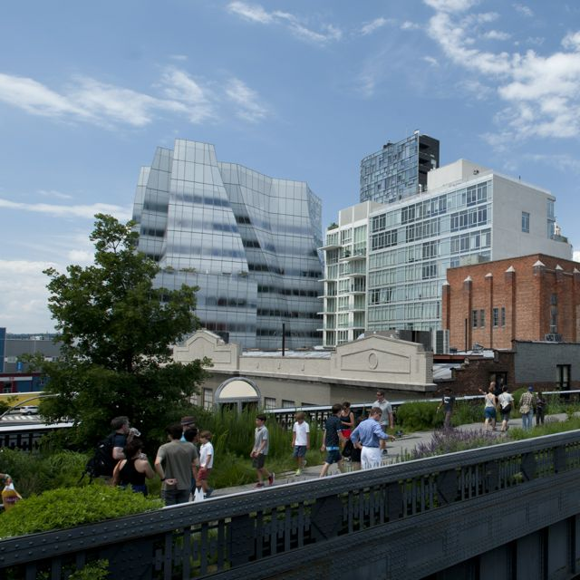
Not so long ago, the High Line was a derelict rail line cutting across New York’s Lower West Side. Faced with the wrecking ball, two local activists started a grassroots campaign to turn the space into a public park. By 2006, with the funding in place, park designers James Corner and Diller Scofidio Renfro began work on a unique space that celebrates the past while breaking new ground in our concept of what a park is, and where a park can be.

Other episodes in the 10 THAT CHANGED AMERICA series are 10 HOMES THAT CHANGED AMERICA (Tuesday, April 5, 2016), which highlights ten homes that transformed residential living, from grand estates such as Thomas Jefferson’s Monticello and Frank Lloyd Wright’s Fallingwater, to the pueblos of Taos, New Mexico and the tenements of 19th century New York; and 10 TOWNS THAT CHANGED AMERICA (Tuesday, April 19, 2016), a look at ten “experimental” towns that did not evolve organically over time, but instead were designed (or redesigned) from the ground up by architects, corporations, and citizens who sought to change the lives of residents using architecture, design, and urban planning.

Accompanying each episode and the three-part series are immersive websites (wttw.com/tenthatchanged) where visitors can explore and learn more about the homes, parks, and towns; discover additional landmark places and spaces; and join the discussion. Featuring additional narrative content, exclusive video, stunning photography, animated and interactive features, activities, and more, the sites bring the stories introduced in the television specials to life. Visitors to the site will have the opportunity to suggest their own homes, parks, and towns for consideration by the online audience. The digital platform also localizes the experience so users can explore their own built environment with content drawing on the rich narrative and video assets from the television productions; interactive maps guide users to drill down to attractions near the homes, parks, and towns; and the sites feature quizzes, timelines, and a peek inside the technical and artistic achievements of each of the subjects. There will also be an educational curriculum that can be used in schools.

10 PARKS THAT CHANGED AMERICA is produced by Dan Protess and hosted by Geoffrey Baer. Executive Producers are Dan Soles and V.J. McAleer. 10 THAT CHANGED AMERICA is available on DVD and Blu-Ray from PBS Distribution: ShopPBS.org; 800-PLAY-PBS, 24 hours a day, 7 days a week.

GEOFFREY BAER (Host) is an Emmy-winning producer, writer and host known for his masterful storytelling, conversational style, and contagious enthusiasm. Nationally, Geoffrey hosted the acclaimed 2013 production 10 Buildings that Changed America as well as documentaries on architects Michael Graves and Robert A. M. Stern, along with Saved from the Wrecking Ball, about Mies van der Rohe’s Farnsworth House. Geoffrey is also familiar to Chicago viewers as the host and writer of numerous extraordinarily popular feature-length WTTW “TV tours” of the Chicago area’s architecture and history, which he has conducted by boat, by ‘L’ train, by bicycle, by car, through a magical “time machine,” and on foot. His special The Foods of Chicago: A Delicious History was nominated for a James Beard Award. Geoffrey appears regularly on WTTW’s flagship nightly newsmagazine program Chicago Tonight, answering viewers’ questions about Chicago architecture and history in a segment called “Ask Geoffrey.” He has been a docent tour guide for the Chicago Architecture Foundation since 1987.

DAN PROTESS (Series Producer) was the producer and writer of 10 Buildings that Changed America. His work has been seen nationally on PBS, ABC, C-SPAN, and at film and video festivals across the country. Dan’s other recent productions include the
feature-length architecture and history specials Chicago Time Machine, Chicago’s Loop: a New Walking Tour, Biking
the Boulevards and Chicago’s Lakefront. He wrote and produced the Emmy-winning, James Beard-nominated The
Foods of Chicago: A Delicious History. He has also produced candidate forums and feature stories for Chicago Tonight, WTTW’s nightly newsmagazine program, for which he has received the prestigious Peter Lisagor Award. He began his career at WTTW in 1999 as an associate producer of arts and architecture programming, and soon after served as the associate producer and writer of A Justice That Heals, a documentary about a teenage murderer and his young victim that was shown on ABC’s Nightline. In 2013 he was selected to attend the CPB/PBS Producers Academy at WGBH in Boston. He began
his career at public television station WHA-TV in Madison, Wisconsin.

10 THAT CHANGED AMERICA is made possible, in part, by The Joseph & Bessie Feinberg Foundation. Major funding is also provided by Joan and Robert Clifford, The Walter E. Heller Foundation, and others. A complete list is available from PBS.

About WTTW Chicago
WTTW Chicago presents a wide array of ground-breaking content for the national public media system, with series and specials on education, politics, public affairs, science, business, arts and entertainment, health, and religion. WTTW Chicago’s landmark series include Soundstage, featuring concerts by top pop and rock artists in an intimate concert setting; the popular cooking series, MEXICO — One Plate at a Time with Rick Bayless; and the new animated series Nature Cat, a co-production with Chicago’s Spiffy Pictures which premiered nationwide in November 2015. WTTW Chicago has also served as the national presenting station for such programs as 1916 - The Irish Rebellion, inCommon with Mike Leonard, Curious Traveler, Dream of Italy, Islands Without Cars, Speakeasy, Vintage, the educational children’s properties Mission to Planet 429 and UMIGO, the award-winning children’s series WordWorld, and many others. For more information, please visit wttw.com/national.

About PBS
PBS, with 350 member stations, offers all Americans the opportunity to explore new ideas and new worlds through television and online content. Each month, PBS reaches more than 103 million people through television and over 33 million people online, inviting them to experience the worlds of science, history, nature and public affairs; to hear diverse viewpoints; and to take front row seats to world-class drama and performances. PBS’ broad array of programs has been consistently honored by the industry’s most coveted award competitions. Teachers of children from pre-K through 12th grade turn to PBS for digital content and services that help bring classroom lessons to life. PBS’ premier children’s TV programming and its website, pbskids.org, are parents’ and teachers’ most trusted partners in inspiring and nurturing curiosity and love of learning in children. More information about PBS is available at www.pbs.org, one of the leading dot-org websites on the Internet, or by following PBS on Twitter, Facebook or through our apps for mobile devices. Specific program information and updates for press are available at pbs.org/pressroom or by following PBS Pressroom on Twitter.

# # #
CONTACT:
CaraMar Publicity
Mary Lugo 770-623-8190 lugo@negia.net
Cara White 843-881-1480 cara.white@mac.com
Abbe Harris 908-244-5516 abbe@caramar.net

For downloadable images, visit pbs.org/pressroom/

