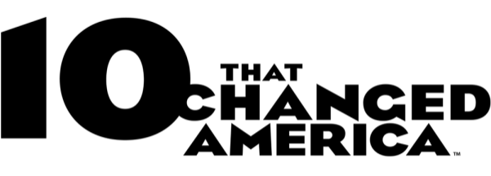



10 THAT CHANGED AMERICA Returns with New Season
Premiering Tuesdays, July 10-24, 2018

Join Host Geoffrey Baer on a Cross-Country Road Trip to Explore the Streets, Monuments, and Modern Marvels
That Transformed America

CHICAGO – 10 THAT CHANGED AMERICA, the popular series that explores the nation’s built environment, returns this summer with three new episodes and website that reveal the fascinating and often untold stories behind America’s streets, monuments and modern marvels.
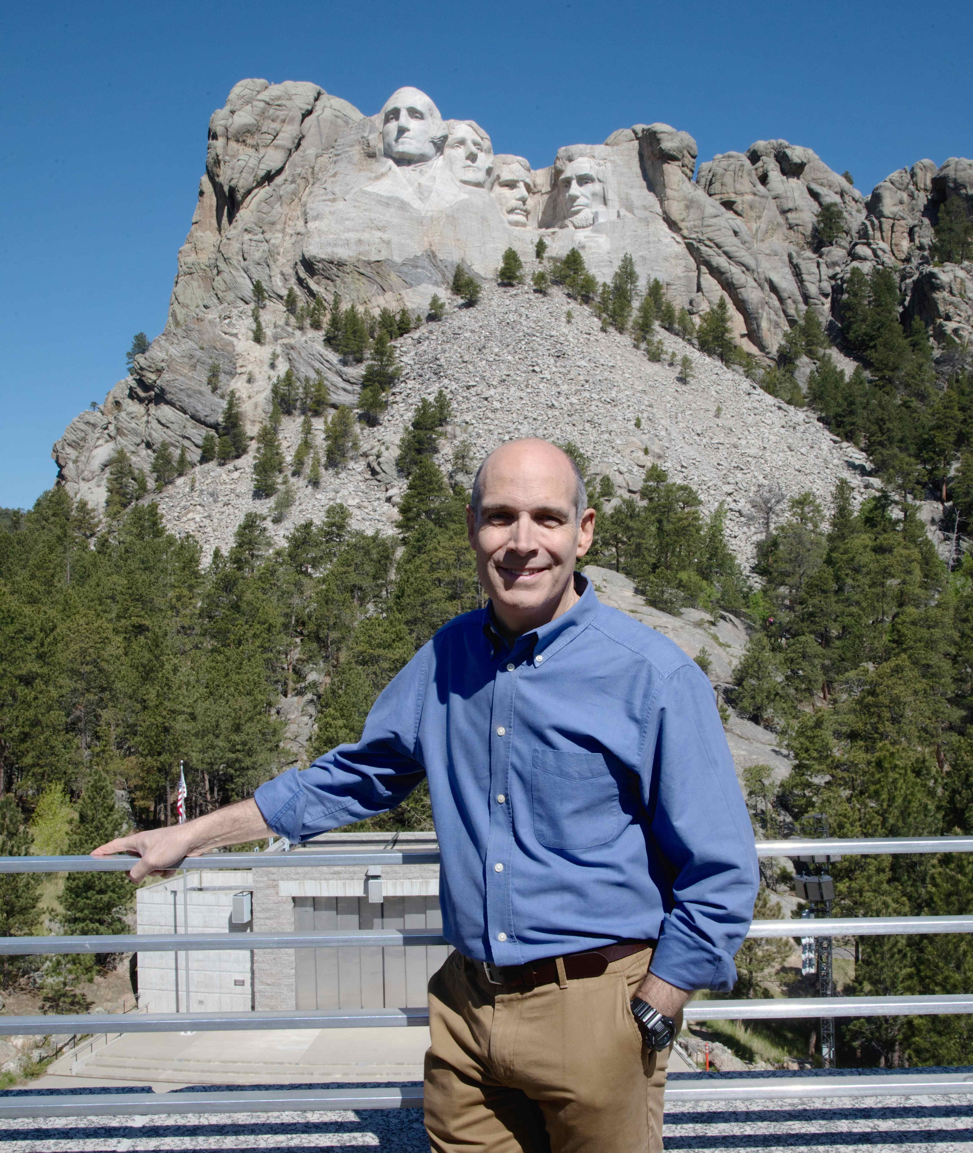
Credit: WTTW and Mike Wolforth

From New York’s Broadway to the Hoover Dam, from Mount Rushmore to the St. Louis Arch, join host Geoffrey Baer on a summer road trip across America as he meets with historians, curators, and guides who share the fascinating backstories behind the iconic streets that connect our nation, the monuments that commemorate our history, and the engineering marvels that transformed our environment and shaped the way we live. Produced and written by Dan Protess, 10 THAT CHANGED AMERICA premieres Tuesdays, July 10, 17, and 24, 8:00-9:00 PM ET (check local listings) on PBS, on pbs.org, and wttw.com/10.

Kicking off the season on July 10 is 10 Streets that Changed America, which reveals how streets and roads have connected the nation, divided communities, and changed the way Americans live, work, and shop. Geoffrey traces the 400-year evolution of New York’s Broadway, from Native American road to Dutch thoroughfare, from theater district to poster child for the “complete streets” movement of the future. Other influential streets include the Boston Post Road, St. Charles Avenue in New Orleans, Wilshire Boulevard in Los Angeles and more.

The 10 THAT CHANGED AMERICA companion website will feature immersive content about the streets, monuments, and modern marvels including original stories, video extras, quizzes, photography, and behind-the-scenes adventures.

10 Monuments that Changed America (July 17) explores the stories behind ten wholly-original American monuments and the historical moments that inspired them, from the Statue of Liberty to Mount Rushmore, from the Vietnam Veterans Memorial to the AIDS Quilt. The episode presents the often-contentious battles over the design of these monuments and the ongoing controversies over Confederate monuments throughout the South.

Finally, 10 Modern Marvels that Changed America (July 24) celebrates the visionary engineers who scoffed at the laws of nature, defied the naysayers — and sometimes even gravity — by undertaking amazing feats of engineering. Each story includes a fun physics lesson and a tale of human folly: from the Erie Canal to the Hoover Dam, from the Transcontinental Railroad to the Interstate Highway System.

“10 that Changed America is a history series, but the subjects we tackled this season couldn’t be more current: the fate of Confederate monuments, infrastructure spending, and battles over public spaces,” said Protess. “Many of these stories could have been ripped from today’s headlines.”

“Hosting this series was like a roller coaster ride of experience and emotion,” said Baer. “The monuments immersed me in triumphs and tragedies of every scale; the engineering marvels took me from thousands of feet in the air to deep underground, pondering the brilliance and hubris of humankind; and as for the streets, I explored them on foot and horseback, in a covered wagon, and in an array of vintage vehicles. It left me in awe of the power of people to imagine and to create.”

10 THAT CHANGED AMERICA is produced and written by Dan Protess and hosted by Geoffrey Baer. Dan Soles and Dan Protess are the Executive Producers. The series is available on DVD and Blu-ray from PBS Distribution at pbs.org/shop.

* * *

GEOFFREY BAER (Host) was also the host for the 2016 season of 10 THAT CHANGED AMERICA and the 2013 program 10 BUILDINGS THAT CHANGED AMERICA. Also for PBS, he traveled to Cuba to host the primetime special Weekend in Havana, which he co-wrote. His other national public television programs include documentaries about acclaimed architects Robert A. M. Stern and Michael Graves, and Saved from the Wrecking Ball, about the rescue of Mies van der Rohe’s Farnsworth House. For WTTW Chicago, Geoffrey is the host and writer of popular feature-length TV specials about Chicago architecture and history, including The Chicago River Tour, Chicago’s Loop: a New Walking Tour, Biking the Boulevards, Chicago’s Lakefront, and Chicago by ‘L’, as well as programs covering virtually all of Chicago’s suburban areas. Geoffrey also appears regularly on WTTW’s flagship nightly public affairs program Chicago Tonight, answering viewer questions about Chicago architecture and history in a segment called Ask Geoffrey. Geoffrey has won seven regional Emmy Awards, the CPB Gold Award from the Corporation for Public Broadcasting, and awards and honors from the National Association of Broadcasters, the New York Festivals, the Chicago Headline Club, the American Institute of Architects, the Society of Architectural Historians, and the American Society of Landscape Architects.

DAN PROTESS (Producer, Writer, and Executive Producer) was the Series Producer of the 2016 season of 10 THAT CHANGED AMERICA, and the Producer and Writer of the 2013 program 10 BUILDINGS THAT CHANGED AMERICA. He has been producing and writing at WTTW Chicago for 17 years. His recent productions include the web series Urban Nature and FoodPhiles as well as the feature-length architecture and history specials Chicago’s Loop: a New Walking Tour, Biking the Boulevards and Chicago’s Lakefront. He wrote and produced the Emmy-winning, James Beard-nominated The Foods of Chicago: A Delicious History. He has also produced candidate forums and feature stories for Chicago Tonight, the station’s nightly newsmagazine program, for which he has received the prestigious Peter Lisagor Award.

About WTTW Chicago
WTTW is the PBS member station in Chicago, committed to creating and presenting unique media content across distinct television and digital channels – WTTW11, WTTW Prime, WTTW Create/WTTW World, WTTW PBS Kids 24/7, wttw.com and the PBS/WTTW video app. Recognized for award-winning journalism and local productions such as Chicago Tonight, Chicago River Tour, Check, Please!, digital-first series Urban Nature and Foodphiles – and national productions 10 That Changed America and Nature Cat – WTTW presents the very best in public affairs, arts and culture, nature and science, history, documentary and children’s public media content.
# # #
CONTACT:
CaraMar Publicity:
Mary Lugo 770-623-8190 lugo@negia.net
Cara White 843-881-1480 cara.white@mac.com
Abbe Harris 908-233-7990 abbe.harris@caramar.net

For additional information and downloadable images, visit pbs.org/pressroom/

