10 TOWNS THAT CHANGED AMERICA
PREMIERES APRIL 19, 2016 AT 8:00 PM ET ON PBS

Third Episode of Three-Part Series 10 THAT CHANGED AMERICA
Visits Ten Planned Towns that Transformed Our Cities and Suburbs

CHICAGO – 10 TOWNS THAT CHANGED AMERICA, the third episode of the new three-part series 10 THAT CHANGED AMERICA, premieres Tuesday, April 19, 2016 at 8:00 pm ET (check local listings) on PBS. Hosted by Geoffrey Baer, 10 TOWNS THAT CHANGED AMERICA, presented nationally by WTTW Chicago, visits ten influential planned towns that transformed our ideas of community. Most cities, towns, and suburbs have evolved organically over time — their design resulting from the disparate actions of individuals. But these ten experimental towns were designed (or redesigned) from the ground up by visionary planners, and ordinary citizens who sought to change the lives of residents using architecture, design, and urban planning. Some of these planners were driven by ideology, others were trying to serve their own financial interests, but all had one thing in common: they believed in the power of our built environment to change the way we live. Featuring interviews with architecture critic Paul Goldberger, historian Francesca Ammon, and architect Robert A.M. Stern, as well as the creators and residents of many of these towns, the program profiles ten towns that have had lasting impact on the way our cities and suburbs are designed. From forward-looking towns such as Greenbelt, Maryland, to Seaside, Florida, a town that tries to recapture the past, from a radical suburb (Riverside, Illinois) to a city with divine inspiration (Salt Lake City, Utah), 10 TOWNS THAT CHANGED AMERICA is an eye-opening look at the evolution of some of the places we call home.

The ten towns, featured in chronological order, are:

St. Augustine, Florida
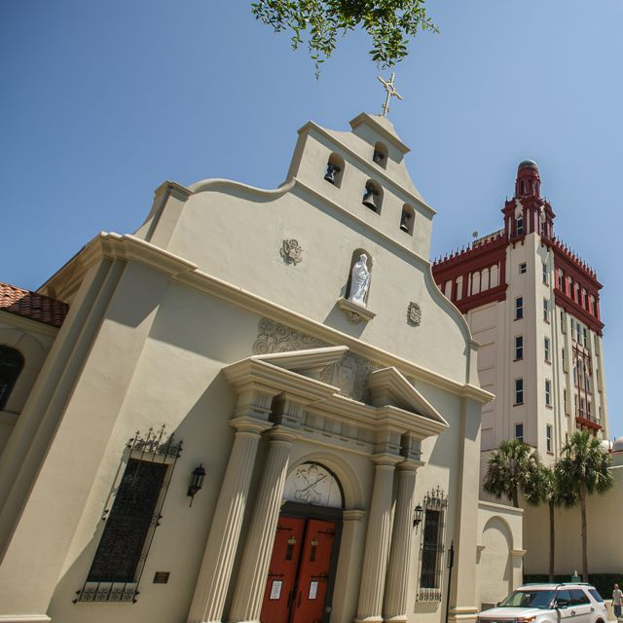
America’s oldest colonial town and the first planned town in America was designed using King Phillip II of Spain’s 148 “Laws of the Indies,” which governed how colonists should settle the new world. The laws governed everything from the width of the streets to the proper place for the market.

Philadelphia, Pennsylvania
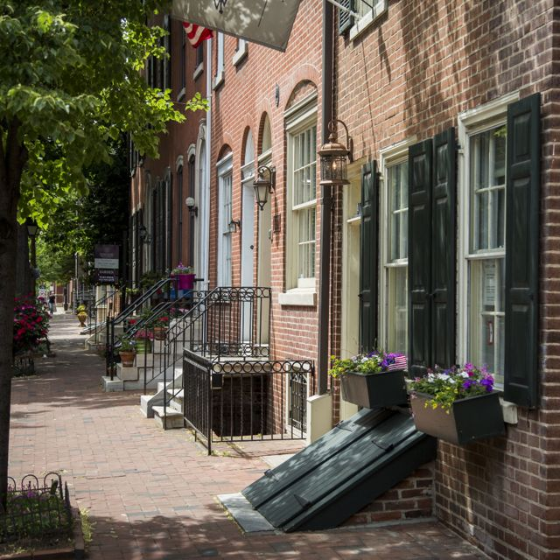
Founded by Quaker William Penn as a pacifist outpost, Penn’s plan for Philadelphia was a spacious grid that called for wide streets and enormous residential lots. Although Penn didn’t live to see it, his idealistic grid would prove enormously influential.

Salt Lake City, Utah
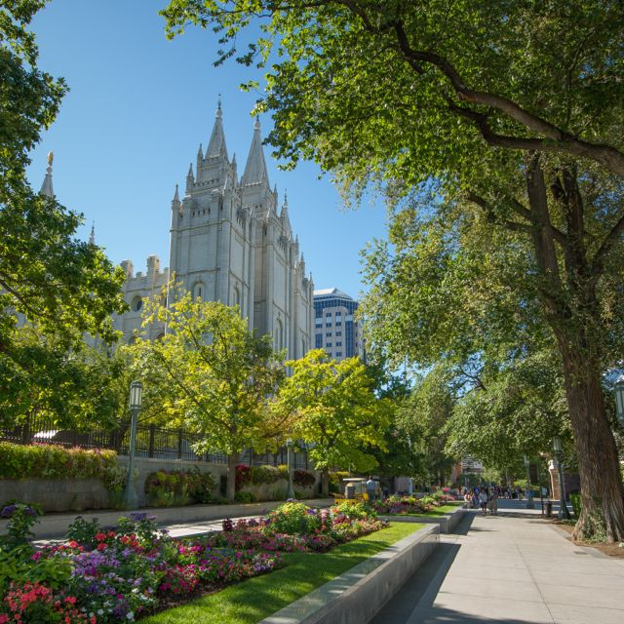
When the first blocks were laid out in this Mormon town in 1847, the man who planned it – Joseph Smith – was long dead. But Salt Lake City, built by Brigham Young using Smith’s “Plat of the City of Zion,” combined divinely-inspired urban planning with a spiritual mission designed to create a city dedicated to God.

Riverside, Illinois
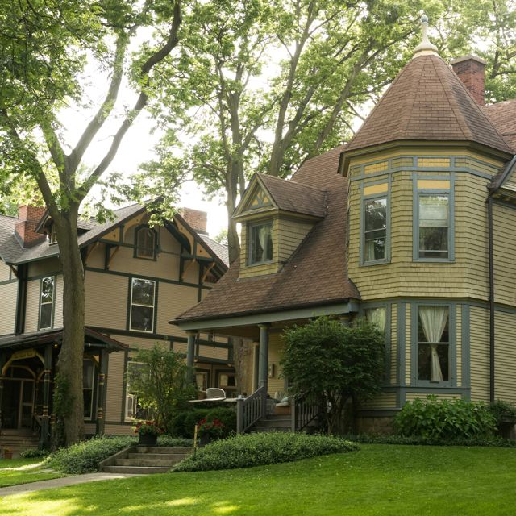
Best known as the designer of New York’s Central Park, Frederick Law Olmsted was the mastermind behind one of America’s first planned suburbs. Eschewing the standard grid pattern, Olmsted designed the suburb to complement the curvilinear nature of the Des Plaines River, and popularized the notion of a suburban retreat composed of winding streets and natural vistas.

Pullman, Illinois
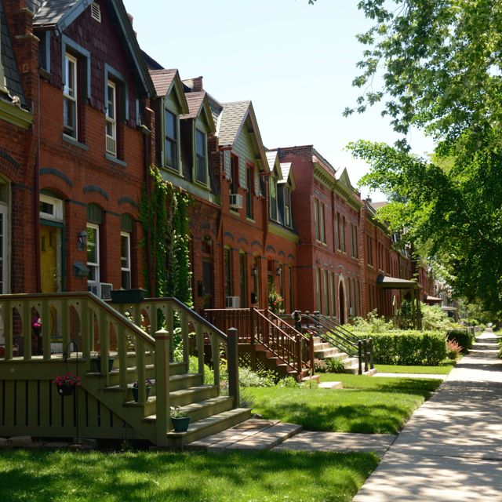
In 1879, railroad car tycoon George Pullman started building a new factory town south of Chicago that would be a workers’ utopia – or so he thought. His architect, 26-year-old Solon S. Berman, created a variety of housing – large homes for managers and tenement blocks for unskilled workers, which Pullman would rent out at a profit. When a strike ensued in 1893, the Illinois Supreme Court ruled that a company does not have the right to control the housing of its workers.

Greenbelt, Maryland
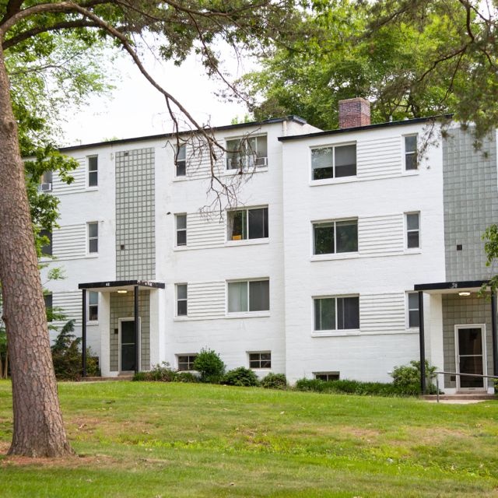
Greenbelt was created to be the antidote to the traffic-filled, run-down cities of the Depression. Greenbelt’s planners created a paradise of footpaths, cul-de-sacs, and green space. With the support of President Franklin D. Roosevelt, these ideas would influence the building of suburbs for years to come.

Levittown, New York
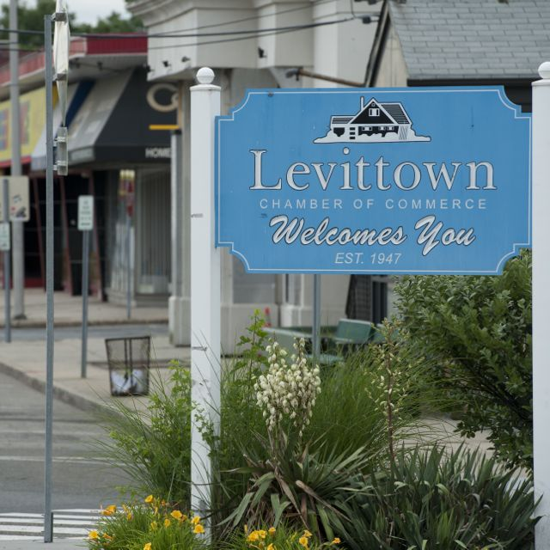
Between 1947 and 1951, Abraham Levitt and his sons William and Alfred built 17,447 houses in a former potato field on Long Island and named it Levittown. Cheap and geared toward returning GIs and their young families, Levittown offered buyers an inroad into the American dream of home ownership – but only if you were white.

Southwest District of Columbia
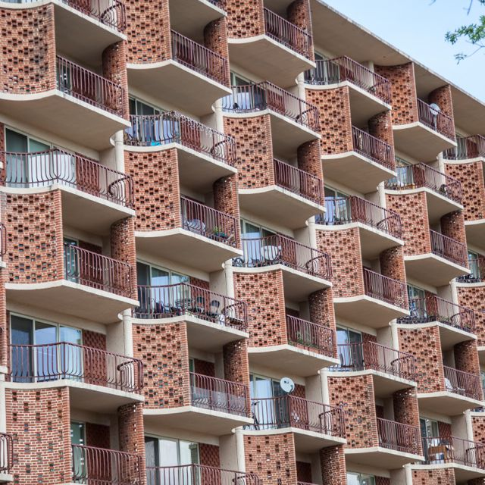
In the shadow of the National Mall was a long-standing African American community packed into row houses in cramped alleys. City leaders, buoyed by the federal government’s “slum-clearing” urban renewal program, leveled the area and created a new type of community where shopping, housing, and entertainment existed in separate districts. In the end, the project drove up real estate prices, drove out working-class African Americans, and started a trend that spread to cities across the country.

Seaside, Florida
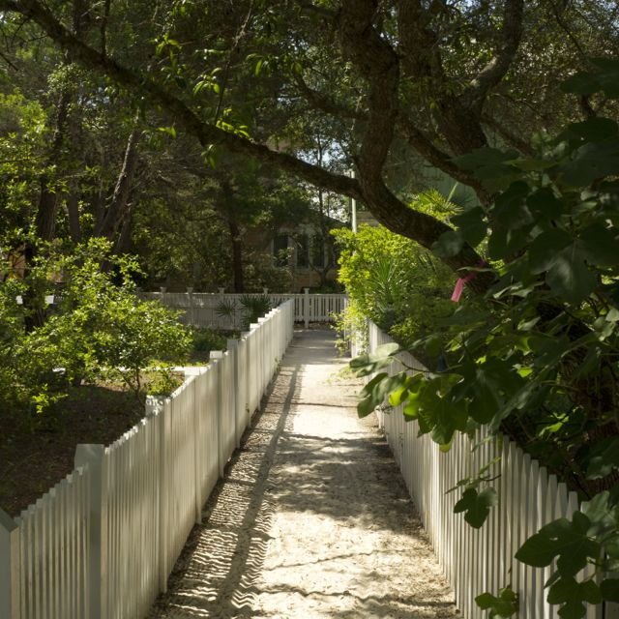
A resort town that offers a vision of the future that looks a lot like the past, Seaside is the passion project of Robert Davis, who summered there as a child. When he inherited the land, Davis hired Miami architects Andres Duany and Elizabeth Plater-Zyberk to create an architecturally diverse, completely walkable town in a style that became known as New Urbanism.

Pearl District - Portland, Oregon
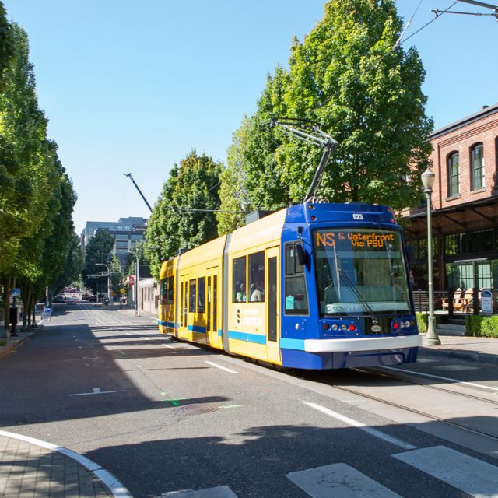
The future of urban planning might look a lot like the Pearl District of Portland, where new and old exist side by side. A “transit-oriented development,” the Pearl is designed around public transportation. Built on abandoned rail yards and warehouses, the Pearl is now a vibrant community with an economically diverse population and a vibrant street life.

Other episodes in the 10 THAT CHANGED AMERICA series are 10 HOMES THAT CHANGED AMERICA (Tuesday, April 5, 2016), which explores ten homes that transformed residential living, from grand estates such as Thomas Jefferson’s Monticello and Frank Lloyd Wright’s Fallingwater, to the pueblos of Taos, New Mexico, and the tenements of 19th century New York, and 10 PARKS THAT CHANGED AMERICA (Tuesday, April 12, 2016), which highlights ten visionaries who took open canvases of land and transformed them into serene spaces that offer city dwellers a respite from the hustle and bustle of urban life.

Accompanying each episode and the three-part series are immersive websites (wttw.com/tenthatchanged) where visitors can explore and learn more about the homes, parks, and towns; discover additional landmark places and spaces; and join the discussion. Featuring additional narrative content, exclusive video, stunning photography, animated and interactive features, activities, and more, the sites bring the stories introduced in the television specials to life. Visitors to the site will have the opportunity to suggest their own homes, parks, and towns for consideration by the online audience. The digital platform also localizes the experience so users can explore their own built environment with content drawing on the rich narrative and video assets from the television productions; interactive maps guide users to drill down to attractions near the homes, parks, and towns; and the sites feature quizzes, timelines, and a peek inside the technical and artistic achievements of each of the subjects. There will also be an educational curriculum that can be used in schools.

10 TOWNS THAT CHANGED AMERICA is produced by Daniel Andries and hosted by Geoffrey Baer. Series Producer is Dan Protess. Executive Producers are Dan Soles and V.J. McAleer. 10 THAT CHANGED AMERICA is available on DVD and Blu-Ray from PBS Distribution: ShopPBS.org; 800-PLAY-PBS, 24 hours a day, 7 days a week.

GEOFFREY BAER (Host) is an Emmy-winning producer, writer and host known for his masterful storytelling, conversational style, and contagious enthusiasm. Nationally, Geoffrey hosted the acclaimed 2013 production 10 Buildings that Changed America as well as documentaries on architects Michael Graves and Robert A. M. Stern, along with Saved from the Wrecking Ball, about Mies van der Rohe’s Farnsworth House. Geoffrey is also familiar to Chicago viewers as the host and writer of numerous extraordinarily popular feature-length WTTW “TV tours” of the Chicago area’s architecture and history, which he has conducted by boat, by ‘L’ train, by bicycle, by car, through a magical “time machine,” and on foot. His special The Foods of Chicago: A Delicious History was nominated for a James Beard Award. Geoffrey appears regularly on WTTW’s flagship nightly newsmagazine program Chicago Tonight, answering viewers’ questions about Chicago architecture and history in a segment called “Ask Geoffrey.” He has been a docent tour guide for the Chicago Architecture Foundation since 1987.

DANIEL ANDRIES (Producer) is a Senior Producer at WTTW in Chicago. Andries has produced a number of documentaries on architects, including nationally distributed programs on Robert A.M. Stern and Michael Graves. His work at WTTW includes Emmy Award-winning programming on artists, from the weekly arts magazine series Artbeat Chicago and Arts Across Illinois to Beauty Rises: Four Lives in the Arts, which weaves together the story of four Illinois artists building to a premiere of a new work. Three feature-length documentaries explored the history of Chicago’s Irish, African-American, and LGBT population. He has five Chicago/Midwest Emmy Awards and nominations for dozens more, as well as honors from festivals and the Society of Professional Journalists.

DAN PROTESS (Series Producer) was the producer and writer of 10 Buildings that Changed America. His work has been seen nationally on PBS, ABC, C-SPAN, and at film and video festivals across the country. Dan’s other recent productions include the
feature-length architecture and history specials Chicago Time Machine, Chicago’s Loop: a New Walking Tour, Biking
the Boulevards and Chicago’s Lakefront. He wrote and produced the Emmy-winning, James Beard-nominated The
Foods of Chicago: A Delicious History. He has also produced candidate forums and feature stories for Chicago Tonight, WTTW’s nightly newsmagazine program, for which he has received the prestigious Peter Lisagor Award. He began his career at WTTW in 1999 as an associate producer of arts and architecture programming, and soon after served as the associate producer and writer of A Justice That Heals, a documentary about a teenage murderer and his young victim that was shown on ABC’s Nightline. In 2013 he was selected to attend the CPB/PBS Producers Academy at WGBH in Boston. He began
his career at public television station WHA-TV in Madison, Wisconsin.

10 THAT CHANGED AMERICA is made possible, in part, by The Joseph & Bessie Feinberg Foundation. Major funding is also provided by Joan and Robert Clifford, The Walter E. Heller Foundation, and others. A complete list is available from PBS.

About WTTW Chicago
WTTW Chicago presents a wide array of ground-breaking content for the national public media system, with series and specials on education, politics, public affairs, science, business, arts and entertainment, health, and religion. WTTW Chicago’s landmark series include Soundstage, featuring concerts by top pop and rock artists in an intimate concert setting; the popular cooking series, MEXICO — One Plate at a Time with Rick Bayless; and the new animated series Nature Cat, a co-production with Chicago’s Spiffy Pictures which premiered nationwide in November 2015. WTTW Chicago has also served as the national presenting station for such programs as 1916 - The Irish Rebellion, inCommon with Mike Leonard, Curious Traveler, Dream of Italy, Islands Without Cars, Speakeasy, Vintage, the educational children’s properties Mission to Planet 429 and UMIGO, the award-winning children’s series WordWorld, and many others. For more information, please visit wttw.com/national.
About PBS
PBS, with 350 member stations, offers all Americans the opportunity to explore new ideas and new worlds through television and online content. Each month, PBS reaches more than 103 million people through television and over 33 million people online, inviting them to experience the worlds of science, history, nature and public affairs; to hear diverse viewpoints; and to take front row seats to world-class drama and performances. PBS’ broad array of programs has been consistently honored by the industry’s most coveted award competitions. Teachers of children from pre-K through 12th grade turn to PBS for digital content and services that help bring classroom lessons to life. PBS’ premier children’s TV programming and its website, pbskids.org, are parents’ and teachers’ most trusted partners in inspiring and nurturing curiosity and love of learning in children. More information about PBS is available at www.pbs.org, one of the leading dot-org websites on the Internet, or by following PBS on Twitter, Facebook or through our apps for mobile devices. Specific program information and updates for press are available at pbs.org/pressroom or by following PBS Pressroom on Twitter.

# # #

CONTACT:
CaraMar Publicity
Mary Lugo 770-623-8190 lugo@negia.net
Cara White 843-881-1480 cara.white@mac.com
Abbe Harris 908-244-5516 abbe@caramar.net

For downloadable images, visit pbs.org/pressroom/

