9 MONTHS THAT MADE YOU Captures the Extraordinary Narrative of the Miracle of Life

Three-Part PBS & BBC Co-Production Premieres June 29 at 10 p.m. ET on PBS

– A fascinating look into human development, from the moment of conception to the moment of birth 280 days later –

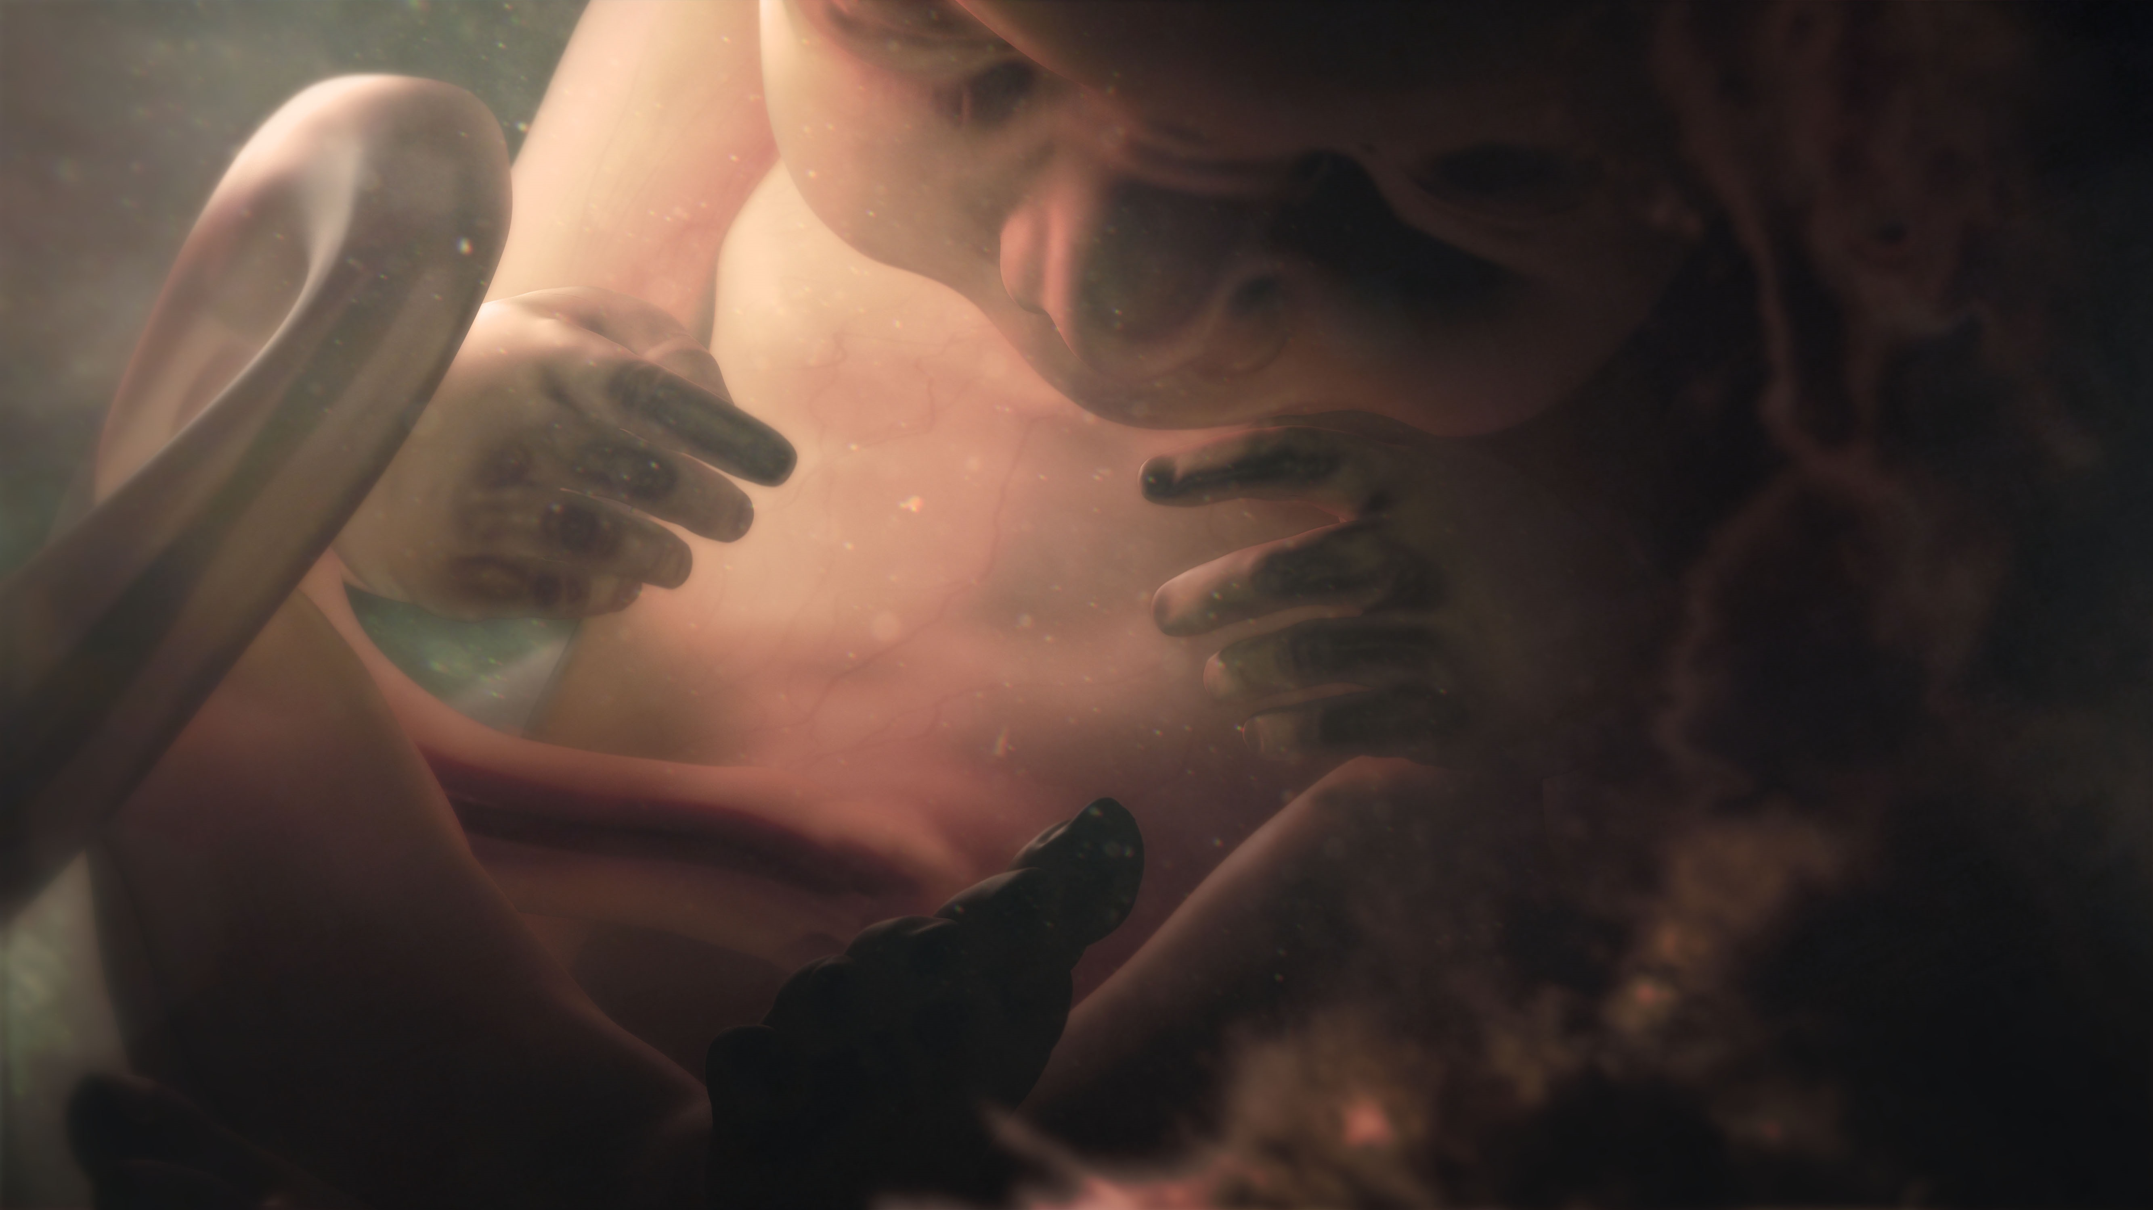
Human embryo at 27 weeks - 9 MONTHS THAT MADE YOU "The Final Countdown"
Credit: Courtesy of BBC
ARLINGTON, VA; June 2, 2016 – 9 MONTHS THAT MADE YOU, a three-part series that takes viewers through the astonishing journey of human gestation and its minute-by-minute genetic process, premieres Wednesday, June 29, 2016, at 10:00 p.m. ET on PBS (check local listings). Told through a series of personal stories that introduce viewers to people born with surprising and unexpected differences, 9 MONTHS THAT MADE YOU explores just how complex the human gestational process truly is.

With the help of CGI, 9 MONTHS THAT MADE YOU goes inside the womb to re-create the growth process of a fetus and explains how genetics can cause fascinating and unexpected mutations. In the initial episode, “The First 8 Weeks,” for example, viewers meet a family in Brazil whose multi-generational genetic mutation has caused half of them to grow six digits on each hand. Later, the series visits professional surfer Laird Hamilton, whose extreme sense of fearlessness is actually a genetic trait he may have passed on to his children.

Below are descriptions for each of the three episodes for 9 MONTHS THAT MADE YOU. For images and screeners, please visit PBS PressRoom.

“The First 8 Weeks”
Premieres June 29, 2016, at 10:00 p.m. ET
Follow the story of how a fertilized egg acquires individual traits through the gestation process. Chart the metamorphosis from the various embryonic forms you once took on until the moment around 12 weeks when you became unmistakably human.

“One of a Kind”
Premieres July 6, 2016, at 10:00 p.m. ET
Learn how you became the unique individual you are. No two people—even “identical” twins—are identical. Through riveting examples, explore how your face was shaped, why you’re likely to be right-handed, even how your sexuality formed.

“The Final Countdown”
Premieres July 13, 2016, at 10:00 p.m. ET
Meet the miracle that is you. See how your time in the womb, as your senses mature, has determined your destiny on the outside. Survey the latest epigenetic research that shows how the womb environment leaves its mark, even altering your DNA.

About PBS
PBS, with 350 member stations, offers all Americans the opportunity to explore new ideas and new worlds through television and online content. Each month, PBS reaches nearly 100 million people through television and nearly 33 million people online, inviting them to experience the worlds of science, history, nature and public affairs; to hear diverse viewpoints; and to take front row seats to world-class drama and performances. PBS’ broad array of programs has been consistently honored by the industry’s most coveted award competitions. Teachers of children from pre-K through 12th grade turn to PBS for digital content and services that help bring classroom lessons to life. PBS’ premier children’s TV programming and its website, pbskids.org, are parents’ and teachers’ most trusted partners in inspiring and nurturing curiosity and love of learning in children. More information about PBS is available at www.pbs.org, one of the leading dot-org websites on the Internet, or by following PBS on Twitter, Facebook or through our apps for mobile devices. Specific program information and updates for press are available at pbs.org/pressroom or by following PBS Pressroom on Twitter.

About BBC
The BBC has an unrivalled global reputation for the factual content it produces across arts, history, documentaries and natural history, and broadcasts some 7,000 hours of high-quality, distinctive factual programs a year on television. The BBC is recognized as an industry leader in terms of innovation, consistently pushing the boundaries of its productions, delivered to our audience by the most engaging and inspirational experts.

– PBS –

For additional information, photos, interviews and more, contact:

Savannah Bassett/Meghan Newton Colleen Flanagan/Atiya Frederick
Goodman Media for PBS PBS
212-576-2700 703-739-8130; 703-739-5147
PBSProgramming@goodmanmedia.com crflanagan@pbs.org; anfrederick@pbs.org

For images and additional up-to-date information on this and other PBS programs, visit PBS PressRoom at pbs.org/pressroom.

