Multi-Platinum Pop Recording Artist Andy Grammer,
Broadway Legend Chita Rivera and “The Voice” Finalist
Kyla Jade Join the All-Star Cast of PBS’ A CAPITOL FOURTH

– America’s Independence Day Celebration for Our Entire Nation Hosted by
John Stamos with Musical Performances by Jimmy Buffett and the
Broadway Cast of Escape to Margaritaville, The Beach Boys, Pentatonix,
The Temptations, Luke Combs, Lauren Alaina, CeCe Winans,
Joshua Bell and Renée Fleming –

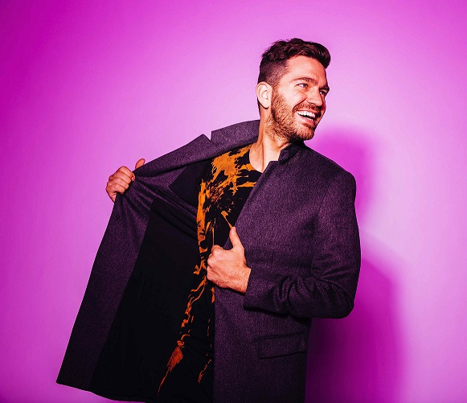
Andy Grammer
Credit: Joseph Llanes
Joining the all-star lineup for the 38th annual editing of PBS’ A CAPITOL FOURTH, the country’s longest-running live national July 4 TV tradition, are multi-platinum pop singer and songwriter Andy Grammer, theatrical icon and one of Broadway’s greatest triple-threat talents Chita Rivera, and “The Voice” season 14 finalist Kyla Jade. Grammer will perform his hit “Back Home,” the lead single from his Gold-certified album Magazines or Novels, while gospel singer Jade will open the show with a performance of the national anthem.

Rivera, a versatile actress/singer/dancer and the recipient of the 2018 Special Tony Award for Lifetime Achievement in the Theatre, will introduce a special tribute to the work of famed American composer Leonard Bernstein, the iconic voice of his age, on August 25, 1918 – his 100th birthday. The segment will feature Bernstein’s beloved composition “Tonight” from West Side Story performed by internationally acclaimed, Grammy Award-winning violinist Joshua Bell with the National Symphony Orchestra under the direction of top pops conductor Jack Everly. Rivera, who has won two Tony Awards and been nominated a record 10 times, rose to stardom when she originated the role of Anita in the Broadway premiere of West Side Story in 1957.

The 38th annual broadcast of A CAPITOL FOURTH, celebrating America’s 242nd birthday, airs live on PBS from the West Lawn of the U.S. Capitol Wednesday, July 4, 2018 from 8:00 to 9:30 p.m. ET before a concert audience of hundreds of thousands, as well as on the American Forces Network to our troops serving arou the world. The program can be heard live in stereo over NPR member stations nationwide. The concert will be live-streamed on PBS (www.pbs.org/a-capitol-fourth), YouTube and Facebook, and will be available as Video on Demand from July 4 to July 18, 2018.

Emmy Award-nominated actor and producer John Stamos (“Fuller House,” “Scream Queens”) hosts the festivities, which will feature all-star musical performances by multi-platinum-selling music legend Jimmy Buffett with the Broadway cast of the new musical Escape to Margaritaville, making its first stop after Broadway at the U.S. Capitol before launching a national tour; the iconic Beach Boys; three-time Grammy Award-winning a cappella group Pentatonix; legendary Motown stars The Temptations; acclaimed country music singer-songwriter and winner of the iHeartRadio Music Award for Best New Country Artist Luke Combs; country music star and “American Idol” alum Lauren Alaina; 12-time Grammy Award-winning gospel legend CeCe Winans; and world-renowned, four-time Grammy Award-winning soprano superstar Renée Fleming, who will perform her show-stopping anthem from the current hit Broadway production of Carousel.

A CAPITOL FOURTH is a co-production of Michael Colbert of Capital Concerts and WETA, Washington, D.C. Executive producer Colbert has assembled an award-winning production team that features the top Hollywood talent behind some of television’s most prestigious entertainment shows, including the Grammy Awards, the Country Music Awards, the Tony Awards, “Saturday Night Live” and many more.

About Capital Concerts
Capital Concerts is the nation’s leading producer of live patriotic television shows, including PBS’ highest-rated performance specials NATIONAL MEMORIAL DAY CONCERT and A CAPITOL FOURTH, the premier celebrations of America’s most important holidays broadcast from the U.S. Capitol in Washington, D.C. For more than 35 years, these two award-winning productions have been national traditions, bringing Americans together as one family to celebrate freedom and democratic ideals, and pay tribute to those who defend the country. The holiday specials have been honored with more than 80 awards, including the New York Film Festival Award, the Golden Cine Award and the Writers Guild of America Award.

Underwriters
A CAPITOL FOURTH is made possible by grants from The Boeing Company, the National Park Service, the Corporation for Public Broadcasting, the Department of the Army, PBS and public television stations nationwide. Air travel is provided by American Airlines.

# # #

For additional information, photos, interviews and more, contact:
Kristina Hallman: (202) 537-5199; khallman@starpower.net
Carol Marshall: (818) 385-1396; carol@cmarshallpr.com

For images and additional information, visit PBS Pressroom at www.pbs.org/pressroom.

Visit the program website at: http://www.pbs.org/a-capitol-fourth

Connect with us on:

https://www.facebook.com/capitolfourth/

@July4thPBS

http://www.instagram.com/July4thPBS

