Sixth Annual PBS Online Film Festival Features [XX Number] Independent Films from [Member Station/Partner]

The Festival Returns to PBS and Station Branded Digital Platforms July 17-28

Click here to Watch the Trailer
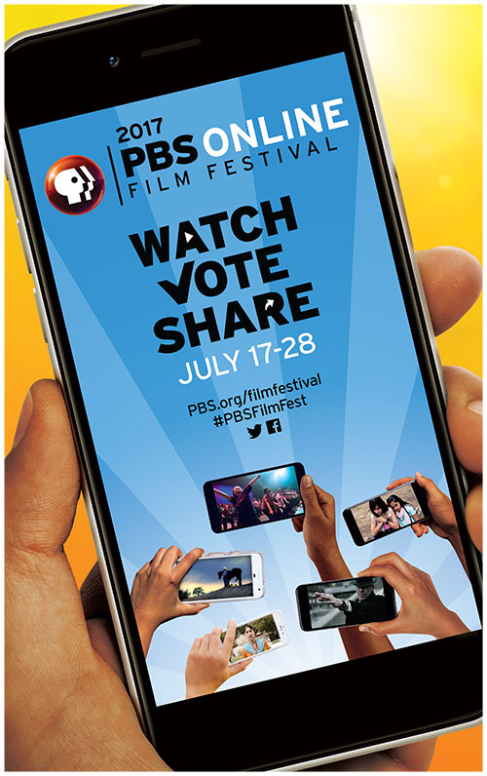
[LOCAL CITY]; June XX, 2017 – Today, PBS announced the 25 films that will be part of the sixth annual, Webby Award-nominated PBS Online Film Festival on July 17-28, 2017. [LOCAL CITY] filmmakers [NAMES] are among those featured in this year’s Festival for their films [TITLES OF FILMS].

Beginning July 17, the festival will be available via PBS and station digital platforms, including PBS.org, YouTube and PBS social media channels. The films will also be available via the PBS app on iOS, Android, Apple TV, Roku and FireTV devices.

Viewers are encouraged to watch, vote and share their favorite film by going to pbs.org/filmfestival. The film with most votes will receive the “Most Popular” award. Additionally, for the first time ever, a distinguished panel of eight jury members will select their favorite film of the festival for the “Juried Prize”. For updates on the festival, follow #PBSFilmFest on Twitter.

The [NUMBER] films from [MEMBER STATION/PARTNER] include:

“NAME OF FILM”
Click here to vote for this film [hyperlink to site]
DESCRIPTION OF FILM

The PBS Online Film Festival showcases powerful and engaging stories from filmmakers across the country. The festival has become a popular annual online event, attracting more than 4.5 million views since the first festival in 2012.
This year’s lineup features films from the Center for Asian American Media (CAAM), Latino Public Broadcasting (LPB), National Black Programming Consortium, Pacific Islanders in Communications (PIC), POV, and Vision Maker Media, as well as PBS local member stations including Alaska Public Media, South Dakota Public Broadcasting, South Florida PBS, WHRO, ITVS, Detroit Public TV WTVS, KTTZ Texas PBS, WPT Wisconsin, KLRU-TV Austin PBS, KQED (San Francisco), Louisiana Public Broadcasting, Twin Cities Public Television, and
Vermont PBS. Promotional partners for the PBS Online Film Festival include Independent Lens and World Channel.

“PBS and its member stations are thrilled to kick off another year of excellent independent films,” said Ira Rubenstein, Chief Digital and Marketing Officer, PBS. “The PBS Online Film Festival provides PBS and its member stations the opportunity to provide a diverse group of independent filmmakers a chance to share their stories with a highly engaged audience. This year brings another impressive lineup of powerful and moving films that will transform perspectives and encourage important conversations.”

About [Member Station/Partner]
BOILERPLATE

About PBS
PBS, with nearly 350 member stations, offers all Americans the opportunity to explore new ideas and new worlds through television and digital content. Each month, PBS reaches nearly 100 million people through television and nearly 28 million people online, inviting them to experience the worlds of science, history, nature and public affairs; to hear diverse viewpoints; and to take front row seats to world-class drama and performances. PBS’ broad array of programs has been consistently honored by the industry’s most coveted award competitions. Teachers of children from pre-K through 12th grade turn to PBS for digital content and services that help bring classroom lessons to life. Decades of research confirms that PBS’ premier children’s media service, PBS KIDS, helps children build critical literacy, math and social-emotional skills, enabling them to find success in school and life. Delivered through member stations, PBS KIDS offers high-quality educational content on TV – including a new 24/7 channel, online at pbskids.org, via an array of mobile apps and in communities across America. More information about PBS is available at www.pbs.org, one of the leading dot-org websites on the internet, or by following PBS on Twitter, Facebook or through our apps for mobile and connected devices. Specific program information and updates for press are available at pbs.org/pressroom or by following PBS Pressroom on Twitter.

Contacts:
Atiya Frederick, PBS, anfrederick@pbs.org, 703-739-5147
Catherine Lincoln, Goodman Media for PBS, pbsdigital@goodmanmedia.com, 212-576-2700

