PBS Digital Studios and Complexly Announce New Paleontology Series EONS

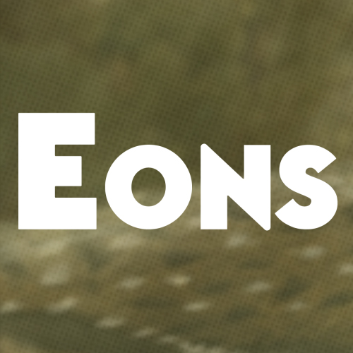
ANAHEIM, CA; June 22, 2017 -- Today at VidCon, Complexly CEO Hank Green announced the launch of EONS, a new weekly YouTube series that explores the billion-years-plus history of life on Earth, and the third co-production between Green’s Complexly video company and PBS Digital Studios. Green will serve as host of EONS alongside paleontologist Kallie Moore and science writer Blake de Pastino.
The series will premiere on June 26. A preview of the series can be viewed here.

EONS whisks viewers through the history of life on Earth with a scope from the dawn of life in the Archaean Eon through the Mesozoic Era — the so-called “Age of Dinosaurs” -- right up to the end of the most recent Ice Age. The evolutionary history of mammals including humans and other modern species is explored with paleontology experts. Series topics will include “What Color Were Dinosaurs (And How Do We Know)?,” “The Story of Saber Teeth” and “The Biggest Thing That Ever Flew.”
Courtesy of PBS Digital Studios

“EONS will go on a deeply engaging and wildly entertaining tour of Earth’s four-billion-year natural history, one fascinating vignette at a time,” said Hank Green. “I’m excited to explore these topics in detail with Kallie and Blake and hope it will encourage audiences to become more interested in paleontology.”

“We are excited to continue working with Complexly on high-quality, entertaining educational series such as EONS,” said Brandon Arolfo, Senior Director of PBS Digital Studios. “EONS aligns perfectly with our desire to engage curious minds, and we’re eager to bring this next series to new audiences.”

Ongoing co-productions from Complexly and PBS Digital Studios include THE ART ASSIGNMENT and CRASH COURSE.

About the hosts:
Hank Green
Hank Green started making YouTube videos in 2007 with his brother, John. They thought it was a pretty dumb idea, but it turned out pretty well. He is now the Executive Producer of SciShow, Crash Course and nearly a dozen other educational YouTube channels under the Complexly brand, and co-founder and CEO of NerdCon and VidCon, DFTBA Records, a merchandise fulfillment company, and DFTBA Games, a tabletop gaming company. He is co-founder and Executive Producer of Pemberly Digital, co-founder of Project for Awesome, and a Billboard top ten musician. He has also written for a variety of publications, including The New York Times, Scientific American, and Mental Floss Magazine. His most recent projects include launching the Internet Creators Guild, developing a new crowdfunded convention, PodCon, and, of course, being a host and Executive Producer on Eons!

Kallie Moore
As a fossil aficionado, Kallie Moore has loved paleontology even before she could spell it. Growing up in Kansas City, she was surrounded by fossiliferous limestones and would spend hours searching for marine fossils. Her excitement of being the first human to see a fossil in millions of years established a deep interest in ancient life. She received a B.S. in Earth Science and a Minor in Paleontology from Emporia State University in southeastern Kansas. During her undergraduate she was the Assistant Curator of the campus geology museum and interned at Ashfall Fossil Beds State Historical Park in Nebraska. Since 2008, Kallie has been the Collections Manager, a.k.a. Fossil Librarian, of the University of Montana Paleontology Center (UMPC) in Missoula. At the UMPC, she is in charge of organizing the collection and making it accessible, as well as managing specimen loans, participating in public outreach events, supervising volunteers, renovating displays, and currently researching an ancient lake deposit. She is also a loyal KC Royals baseball fan -let’s go Royals...clap, clap, clapclapclap!

Blake de Pastino
Blake is a science journalist who specializes in the exploration of human and natural history. As a founding editor of National Geographic News, he interviewed researchers in a variety of fields, visited dinosaur digs, and covered the latest developments in archaeology and space science. Since 2011, Blake has served as editor in chief of two of YouTube’s leading education channels: Crash Course and SciShow, where he occasionally appears on screen . Blake is also the publisher of Western Digs, a site that covers the latest discoveries in archaeology and paleontology around the American West.

About Complexly
Complexly is the production company for Crash Course, SciShow, and a dozen other education video channels. With over 14,000,000 subscribers and 60,000,000 views per month, it is one of the largest global online educational companies.

Crash Course has created over 600 videos covering 17 academic courses with more in the works. Subjects include World History, English Literature, Chemistry, Biology, Economics, Physics, Psychology and Philosophy. Crash Course is produced in cooperation with PBSDigital Studios. Crash Course has over 6 million subscribers and its videos have been viewed over 600,000,000 times.

SciShow is an online video news and informational show about science. Whether we're answering the burning questions of our audience (If I weigh 99 pounds and eat 1 pound of nachos...am I 1% nacho?) or talking about the latest findings of the Mars Science Laboratory, we do it in short, fast-paced, entertaining bits five days a week. SciShow has over four million subscribers and its videos have been viewed nearly 600,000,000 times.

About PBS Digital Studios
The PBS Digital Studios network on YouTube includes more than 15 ongoing original series, including from PBS member stations across the country, designed to engage, enlighten and entertain online audiences. The PBS Digital Studios network has more than 12 million subscribers and has generated more than one billion views. Series include the Webby Award-winning It’s Okay To Be Smart, Physics Girl and Crash Course, as well as popular series such as BrainCraft, PBS Space Time and more.

About PBS
PBS, with nearly 350 member stations, offers all Americans the opportunity to explore new ideas and new worlds through television and digital content. Each month, PBS reaches nearly 100 million people through television and nearly 28 million people online, inviting them to experience the worlds of science, history, nature and public affairs; to hear diverse viewpoints; and to take front row seats to world-class drama and performances. PBS’ broad array of programs has been consistently honored by the industry’s most coveted award competitions. Teachers of children from pre-K through 12th grade turn to PBS for digital content and services that help bring classroom lessons to life. Decades of research confirms that PBS’ premier children’s media service, PBS KIDS, helps children build critical literacy, math and social-emotional skills, enabling them to find success in school and life. Delivered through member stations, PBS KIDS offers high-quality educational content on TV – including a new 24/7 channel, online at pbskids.org, via an array of mobile apps and in communities across America. More information about PBS is available at www.pbs.org, one of the leading dot-org websites on the internet, or by following PBS on Twitter, Facebook or through our apps for mobile and connected devices. Specific program information and updates for press are available at pbs.org/pressroom or by following PBS Pressroom on Twitter.

– PBS –

For additional information, photos, interviews and more, contact:

Atiya Frederick / Colleen Flanagan
PBS
703-739-5000
anfrederick@pbs.org
crflanagan@pbs.org

Chelsey Saatkamp
Goodman Media for PBS
212-576-2700
pbsdigital@goodmanmedia.com

Julie Walsh
Complexly
julie@complexly.com

