WILD ALASKA LIVE, a PBS and BBC Co-Production,
Captures Life and Survival in the Alaskan Wilderness in
Three-Part, Not-to-be-Missed Television Event

- Part of PBS’ “Summer of Adventure,” WILD ALASKA LIVE Airs on PBS Stations and Digital Platforms July 2017 –

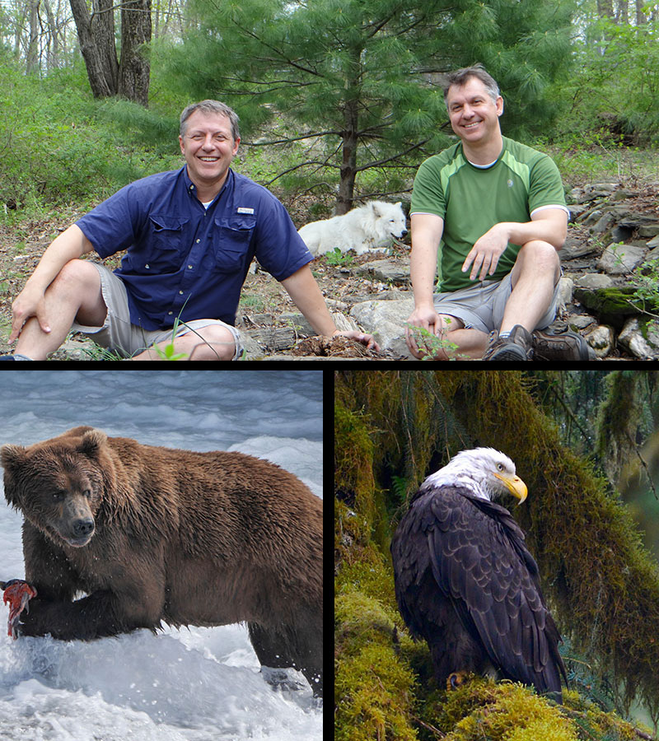
ARLINGTON, VA; MAY 22, 2017 -- PBS announced plans today for its latest venture into live, natural-history adventure programming with WILD ALASKA LIVE, a three-part, multi-platform production that airs July 23, 26 and 30 at 8:00 p.m. ET, as a part of its “Summer of Adventure” lineup. Over three nights, in partnership with the BBC, PBS turns the cameras on a must-see natural spectacle that plays out across the vast Alaskan wilderness, where some of the world’s most remarkable animals – bears, wolves, moose, orcas and eagles – gather by the thousands to take part in Alaska’s summer feast, an event never before captured live on television. WILD ALASKA LIVE is hosted by Emmy Award®-winning zoologists, adventurers and brothers Chris Kratt and Martin Kratt, the creators, executive producers and stars of the hit PBS KIDS series WILD KRATTS. Liz Bonnin and Steve Backshall, both of whom presented BIG BLUE LIVE, will join the Kratts as on-air correspondents. On the PBS KIDS 24/7 channel and live stream, WILD ALASKA LIVE will air immediately after WILD KRATTS one-hour specials, including WILD KRATTS: Creatures of the Deep Sea (on July 23) and the all-new WILD KRATTS Alaska: Hero’s Journey (on July 26 and 30).
Top left to right: Martin Kratt and Chris Kratt in Alaska with arctic wolf. Credit: Jarod Miller. Bottom left: Brown bear catching salmon in Brooks Falls Katmai National Park and Preserve, Alaska. Courtesy of Gareth Wildman. Bottom right: Bald eagle in Juneau, Alaska. Courtesy of Adam White.

What happens in the Alaskan wilderness in late July affects the animals’ survival and well-being for the remainder of the year. With some of largest areas of wilderness left on Earth, Alaska is the best place in the world to see the huge animals and top predators in all their glory. The three-night live presentation also explores the challenges of preserving America’s last frontier, as scientists, filmmakers, photographers and other experts gather there to tell some of the planet’s extraordinary wildlife stories.

Over three nights, WILD ALASKA LIVE will visit several locations, including points near Juneau and the Tongass National Forest, where the team will look for black bears and bald eagles; the vast Kenai Fjords National Park, in search of orcas and humpback whales; and the wilderness of Katmai National Park, where brown bears and elusive wolves live and hunt. WILD ALASKA LIVE will also introduce viewers to local experts who explore the relationship between Alaska’s First Peoples and the animals among whom they co-exist.

“WILD ALASKA LIVE is the blueprint for the incredible family trip you’ve always wanted to take,” said Beth Hoppe, Chief Programming Executive and General Manager, General Audience Programming, PBS. “The beauty of America’s most remote state is awe-inspiring and jaw-dropping; it’s the true meaning of wilderness. Nature lovers, adventurers and families alike can follow the action live on TV, online and on their mobile devices throughout the week, to catch every exceptional moment. This immersive event is not to be missed.”

“BIG BLUE LIVE was a summer smash in 2015 and I'm delighted that the team behind our BAFTA Award winning series are reuniting for WILD ALASKA LIVE,” said Tom McDonald, BBC Head of Commissioning for Natural History and Specialist Factual. “The series will be the most ambitious live natural history project we've ever commissioned - broadcasting from one of the last truly wild places on earth for what promises to be an unforgettable week of animal encounters.”

WILD ALASKA LIVE will use state-of-the-art filming technologies and live reports from the air, by boat and on the rugged Alaskan terrain. The event will be anchored by an on-location team of hosts, including Chris Kratt and Martin Kratt, correspondents, scientists and wildlife experts who will provide insights and perspective during the broadcasts. In addition to the live portions of the programs, PBS and BBC crews will shoot video and b-roll footage in the weeks preceding the live broadcast, to enhance each live broadcast by telling the bigger stories of each unique species.

WILD ALASKA LIVE follows the multi-platform success of 2015’s BIG BLUE LIVE television event, which captured the late summer feeding frenzy of marine life in Monterey Bay, California, on air, streaming online and through comprehensive social media activity. That event showcased Monterey Bay’s unique underwater community of humpback whales, sea lions, dolphins, elephant seals, sea otters, great white sharks, shearwaters, brown pelicans, blue whales and more, and was experienced by millions of viewers worldwide in a shared multimedia experience.

On PBS digital platforms and on social media, viewers can explore the Alaskan wilderness as events take place during the week, on-air and off. Inspired by stunning images, and through video and interactive games, audiences can dive deeper into the region’s environmental challenges and its conservation success stories. On Facebook, Instagram and Twitter, viewers will get behind-the-scenes looks at the show’s massive production each broadcast night. All three broadcast episodes will live-stream simultaneously on PBS.org and will be simulcast on the new PBS KIDS 24/7 channel and live stream, which is provided by member stations across the country on TV and streaming on digital platforms. On the PBS KIDS channel and live stream, WILD ALASKA LIVE will air immediately after WILD KRATTS one-hour specials, including WILD KRATTS: CREATURES OF THE DEEP SEA (on July 23) and WILD KRATTS ALASKA: HERO’S JOURNEY (on July 26 and 30).

In addition to the live program, PBS Education will share the WILD ALASKA LIVE experience with educators, children and parents across the nation on a variety of platforms, through the unique perspective of teachers who live and work in Alaska.

WILD ALASKA LIVE is presented as part of a multi-title co-production deal among PBS, BBC and BBC Worldwide North America. The partnership provides a pipeline of the high-quality, entertaining factual programs that PBS and BBC audiences have come to expect. Distributed by BBC Worldwide, it is executive produced by Roger Webb and series produced by Adam White for the BBC Studios’ Natural History Unit. Vice President of Programming and Development Bill Gardner and Sr. Director of Programming and Development Bill Margol oversee the project for PBS.

WILD ALASKA LIVE is part of PBS “Summer of Adventure,” taking viewers and their families on an adventure around the world this season. The lineup of history, science and natural history programming includes the six-part series THE STORY OF CHINA, an exploration of China’s 4,000-year history, featuring Michael Wood and beginning June 20. The five-part program BIG PACIFIC, starting June 21, reveals the Pacific Ocean’s most guarded secrets. Following BIG PACIFIC on June 21, GREAT YELLOWSTONE THAW showcases the stories of wolves, grizzlies, beavers and Great Gray owls in three episodes as they attempt to survive one of the greatest seasonal changes on the planet. On July 12, the three-part NATURE’S GREAT RACE explores the most astounding migrations on earth. RARE – CREATURES OF THE PHOTO ARK, beginning July 18, follows National Geographic photographer Joel Sartore in three episodes as he documents the world’s species at risk of extinction. WEEKEND IN HAVANA, on July 18, is a one-hour walking tour through Cuba. On August 2, IRELAND’S WILD COAST takes viewers on a one-hour journey along the island’s rugged Atlantic coast. “Summer of Adventure” will also include PBS KIDS programming, featuring three new one-hour specials: NATURE CAT: OCEAN COMMOTION (premieres June 19), WILD KRATTS ALASKA: HERO’S JOURNEY (premieres Monday, July 24) and READY JET GO!: BACK TO BORTRON 7 (premieres August 14).
About PBS
PBS, with nearly 350 member stations, offers all Americans the opportunity to explore new ideas and new worlds through television and digital content. Each month, PBS reaches nearly 100 million people through television and nearly 28 million people online, inviting them to experience the worlds of science, history, nature and public affairs; to hear diverse viewpoints; and to take front row seats to world-class drama and performances. PBS’ broad array of programs has been consistently honored by the industry’s most coveted award competitions. Teachers of children from pre-K through 12th grade turn to PBS for digital content and services that help bring classroom lessons to life. Decades of research confirms that PBS’ premier children’s media service, PBS KIDS, helps children build critical literacy, math and social-emotional skills, enabling them to find success in school and life. Delivered through member stations, PBS KIDS offers high-quality educational content on TV – including a new 24/7 channel, online at pbskids.org, via an array of mobile apps and in communities across America. More information about PBS is available at www.pbs.org, one of the leading dot-org websites on the internet, or by following PBS on Twitter, Facebook or through our apps for mobile and connected devices. Specific program information and updates for press are available at pbs.org/pressroom or by following PBS Pressroom on Twitter.

About BBC
The BBC has an unrivalled global reputation for the factual content it produces across arts, history, documentaries and natural history, and broadcasts some 7,000 hours of high-quality, distinctive factual programs a year on television. The BBC is recognized as an industry leader in terms of innovation, consistently pushing the boundaries of its productions, delivered to our audience by the most engaging and inspirational experts.
– PBS –

For additional information, photos, interviews and more, contact:

Carrie Johnson / Colleen Flanagan, PBS
cjohnson@pbs.org / crflanagan@pbs.org
703-739-5129 / 703-739-8130

John Michael Kennedy / Sara Levin, Goodman Media for PBS
PBSprogramming@goodmanmedia.com; 212-576-2700

Deborah Schonfeld, BBC Worldwide North America
Deborah.schonfeld@bbc.com; 212-705-9498

For more information on this and other PBS programs, visit PBS PressRoom at pbs.org/pressroom.

