Explore the Fascinating World of Bestselling Novelist Agatha Christie with Two New Specials

INSIDE THE MIND OF AGATHA CHRISTIE Premieres Sunday, January 17 and AGATHA CHRISTIE’S ENGLAND
Premieres Sunday, January 24 on PBS

ARLINGTON, VA – Surpassed only by the Bible and Shakespeare, Agatha Christie is the most successful writer of all time; her books have sold over a billion copies in English and a billion in translation. She wrote an astounding 66 murder mysteries, several plays including The Mousetrap -— the longest-running play of all time — and her classic works continue to be adapted for film and television. But how did a refined, upper-class British girl evolve into the queen of crime, poison, and murder?
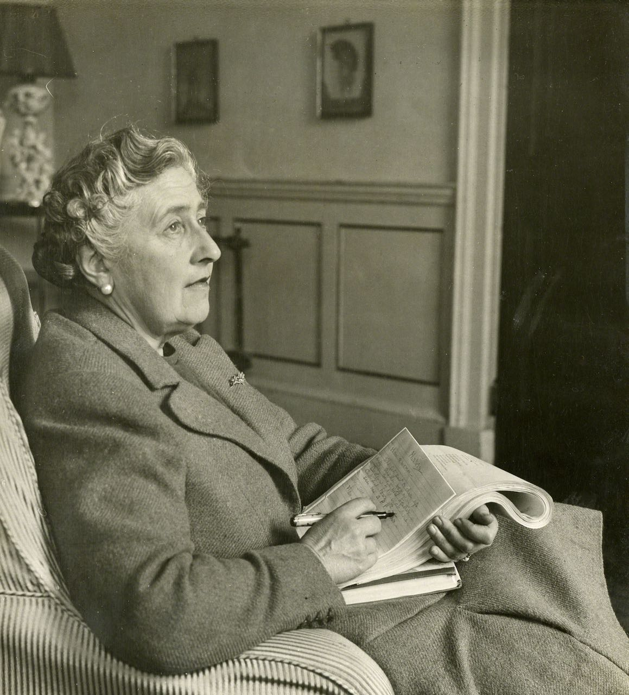
Credit: Christie Archive Trust

Two new specials — INSIDE THE MIND OF AGATHA CHRISTIE and AGATHA CHRISTIE’S ENGLAND — attempt to solve this mystery, exploring the life and times of the woman who transformed crime fiction and continues to win loyal readers across the globe. Narrated by Samantha Bond, both programs are filled with clips from movies and television series based on Agatha Christie novels, as well as home movies and audio recordings of Christie. INSIDE THE MIND OF AGATHA CHRISTIE premieres Sunday, January 17, 10:00-11:00 p.m. ET (check local listings); AGATHA CHRISTIE’S ENGLAND premieres Sunday, January 24, 10:00-11:00 p.m. ET (check local listings) on PBS, PBS.org and the PBS Video app.

With rare access to family members, scholars and her personal archive, INSIDE THE MIND OF AGATHA CHRISTIE explores what made the world’s most successful crime writer tick. Millions of readers worldwide know Agatha Christie’s indelible characters and plot twists, but what do we know about the author herself? Dr. John Curran has spent years poring over her personal archive, a treasure trove containing letters, manuscripts and 73 meticulously kept notebooks in which she documented everything she saw and heard. He and others explain how the author used her experiences to weave together formidable plots and how, despite being known as the queen of “cozy” crime, Agatha’s mind was, in the words of screenwriter Sarah Phelps, “incredibly dark.”

While she may have outwardly resembled a tweedy, Marple-esque figure, Agatha Christie was infinitely more complex. Insights into her life reveal that her isolated childhood sparked her imagination, and her time as a nurse during World War I gave her a knowledge of medicine — and poison, blood and gore. Biographer Laura Thompson reveals how the heartbreaking breakdown of her first marriage gave her a starring role in her own mystery — a disappearance that transfixed the nation. Ultimately, wanderlust healed her broken heart as she traveled the world and transformed her writing from a hobby into a profession. World War II brought a sense of her own mortality and an urgency to her writing, resulting in a staggering three to four books each year. Towards the end of her life, the increasingly famous Christie retreated from the public eye to her beloved holiday home, Greenway.

AGATHA CHRISTIE’S ENGLAND explores how the settings of Christie’s stories and novels were, in fact, drawn from real places. There is no more quintessentially English writer than Christie. Through her sensational murder mysteries, she created a literary universe that almost singlehandedly shaped the world’s image of England. Retracing Christie’s footsteps, this new special visits Beacon Cove, where a young Agatha swam with her nephew when he narrowly escaped drowning, the memory of which would be reprised in her 1939 novel And Then There Were None. In Ealing, Christie witnessed her great-aunt, affectionately known as Granny, devouring local gossip and news of gruesome murder trials, the blueprint for the author’s fictional world of Miss Marple and the village of St Mary’s Mead. And the influx of Belgian refugees into her hometown of Torquay during World War I inspired another of Christie’s great characters, Hercule Poirot.

AGATHA CHRISTIE’S ENGLAND explores how the author drew on her surroundings and the people she encountered to create her extraordinary and timeless canon of work. Among the many stops during this tour are Ugbrook House, where she met first husband Archie; Abney Hall, the original inspiration for the author’s inimitable country house murder template; Brown’s Hotel, immortalized in 1965’s At Bertram’s Hotel; and her country retreat Greenway, the boathouse of which plays host to a scene in Dead Man’s Folly.

INSIDE THE MIND OF AGATHA CHRISTIE and AGATHA CHRISTIE’S ENGLAND will stream simultaneously with broadcast and be available on all station-branded PBS platforms, including PBS.org and the PBS Video app, available on iOS, Android, Roku, Apple TV, Amazon Fire TV, Android TV, Samsung Smart TV and Chromecast.

INSIDE THE MIND OF AGATHA CHRISTIE is produced and directed by Matt Cottingham. Executive Producers are Basi Akpabio, Jonathan Stadlen and Natalie von Hurter.

AGATHA CHRISTIE’S ENGLAND is filmed, produced and directed by Toby Roebuck. Executive Producers are Jonathan Stadlen and Natalie von Hurter.

About PBS
PBS, with more than 330 member stations, offers all Americans the opportunity to explore new ideas and new worlds through television and digital content. Each month, PBS reaches over 120 million people through television and 26 million people online, inviting them to experience the worlds of science, history, nature and public affairs; to hear diverse viewpoints; and to take front row seats to world-class drama and performances. PBS’s broad array of programs has been consistently honored by the industry’s most coveted award competitions. Teachers of children from pre-K through 12th grade turn to PBS for digital content and services that help bring classroom lessons to life. Decades of research confirms that PBS’s premier children’s media service, PBS KIDS, helps children build critical literacy, math and social-emotional skills, enabling them to find success in school and life. Delivered through member stations, PBS KIDS offers high-quality educational content on TV— including a 24/7 channel, online at pbskids.org, via an array of mobile apps and in communities across America. More information about PBS is available at www.pbs.org, one of the leading dot-org websites on the internet, or by following PBS on Twitter, Facebook or through our apps for mobile and connected devices. Specific program information and updates for press are available at pbs.org/pressroom or by following PBS Pressroom on Twitter.

– PBS –
CONTACTS:

Liza Pluto
PBS
ljpluto@pbs.org

Cara White / Mary Lugo
843-881-1480; 770-623-8190
CaraMar, Inc.
cara.white@mac.com; lugo@negia.net

For images and additional up-to-date information on this and other PBS programs, visit PBS PressRoom at pbs.org/pressroom.

