THE AGE OF NATURE
Premieres Wednesdays, October 14-28, 2020 on PBS

New Documentary Series Explores Humanity’s Relationship with Nature and Wildlife, as Scientists and Conservationists From All Over the World Find Innovative Ways to Restore Our Planet

ARLINGTON, VA – THE AGE OF NATURE, a three-part documentary series, explores how an increased awareness of the natural world is leading to a new chapter in the story of both humanity and the planet. With stunning photography, the series focuses on the resiliency of Earth’s ecosystems through stories of success, as scientists, citizens and governments act to fix past mistakes and restore the environment. With the current pandemic exposing the fragility and vulnerability of humankind, the balance of nature and our relationship with it is more important than ever. Narrated by Uma Thurman, THE AGE OF NATURE premieres Wednesdays, October 14-28, 10:00-11:00 p.m. ET (check local listings) on PBS, pbs.org and the PBS Video App.
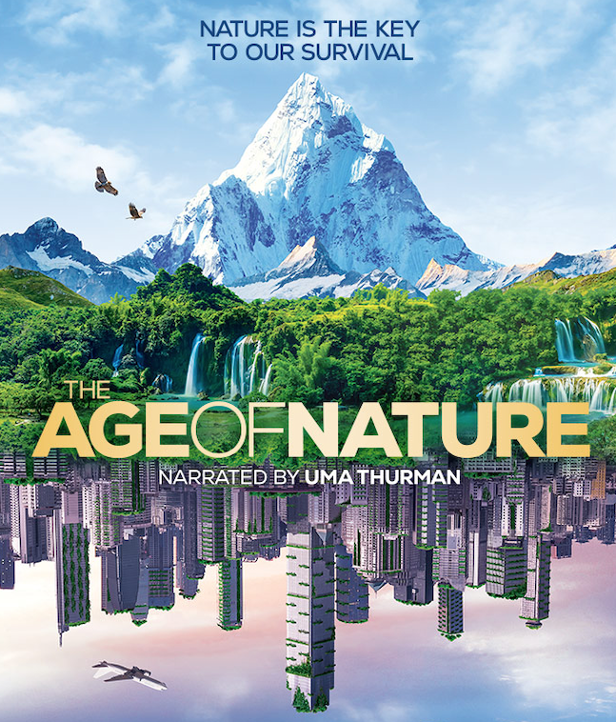

Filmed on seven continents, THE AGE OF NATURE presents creative ideas from around the globe for dealing with such pressing issues as climate change, animal extinction, and environmental degradation. Each episode highlights some of the latest scientific research that helps us understand the workings of the planet and explores effective strategies for restoring the environment, re-wilding landscapes and maintaining a balance between species. The series examines the work of a diverse international scientific community as well as indigenous citizen activists committed to bringing about change in their local communities.

Episode 1 “Awakening” (October 14)

Discover how a new awareness of nature is helping to restore ecosystems across the globe, with inventive actions being taken to repair manmade damage and restore reefs, rivers, animal populations and more. In the Pacific Island of Bikini Atoll, the full extent of the ocean’s ability to recover is evident. When scientists returned 50 years after the world’s most powerful nuclear weapons experiment devastated the island, they were astonished to discover that the reefs they thought destroyed were thriving. When forest land began to be developed around the Panama Canal, scientists stepped in to explain that there would be no water for the canal without the trees. A national park was created, saving some of the richest rainforests on Earth. In Norway, the crash of the cod industry is a cautionary tale about exhausting a once-abundant natural resource. But working sustainably, the fishing community has learned to manage resources for future generations. The resurrection of Gorongosa National Park in Mozambique in the wake of civil war and widespread poaching shows that ecosystems can be repaired — with a nudge in the right direction. Finally, in China, the enormous potential for humans to improve the environment is stunningly realized in the 25-year restoration of the Loess Plateau, the cradle of Chinese civilization, which had turned to dust during 8000 years of human activity.

Episode 2 “Understanding” (October 21)

Explore how a new understanding of nature is helping us find surprising ways to fix it. Along the Elwha River in Washington, we learn how removing dams has led not only to the recovery of the local forest but also Chinook salmon, which provide food for the endangered orca population. In China, one scientist’s determination to restore fireflies, which provide natural pest control, is transforming the lives of rural farming communities — even tiny creatures can have a significant impact. The return of wolves to America’s first National Park, Yellowstone, has rejuvenated the entire landscape, repairing and restoring habitat that had been over-grazed by herbivores. This pioneering project discovered the crucial role of predators in bringing balance to ecosystems. In Scotland, planting trees is reversing massive deforestation which took place centuries ago, helping native wildlife thrive and mitigating some of the effects of climate change. And in South Africa’s Cape Town, innovative efforts to remove massively thirsty European pines and other invasive species are helping to restore the watershed, which faced a severe shortage in 2018 after three years of drought.

Episode 3 “Changing” (October 28)

An urgent problem faces the planet: climate change. But around the world, scientists, citizens and indigenous activists are increasing our understanding of the potential of nature to help us cope with and even mitigate it. From Bhutan — the only carbon-neutral country in the world — to Borneo, an encouraging restoration of ecosystems is taking place, from planting forests to re-wilding areas to increasing biodiversity. In Poland, bison have been reintroduced to the Bialowieza Forest, the largest in Europe. New discoveries in Australia reveal that seagrass meadows lock massive amounts of carbon underwater and may help save the Great Barrier Reef. In Antarctica, whales — whose digestive processes feed microscopic phytoplankton, the basis for life in the oceans — are recovering. And in Belize, we meet Madison Edwards, who at 11-years-old waged a social media campaign that became a national movement, resulting in a government ban on offshore drilling.
THE AGE OF NATURE will stream simultaneously with broadcast and be available on all station-branded PBS platforms, including PBS.org and the PBS Video App, available on iOS, Android, Roku, Apple TV, Amazon Fire TV, Android TV, Samsung Smart TV and Chromecast.

The Nature Conservancy (TNC) is the engagement and outreach partner for THE AGE OF NATURE. TNC will extend the reach and impact of the digital and broadcast initiative, and bring awareness to the science, perspectives, and solutions of TNC’s work.

A carbon offset production, THE AGE OF NATURE is produced by Brian Leith Productions Ltd. in association with BBC Studios Distribution and PBS. Executive Producers are Brian Leith and Patrick Morris. The series producer is Verity White. The director of photography is George Woodcock and the editors are Dan Glendenning for episode 1, Mark Fox for episode 2 and Bobby Sheikh for episode 3. Music is by John Wygens. Executive in charge for PBS is Bill Gardner.

Original production funding provided by Anne Ray Foundation, a Margaret A. Cargill Philanthropy.

About PBS
PBS, with more than 330 member stations, offers all Americans the opportunity to explore new ideas and new worlds through television and digital content. Each month, PBS reaches over 120 million people through television and 26 million people online,
inviting them to experience the worlds of science, history, nature and public affairs; to hear diverse viewpoints; and to take front row seats to world-class drama and performances. PBS’s broad array of programs has been consistently honored by the industry’s most coveted award competitions. Teachers of children from pre-K through 12th grade turn to PBS for digital content and services that help bring classroom lessons to life. Decades of research confirms that PBS’s premier children’s media service, PBS KIDS, helps children build critical literacy, math and social-emotional skills, enabling them to find success in school and life. Delivered through member stations, PBS KIDS offers high-quality educational content on TV— including a 24/7 channel, online at pbskids.org, via an array of mobile apps and in communities across America. More information about PBS is available at www.pbs.org, one of the leading dot-org websites on the internet, or by following PBS on Twitter, Facebook or through our apps for mobile and connected devices. Specific program information and updates for press are available at pbs.org/pressroom or by following PBS Pressroom on Twitter.

– PBS –
CONTACTS:

Stephanie Kennard, PBS, 571-319-7478; skkennard@pbs.org

Cara White / Mary Lugo
843-881-1480; 770-623-8190
CaraMar, Inc.
cara.white@mac.com; lugo@negia.net

For images and additional up-to-date information on this and other PBS programs, visit PBS PressRoom at pbs.org/pressroom.

