PBS Presents “Gangster Night” Featuring AL CAPONE: ICON and HISTORY DETECTIVES SPECIAL INVESTIGATIONS
“Who Killed Jimmy Hoffa?”
– “Gangster Night” Airs Tuesday, July 22, Beginning at 8 p.m. ET on PBS –

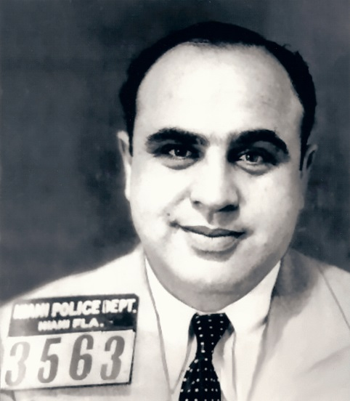
Al Capone’s Florida mug shot.
Courtesy of John Binder
ARLINGTON, VA; June 19, 2014 — PBS announced today that it will air a “Gangster Night” primetime programming block on Tuesday, July 22, beginning at 8:00 p.m. ET (check local listings). The lineup features AL CAPONE: ICON, a profile of the celebrity gangster, and a new HISTORY DETECTIVES SPECIAL INVESTIGATIONS episode that seeks to uncover Jimmy Hoffa’s killer.

Was Al Capone the quintessential self-made American man, a ruthless killer or both? His name sparks images of pin-stripe suits and bloody violence, but why do Americans continue to be fascinated by this man? PBS examines Capone’s lasting legacy to determine why.

From his early days rising through the ranks of New York’s gangs, to his slow demise in the aftermath of the St. Valentine’s Day Massacre, AL CAPONE: ICON chronicles the complicated life of one of America’s favorite mob bosses. The special exposes Capone not only as a bootlegger, killer and gangster, but as the popular public figure who opened one of the nation’s first soup kitchens, fought for expiration dates on milk and wrote love songs to his wife from prison.

It’s been more than 80 years since the height of Capone’s power, yet his impact is still felt. In addition to Capone’s history, AL CAPONE: ICON unveils his unexpected connections to modern-day organized crime, law enforcement, popular culture and even everyday life in Chicago.

Immediately following at 9:00 p.m. ET, HISTORY DETECTIVES SPECIAL INVESTIGATIONS premieres “Who Killed Jimmy Hoffa?” Hosted by veteran detectives Tukufu Zuberi and Wes Cowan and new host Kaiama Glover, the reformatted 11th season of HISTORY DETECTIVES explores controversial Teamsters president Hoffa’s final days and the multiple theories as to why he was killed and just who pulled the trigger. While others have concentrated on locating Hoffa’s body, the History Detectives are after the answer to the more important question: Who Killed Jimmy Hoffa?”

New mysteries air all summer on PBS. Highlights include cases from MASTERPIECE MYSTERY!, such as “The Escape Artist” with David Tennant and “Endeavour, Season 2,” and real-life investigations from TIME SCANNERS and HISTORY DETECTIVES SPECIAL INVESTIGATIONS.

About PBS
PBS, with its over 350 member stations, offers all Americans the opportunity to explore new ideas and new worlds through television and online content. Each month, PBS reaches nearly 109 million people through television and over 28 million people online, inviting them to experience the worlds of science, history, nature and public affairs; to hear diverse viewpoints; and to take front row seats to world-class drama and performances. PBS’ broad array of programs has been consistently honored by the industry’s most coveted award competitions. Teachers of children from pre-K through 12th grade turn to PBS for digital content and services that help bring classroom lessons to life. PBS’ premier children’s TV programming and its website, pbskids.org, are parents’ and teachers’ most trusted partners in inspiring and nurturing curiosity and love of learning in children. More information about PBS is available at www.pbs.org, one of the leading dot-org websites on the Internet, or by following PBS on Twitter, Facebook or through our apps for mobile devices. Specific program information and updates for press are available at pbs.org/pressroom or by following PBS PressRoom on Twitter.

– PBS –

For additional information, photos, interviews and more, contact Goodman Media or PBS:

Meghan Newton / Nisa Kiang, Goodman Media International for PBS: 212-576-2700; PBSProgramming@goodmanmedia.com

Lara Davidson, PBS: 703-739-5115; lkdavidson@pbs.org

For images and additional up-to-date information on this and other PBS programs, visit PBS PressRoom at pbs.org/pressroom.

