A Tony Award-Winning Star Brings His Acclaimed Cabaret Show to PBS, When ALAN CUMMING SINGS SAPPY SONGS Premieres Friday, November 18

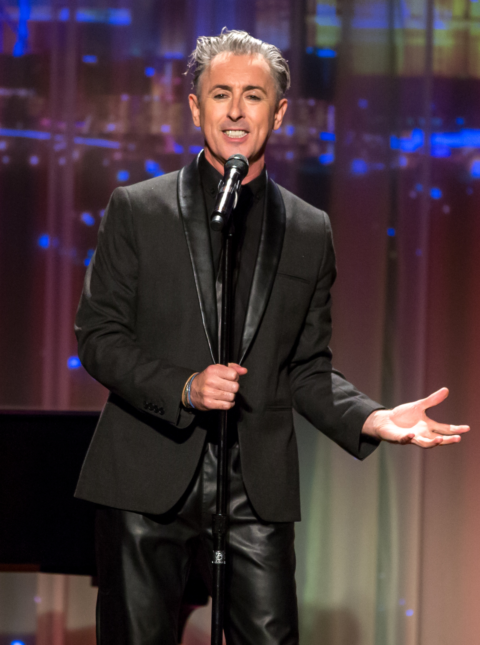
ARLINGTON, VA; November 3, 2016 – The Tony and Olivier Award-winning Broadway and television star Alan Cumming’s critically-acclaimed touring show, ALAN CUMMING SINGS SAPPY SONGS, comes to PBS Friday, November 18 at 9:00 -10:00 p.m. ET, as part of the sixth annual PBS Arts Fall Festival (check local listings).

The special gives PBS audiences a front row seat at “Club Cumming,” the cabaret setting for the star’s personal and intimate performance that has been likened to “an emotional firestorm.” In it, Cumming performs songs that mark poignant moments in his life that were originally written or made famous by artists like Annie Lennox (“Why”), Rufus Wainwright (“Dinner at Eight”), Keane (“Somewhere Only We Know”), Billy Joel (“Goodnight Saigon”), a medley of hits by Adele, Lady Gaga, Katy Perry titled “Someone like the Edge of Firework” and more.

“This beloved, award-winning star has entertained millions on Broadway, television and in films…but far fewer people know about his singing career,” said Beth Hoppe, Chief Programming Executive and General Manager of General Audience Programming for PBS. “ALAN CUMMING SINGS SAPPY SONGS is the perfect showcase for his trademark energy and boisterous personality. There is no better place to spend a wonderfully intimate Friday night than at ‘Club Cumming’ with a truly unique star who brings an eclectic mix of songs and stories of his interesting life and career.”
Alan Cumming. Photo: Erik Kabik/The Smith Center

“This broadcast provides a valuable opportunity to remind the nation that the performing arts are alive and well in Las Vegas,” said Myron Martin, president and CEO of The Smith Center. “It has been a pleasure working with PBS, and I hope we can highlight many more fantastic shows together.”

“We were pleased to work with The Smith Center and PBS to produce a program that will promote the excellent arts opportunities offered by The Smith Center to a national audience,” said Tom Axtell General Manager of Vegas PBS.

Cumming has toured this show recently in the U.S., U.K., Canada, and Australia, and made his sold-out solo debut at Carnegie Hall earlier this year. ALAN CUMMING SINGS SAPPY SONGS was filmed live for PBS in Cabaret Jazz at The Smith Center for the Performing Arts in Las Vegas and is presented by Vegas PBS.

Beginning November 19, the program will also be available via PBS and station digital platforms including PBS.org, and via the PBS app on iOS, Android, Apple TV, Roku and FireTV devices.

Funding for the 2016 PBS Arts Fall Festival is made possible by generous support from the Anne Ray Charitable Trust.

About the PBS Arts Fall Festival
PBS premieres its sixth annual PBS Arts Fall Festival on Friday, October 21, with host Lin-Manuel Miranda, creator and star of the Pulitzer Prize and Tony Award-winning musical Hamilton. The PBS Arts Fall Festival, which last year reached more than nine million viewers, is a cornerstone of the Friday primetime lineup, underscoring PBS’ ongoing commitment to give audiences the best seats in the house to watch arts performances on air and online. The festival presents diverse artists and performances from across the country, including programs from GREAT PERFORMANCES and LIVE FROM LINCOLN CENTER as well as the specials BILL MURRAY: THE MARK TWAIN PRIZE and ALAN CUMMING SINGS SAPPY SONGS. Most programs will be available online at video.pbs.org/ after their broadcast premiere. For more, visit pbs.org/pressroom.

Arts on PBS This Fall
Arts programming on PBS will continue throughout the fall in addition to the PBS Arts Fall Festival. Viewers get a backstage pass to learn how technology combines with human artistry to create modern recorded music with SOUNDBREAKING: STORIES FROM THE CUTTING EDGE OF RECORDED MUSIC, an eight-part series airing weeknights from November 14-23 at 10:00 p.m. ET. SOUNDBREAKING was the last project produced by legendary music producer Sir George Martin and features more than 150 exclusive and original interviews. Also airing this fall are encore performances of two programs first featured as part of the 2015 PBS Arts Fall Festival. GREAT PERFORMANCES “Andrea Bocelli: Cinema” will air Friday, December 2 at 9:00 p.m. ET and FIRST YOU DREAM—THE MUSIC OF KANDER & EBB will air Friday, December 9 at 9:00 p.m. ET. The recent eighth season of ART21’s series ART IN THE TWENTY-FIRST CENTURY, which featured 16 exceptional artists in four contemporary art hubs (Chicago, Los Angeles, Mexico City and Vancouver) is now available for streaming at PBS.org.

About PBS
PBS, with nearly 350 member stations, offers all Americans the opportunity to explore new ideas and new worlds through television and online content. Each month, PBS reaches nearly 100 million people through television and nearly 33 million people online, inviting them to experience the worlds of science, history, nature and public affairs; to hear diverse viewpoints; and to take front row seats to world-class drama and performances. PBS’ broad array of programs has been consistently honored by the industry’s most coveted award competitions. Teachers of children from pre-K through 12th grade turn to PBS for digital content and services that help bring classroom lessons to life. PBS’ premier children’s TV programming and its website, pbskids.org, are parents’ and teachers’ most trusted partners in inspiring and nurturing curiosity and love of learning in children. More information about PBS is available at www.pbs.org, one of the leading dot-org websites on the Internet, or by following PBS on Twitter, Facebook or through our apps for mobile devices. Specific program information and updates for press are available at pbs.org/pressroom or by following PBS Pressroom on Twitter.

ABOUT THE SMITH CENTER FOR THE PERFORMING ARTS
The hallmark of downtown Las Vegas’ 61-acre urban development known as Symphony Park, The Smith Center for the Performing Arts is a public-private partnership that opened in March 2012. Heralded as the city’s Heart of the Arts®, The Smith Center is an architectural triumph and long-awaited cultural achievement that educates and entertains the citizens of Southern Nevada. The $470 million world-class performing arts center offers a blend of performances by resident companies, first-run touring attractions, lectures and internationally-acclaimed performers in music, theater and dance. The five-acre campus features four performance spaces including the 2,050-seat Reynolds Hall, the 258-seat Cabaret Jazz club, the 240-seat Troesh Studio Theater and the 1.7-acre Donald W. Reynolds Symphony Park for outdoor concerts. Additionally, the campus is home to the Discovery Children’s Museum that opened in March 2013. For more information about The Smith Center for the Performing Arts, please visit www.TheSmithCenter.com. Keep up with news and events on Facebook and follow The Smith Center on Twitter at @SmithCenterLV.

– PBS –

For additional information, photos, interviews and more, contact Goodman Media or PBS:

Meghan Newton/John Michael Kennedy Michae Godwin/Kayla Springer
Goodman Media International for PBS PBS
212-576-2700 (703) 739-8483 / 703-739-5351
PBSArts@goodmanmedia.com mmgodwin@pbs.org / kmspringer@pbs.org

For images and additional up-to-date information on this and other PBS programs, visit PBS PressRoom at pbs.org/pressroom.

