AMERICA AFTER FERGUSON on PBS to Examine the Issues Surrounding the Events in Ferguson, Missouri
Friday, September 26, 2014, 8-9 p.m. ET
In a PBS first, the broadcast will include viewer tweets to expand the discussion at #AfterFergusonPBS

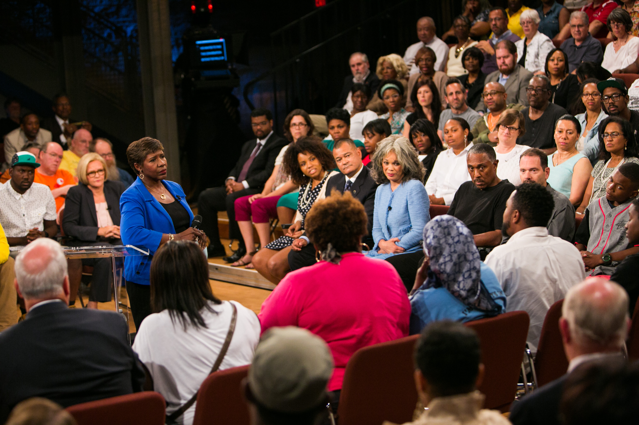
Moderator Gwen Ifill with town hall guests
Credit: Nine Network /Jason Winkeler Photography

ARLINGTON, VA, September 24, 2014 -- PBS today announced additional details relevant to its special broadcast of AMERICA AFTER FERGUSON, a one-hour town hall meeting exploring the many issues brought into public discourse in the wake of Michael Brown’s death in Ferguson, Missouri. Moderated by Gwen Ifill, PBS NEWSHOUR co-anchor and managing editor and moderator and managing editor of WASHINGTON WEEK, the town hall meeting was held Sunday, September 21, on the campus of the University of Missouri-St. Louis with an audience of more than 400. The program, produced by WGBH Boston in partnership with Nine Network/KETC in St. Louis and WETA in Washington DC, airs Friday, September 26, 2014, 8:00-9:00 p.m. ET on PBS (check local listings).

To help foster a national dialogue, PBS and its member stations will, for the first time, incorporate live tweets during the 8:00 p.m. ET broadcast of AMERICA AFTER FERGUSON, as well as the West Coast feed at 11:00 p.m. ET. Viewers will be encouraged to use the Twitter hashtag #AfterFergusonPBS to join the conversation and to have their tweets considered for inclusion in the broadcast.

AMERICA AFTER FERGUSON will also include interviews with former president Bill Clinton, NPR host and special correspondent Michele Norris and actress and playwright Anna Deavere Smith, among others. Among the issues and questions to be explored in the broadcast are:
- What kind of America did Ferguson reveal?
- What is the relationship between communities of color and law enforcement?
- How do we speak about race? How do Americans see themselves reflected in stories like Ferguson?

Online, AMERICA AFTER FERGUSON will deliver content and conversation through a robust digital presence at pbs.org/afterferguson, including:
- A simulcast of the 8:00 p.m. ET broadcast of AMERICA AFTER FERGUSON
- Aggregation of shows, films and educational resources relevant to the Ferguson
discussion
- Real-time polling and surveys
- Thematic discussion pages for continued conversation

“As viewers will see in AMERICA AFTER FERGUSON, the outrage and pain surrounding the events in Ferguson are still very raw and very real — in Ferguson and across the country,” Ifill said. “Drawing from conversations with Missouri residents and leaders in national politics, journalism, law enforcement and faith, AMERICA AFTER FERGUSON will underscore there is a lot of healing yet to do.”

“PBS is proud to present AMERICA AFTER FERGUSON, which will bring together the voices of experts and ordinary citizens to examine where we are in the wake of the events of Ferguson,” said Beth Hoppe, Chief Programming Executive and General Manager, General Audience Programming, PBS. “We hope to encourage a national dialogue and truly multi-platform town hall discussion on important questions that Ferguson brought into the foreground.”

“AMERICA AFTER FERGUSON will showcase the power of civil dialogue in the town hall auditorium and over the air, and also through digital content and social media,” said Marie Nelson, WGBH executive producer for the program. “We’re pleased to bring together a diverse range of voices across America in an often-surprising and constructive discourse about the issues raised by the events in Ferguson.”

About PBS
PBS, with its over 350 member stations, offers all Americans the opportunity to explore new ideas and new worlds through television and online content. Each month, PBS reaches nearly 120 million people through television and nearly 28 million people online, inviting them to experience the worlds of science, history, nature and public affairs; to hear diverse viewpoints; and to take front row seats to world-class drama and performances. PBS’ broad array of programs has been consistently honored by the industry’s most coveted award competitions. Teachers of children from pre-K through 12th grade turn to PBS for digital content and services that help bring classroom lessons to life. PBS’ premier children’s TV programming and its website, pbskids.org, are parents’ and teachers’ most trusted partners in inspiring and nurturing curiosity and love of learning in children. More information about PBS is available at www.pbs.org, one of the leading dot-org websites on the Internet, or by following PBS on Twitter, Facebook or through our apps for mobile devices. Specific program information and updates for press are available at pbs.org/pressroom or by following PBS Pressroom on Twitter.
About WGBH
WGBH Boston is America’s preeminent public broadcaster and the largest producer of PBS content for TV and the web. Television channels include WGBH 2, WGBX 44, and the digital channels World and Create. WGBH Radio serves listeners across New England with 89.7 WGBH Boston’s Local NPR®; 99.5 WCRB; and WCAI, the Cape and Islands NPR® Station. Find more information at wgbh.org.

– PBS –

CONTACTS:
Jennifer Rankin Byrne, PBS, 703-739-5487; jrbyrne@pbs.org
Carrie Johnson, PBS, 703-739-5129; cjohnson@pbs.org

For images and additional up-to-date information on this and other PBS programs, visit PBS PressRoom at pbs.org/pressroom.

