PBS to Present AMERICA AFTER FERGUSON
Friday, September 26, 2014, 8-9 p.m. ET
– Moderated by PBS NEWSHOUR’s Gwen Ifill, town hall meeting will explore the complex issues surrounding the events in Ferguson, Missouri –

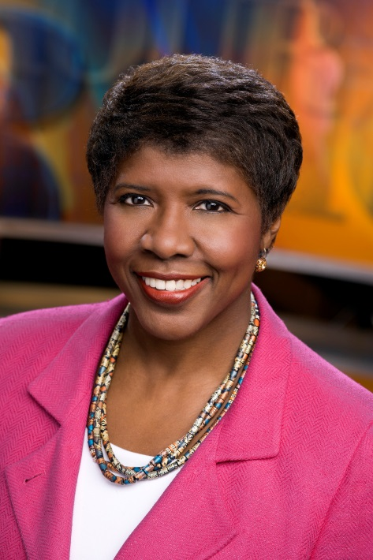
Moderator Gwen Ifill
Credit: Robert Severi
ARLINGTON, VA, September 17, 2014 -- PBS today announced that Gwen Ifill, PBS NEWSHOUR co-anchor and managing editor, and moderator and managing editor of WASHINGTON WEEK, will moderate AMERICA AFTER FERGUSON, a town hall meeting that will explore the many issues that have been brought into public discourse in the wake of Michael Brown’s death in Ferguson, Missouri. The program, produced by WGBH Boston in partnership with the Nine Network/KETC in St. Louis and WETA in Washington DC, will air Friday, September 26, 2014, 8:00-9:00 p.m. ET on PBS (check local listings).

While the facts of the case are still in dispute, for many the story of Ferguson has become a symbol of the larger social divides in America, exposing a persistent disconnect along lines of race, class and identity. Through conversations and special reports, AMERICA AFTER FERGUSON will explore these complex questions raised by the events in Ferguson.

AMERICA AFTER FERGUSON will be taped before an audience on Sunday, September 21, at the Touhill Performing Arts Center on the campus of the University of Missouri-St. Louis. Intended for audiences in communities across the country, AMERICA AFTER FERGUSON will include national leaders in the areas of law enforcement, race and civil rights, as well as government officials, faith leaders and youth.

“The upheaval in Ferguson stirred up an all too familiar stew of debate over race, justice and citizenship," Ifill said. "It's a discussion fueled by community outrage and resentment on all sides, but it is one that shouldn't end. Our town hall conversation will shed light rather than heat on the topic, as we seek out the voices interested in digging deeper.”

“In light of the ongoing events in Ferguson, we wanted to help convene a conversation to delve deeper into these complex cultural questions,” said Beth Hoppe, Chief Programming Executive and General Manager, General Audience Programming, PBS. “By bringing together PBS’ trusted brand of news and public affairs analysis with the local expertise of our St. Louis PBS member station KETC, we will deliver a compelling and informative program that helps move these important conversations forward.”

“This can be a town hall where a civil dialogue happens not only in the auditorium and over the air, but also through social media” said Marie Nelson, WGBH executive producer for the program. “It’s a chance for a wide range of voices and ideas to be heard in a truly national discourse.”

As a multi-platform initiative, AMERICA AFTER FERGUSON will also deliver content and conversation through a robust digital presence and social media discussion. To continue the dialogue after the town hall, visit pbs.org/afterferguson and follow #AfterFerguson.

About PBS
PBS, with its over 350 member stations, offers all Americans the opportunity to explore new ideas and new worlds through television and online content. Each month, PBS reaches nearly 120 million people through television and nearly 28 million people online, inviting them to experience the worlds of science, history, nature and public affairs; to hear diverse viewpoints; and to take front row seats to world-class drama and performances. PBS’ broad array of programs has been consistently honored by the industry’s most coveted award competitions. Teachers of children from pre-K through 12th grade turn to PBS for digital content and services that help bring classroom lessons to life. PBS’ premier children’s TV programming and its website, pbskids.org, are parents’ and teachers’ most trusted partners in inspiring and nurturing curiosity and love of learning in children. More information about PBS is available at www.pbs.org, one of the leading dot-org websites on the Internet, or by following PBS on Twitter, Facebook or through our apps for mobile devices. Specific program information and updates for press are available at pbs.org/pressroom or by following PBS Pressroom on Twitter.
About WGBH
WGBH Boston is America’s preeminent public broadcaster and the largest producer of PBS content for TV and the web. Television channels include WGBH 2, WGBX 44, and the digital channels World and Create. WGBH Radio serves listeners across New England with 89.7 WGBH Boston’s Local NPR®; 99.5 WCRB; and WCAI, the Cape and Islands NPR® Station. Find more information at wgbh.org.

– PBS –

CONTACTS:
Jennifer Rankin Byrne, PBS, 703-739-5487; jrbyrne@pbs.org
Carrie Johnson, PBS, 703-739-5129; cjohnson@pbs.org

For images and additional up-to-date information on this and other PBS programs, visit PBS PressRoom at pbs.org/pressroom.

