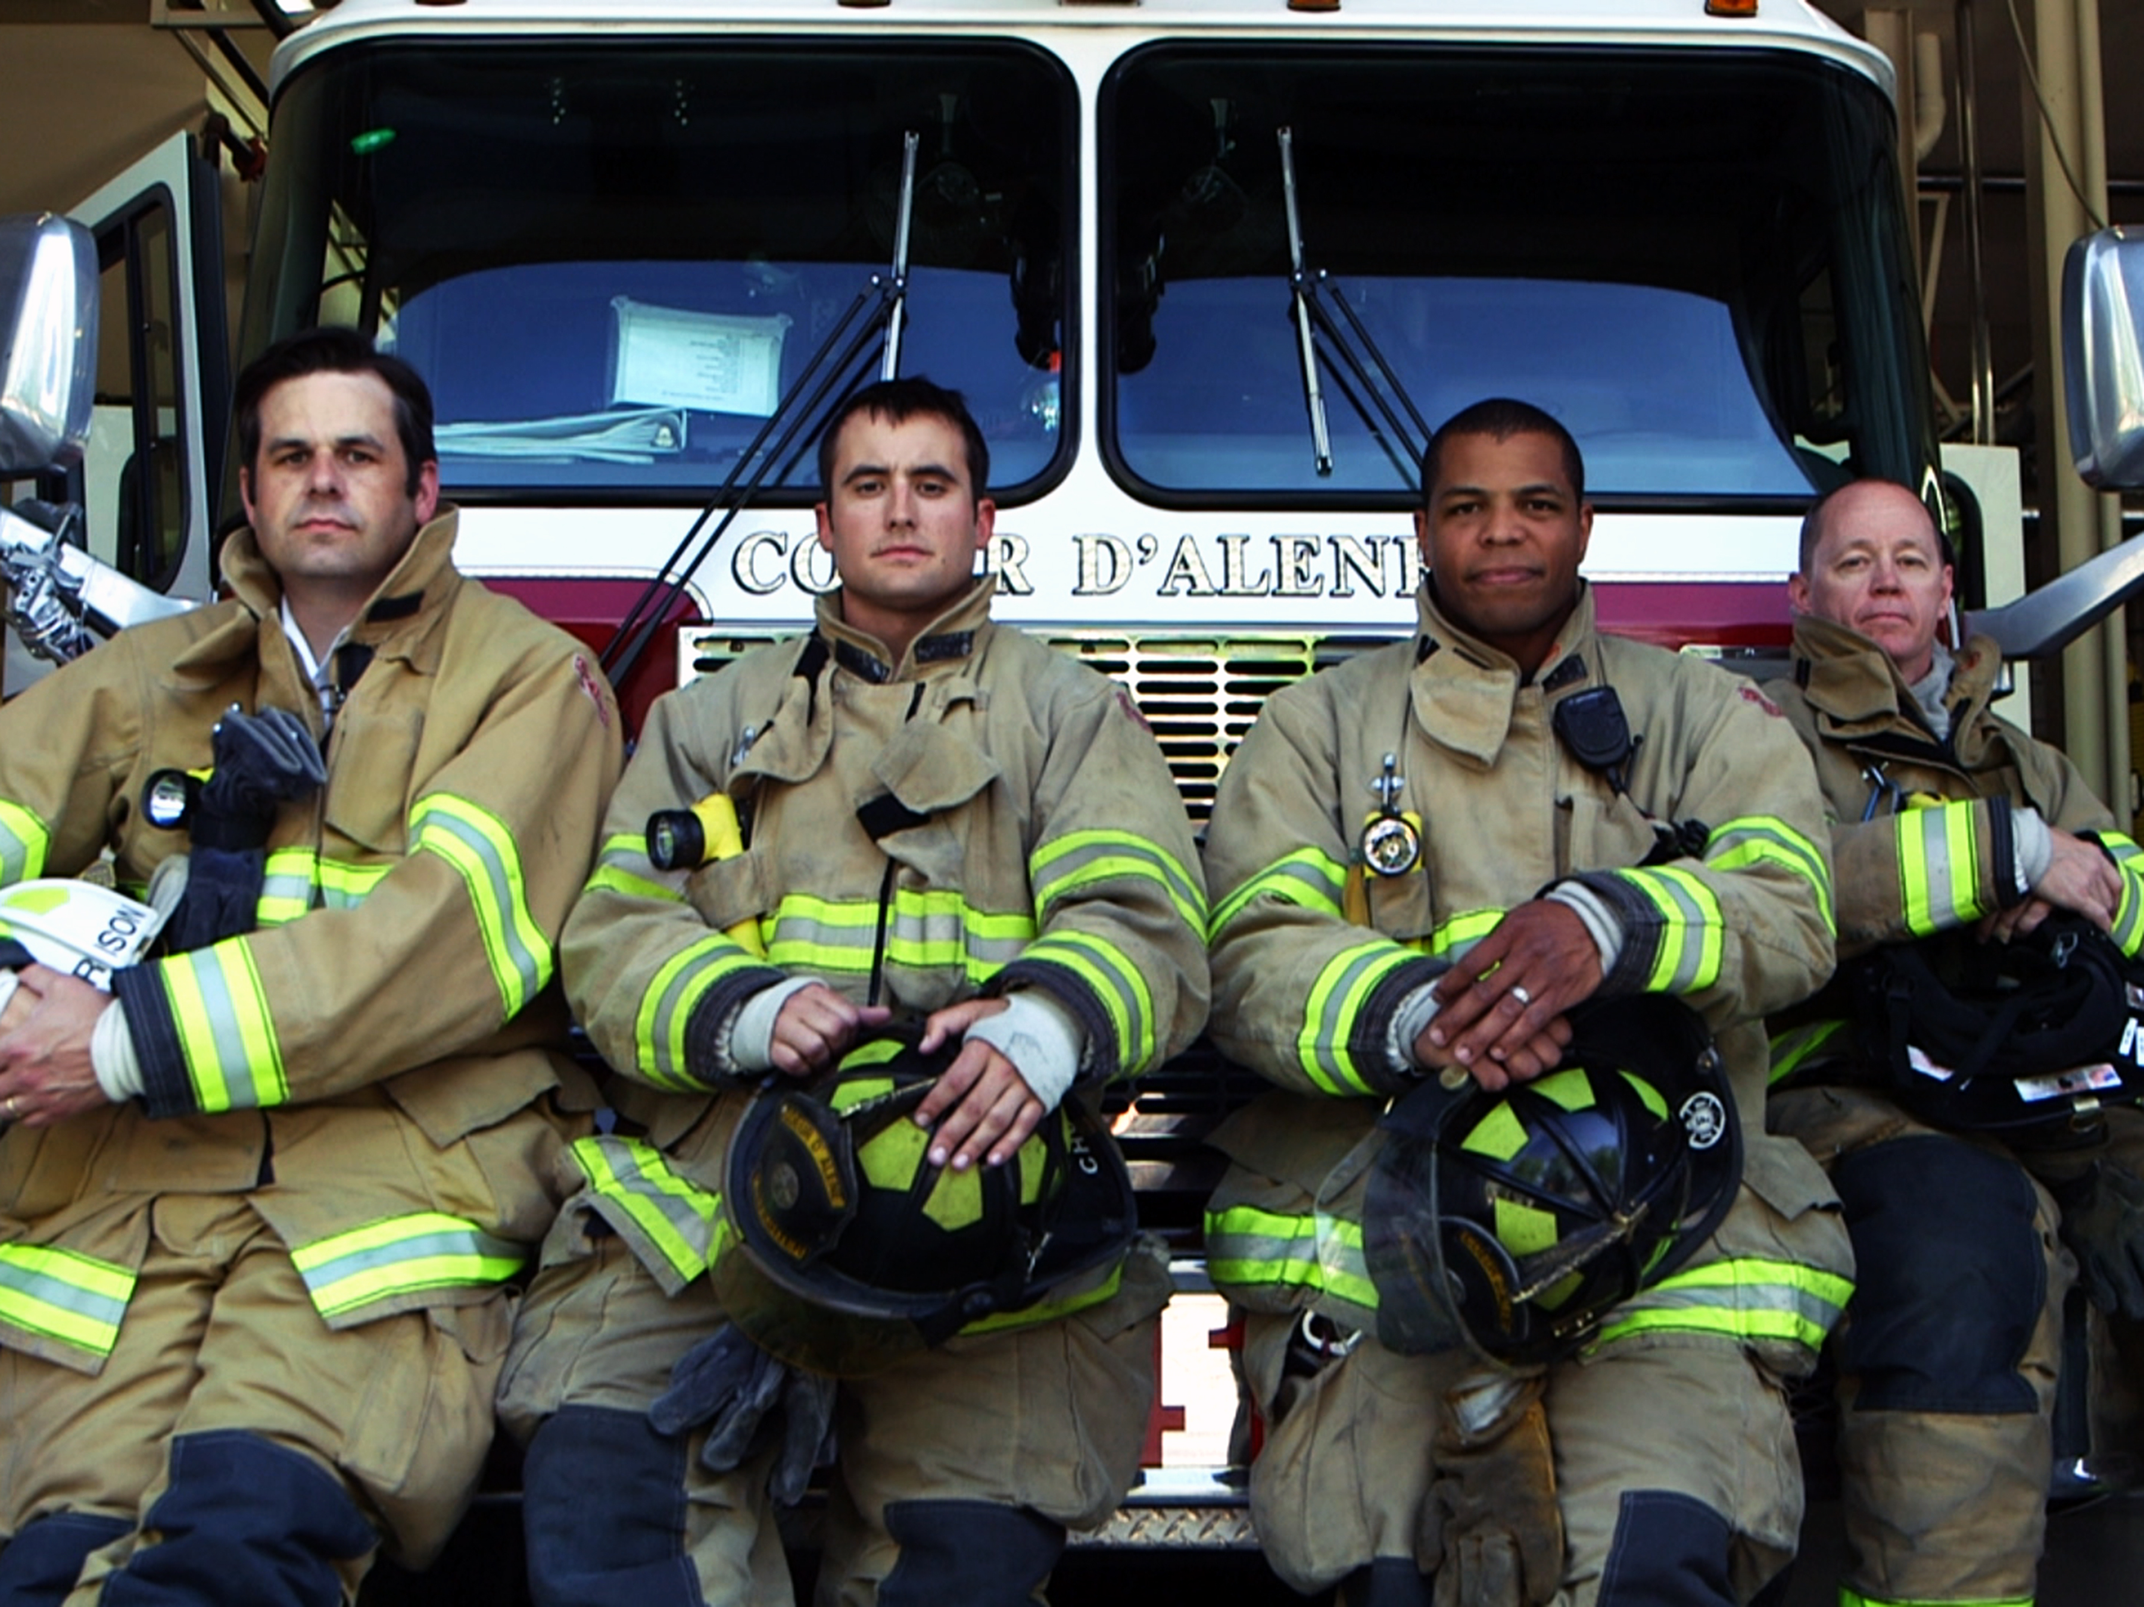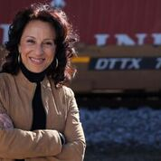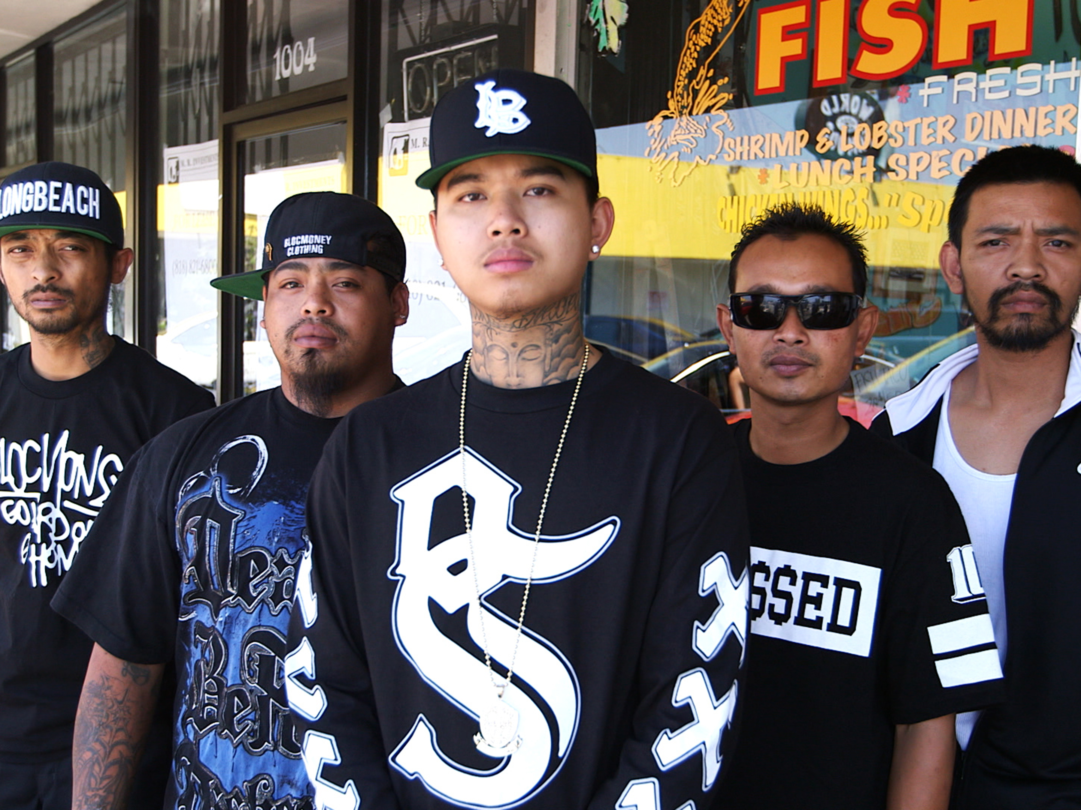

The Futuro Media Group to Rebroadcast America By The Numbers with Maria Hinojosa

Rebroadcast on PBS stations scheduled as a Lead Up to the ABTN One-Hour Election Special,
“The New Deciders” broadcast on September 6, 2016

NEW YORK, NY (July 18, 2016) – In anticipation of the national broadcast of the one-hour 2016 election special, “The New Deciders,” which will air on local public TV stations nationwide September 6, PBS will rebroadcast programs with updated data from the original America By The Numbers with Maria Hinojosa (ABTN) series produced by The Futuro Media Group. Check local listings for dates and times for the ABTN rebroadcasts. America By The Numbers is the first national program to chronicle the demographic shift in the United States to a majority non-white nation.

The programs from the first ABTN series will be available for public TV rebroadcast beginning July 26, 2016, featuring the original documentary content, as well as new demographic and trend data, supporting graphics and narration. Additionally, the programs will include epilogues providing information on main characters from the six programs, updating what has transpired in their lives since the original broadcast in fall 2014.

“America is increasingly experiencing dramatic changes in its demographics, shifting the cultural landscape and deeply impacting how we look, vote, shop and live,” said ABTN Executive Producer and award-winning journalist Maria Hinojosa. Hinojosa is also Executive Producer of NPR’s Peabody Award-winning weekly radio show, Latino USA, and President and Founder of the Futuro Media Group. “We are pleased to be able to update the demographic data and numbers of the first series as well as our storytelling, to support the ongoing national dialogue about race, identity, democracy and nationhood.”

In visually compelling programs anchored by Hinojosa, viewers will once again experience surprising numbers and gripping personal stories behind population change in America. The six programs to air from the first season of ABTN include:

- “Politics of the New South” – More than 80,000 refugees have settled in Georgia since the 1980s, and 10,000 of them were placed just outside of Atlanta in the small city of Clarkston. As a result, Clarkston’s population went from 97 percent American-born to 53 percent foreign-born. ABTN documents former refugees exercising their civic agency as candidates, running for public office for the first time, in one of the most racially and ethnically diverse towns in the nation.
- “Our Private Idaho” – Coeur D’Alene, Idaho has one of the highest white growth rates in the nation, and was once the headquarters for the Aryan Nations white supremacy movement. At a time when the overall percentage of whites in the U.S. is 62 percent and falling, Coeur D’Alene and its surrounding county is holding steady at 90 percent. America By The Numbers goes on location to Coeur D’Alene to understand how white Americans view their place in an increasingly diverse national landscape.

- “Island of Warriors”– Nearly 3 million Americans have been deployed in the wars in Iraq and Afghanistan since 9/11. Roughly 50 percent of returning veterans say they struggle with physical or mental health problems due to their service, and as many as one in five suffer from post-traumatic stress disorder. “Island of Warriors” examines the treatment of veterans who live in Guam and have some of the highest rates of enlistment as well as causalities and death.
- “Pass or Fail in Cambodia Town” – 54 percent of Asian-Americans aged 25 and older hold a college degree, compared to 33 percent of all U.S. adults. By contrast, Southeast Asian Americans have one of the lowest high school completion rates in the country; as 31.2 percent of Cambodian, 28.1 percent of Hmong, and 28.4 percent of Laotian adults do not have a high school diploma or equivalent. This episode investigates the unique obstacles facing Southeast Asian American students in Long Beach, California.
- “Surviving Year One” – In the city of Rochester, NY and surrounding Monroe county, a baby born to an African American or Latino mother is more than twice as likely to die before reaching its first birthday as a baby born to a white mother. Rochester is home to some of the most technologically advanced health care facilities in the nation, yet this rate of infant mortality is higher than Botswana, Sri Lanka and many other developing countries. ABTN investigates the root causes behind these alarming statistics.
- “The New Mad Men” – Latinos represent one of the fastest growing groups in the U.S., with a purchasing power of $1.2 trillion. Nearly a quarter of Americans between the ages of six and 34 is Latino. This episode takes a deep dive into trends in advertising and the influence of Latino consumers, especially Latina Millennials.

Funding for the six America By The Numbers documentaries has been provided by the National Minority Consortia (NMC), which is composed of Latino Public Broadcasting, Center for Asian American Media, Pacific Islanders in Communications, Vision Maker Media, and the National Black Programming Consortium. The NMC has been a long-time supporter of America By The Numbers with Maria Hinojosa, contributing to completion of the pilot program as well as the full series. NMC co-chairs, Sandie Viquez Pedlow and Stephen Gong have expressed their enthusiasm for broadcast of the ABTN programs saying, “We are thrilled that the updated America by the Numbers will be re-broadcast on PBS. Maria Hinojosa is a master journalist, and the perspective she provides through these programs makes for vital and compelling television.”

“The New Deciders” will air on public TV stations nationwide September 6, 2016 and is presented by WGBH TV for PBS. The ABTN election special “The New Deciders” will examine voters whose power and influence are growing and impacting the 2016 election. Funding for the one-hour special was provided by the Corporation for Public Broadcasting and PBS.

Futuro Media Group produces two other multi-media products focused on politics, including “HUMANIZING AMERICA,” video shorts that present the human stories behind the American electorate in vignettes about engaged voters, and “In The Thick” a podcast hosted by Maria Hinojosa featuring a wide variety of reporters and pundits, providing new voices and diverse points of view about the 2016 election and a changing America.

For more information, visit www.americabythenumbers.org.

# # #

ABOUT the National Minority Consortia (NMC)
The National Minority Consortia (NMC) is comprised of five distinct and separate organizations—Center for Asian American Media (CAAM), Latino Public Broadcasting (LPB), National Black Programming Consortium (NBPC), Pacific Islanders in Communications (PIC), and Vision Maker Media. With primary funding from the Corporation for Public Broadcasting, the NMC has emerged as a leader in the field of diverse independent filmmaking and digital media and contributed to the nation’s appreciation of diverse cultures and storytelling. Over the past 30 years, the NMC has developed and provided production support to a wealth of diverse content for broadcast and new media for multi-platform distribution on PBS, and to schools and libraries. The NMC collaborates on national series and specials for public media and works with public television stations to launch community engagement initiatives. The organizations provide production training, professional development and mentorship for the advancement of producers of color. For more information, visit www.nmcmedia.org.

ABOUT PBS Election 2016
PBS Election 2016 is a year-long, cross-platform initiative that brings together PBS’ news, public affairs, documentary and digital programming to create a comprehensive look at the 2016 election cycle. Acclaimed series PBS NEWSHOUR, FRONTLINE and WASHINGTON WEEK, as well as new and returning series and specials such as 16 FOR ’16 and AMERICA BY THE NUMBERS, will cover breaking news, provide context for political issues and explore behind-the-scenes stories of the candidates and the election process. PBS Election 2016 also includes a partnership with NPR in which the two organizations will share information across broadcast, radio and digital platforms.

ABOUT PBS
PBS, with 350 member stations, offers all Americans the opportunity to explore new ideas and new worlds through television and online content. Each month, PBS reaches more than 100 million people through television and over 33 million people online, inviting them to experience the worlds of science, history, nature and public affairs; to hear diverse viewpoints; and to take front row seats to world-class drama and performances. PBS’ broad array of programs has been consistently honored by the industry’s most coveted award competitions. Teachers of children from pre-K through 12th grade turn to PBS for digital content and services that help bring classroom lessons to life. PBS’ premier children’s TV programming and its website, pbskids.org, are parents’ and teachers’ most trusted partners in inspiring and nurturing curiosity and love of learning in children. More information about PBS is available at www.pbs.org, one of the leading dot-org websites on the Internet, or by following PBS on Twitter, Facebook or through our apps for mobile devices. Specific program information and updates for press are available at pbs.org/pressroom or by following PBS Pressroom on Twitter.

ABOUT WGBH
WGBH Boston is America’s preeminent public broadcaster and the largest producer of PBS content for TV and the Web, including Point Taken, Frontline, Nova, American Experience, Masterpiece, Antiques Roadshow, Arthur, Curious George and more than a dozen other primetime, lifestyle, and children’s series. WGBH also is a major supplier of programming for public radio, and oversees Public Radio International (PRI). As a leader in educational multimedia for the classroom, WGBH supplies content to PBS LearningMedia, a national broadband service for teachers and students. WGBH also is a pioneer in technologies and services that make media accessible to those with hearing or visual impairments. WGBH has been recognized with hundreds of honors. More info at www.wgbh.org.

ABOUT CPB
The Corporation for Public Broadcasting (CPB), a private, nonprofit corporation created by Congress in 1967, is the steward of the federal government's investment in public broadcasting. It helps support the operations of nearly 1,500 locally owned and operated public television and radio stations nationwide. CPB is also the largest single source of funding for research, technology and program development for public radio, television and related online services. For more information, visit cpb.org and follow us on Twitter @CPBmedia, Facebook and LinkedIn.

ABOUT THE FUTURO MEDIA GROUP
The Futuro Media creates multimedia content for and about the new American mainstream in the service of empowering people to navigate the complexities of an increasingly diverse and connected world. As an independent nonprofit organization, Futuro Media Group produces journalism that is designed to educate and enlighten viewers and listeners.

For more information on the Futuro Media Group visit Futuro Media Group: Homepage and follow the Futuro Media Group on Twitter @futuromedia and Facebook at facebook.com/TheFuturoMediaGroup.

FUTURO MEDIA GROUP MEDIA CONTACTS
Shin-Jung Hong, ShinJung@nicholaslence.com / 212.938.0005
Natalia Kozikowska, Natalia@nicholaslence.com / 212.205.6633
Skye Ostreicher, Skye@nicholaslence.com / 212.205.6635

