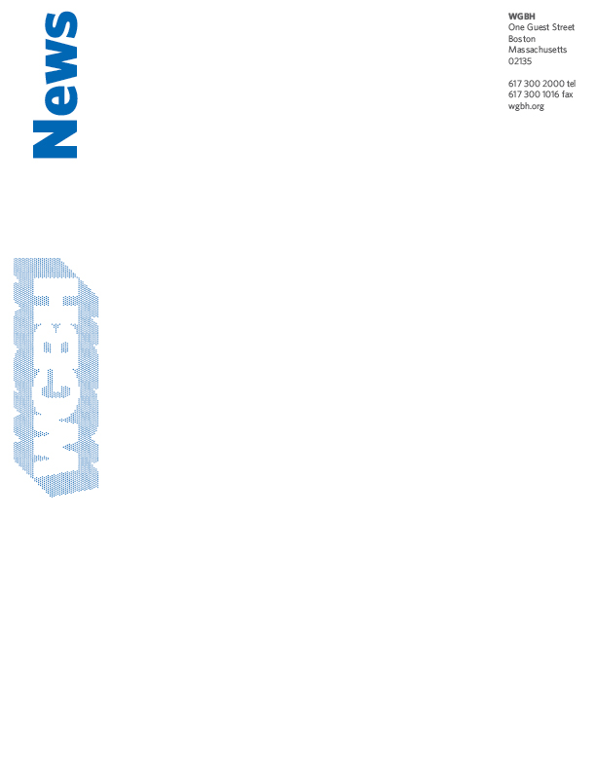
DRAMATIC SHIFTS IN THE AMERICAN CULTURAL LANDSCAPE EXAMINED IN NEW DOCUMENTARY SERIES
AMERICA BY THE NUMBERS WITH MARIA HINOJOSA
BOSTON, July 22, 2014 – Behind every number, there’s a story. Dramatic changes in the demographics of this country are playing out in mainstream America, shifting the cultural landscape and deeply impacting how we look, vote, shop, and live. Launching in fall 2014, AMERICA BY THE NUMBERS is the first national series to examine the new American mainstream-with its growing numbers of Asians, Latinos, African Americans, people of mixed race, immigrants, women, youth, and members of the LGBTQ community-who are creating a new consensus and increasingly determining the outcomes of political elections. With growing purchasing power and influence over the arts, culture and commerce, these changes affect every aspect of contemporary life across the country.
Helmed by award-winning reporter, author, news anchor, and executive producer Maria Hinojosa (NPR’s Latino USA), this compelling documentary series features eight half-hour episodes. Produced by The Futuro Media Group and presented by WGBH Boston and the National Minority Consortia (Center for Asian American Media, Pacific Islanders in Communications, Latino Public Broadcasting, National Black Programming Consortium, and Vision Maker Media), AMERICA BY THE NUMBERS premieres in primetime on Thursday, October 2 on WORLD Channel, the 24/7 digital multicast public media channel, and will broadcast on PBS beginning Saturday, October 4, 2014, following PBS NewsHour Weekend (check local listings). The series will also be available across multiple media platforms and supported by a civic engagement campaign and educational curriculum.

“The racial, cultural, and social landscape of America is changing rapidly and we need to address the dramatic shifts and what they mean to us as a nation, together,” says Maria Hinojosa, series anchor, executive producer, and president of The Futuro Media Group. “The rising influence and empowerment of multicultural groups, along with other demographic shifts, are evident everywhere. It is vital to explore these changes as well as the challenges and opportunities they present for our country.”

“AMERICA BY THE NUMBERS exemplifies the mission of WGBH and public television to champion innovation and diversity in all of its iterations, helping to understand our changing world,” said Marie Nelson, WGBH executive producer. “Maria Hinojosa’s journalistic experience and immersive reporting style enable her to connect with fellow citizens while addressing tough questions and topical issues.”

Featuring gripping narratives and stunning visuals, AMERICA BY THE NUMBERS focuses on news stories that are often under-reported in the mainstream media: health disparities in the U.S. as viewed through the lens of infant mortality; military service by residents from the non-voting territories of the Pacific Islands; the impact of a domestic oil boom on Native American lands; and the high dropout rate in Asian American refugee communities. Viewers will be transported to locations across the country rarely seen on television to witness human dramas that are seldom heard. Each episode will focus on stories from every corner of the nation, amplified by “the numbers” – a distillation of the latest statistical information about population, health, education, quality of life, and consumer trends in America.

AMERICA BY THE NUMBERS is composed of eight half-hour stories:
“Mainstream, USA”
In the original pilot episode, AMERICA BY THE NUMBERS explores the new multicultural mainstream through a portrait of Clarkston, Georgia, home to over 40 nationalities in a single square mile, and a laboratory for the future of our country. Once an organizing hub for the Ku Klux Klan, this small city outside of Atlanta went from 90 percent white to 82 percent non-white in 30 years after becoming a designated location for refugee resettlement. The series visits Clarkston to document how its daily realities reflect wider demographic trends and examine the collaborations and collisions that are occurring between old and new residents.
“Island of Warriors”
Pacific Islanders, including citizens of Guam, serve at a disproportionately high rate in the U.S. armed forces, and also have the highest per capita rate of casualties and deaths in the wars in Iraq and Afghanistan. But with no VA hospital on the island, returning Guamanian vets suffering from war-related injuries and post-traumatic stress disorder (PTSD) are having greater difficulty getting access to care than their counterparts on the mainland. AMERICA BY THE NUMBERS examines the difficulties faced by these discrepancies in veteran care.
“Our Private Idaho”
It is estimated that by 2043, if not before, white Americans will no longer constitute a majority in the U.S. According to Census data, cities such as Coeur d'Alene, Idaho have some of the most concentrated and fastest growing white populations in the nation. Coeur d’Alene is also the former headquarters of the Aryan Nations. Local residents banded together to force the white separatists out, and some initiatives in Coeur d’Alene public schools now focus on diversity. While Coeur d’Alene remains 92 percent white, the composition of the town, and the state of Idaho, are changing. AMERICA BY THE NUMBERS travels to Coeur d’Alene to explore both the allure and complexity of living in an overwhelming white community, and what it means to be white in America today.
“Native American Boomtown”
The Bakken Oil Boom is bringing billions of dollars and tens of thousands of jobs to North Dakota, but most people don’t know that 1/5 of North Dakota’s oil production comes from an Indian reservation. While the oil boom has led to more jobs and affluence for some, the more than 1,000 wells on the Fort Berthold Reservation have also attracted a huge influx of non-Indian
oil workers, as well as increased drug trafficking, crime, and traffic accidents. AMERICA BY THE NUMBERS speaks to tribal members who are facing new threats along with new wealth, to assess the impact of the North Dakota oil boom on the Native American way of life.
“Politics of the New South”
AMERICA BY THE NUMBERS revisits Clarkston, Georgia to track candidates in the local 2013 election. This election could be historic for Clarkston, as three of the candidates running for Mayor and City Council are former refugees from Somalia and Bhutan, who are voting and running for office for the first time ever. The new American candidates say they decided to run for office after participating in the original pilot episode of AMERICA BY THE NUMBERS and screening event.

“Pass or Fail in Cambodia Town”
Asian Americans are the best-educated ethnic group in the U.S., and are seen as a “model minority.” However, Southeast Asian Americans have some of the lowest high school completion rates in the country. Research suggests that language barriers, inherited PTSD from refugee experiences, cultural alienation, and gang violence are contributing factors. AMERICA BY THE NUMBERS investigates in Long Beach, California, home to the largest Cambodian community in the U.S. “Model Minority Myth” is a part of American Graduate: Let’s Make It Happen, a public media initiative supported by the Corporation for Public Broadcasting to help local communities across America address the dropout crisis.
“Surviving Year One”
While the numbers for infant mortality are improving for the U.S. as a whole, women of color, especially African Americans and Latinas, are losing babies at alarming rates. Babies of color born in Rochester, New York have a greater chance of not living to their first birthdays than babies in developing countries such as Libya and Jamaica. AMERICA BY THE NUMBERS travels to Rochester, where researchers, doctors, and prenatal care programs are investing in initiatives that could make a difference.

“The New Mad Men”
It is estimated that consumers of color represent a $3 trillion market, and advertisers are taking particular notice of the rapidly growing purchasing power of Latinos. AMERICA BY THE NUMBERS goes to the Austin, Texas headquarters of LatinWorks, an award-winning ad agency at the forefront of efforts to win the attention of the growing multicultural market, to examine how advertisers of today are reframing their messaging to appeal to Latino consumers, and how these consumers are responding.
# # #
AMERICA BY THE NUMBERS is produced by The Futuro Media Group in association with PBS and presented by WGBH Boston along with the members of the National Minority Consortia: The Center for Asian American Media, Pacific Islanders in Communications, Latino Public Broadcasting, National Black Programming Consortium, and Vision Maker Media. Funding for AMERICA BY THE NUMBERS is provided by: The California Endowment, Corporation for
Public Broadcasting, the Druckenmiller Foundation, Ford Foundation, PBS, and W.K. Kellogg Foundation.

About The Futuro Media Group:
The Futuro Media Group is an independent nonprofit organization producing multimedia journalism that explores and gives a critical voice to the diversity of the American experience. Based in Harlem and founded in 2010 by award-winning journalist Maria Hinojosa, Futuro Media Group is committed to telling stories often overlooked by mainstream media. For AMERICA BY THE NUMBERS, The Futuro Media Group has assembled one of the most diverse teams in broadcasting including: executive producer and anchor Maria Hinojosa; executive producer Sandra Rattley; and series producer Charlotte Mangin.

About WGBH:
WGBH Boston is America’s preeminent public broadcaster and the largest producer of PBS content for TV and the Web, including Masterpiece, Antiques Roadshow, Frontline, Nova, American Experience, Arthur, Curious George, and more than a dozen other prime-time, lifestyle, and children’s series. WGBH’s television channels include WGBH 2, WGBH 44, and the digital channels World and Create. WGBH TV productions focusing on the region’s diverse community include Greater Boston, Basic Black, High School Quiz Show, and Neighborhood Kitchens. WGBH Radio serves listeners across New England with 89.7 WGBH, Boston Public Radio; 99.5 WCRB, Classical New England; and WCAI, the Cape and Islands NPR® Station. WGBH also is a major source of programs for public radio (among them, PRI’s The World®), a leader in educational multimedia (including PBS LearningMedia™, providing the nation’s educators with free, curriculum-based digital content), and a pioneer in technologies and services that make media accessible to deaf, hard of hearing, blind, and visually impaired audiences. WGBH has been recognized with hundreds of honors: Emmys, Peabodys, duPont-Columbia Awards and Oscars. Find more information at wgbh.org.

About WORLD Channel:
The WORLD Channel is a 24/7, multicast channel dedicated to delivering the best of public television's nonfiction, news and documentary programming as well as a growing schedule of original content from independent producers and communities of difference. The complementary website, www.WORLDchannel.org, expands on broadcast topics and fuels content across social media, providing opportunities for broad and diverse audience interaction. WORLD Channel is produced by WGBH/Boston, in partnership with American Public Television and WNET/New York, and in association with the Public Broadcasting Service and the National Educational Telecommunications Association. Funding for WORLD Channel is provided by the Corporation for Public Broadcasting and the Ford Foundation.

About PBS:
PBS, with its over 350 member stations, offers all Americans the opportunity to explore new ideas and new worlds through television and online content. Each month, PBS reaches nearly 109 million people through television and over 28 million people online, inviting them to experience the worlds of science, history, nature and public affairs; to hear diverse viewpoints; and to take front row seats to world-class drama and performances. PBS’ broad array of
programs has been consistently honored by the industry’s most coveted award competitions. Teachers of children from pre-K through 12th grade turn to PBS for digital content and services that help bring classroom lessons to life. PBS’ premier children’s TV programming and its website, pbskids.org, are parents’ and teachers’ most trusted partners in inspiring and nurturing curiosity and love of learning in children. More information about PBS is available at www.pbs.org, one of the leading dot-org websites on the Internet, or by following PBS on Twitter, Facebook or through our apps for mobile devices. Specific program information and updates for press are available at pbs.org/pressroom or by following PBS Pressroom on Twitter.

CONTACTS:
Alexandra Ruffing, Nicholas & Lence Communications
(631) 294-9308, Alexandra@nicholaslence.com

Eileen Campion, Roslan & Campion PR
(212) 966-4600; Eileen@rc-pr.com
Mandy Miller, WGBH
(617) 300-5334; Mandy_Miller@WGBH.org

