AMERICA OUTDOORS WITH BARATUNDE THURSTON
PRESS ROUNDTABLE BIOS

Baratunde Thurston
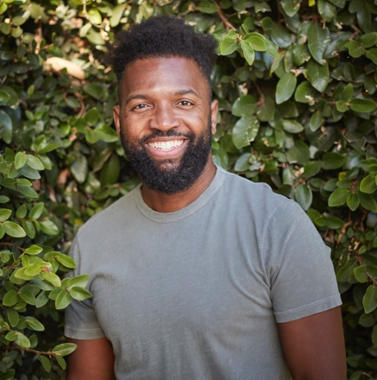
Baratunde Thurston tells a better story of us, weaving together threads of race, technology, democracy, and climate through his work as an Emmy-nominated host, producer, writer, and public speaker. He is the host and executive producer of the PBS television series America Outdoors with Baratunde Thurston, creator and host of How To Citizen with Baratunde which Apple named one of its favorite podcasts of 2020, and a founding partner of the new media startup Puck. His comedic memoir, How To Be Black, is a New York Times best-seller. In 2019, he delivered what MSNBC’s Brian Williams called “one of the greatest TED talks of all time.” Baratunde is unique in his ability to integrate and synthesize different and difficult topics in a style that’s intelligent, compassionate, and humorous. Baratunde serves on the boards of Civics Unplugged and the Brooklyn Public Library and lives in Los Angeles, California.

Kayle Browning

Kayle Browning is an American Olympian sport shooter and the founder and CEO of Cypress Creek Shooting Lodge, a premier destination for hunting and shooting enthusiasts. Born and raised in a family of competitive shooters, Kayle has always been passionate about the sport and the thrill of the game. Her early experiences in competitive shooting with her father sparked her love for the sport and inspired her to pursue a career in the industry. Since starting at the age of 8, she has set national titles, world records and most recently became an Olympic Silver Medalist in the 2020 Olympic Games. Under Kayle's leadership, Cypress Creek Shooting Lodge has grown into one of the most respected and sought-after lodges in the country. With a state-of-the-art shooting range, luxury cabins for overnight stays and access to some of the best training grounds in the region, the lodge has earned a reputation for providing an unforgettable experience for guests. Kayle is a graduate of Greenbrier High School and attended University of Central Arkansas.

Dan Devereaux
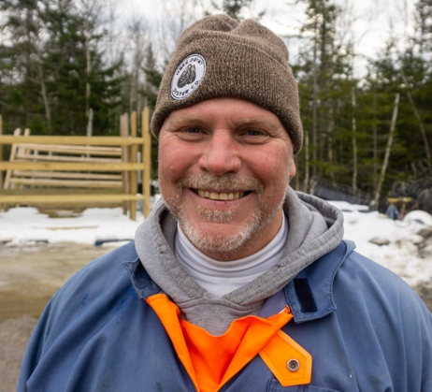
Dan was raised in a rural farming community in the middle of Michigan. Farming and the natural world were in his blood from early on. He made his way to Maine in 1989 after he enlisted in the United States Navy. Serving in Europe and other parts of the world, as well as, living along the Maine Coast for the last 30 years, Dan has instilled a profound amount of respect and passion for Maine’s pristine coastal areas and the resources that abound. Knowing how important shellfish are as a keystone species in these waters, he took particular interest in the critical role they play as part of a healthy ecosystem. Dan is better known as the Marine Resource Officer and Harbormaster in Brunswick. He founded the Maine Shellfish Warden Association, the Maine Shellfish Advisory Council and played active roles on the statewide marine resource advisory panels. Over the 30 years that Dan has worked on the water, he has seen numerous negative changes in the near shore coastal waters. These changes spurred Dan and his Business Partner Doug Niven to look for ways to help mitigate the changes they both had witness over the last three decades. Oyster and seaweed farming in the near shore bays provides opportunity to offset some of the changes they are seeing and help contribute positively to the bay environments. In 2016, they co-founded Mere Point Oyster Company which now employs over 17 farmers and sells oysters nationwide. Since they have established the farms in Maquoit Bay, there has been an increase in marine biodiversity and in the quality and health of the estuary.

Lisa Hicks-Gilbert
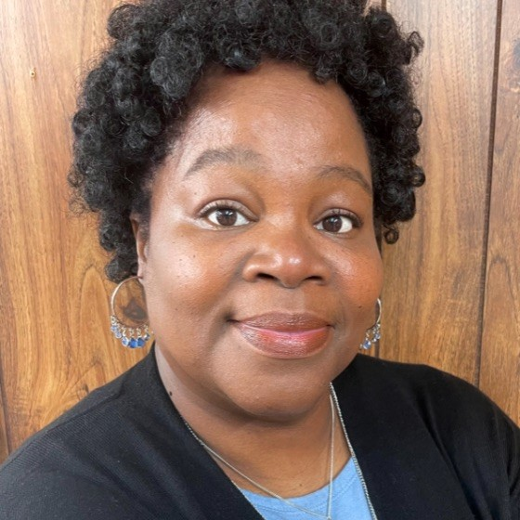
Currently living in her hometown of Elaine, Arkansas, Lisa is the Volunteer Program Manager with Lee Street Community Center. A descendant, Lisa founded the Descendants of the Elaine Massacre of 1919 (DOEM1919) which focuses on educating, protecting, and preserving the history and stories of the Elaine Massacre. In 2022, Lisa began a yearlong fellowship as an “Artist at Work” Fellow with THE OFFICE performing arts +film, which has afforded her the opportunity to focus on community building, collaborations, writing her grandmother's stories, poetry, and educational exhibits in hopes of inspiring other descendants to share family stories and histories that inspire bridge-building, reconciliation, and healing. On December 6, 2022, in a runoff election against the incumbent, Lisa was elected Mayor, and made history as the first Black, and first elected female Mayor of Elaine, Arkansas. Lisa was sworn in on January 1, 2023, and began serving a four-year term with a focus on addressing economic and social disparities, inspiring new leaders, and healing and building a more thriving Elaine community.

