AMERICAN PHARAOH, Documentary About Egyptian National Soccer Team and Its Former Coach, American Bob Bradley, Debuts on PBS June 16

– Program Scheduled to Air During the 2014 World Cup –

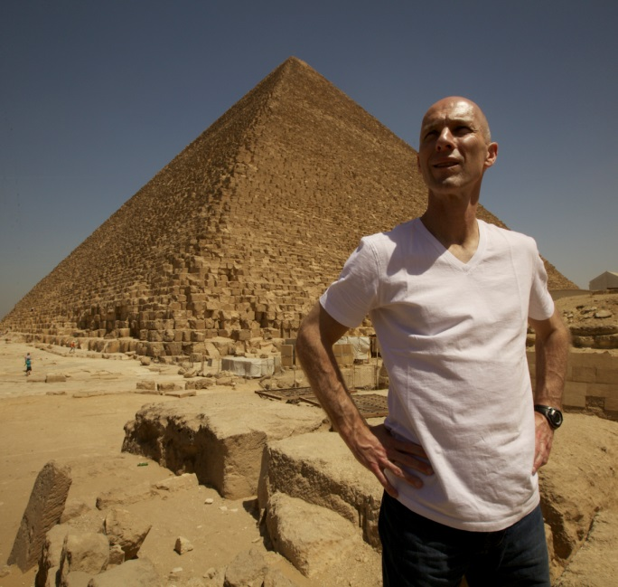
Coach Bob Bradley. Courtesy Soura Films, LLC.
ARLINGTON, VA; May 20, 2014 -- PBS will air the dramatic and multi-faceted one-hour documentary AMERICAN PHARAOH, which goes behind the scenes with the Egyptian national soccer team — the “Pharaohs” — and its former coach, American Bob Bradley, to capture their historic attempt to reach the 2014 World Cup, which created intense national pride and sparked headlines across the globe. Scheduled to premiere June 16, 2014, 10:00-11:00 p.m. ET (check local listings), during the FIFA World Cup in Brazil, the film by Egyptian filmmaker Hossam Aboul-Magd follows the team’s efforts to qualify for soccer’s ultimate event for the first time in more than 20 years. The program also illustrates the relationship in Egypt between soccer, the revolution and political activism. In production for more than two years, the film sets the soccer team’s challenge to succeed against the backdrop of the ongoing turmoil in Egypt.

Bradley and the Pharaohs’ run for a World Cup berth was punctuated by obstacles — a popular revolution, military takeover, protests, a fatal and tragic riot and political strife — and it ended with a dream-crushing loss to the strongest team in the region, Ghana. However, through their hard push for World Cup qualifications, Bradley and his team won a string of stirring victories that transcended the playing field.

“This is not just a film about soccer,” says Aboul-Magd. “This is about my country, my team, a coach I respect and the dream of capturing the World Cup in spite of enormous challenges. I see the goal of developing a strong team, in the middle of a revolution, as a metaphor for the rebuilding of Egypt.”

“This film not only tells a compelling story, but also provides a unique window into Egyptians’ ongoing struggle to define themselves during a time of national unrest. The journey of the Pharaohs on the road to the World Cup, with the perspective of their American coach, makes this a truly unusual and intimate film,” says Bill Gardner, Vice President, Programming and Development, PBS.

After a successful run as coach of the U.S. men’s national soccer team, reaching the second round in the 2010 World Cup, Bradley signed on to coach the Egyptian team in September 2011. Faced with ongoing violence and political upheaval within the country, the Pharaohs were the only team in the world to win every qualification game prior to a 6-1 regional loss to Ghana in October 2013. Bradley is now the manager of the Norwegian club Stabaek.

AMERICAN PHARAOH follows Bradley — recently elected to the National Soccer Hall of Fame — his wife, Lindsay, his staff and players. In gaining access to the training camps and providing in-depth coverage of the Pharaohs’ games in Africa, the filmmaker documents the team’s personal and professional struggles to keep their eyes on the prize of reaching the World Cup while living in and representing a country in turmoil.

Award-winning filmmaker Hossam Aboul-Magd, an avid Egyptian soccer fan born and raised in Cairo, has made films for PBS, National Geographic, Discovery Channel, History Channel, BBC, ABC, CNN, NHK and Al- Jazeera.

Producer: Soura Films, LLC
Executive Producer | Director |Writer | Director of Photography: Hossam Aboul-Magd
Producer: Sandy Petrykowski
Editor: Lesley Kubistal

Enjoy new shows all summer on PBS. Highlights include new drama and mysteries from MASTERPIECE — with David Tennant in “The Escape Artist” and a new season of “Endeavour” — comedies like VICIOUS starring Sirs Ian McKellen and Derek Jacobi (also seen in LAST TANGO IN HALIFAX, Season 2), documentaries from POV (beginning with “When I Walk”), and AMERICAN EXPERIENCE (“Freedom Summer”), scientific explorations such as MY WILD AFFAIR and SEX IN THE WILD, and insights into British culture with SECRETS OF UNDERGROUND LONDON and THE ROYAL PAINTBOX.

About PBS
PBS, with its over 350 member stations, offers all Americans the opportunity to explore new ideas and new worlds through television and online content. Each month, PBS reaches nearly 109 million people through television and over 28 million people online, inviting them to experience the worlds of science, history, nature and public affairs; to hear diverse viewpoints; and to take front row seats to world-class drama and performances. PBS’ broad array of programs has been consistently honored by the industry’s most coveted award competitions. Teachers of children from pre-K through 12th grade turn to PBS for digital content and services that help bring classroom lessons to life. PBS’ premier children’s TV programming and its website, pbskids.org, are parents’ and teachers’ most trusted partners in inspiring and nurturing curiosity and love of learning in children. More information about PBS is available at www.pbs.org, one of the leading dot-org websites on the Internet, or by following PBS on Twitter, Facebook or through our apps for mobile devices. Specific program information and updates for press are available at pbs.org/pressroom or by following PBS Pressroom on Twitter.

– PBS –

MEDIA CONTACTS:
Meghan Newton or Nisa Kiang, Goodman Media International for PBS,
Pharaoh@goodmanmedia.com; 212-576-2700

Michaé Godwin, PBS, mmgodwin@pbs.org, 703-739-8483

For images and additional up-to-date information on this and other PBS programs, visit PBS PressRoom at pbs.org/pressroom.

