PBS THANKSGIVING BROADCAST OF NEW “ANNE OF GREEN GABLES” OFFERS SPECIAL FAMILY TREAT

Breakthrough Entertainment’s New Film Version of Lucy Maud Montgomery’s Classic Features Martin Sheen
POLLYANNA Also Airs Thanksgiving Night
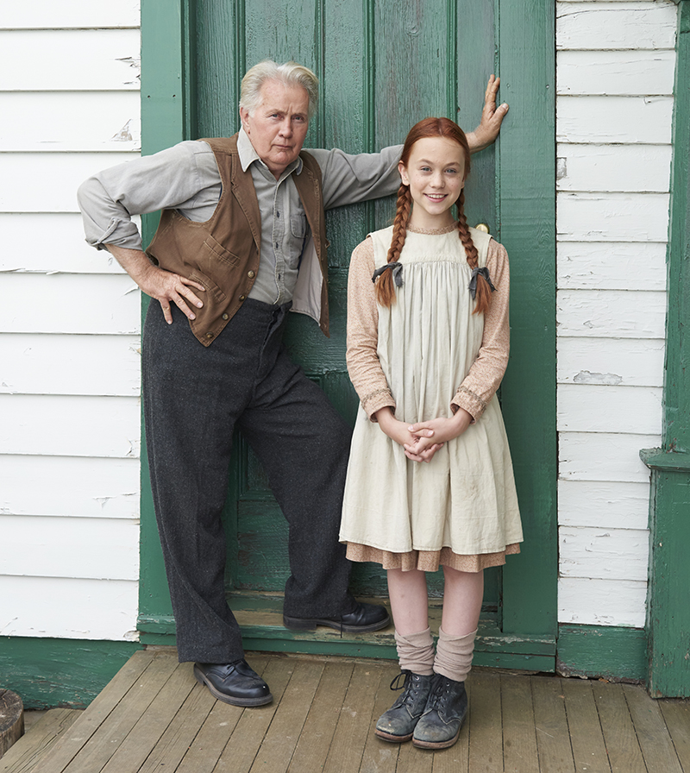
ARLINGTON, VA; September 21, 2016 – PBS announced today that the classic Lucy Maud Montgomery story of a young girl’s life on Prince Edward Island, L.M. MONTGOMERY’S ANNE OF GREEN GABLES (watch clip here), will air on Thanksgiving night, Thursday, November 24, 2016, at 8:00 p.m. ET (check local listings). Following the two-hour revival the same night is POLLYANNA, the film version of the 1913 best-selling novel by Eleanor H. Porter.
“We are excited to bring both ANNE OF GREEN GABLES and POLLYANNA to our viewers on Thanksgiving evening,” said Beth Hoppe, Chief Programming Executive and General Manager of General Audience Programming, PBS. “These two films are great examples of the quality, family-friendly programming PBS strives to provide during the holiday season and all year long.”
Martin Sheen as Matthew Cuthbert and Ella Ballentine as Anne Shirley.
Photo courtesy of Breakthrough Entertainment/©2015 Gables Productions Inc.

L.M. MONTGOMERY’S ANNE OF GREEN GABLES tells the story of Anne Shirley, a precocious young girl taken from an orphanage and placed in the care of the uptight Marilla Cuthbert and her brother, Matthew. The conservative Marilla has a profound effect on the adventurous Anne and creates a journey of learning and personal engagement that has resonated with generations since L.M. Montgomery’s Anne of Green Gables was first published in 1908. The book remains an iconic work of Canadian literature and has sold more than 50 million copies worldwide.
-more-

Directed by John Kent Harrison and based on the original script by Susan Coyne, this adaptation, filmed in Canada, stars critically acclaimed actor Martin Sheen. Sheen – who has appeared in blockbuster films such as The Amazing Spider Man and The Amazing Spider Man 2, and played the President of the United States in the multi-Emmy winning series “The West Wing” –portrays Matthew Cuthbert, one half of the brother-sister couple who care for Anne Shirley.
Additional cast members of L.M. MONTGOMERY’S ANNE OF GREEN GABLES include 14-year old Ella Ballentine (The Captive) as Anne Shirley, Sara Botsford (“E.N.G.”) as Marilla Cuthbert, Julia Lalonde (“Catch a Christmas Star”) as Diana Barry, Kate Hennig (“Thirty Two Short Films About Glenn Gould”) as Rachel Lynde, Stefani Kimber (Remember) as Josie Pye, Drew Haytaoglu (“Looks Just Like the Sun) as Gilbert Blythe, Kyle Gatehouse (Source Code) as Mr. Phillips and Linda Kash (Cinderella Man) as Mrs. Barry.
L.M. MONTGOMERY’S ANNE OF GREEN GABLES will be available on DVD from PBS Distribution: ShopPBS.org; 800-PLAY-PBS, 24 hours a day, 7 days a week. The film will also be available for digital download.

L.M. MONTGOMERY’S ANNE OF GREEN GABLES was produced by Breakthrough Entertainment in association with Corus Entertainment’s YTV and the author’s granddaughter, Kate Macdonald Butler, who served as executive producer.

PBS’ Thanksgiving programming also includes POLLYANNA, which tells the story of a girl who moves in with her embittered aunt after her father passes away. Soon, she charms everyone in the village she now calls home – all except her cold-hearted aunt who, despite her vast wealth, refuses to see the brighter side of life. Aunt Polly treats Pollyanna more like a stranger than a relative. When tragedy strikes, Pollyanna’s sunny outlook induces her aunt to confront the past and embrace the promise of happiness. POLLYANNA premieres Thanksgiving night, Thursday, November 24, 2016, at 9:30 p.m. ET (check local listings) on PBS.
About Breakthrough Entertainment
Breakthrough Entertainment Inc. is an award-winning producer and distributor of premium content for worldwide audiences. The entertainment studio’s operations include the development and distribution of feature films, television and digital content; international co-productions and production services. Breakthrough’s digital media division ranks amongst the industry’s most respected producers of high-quality interactive entertainment on mobile and online platforms. Established over 30 years ago, Breakthrough’s library now boasts over 40 feature films and 4,000 television episodes which air on major networks and digital channels across the globe. The studio has been recognized with international awards, including numerous Geminis, Canadian Screen Awards and Canadian Comedy Awards.
www.breakthroughentertainment.com Follow @breakthru_ent on Twitter.

PBS Distribution
PBS Distribution is the leading media distributor for the public television community, both domestically and internationally, extending the reach of programs beyond broadcast while generating revenue for the public television system and our production partners.

PBS Distribution offers a diverse range of programming to our customers, including Ken Burns’s films, documentaries from award-winning series such as NOVA, FRONTLINE, AMERICAN MASTERS, NATURE and AMERICAN EXPERIENCE, dramas from MASTERPIECE, as well as films from independent producers and popular children’s programming. As a multi-channel distributor, PBS Distribution offers consumers high-quality content in multiple formats, including DVD, Blu-ray, digital download and digital streaming. PBS Distribution is also a leading source for factual content for international broadcast, cable and satellite services.

About PBS
PBS, with nearly 350 member stations, offers all Americans the opportunity to explore new ideas and new worlds through television and online content. Each month, PBS reaches nearly 100 million people through television and nearly 33 million people online, inviting them to experience the worlds of science, history, nature and public affairs; to hear diverse viewpoints; and to take front row seats to world-class drama and performances. PBS’ broad array of programs has been consistently honored by the industry’s most coveted award competitions. Teachers of children from pre-K through 12th grade turn to PBS for digital content and services that help bring classroom lessons to life. PBS’ premier children’s TV programming and its website, pbskids.org, are parents’ and teachers’ most trusted partners in inspiring and nurturing curiosity and love of learning in children. More information about PBS is available at www.pbs.org, one of the leading dot-org websites on the Internet, or by followingPBS on Twitter, Facebook or through our apps for mobile devices. Specific program information and updates for press are available at pbs.org/pressroom or by following PBS Pressroom on Twitter.

– PBS –

CONTACTS:
Carrie Johnson, PBS, cjohnson@pbs.org; 703-739-5129
Joe DePlasco, DKC, Joe_DePlasco@dkcnews.com, 212-981-5125
Liz Sharkey, DKC, Liz_Sharkey@dkcnews.com; 212-981-5154

For images and additional up-to-date information on this and other PBS programs, visit PBS PressRoom at pbs.org/pressroom.

