PBS TO PRESENT “ARMED IN AMERICA,”
A SPECIAL TWO-NIGHT TELEVISION EVENT ON
MONDAY, MAY 9, AND TUESDAY, MAY 10

– Broadcasts of Acclaimed INDEPENDENT LENS Films “Peace Officer” and “The Armor of Light” Will be Followed by Town Hall Conversations Hosted by NPR’s Michel Martin –

ARLINGTON, VA; May 2, 2016 — PBS announced that ARMED IN AMERICA, a special two-night television event exploring gun violence in America, is scheduled for Monday and Tuesday, May 9-10, 2016. ARMED IN AMERICA centers around two acclaimed documentaries presented by INDEPENDENT LENS: “Peace Officer,” about a former sheriff who, after establishing and training one of Utah’s first SWAT team, raises questions about the dangers of what he sees as the increased militarization of police when that same unit kills his son-in-law 30 years later (airs Monday, May 9, 9:00-10:30 p.m. ET on PBS, check local listings), and “The Armor of Light,” which profiles the faith journeys of two Christians as they fight gun violence: the mother of a teenage shooting victim and an evangelical minister who questions whether one can be both pro-gun and pro-life. (airs Tuesday, May 10, 8:00-9:30 p.m. ET on PBS, check local listings). One-hour town hall conversations about the issues presented in the films will immediately follow both broadcasts. Viewers will be able to watch the two-night event on-air and online via a live stream simulcast on pbs.org/armedinamerica and the "Michel Martin: Going There" page on NPR.org, and are encouraged to engage in the conversation using the hashtags #PeaceOfficerPBS and #ArmorOfLightPBS.
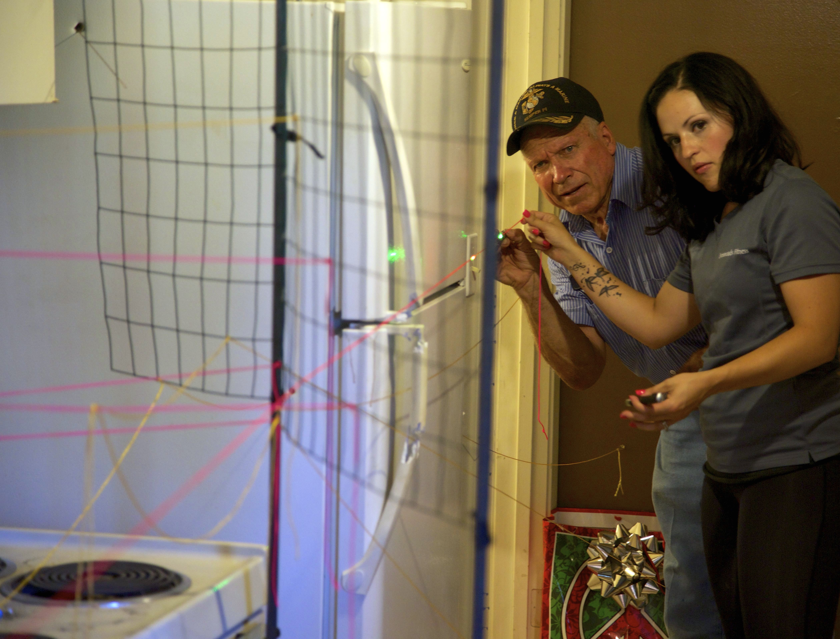
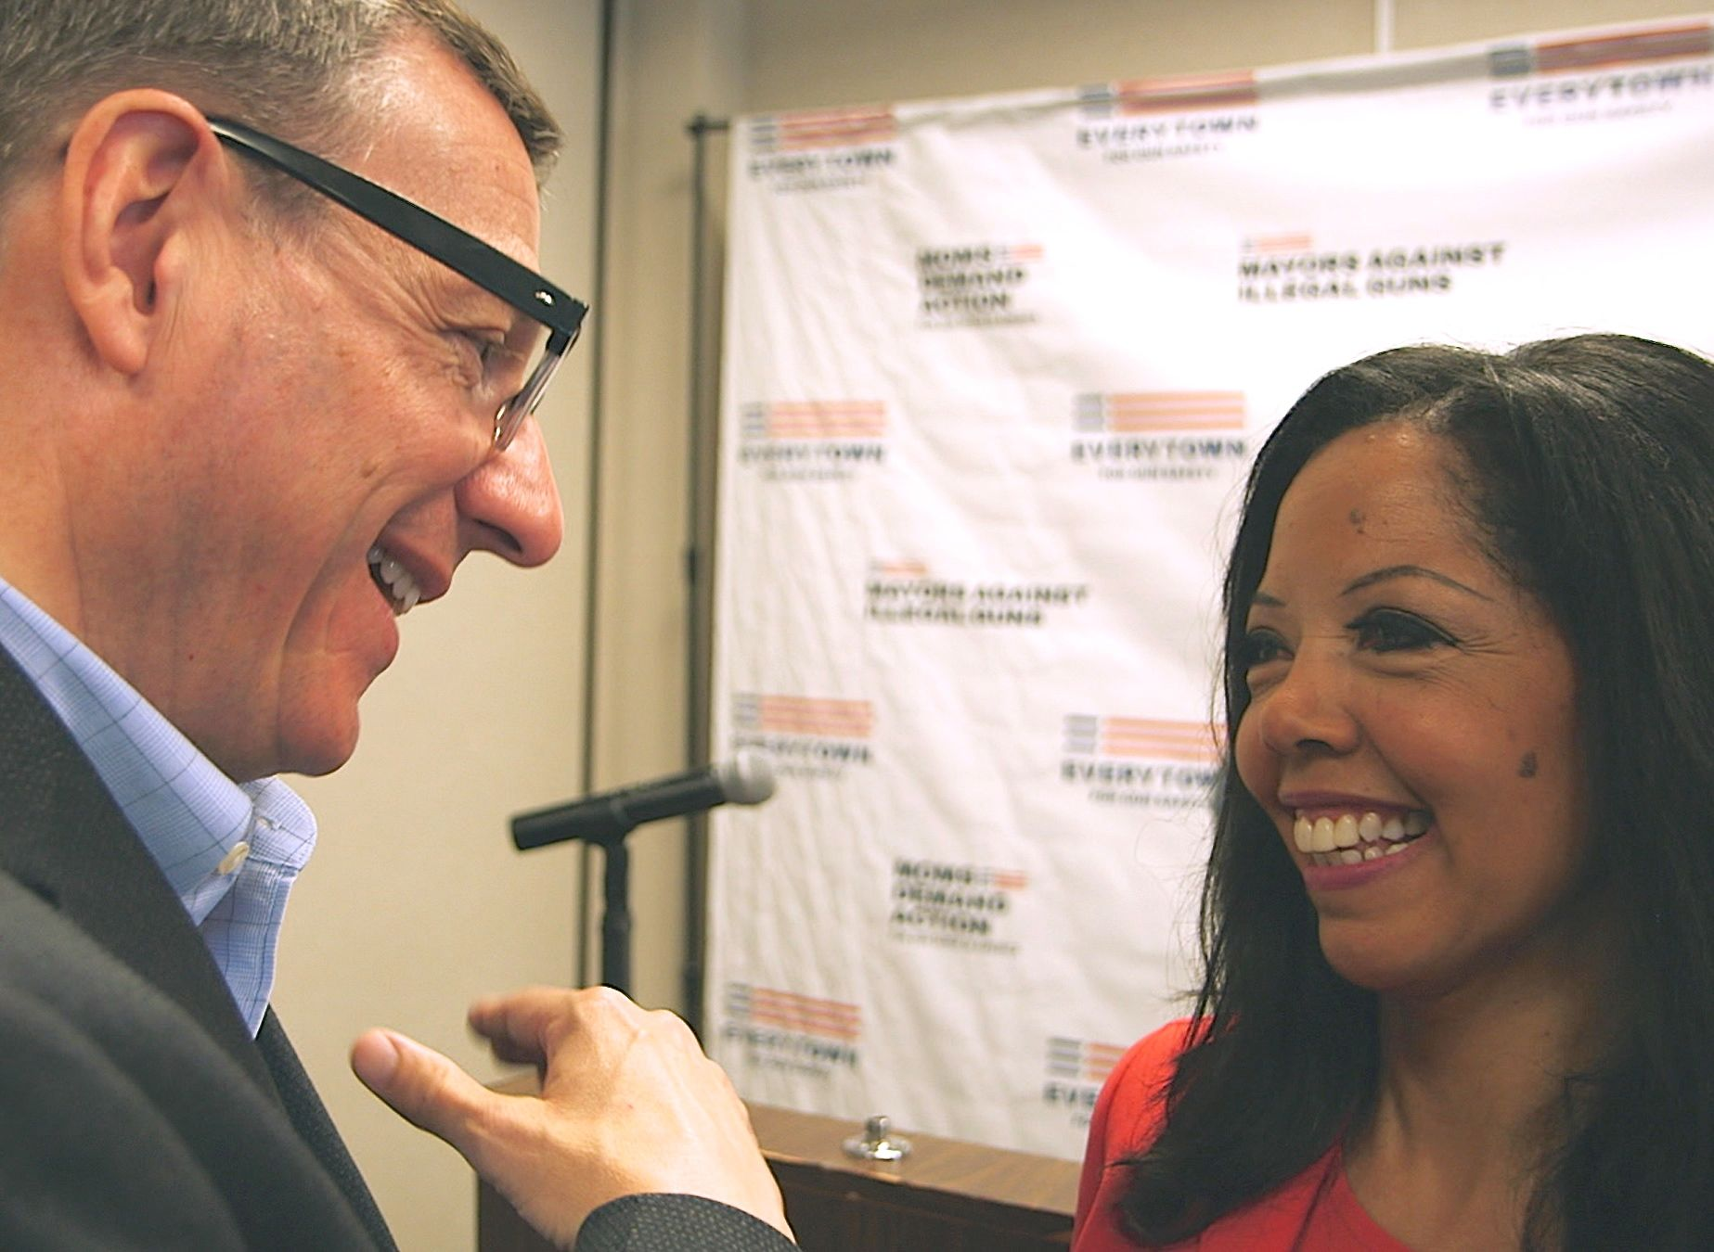
Top: Dub Lawrence and Erna Stewart reconstruct the path of bullets.
Credit: Jared Jakins
Bottom: Rob Schenck and Lucy McBath. Credit: Jeff Hutchens

Michel Martin, weekend host of NPR’s “All Things Considered,” moderates these special discussions. Both ARMED IN AMERICA town halls were taped at the Northland Church in Longwood, Florida, on Wednesday, April 27.

“PBS is committed to presenting programs that focus on critical issues facing our nation and providing a platform for discussion,” said Marie Nelson, Vice President, News and Public Affairs, PBS. “While the debate over guns may divide our country, the devastating toll of gun violence is something that everyone is united against. We hope the broadcast of these films, and the town hall conversations to follow, will help foster a public dialogue around these complex issues.”

“‘Peace Officer’” and ‘The Armor of Light’ are two powerful films that present unexpected perspectives on gun violence,” said Lois Vossen, INDEPENDENT LENS executive producer. “Former sheriff Dub Lawrence asks what is happening to law enforcement when officers sworn to serve the public appear to be using increasingly aggressive tactics against that public. And conservative evangelical minister Rob Schenck finds himself at odds with many other Christians as he asks whether being pro-gun is consistent with being pro-life. Probing deeply into some of the most difficult questions facing our country, these films urge us to take a hard look at our nation and ourselves.”

As a multi-platform initiative, ARMED IN AMERICA will also deliver content and conversation through a robust digital presence and social media discussion. Live perspectives shared on social media during the broadcast will be directly integrated into the on-air broadcast and aggregated online in a social hub for continued dialogue and discussion.

Full details of both films and their subsequent town hall conversations follow:

Winner of both the Grand Jury and Audience Awards for Best Documentary at the 2015 SXSW Film Festival, “Peace Officer” examines the increasingly militarized state of American police through the story of William “Dub” Lawrence, who uses his investigative skills to uncover the truth about not only his son-in-law’s death but other officer-involved shootings in his community, while tackling larger questions about the changing face of peace officers nationwide. Directed by Scott Christopherson and Brad Barber, “Peace Officer” premieres on INDEPENDENT LENS, Monday, May 9, 2016, 9:00-10:30 p.m. ET (check local listings) on PBS.

“Peace Officer” will be followed at 10:30 p.m. by ARMED IN AMERICA: Police & Guns, a one-hour town hall conversation exploring whether U.S. police forces are becoming increasingly militarized. Among those that participated in this conversation are Mr. Lawrence; Betty Taylor, former Winfield, Mo. Police Chief and SWAT Team Member; Alecia Phonesavanh, the mother of baby who was injured when a flash bang landed in his crib during a “no-knock” SWAT raid; Haiku, hip hop artist and activist; Anthony Batts, former Commissioner of the Baltimore Police Department; Richard Beary, University of Central Florida Police Chief; Michael Foreman, former Orange County Police Chief and President of the Florida SWAT Association; and Susan Rahr, former King County Sheriff and current Director of the WA State Criminal Justice Training Commission.

“The Armor of Light” follows two people of faith who come together to explore the contradictions of a nation rife with gun violence: Reverend Dr. Rob Schenck, an evangelical minister who is trying to find the courage to preach about the growing toll of gun violence in America, and Lucy McBath, the mother of Jordan Davis, an unarmed teenager who was murdered in Florida and whose story casts a spotlight on the state’s “Stand Your Ground” laws. Directed by Abigail Disney and produced and co-directed by Kathleen Hughes, “The Armor of Light” premieres on INDEPENDENT LENS Tuesday, May 10, 2016, 8:00-9:30 p.m. ET (check local listings) on PBS.

“The Armor of Light” will be followed at 9:30 p.m. by ARMED IN AMERICA: Faith & Guns, a one-hour town hall conversation exploring the relationship between faith and guns in America. Reverend Schenck and Ms. McBath participated in this conversation, along with Reverend Joel Hunter, Pastor of Northland Church; Shane Claiborne, Evangelical community organizer; Dianna Hobbs, Christian blogger; Dr. Karen Swallow Prior, Professor at Liberty University; Reverend Kenneth Blanchard, author of Black Man with a Gun; and Troy Newman, President of Operation Rescue.

The town hall conversations were moderated by award-winning journalist Michel Martin, weekend host of NPR’s “All Things Considered.” Outside the studio, she hosts "Michel Martin: Going There," an ambitious live event series in collaboration with NPR Member Stations all over the country. Martin joined NPR in 2006, where she launched and hosted “Tell Me More,” a one-hour daily NPR news and talk show from 2007-2014. Prior to NPR, Martin was an on-air journalist for ABC News. Previously she also covered politics for the Wall Street Journal and the Washington Post.

After their broadcasts, both films and the subsequent town hall discussions will be available to watch on PBS.org and across all platforms and devices that support PBS video streaming apps, including Apple TV, Android TV, Amazon Fire, and Chromecast, as well as Android, iOS, and Windows 10 mobile devices.

Both “Peace Officer” and “The Armor of Light” are being shown in cities across the country as part of Indie Lens Pop-Up, the neighborhood screening series that brings people together for community-driven conversations around films from INDEPENDENT LENS.

PBS LearningMedia, an online library with more than 120,000 digital resources for preK-12 teachers and students, will make clips, discussion guides, and other classroom resources from “Peace Officer,” “The Armor of Light,” and the ARMED IN AMERICA Town Halls available to teachers and students to facilitate discussion and classroom engagement. This material will complement a wide range of other PBS LearningMedia resources addressing gun violence such as Not in Our Town, A Path to Violence, After Newtown, U.S. Gun Homicides: Visualizing the Numbers, and America After Ferguson.

ARMED IN AMERICA is produced by Lincoln Square Productions for PBS.

About INDEPENDENT LENS
INDEPENDENT LENS is an Emmy® Award-winning weekly series airing on PBS Monday nights at 10:00 p.m. ET. The acclaimed series features documentaries united by the creative freedom, artistic achievement, and unflinching visions of independent filmmakers. Presented by Independent Television Service, the series is funded by the Corporation for Public Broadcasting, a private corporation funded by the American people, with additional funding from PBS and the John D. and Catherine T. MacArthur Foundation. For more, visit pbs.org/independentlens. Join the conversation: facebook.com/independentlens and on Twitter @IndependentLens.

About PBS
PBS, with 350 member stations, offers all Americans the opportunity to explore new ideas and new worlds through television and online content. Each month, PBS reaches more than 100 million people through television and over 33 million people online, inviting them to experience the worlds of science, history, nature and public affairs; to hear diverse viewpoints; and to take front row seats to world-class drama and performances. PBS’ broad array of programs has been consistently honored by the industry’s most coveted award competitions. Teachers of children from pre-K through 12th grade turn to PBS for digital content and services that help bring classroom lessons to life. PBS’ premier children’s TV programming and its website, pbskids.org, are parents’ and teachers’ most trusted partners in inspiring and nurturing curiosity and love of learning in children. More information about PBS is available at www.pbs.org, one of the leading dot-org websites on the Internet, or by following PBS on Twitter, Facebook or through our apps for mobile devices. Specific program information and updates for press are available at pbs.org/pressroom or by following PBS Pressroom on Twitter.

###

CONTACTS:

Jennifer Byrne, PBS, 703-739-5487; jrbyrne@pbs.org
Atiya Frederick, PBS, 703-739-5147; anfrederick@pbs.org
Cara White, Independent Lens, 843-881-1480; cara.white@mac.com
Mary Lugo, Independent Lens, 770-623-8190; lugo@negia.net

For images and additional up-to-date information on this and other PBS programs, visit PBS PressRoom at pbs.org/pressroom.

