PBS and WETA Announce Groundbreaking Documentary Series
ASIAN AMERICANS
To Premiere May 2020 on PBS stations

The most ambitious television chronicle of the Asian American story
in the United States will launch during Asian Pacific American Heritage Month
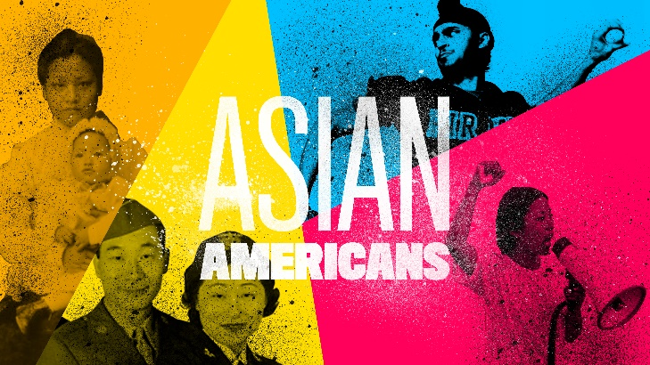
Beverly Hills, CA; July 29, 2019 – Today at the Television Critics Association Press Tour, PBS and WETA announced ASIAN AMERICANS, a new five-part documentary series currently in production and expected to broadcast in May 2020 on PBS. The series examines what the 2010 U.S. Census identifies as the fastest growing racial/ethnic group in the United States. Told through individual lives and personal histories, ASIAN AMERICANS explores the impact of this group on the country’s past, present, and future.
Led by a team of Asian American filmmakers, including Academy Award®-nominated series producer Renee Tajima-Peña (Who Killed Vincent Chin?, No Más Bebés), ASIAN AMERICANS examines the significant role of Asian Americans in shaping American history and identity, from the first wave of Asian immigrants in the 1850s and identity politics during the social and cultural turmoil of the twentieth century to modern refugee crises in a globally connected world.

“As America’s home for documentaries, PBS is committed to telling stories that illuminate and celebrate the rich diversity of our country,” said Paula Kerger, PBS President and CEO. “We are proud to share this important series with our audiences, and to deepen understanding about the extraordinary impact of Asian Americans on our national identity.”
“ASIAN AMERICANS is a comprehensive multiplatform initiative that will embrace the question of what it means to be an American,” said Sharon Percy Rockefeller, President and CEO of WETA. “Following our previous series, The Jewish Americans, The Italian Americans and Latino Americans, WETA remains committed to revealing the significant stories of the entire American people.”

“We are proud to support the Center for Asian American Media for the important work they do bringing programs about the Asian American experience to public media and audiences across the country,” said Pat Harrison, CPB president and CEO. “CPB is committed to supporting diverse content for and about people of all backgrounds, and ASIAN AMERICANS is a powerful example of our mission.”

“We are proud to have WETA as a partner on this milestone series, which weaves the histories of many Asian American communities within the broad sweep of American history,” said Stephen Gong, Executive Director of the Center for Asian American Media. “These are American stories: stories of resilience in the face of racism, of overcoming challenges as refugees from war and strife, of making contributions in all sectors of society: business, technology, military service, and the arts. These Asian American experiences and voices provide a vital foundation for a future fast approaching, in which no single ethnic or racial group defines America, in which shared principles will define who we are as Americans.”

Accompanied by robust educational, engagement, and digital components, this groundbreaking initiative will bring a new perspective to the American experience. Partnering with Asian Americans Advancing Justice - Los Angeles, the series will aim to expand audience reach and engage diverse perspectives through targeted community events, impactful education initiatives and integrated digital content.

ASIAN AMERICANS is a production of WETA Washington, DC and the Center for Asian American Media (CAAM) for PBS, in association with the Independent Television Service (ITVS), Flash Cuts and Tajima-Peña Productions. The series executive producers are Jeff Bieber and Dalton Delan for WETA; Stephen Gong and Donald Young for CAAM; Sally Jo Fifer for ITVS; and Jean Tsien. The series producer is Renee Tajima-Peña. The producer for Flash Cuts is Eurie Chung. The episode producers are S. Leo Chiang, Geeta Gandbhir and Grace Lee. The consulting producer is Mark Jonathan Harris.

Major funding for ASIAN AMERICANS is provided by Corporation for Public Broadcasting (CPB), Wallace H. Coulter Foundation, Public Broadcasting Service (PBS), Ford Foundation/JustFilms, National Endowment for the Humanities, The Freeman Foundation, The Arthur Vining Davis Foundations, Carnegie Corporation of New York, Kay Family Foundation, Long Family Foundation, Spring Wang and California Humanities.

For more information, please visit pbs.org. Press materials and photography can be found on the PBS Pressroom at pressroom.pbs.org.

# # #

About WETA
WETA is the leading public broadcasting company in the nation’s capital, serving Virginia, Maryland, and the District of Columbia with educational initiatives and with high-quality programming on WETA Television and Classical WETA 90.9 FM. For national PBS audiences, WETA Washington, D.C., is one of the largest-producing stations of new content for public television in the United States, with news and public affairs programs including PBS NewsHour and Washington Week; films by Ken Burns such as The Civil War and The Roosevelts: An Intimate History; and performance specials from the White House, the U.S. Capitol, and the John F. Kennedy Center for the Performing Arts. More information on WETA and its programs and services is available at www.weta.org. On social media, visit www.facebook.com/wetatvfm on Facebook or follow @WETAtvfm on Twitter.

About CAAM
CAAM (Center for Asian American Media) is a nonprofit organization dedicated to presenting stories that convey the richness and diversity of Asian American experiences to the broadest audience possible. CAAM does this by funding, producing, distributing, and exhibiting works in film, television, and digital media. For more information on CAAM, please visit www.caamedia.org.

About Flash Cuts
Flash Cuts is an Asian American-owned post-production facility based in Los Angeles. With over 30 years of experience in commercials, trailers, public television, and independent film, Walt Louie started Flash Cuts to serve a community of filmmakers east of Hollywood. For more information about Flash Cuts, please visit www.flashcuts.com.

About ITVS
ITVS is a San Francisco-based nonprofit organization that has, for over 25 years, funded and partnered with a diverse range of documentary filmmakers to produce and distribute untold stories. ITVS incubates and co-produces these award-winning films and then airs them for free on PBS via our weekly series, Independent Lens, as well as other series, and Indie Lens Storycast and our digital platform, OVEE. ITVS is funded by the Corporation for Public Broadcasting. For more information, visit itvs.org.

About PBS
PBS, with more than 330 member stations, offers all Americans the opportunity to explore new ideas and new worlds through television and digital content. Each month, PBS reaches over 126 million people through television and 26 million people online, inviting them to experience the worlds of science, history, nature and public affairs; to hear diverse viewpoints; and to take front row seats to world-class drama and performances. PBS’ broad array of programs has been consistently honored by the industry’s most coveted award competitions. Teachers of children from pre-K through 12th grade turn to PBS for digital content and services that help bring classroom lessons to life. Decades of research confirms that PBS’ premier children’s media service, PBS KIDS, helps children build critical literacy, math, and social-emotional skills, enabling them to find success in school and life. Delivered through member stations, PBS KIDS offers high-quality educational content on TV – including a 24/7 channel, online at pbskids.org, via an array of mobile apps and in communities across America. More information about PBS is available at www.pbs.org, one of the leading dot-org websites on the internet, or by following PBS on Twitter, Facebook or through our apps for mobile and connected devices. Specific program information and updates for press are available at pbs.org/pressroom or by following PBS Pressroom on Twitter.

About CPB
The Corporation for Public Broadcasting (CPB), a private, nonprofit corporation created by Congress in 1967, is the steward of the federal government’s investment in public broadcasting. It helps support the operations of more than 1,500 locally owned and operated public television and radio stations nationwide. CPB is also the largest single source of funding for research, technology, and program development for public radio, television, and related online services. For more information, visit www.cpb.org and follow us on Twitter @CPBmedia, Facebook and LinkedIn, and subscribe for email updates.

Press Contacts
Olivia Wong, WETA Director of Public Relations, 703.998.2086, owong@weta.org

