PBS and BBC’s New Live Event, AUTUMNWATCH - NEW ENGLAND, Announces Lineup of Contributors Bringing Depth and Color to the Fall Experience

- Samantha Brown and Chris Packham to Explore America’s Love Affair with Fall Food, Science, Wildlife, Culture and Traditions –

- Cinematographer Bob Poole to Capture Nocturnal Animal Life
in New England –

ARLINGTON, VA; October 4, 2018 – AUTUMNWATCH - NEW ENGLAND, airing Wednesday-Friday, October 17-19, 2018, at 8:00 p.m. ET on PBS (check local listings), will feature an array of expert contributors exploring the food, culture and wildlife that embody fall in the region.
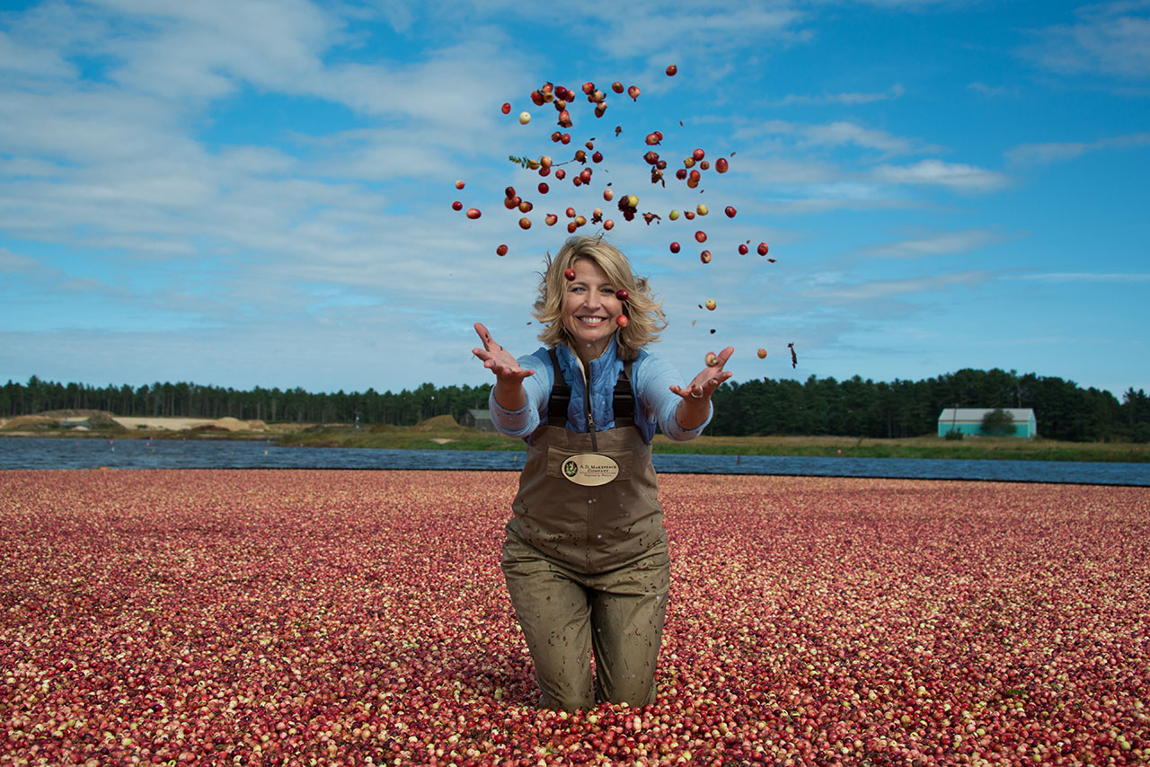
Caption: Samantha Brown explores cranberry bog in Wareham, Massachusetts.
Credit: PBS/BBC

Each night, special contributors will join co-hosts Samantha Brown and Chris Packham alongside a campfire on Squam Lake in New Hampshire, while Bob Poole will brave the darkness using the very latest technologies to witness the nightly routines of owls, bats, bobcats, porcupines and black bears.

In addition to investigating the wild side of fall, the co-hosts and contributors will dive into the rich cultural traditions and celebrations that make it such a fascinating time of year, including a visit to a pumpkin festival in New Hampshire and the Fryeburg Fair in Maine – one of the oldest and largest seasonal fairs, held every year since 1851.

Special contributors include:

Vivian Howard, Author, Chef and Host of PBS’ Award-Winning A CHEF’S LIFE – A chef who values local ingredients and embraces the farm-to-table experience, Vivian joins the hosts to explore the region’s prized foods: pumpkins and maple syrup. She’ll give audiences a peek into the history, process and culture that sustains many beloved fall traditions.

Loren M. Spears, Author, Tribal Councilwoman of Narragansett Tribe and Executive Director of the Tomaquag Museum in Rhode Island – Native Americans share unique connections to local land and wildlife. Loren will help audiences understand these connections and explore the history of Native American tribes in this region.

Abby van den Berg, Ph. D., Plant Physiologist and Assistant Professor at University of Vermont – Abby van den Berg is studying the unique ecosystems throughout the region and will help audiences understand why fall in New England is so unique.

Dr. Greg Skomal, Marine Biologist – Joining the hosts from the shores of Maine, Greg studies great white sharks and their special migratory patterns across New England shores. He is currently the North Atlantic’s go-to guy for understanding the largest predatory and often misunderstood fish.

Pete Perkins, Moose Biologist – Bob Poole will join Pete at New Hampshire’s Jericho State Park and in Greeneville, Maine for moose excursions and to learn more about the animal’s population in New England.

Kim Smith, Photographer and Filmmaker – There's nobody more passionate about monarch butterflies than Kim Smith, who films them on their migration through New England every fall. But the story surrounding this beautiful insect on its epic journey is complicated, and Kim will share more about how this population is faring.

Please visit PBS PressRoom for episode descriptions, a full list of contributors, and host and contributor bios and headshots.

AUTUMNWATCH – NEW ENGLAND, a co-production with BBC Studios Natural History Unit and PBS, will be Executive Produced by Rosemary Edwards and Series Produced by Chris Howard. Tom McDonald, BBC Head of Commissioning and Bill Margol, Senior Director of Programming and Development at PBS oversee the project.

About Samantha Brown
Samantha Brown spent her formative years in New Hampshire and has a deep connection to the region, which she will be bringing to her role as co-host for AUTUMNWATCH – NEW ENGLAND. Previously, she’s hosted PBS’ SAMANTHA BROWN’S PLACES TO LOVE and has nearly 20 years experience as a television travel host and storyteller.

About Chris Packham
Chris Packham has been presenting BBC’s “Autumnwatch” programs since 2008 and is the series’ longest serving host. He brings a mix of wildlife knowledge and a deep love of all things cultural to the show, and is looking forward to learning about fall in America and the myriad ways it is celebrated.

About Bob Poole
Emmy award-winning filmmaker Bob Poole has worked on productions all over the globe for both PBS and the BBC, and will bring New England’s wildlife into focus for the series.

About PBS
PBS, with nearly 350 member stations, offers all Americans the opportunity to explore new ideas and new worlds through television and digital content. Each month, PBS reaches over 90 million people through television and 30 million people online, inviting them to experience the worlds of science, history, nature and public affairs; to hear diverse viewpoints; and to take front row seats to world-class drama and performances. PBS’ broad array of programs has been consistently honored by the industry’s most coveted award competitions. Teachers of children from pre-K through 12th grade turn to PBS for digital content and services that help bring classroom lessons to life. Decades of research confirms that PBS’ premier children’s media service, PBS KIDS, helps children build critical literacy, math and social-emotional skills, enabling them to find success in school and life. Delivered through member stations, PBS KIDS offers high-quality educational content on TV – including a 24/7 channel, online at pbskids.org, via an array of mobile apps and in communities across America. More information about PBS is available at www.pbs.org, one of the leading dot-org websites on the internet, or by following PBS on Twitter, Facebook or through our apps for mobile and connected devices. Specific program information and updates for press are available at pbs.org/pressroom or by following PBS Pressroom on Twitter.

– PBS –

CONTACTS:
Chris Roslan, Roslan & Campion PR, 212-966-4600, chris@rc-pr.com
Michaé Godwin, PBS, 703-739-8483, mmgodwin@pbs.org
Stephanie Kennard, PBS, 703-739-5454, skkennard@pbs.org

For images and additional up-to-date information on this and other PBS programs, visit PBS PressRoom at pbs.org/pressroom.

