CHRIS PACKHAM – BIOGRAPHY 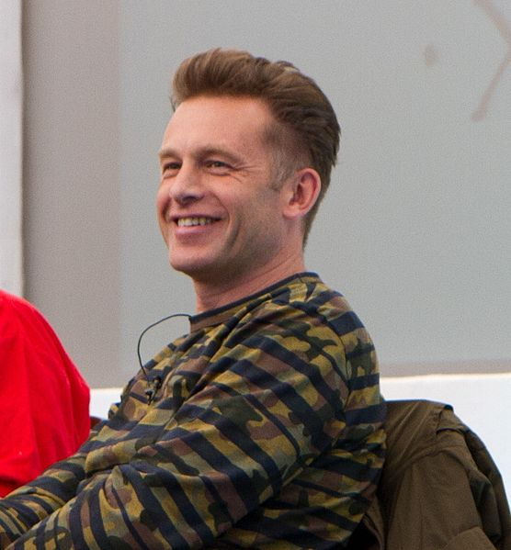

Chris Packham has gained recognition as a naturalist, television presenter, writer, photographer, conservationist, campaigner and filmmaker.

Chris was born in Southampton in 1961 and as soon as he was crawling around suburbia ladybirds were being desiccated in matchboxes and tadpoles tortured in jam jars. Husbandry skills improved and the menagerie expanded to large collections of reptiles (inside) and birds of prey, foxes, badgers, squirrels etc (generally outside). A precocious young scientist and nerd in training he studied kestrels, shrews and badgers in his teens and undergraduate days at the Zoology department of Southampton University. He also embraced Punk Rock and played in a band and the DIY ethos and determination to never take ‘no’ for an answer are forcefully retained.

Postgraduation and a cancelled PhD, (the Badgers were getting a bit much), Chris began taking still photographs and trained as a wildlife film cameraman. The photography continues with exhibitions and invitations to judge prestigious competitions but the camerawork gave way to presenting. He’s presented many popular natural history programmes since the beginning of his career in 1986 when he was a presenter on the children’s BBC series The Really Wild Show. He recently explained what it was like to live with Aspergers in the documentary Aspergers and Me. Chris has also presented the long running wildlife series on BBC2, Springwatch since 2009.
Other credits include Wildshots, Wild watch, Go Wild, basically lots of things with ‘wild’ in the title. X-Creatures, Postcards from the Wild, Hands on Nature, Nature’s Calendar, Nature of Britain, Nature’s Weirdest Events, World’s Weirdest Events, World’s Sneakiest Animals, Cats V Dogs, The Burrowers, Inside the Animal Mind, Operation Iceberg and Secrets of our Living Planet. He was featured on The Tonight Show starring Jimmy Fallon (NBC – US) where he introduced Jimmy to a porcupine and baby spotted hyena, and sent a vulture flying to him as he stood in the audience.

In May 2016 Chris’s autobiography, ’Fingers in the Sparkle Jar: A Memoir’, was released to critical acclaim, reaching number 1 in The Sunday Times Bestsellers in just 2 weeks. It was featured as a Radio 4 ‘Book of the Week, read by Chris. Critics stated that it was ‘Astonishing… brilliantly written’, ‘… a flickering vat of life itself. A brilliant and remarkable book’ ‘… bold and beautiful, both raw and lyrical, and a rather special book’.

In 2010 Chris was awarded the Dilys Breese BTO Medal for ‘his outstanding work in promoting science to new audiences’. He was voted ‘Conservation Hero of the Year’ (2014) in the Birders’ Choice Awards (Birdwatch magazine). In 2015 he reached second place in a line-up of Britain’s 50 most influential conservation heroes in The Wildlife Power List featured in the BBC Wildlife Magazine. In October 2016 Chris earned the top honour at the Wildscreen Panda Awards - The Christopher Parsons Award for Outstanding Achievement - in recognition of his significant contribution to wildlife filmmaking, conservation and the public’s understanding of the environment. In a theatre packed with natural history filmmaking’s most respected and accomplished leaders, he received a standing ovation as the award was presented by Sir David Attenborough.

Chris has had the good fortune to travel widely and he has explored many habitats from Antarctic Islands, rainforests, deserts, the Everest range, the deep oceans and some of the planets most notorious nightclubs and drinking dens. He is a sucker for Archaeology and likes to holiday amongst ruins.

He has a couple of old cars which don’t get much exercise, a beloved dog who can’t get enough exercise, has no fondness for unnecessary exercise himself but reads and writes continuously. He dabbles in the art market and wishes he had a Miro. His top-ten favourite birds has a hundred in the list, he wants to see a Philippines Eagle before he dies and thinks Audrey Hepburn has no known earthly equal. He cannot sing and cannot dance.

Outside of his BBC work, Chris has the honour of being a pro-active president, vice president and patron of some notable conservation charities and regularly expounds his entertaining, pragmatic and enthusiastic, occasionally controversial view, on the environment and its care.

