PBS and BBC Announce AUTUMNWATCH - NEW ENGLAND
Wednesday-Friday, October 17-19, 2018 on PBS

- Travel journalist Samantha Brown, wildlife cinematographer Bob Poole and BBC presenter Chris Packham host the live nature show celebrating fall in New England –

ARLINGTON, VA; August 28, 2018 – PBS announced today, as part of its co-production partnership with the BBC, that a new three-part live event, AUTUMNWATCH – NEW ENGLAND, will air Wednesday-Friday, October 17-19, 2018, at 8:00-9:00 p.m. ET.
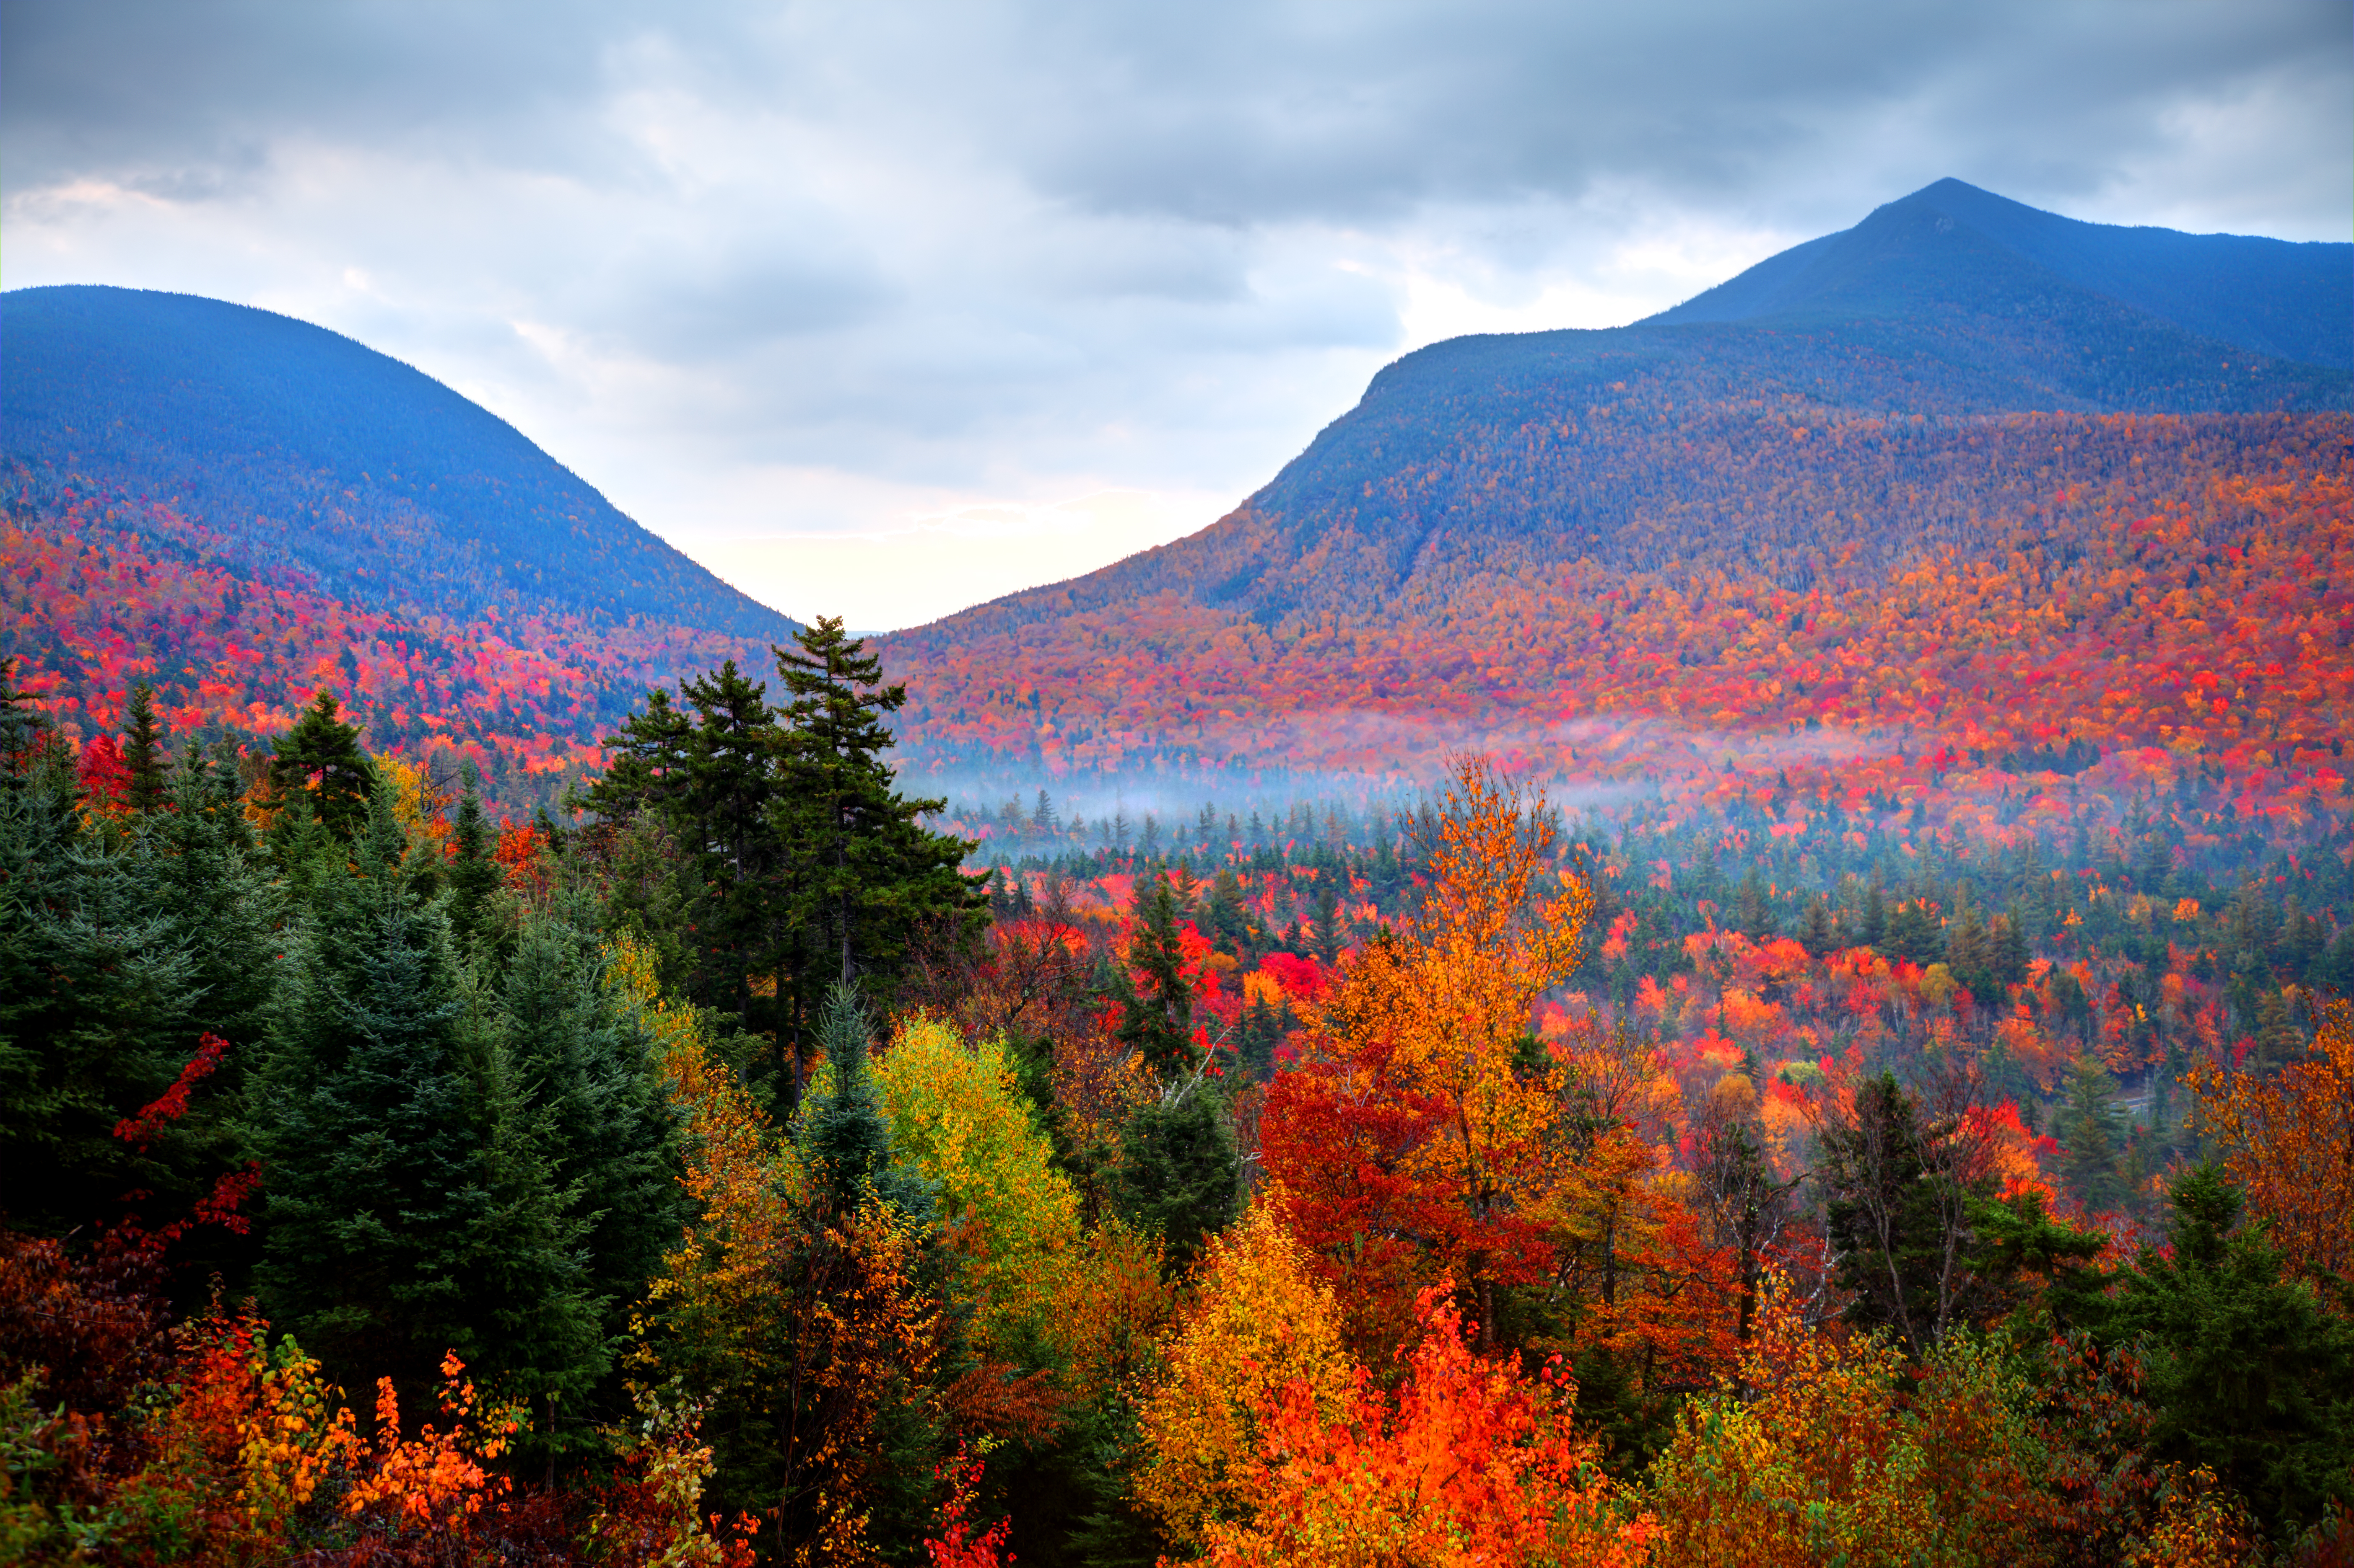
Caption: Autumn foliage in the White Mountains National Forest in New Hampshire. Photo taken during the peak fall foliage season producing vivid brilliant colors. New Hampshire is one of New England’s most popular fall foliage destinations bringing out some of the best foliage in the United States.
Credit: DenisTangneyJr.

Travel journalist Samantha Brown, BBC presenter Chris Packham and wildlife cinematographer Bob Poole will host the multi-platform television experience from alongside Squam Lake, New Hampshire. Similar in format to PBS’ previous summer spectacles BIG BLUE LIVE and WILD ALASKA LIVE, the new series will include a mix of live feeds and pre-taped footage from across New England.

Unique to AUTUMNWATCH – NEW ENGLAND, the live event will focus on cultural traditions and historical sites in addition to local wildlife and the colorful gold and red landscapes in the region that’s best known for them.

To accomplish this, local experts in food, wildlife, music, literature and history will join the trio of hosts each night to showcase characteristics special to New England.

“In AUTUMNWATCH – NEW ENGLAND, audiences will experience exquisite outdoor adventures while surrounded by nature’s most picturesque imagery,” said Bill Gardner, Vice President, Programming & Development, PBS. “We look forward to partnering with the BBC once again to present this ambitious live production and share this American experience with PBS and BBC viewers.”

AUTUMNWATCH – NEW ENGLAND cameras will be there to capture time-lapse changes of fall foliage; a quest for majestic moose in Maine; key wildlife species like squirrels, chipmunks and turkey gangs as they invade backyards in preparation for the winter months; and the critters like owls, bats and bears that make the most of nighttime.

Audiences can expect to see segments that highlight Native American history and traditions, Halloween traditions, regional fairs and the many farms that provide the region with its rich varieties of apples, pumpkins, cranberries and maple syrups.

“I'm thrilled that AUTUMNWATCH is moving to New England for this very special week of live programming,” Tom McDonald, BBC Head of Commissioning, Natural History and Specialist Factual, said. “The teams are heading to one of the most iconic locations in the USA to experience the great American 'fall' for what promises to be an unforgettable chapter in the Watches' history.”

AUTUMNWATCH – NEW ENGLAND, a co-production with BBC Studios Natural History Unit and PBS, will be Executive Produced by Rosemary Edwards and Series Produced by Chris Howard. Tom McDonald, BBC Head of Commissioning and Bill Margol, Senior Director of Programming and Development at PBS will oversee the project.

About PBS
PBS, with nearly 350 member stations, offers all Americans the opportunity to explore new ideas and new worlds through television and digital content. Each month, PBS reaches over 90 million people through television and 30 million people online, inviting them to experience the worlds of science, history, nature and public affairs; to hear diverse viewpoints; and to take front row seats to world-class drama and performances. PBS’ broad array of programs has been consistently honored by the industry’s most coveted award competitions. Teachers of children from pre-K through 12th grade turn to PBS for digital content and services that help bring classroom lessons to life. Decades of research confirms that PBS’ premier children’s media service, PBS KIDS, helps children build critical literacy, math and social-emotional skills, enabling them to find success in school and life. Delivered through member stations, PBS KIDS offers high-quality educational content on TV – including a 24/7 channel, online at pbskids.org, via an array of mobile apps and in communities across America. More information about PBS is available at www.pbs.org, one of the leading dot-org websites on the internet, or by following PBS on Twitter, Facebook or through our apps for mobile and connected devices. Specific program information and updates for press are available at pbs.org/pressroom or by following PBS Pressroom on Twitter.

– PBS –

CONTACTS:
Chris Roslan, Roslan & Campion PR, 212-966-4600, chris@rc-pr.com
Carrie Johnson, PBS, 703-739-5129, cjohnson@pbs.org
Michaé Godwin, PBS, 703-739-8483, mmgodwin@pbs.org

For images and additional up-to-date information on this and other PBS programs, visit PBS PressRoom at pbs.org/pressroom.

