American Experience Summer of Love
Encore Broadcast Tuesday, July 25, 2017
8:00-9:00 p.m. ET on PBS

Fifty Years Later, Revisit the Summer of 1967 When Thousands of
Young People Flocked to San Francisco’s Haight Ashbury
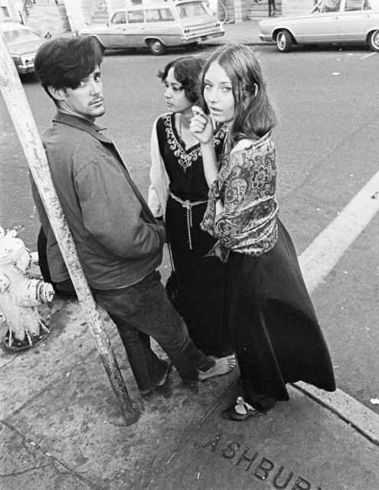
Credit: ©Herb Greene

(BOSTON, MA) — In celebration of its 50th anniversary, American Experience presents an encore broadcast of Summer of Love, a striking look at the social and cultural forces that sparked the largest migration of young people in America’s history. From its utopian beginnings, when peace and love prevailed, to the chaos, unsanitary conditions and widespread drug use that ultimately signaled the end, Academy Award-nominated filmmakers Gail Dolgin and Vicente Franco (Daughter from Danang) revisit a fleeting moment in time which still resonates to this day. Written, produced and directed by Gail Dolgin and Vicente Franco and executive produced by Mark Samels, Summer of Love, originally broadcast in 2007, will have an encore broadcast on American Experience Tuesday, July 25, 2017, 8:00-9:00 p.m. ET (check local listings) on PBS.

“Many of these idealistic youth were products of the 1950s with its confusing mix of post-war affluence and the threat of nuclear annihilation,” said Dolgin. “San Francisco, in 1967, seemed like mecca, the center of a visionary new society — one that rejected war, hatred, conformity and money. The Haight Ashbury, for a brief period, was the playing field for a new way of life.”

In January 1967, the thousands of youth already in San Francisco descended on Golden Gate Park for a Human Be-In. The media flocked to the event, putting hippies in the national spotlight for the first time. And once the press offered a window into the world of Haight Ashbury, even more young people flooded in. The new arrivals were looking to “turn on, tune in, and drop out,” the popular refrain that offered people a mind-blowing new experience courtesy of LSD. “We really thought that drugs were going to change the world,” recalls Mary Kasper, who was in the Haight from the start of the movement. “We thought if you turned on, if you took acid, you would really change, because we had changed from those experiences of cosmic oneness.”

San Francisco was fast becoming an outdoor society where free music was as readily available as free love. The Grateful Dead became the poster children for a generation, offering free concerts to anyone who wanted to listen. But along with free music, free love and “cosmic oneness,” the onslaught of people also brought a lack of housing, shortage of food, rampant drug problems and sexually transmitted diseases. Free clinics and soup kitchens tried to keep up with the massive population, estimated to be from fifty thousand to one hundred thousand at its peak.

The Haight soon became a caricature of its idealistic beginnings, as sightseeing buses crawled through the area and shops and restaurants sprung up catering to souvenir hungry tourists and “weekend hippies.” College students with no intention of “dropping out” took on hippie personas for the summer. Hundreds of young runaways wandered the streets aimlessly. For many, the center of the counterculture no longer seemed a shimmering wonderland. By fall, the numbers began to drop as precipitously as they had grown.

The Summer of Love was a fleeting moment in the turbulent history of the 1960s. But its underlying message left an indelible impression on those who witnessed it. “So many of those things from that time have stayed with me, certainly the importance of community,” said Kasper. “I thought we could change the world, and I thought we could make it a better place. And I think in some ways we succeeded.”

“1967 represents a touchstone and a turning point for so many people,” said American Experience executive producer Mark Samels. “The Summer of Love was the moment when hippies — and all the beliefs they represented — took center stage and became a cultural phenomenon.”

A Franco Dolgin Productions Film for American Experience in association with KQED

Written, Produced and Directed by | Gail Dolgin and Vicente Franco
Edited by | David Espar
Assistant Editor | Lawrence Lerew
Associate Producer | Lynn Adler
Cinematography  Music by  Narrated by | Vicente Franco  Gary Lionelli  David Ogden Stiers

For KQED

Executive in Charge | Michael J. Isip
Executive Manager | Sue Ellen McCann
Coordinating Producer | Rachel Raney

American Experience is a production of WGBH Boston

Senior Producer | Susan Bellows
Executive Producer | Mark Samels

Mark Samels (Executive Producer)
As executive producer of PBS’ flagship history series, Mark Samels conceives, commissions and oversees all American Experience films. Samels has overseen more than 130 films, expanding both the breadth of subjects and the filmmaking style embraced by the series, allowing for more contemporary topics and more witness-driven storytelling. Beginning his career as an independent documentary filmmaker, he held production executive positions at public television stations in West Virginia and Pennsylvania before joining WGBH. Samels is a founding member of the International Documentary Association and has served as a governor of the Academy of Television Arts & Sciences. A graduate of the University of Wisconsin, Samels holds honorary Doctor of Humane Letters degrees from Emerson College and Elizabethtown College.

About American Experience
For more than 28 years, American Experience has been television’s most-watched history series. The series has been hailed as “peerless” (The Wall Street Journal), “the most consistently enriching program on television” (Chicago Tribune) and “a beacon of intelligence and purpose” (Houston Chronicle). On air and online, the series brings to life the incredible characters and epic stories that have shaped America’s past and present. Acclaimed by viewers and critics alike, American Experience documentaries have been honored with every major broadcast award, including 30 Emmy Awards, four duPont-Columbia Awards and 17 George Foster Peabody Awards; the series received an Academy Award® nomination for Best Documentary Feature in 2015 for Last Days in Vietnam. Visit pbs.org/americanexperience and follow us on Facebook, Twitter, Instagram and YouTube to learn more.

Exclusive corporate funding for American Experience provided by Liberty Mutual Insurance. Major funding provided by the Alfred P. Sloan Foundation, the Corporation for Public Broadcasting and public television viewers. American Experience is produced for PBS by WGBH Boston.

###
Press Contacts:
CaraMar, Inc.
Mary Lugo 770-623-8190 lugo@negia.net
Cara White 843-881-1480 cara.white@mac.com
Abbe Harris 908-244-5516 abbe.harris@caramar.net

For further information and photos visit http://www.pbs.org/pressroom.

