American Experience Presents 1964
An Examination of the Year that Transformed America

Premieres Tuesday, January 14, 2014

8:00-10:00 p.m. ET on PBS

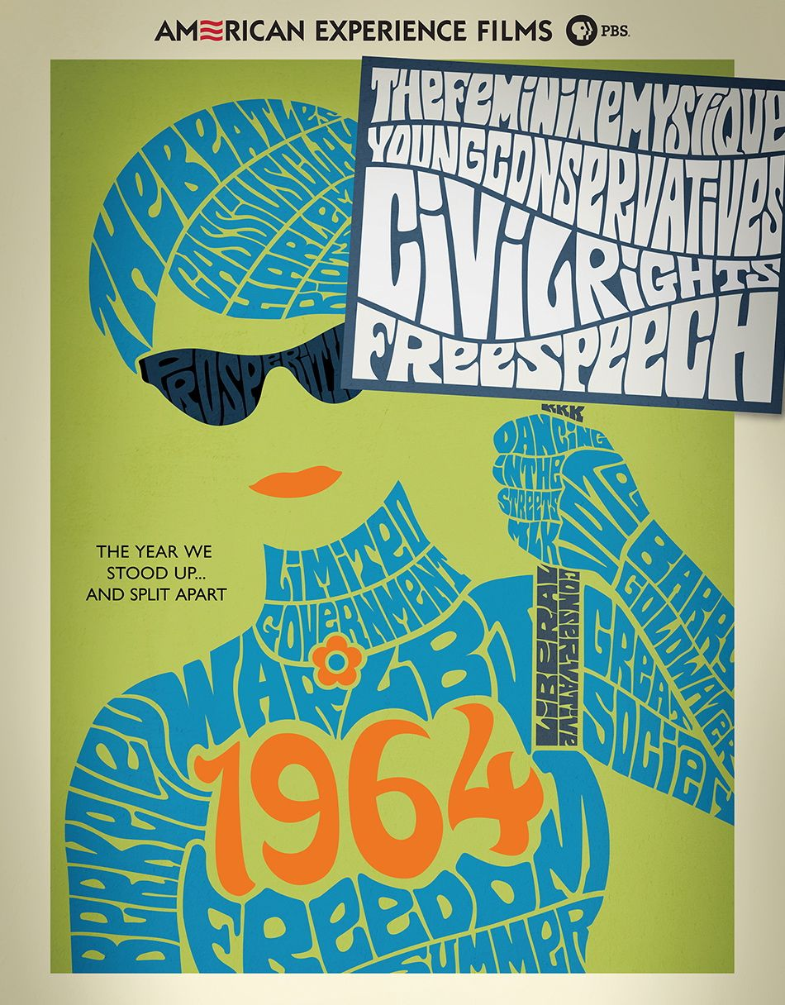
1964 was the year the Beatles came to America, Cassius Clay became Muhammad Ali, and three civil rights workers were murdered in Mississippi. It was the year when Berkeley students rose up in protest, African Americans fought back against injustice in Harlem, and Barry Goldwater’s conservative revolution took over the Republican Party. In myriad ways, 1964 was the year when Americans faced choices: between the liberalism of Lyndon Johnson or Barry Goldwater’s grassroots conservatism, between support or opposition to the civil rights movement, between an embrace of the emerging counterculture or a defense of traditional values. Based in part on The Last Innocent Year: America in 1964 by Jon Margolis, 1964 follows some of the most influential figures of the time — Lyndon Johnson, Barry Goldwater, Betty Friedan — but also brings out from the shadows the stories of ordinary Americans whose principled stands would set the country onto a new and different course. “1964 was when, for better or worse, the outlines of the America we live in began to be visible,” says Writer/Director Stephen Ives. 1964 premieres on American Experience on Tuesday, January 14, 2014, 8:00-10:00 p.m. ET on PBS (check local listings).

As champagne popped on December 31, 1963, America’s optimism was tinged with a deep anxiety. Just five weeks earlier, President Kennedy had been assassinated, leaving Americans shaken and vulnerable. Eight days into the new year, the new President, Lyndon Johnson, gave his first State of the Union address, demanding an end to racial injustice and an “unconditional war on poverty in America.” Only a few days earlier, Arizona Senator Barry Goldwater had announced his intention to seek the Republican nomination for president, igniting a conservative movement that would reshape the politics of 1964 and transform the American political landscape for generations to come.

Everywhere one looked in 1964, old conventions and attitudes were under assault. The arrival of the Beatles electrified teenagers across the country. One day after shocking the sports world by defeating Sonny Liston and becoming the heavyweight champion of the world, the young Cassius Clay announced he had become a Muslim, declaring, “I don't have to be what you want me to be. I am free to be who I want.” It was a mantra that seemed to be rippling throughout American society in 1964. Housewives across America were finding a new voice as well. Awakened by Betty Friedan’s bestseller The Feminine Mystique, millions of mostly middle-class women began to reject their conventional roles in society and embrace new identities and new values, sparking a feminist movement that would transform American culture.

In the spring, visitors flocked to the New York World’s Fair where the stylish Ford Mustang made its debut. On the political front, seismic change could also be felt. At his commencement address at the University of Michigan, President Johnson called upon the graduates to help him build a “Great Society,” and used his legendary powers of persuasion to engineer the passage of the landmark Civil Rights Act of 1964. But even with such a historic federal commitment to advance the cause of equality, racial unrest, in both the rural South and the cities of the North, would continue to fester.

During the summer of 1964, Martha Reeves’s “Dancing in the Street,” became an unexpected anthem for a nation in the midst of radical social change. In June, nearly 300 students and veteran civil rights activists joined together to launch Freedom Summer, a nonviolent campaign to challenge Mississippi’s voter registration laws. On June 21, three of the young activists — two whites from the North and a local black volunteer — went missing. While the search for the men continued, the killing of a black youth by a white police officer in Harlem triggered an explosion of violence and looting that shocked the nation. For the first time, the racial violence that had defined the civil rights struggle in the South was now consuming a northern city.

On August 4, 1964, the bodies of the three Freedom Summer volunteers were finally found. As classes began on the campus of Berkeley, hundreds of young people, including many Freedom Summer veterans, began to demonstrate for racial justice in the Bay Area. When the university administration tried to crack down on the students, the Free Speech Movement was born. The Berkeley protests were a spontaneous expression by a generation of affluent young men and women who, for the first time, began to flex their political muscle and demand a seat at the table. Their nonviolent, highly organized, grassroots style of protest would become the model for student protest and student activism that would reverberate throughout the decade.

That November, Johnson was elected president by a landslide. But his fight for civil rights in the South transformed the previously Democratic region into a formidable block for the emerging Republican right. In the years to follow, Johnson’s dream of a Great Society would be shattered by the long and divisive war in Vietnam. Out of the ashes of Goldwater’s defeat, young Republicans regrouped and finally made good on their conservative revolution. Young people increasingly embraced the growing counterculture and women, awakened by the ideas set forth in The Feminine Mystique, would go on to champion a revolution that forever changed the nature of American society.

“In 1964, we see everything being called into question, from our relationship with our government and the military to our notions of free speech and individual freedom,” says American Experience Executive Producer Mark Samels. “We see the schisms widen between young and old and liberal and conservative. 1964 was the year that America came apart, and out of that discord was born the America we have become.”

1964 will be available on DVD on January 15, 2014, as well as for online viewing at pbs.org.

* * *

About the Participants, in Order of Appearance

Robert A. Caro is a two-time Pulitzer Prize-winner and author of the multi-volume biography series The Years of Lyndon Johnson.

Dan T. Carter is a historian of the American South and Professor of History Emeritus at University of South Carolina; his research focuses on conservatism in the South in the 20th century.

Robert Dallek is a historian and presidential scholar. His books include Lone Star Rising: Lyndon Johnson and His Times, and Flawed Giant: Lyndon Johnson and His Times.

Jann S. Wenner founded Rolling Stone in 1967 and participated in the Free Speech Movement.

Mark Kurlansky is a journalist and author of Ready for a Brand New Beat: How "Dancing in the Street" Became the Anthem for a Changing America.

Robert Lipsyte is a sportswriter, novelist and memoirist. In 1964, he covered the meeting between Ali and The Beatles, and the Ali/Liston fight for The New York Times.

Marilyn B. Young is a professor of history with a focus on American foreign policy at NYU. She is the author of The Vietnam Wars.

Dave Dennis participated in Freedom Summer and delivered an impassioned eulogy at James Chaney's funeral.

Lee Edwards served as Director of Information on Barry Goldwater’s 1964 presidential campaign, and has written a biography of Goldwater.

Richard A. Viguerie was a leader of Young Americans for Freedom and transformed American politics in the 1960s and 70s by pioneering the use of direct mail fundraising to help build the conservative movement.

Leah Wright Rigueur is assistant professor of history and African American Studies at Wesleyan University; her research focuses on African Americans in the conservative movement.

Robert Cohen is a professor of social studies education at NYU. He is the author of a biography of Mario Savio, titled Freedom's Orator, and the editor and a contributor to the volume The Free Speech Movement: Reflections on Berkeley in the 1960s.

Hodding Carter, III is a journalist and politician who served as the Assistant Secretary for Public Affairs in the Carter administration.

Reverend Ed King was one of the four Mississippi Freedom Democratic Party delegates who attended the Democratic National Convention in Atlantic City.

Stephanie Coontz teaches history and family studies at The Evergreen State College, and is the author of A Strange Stirring: The Feminine Mystique and American Women at the Dawn of the 1960s. Coontz graduated from Berkeley in 1966 and participated in the Free Speech Movement.

Rick Perlstein is a historian, journalist and author of Before the Storm: Barry Goldwater and the Unmaking of the American Consensus and Nixonland: The Rise of a President and the Fracturing of America.

John H. Bracey, Jr., who teaches in the W.E.B. Du Bois Department of Afro-American Studies at the University of Massachusetts, was a member of Chicago Friends of SNCC in 1964.

Jon Margolis is a journalist-turned-author who wrote The Last Innocent Year: America in 1964.

Phyllis Schlafly has been a national leader of the conservative movement since the publication of her bestselling 1964 book, A Choice Not an Echo.

Susan J. Douglas is a prize-winning author, columnist, and cultural critic, and the Catherine Neafie Kellogg Professor of Communication Studies at The University of Michigan.

Todd Gitlin was the president of SDS in 1963-1964. He is the author of 15 books, including The Sixties.

Claire Bond Potter is a scholar of recent American history at The New School for Public Engagement, with a particular interest in Betty Friedan.

Civil rights leader Bob Moses was one of the chief organizers of Freedom Summer.

Rita Schwerner was a civil rights worker whose husband, Michael Schwerner, was killed in Mississippi in 1964. She played a large role during Freedom Summer.

Max Frankel worked at The New York Times for almost fifty years, retiring in 2000. In 1964, he was a diplomatic correspondent at the Times and covered the U.S. involvement in Vietnam.

About the Filmmakers

Written and Directed By |  | Stephen Ives
Produced By |  | Amanda Pollak
Edited By |  | George O’Donnell  Amy Foote
Cinematography By  Original Music By  Narrated By |  | Andrew Young  Peter Rundquist  Oliver Platt

Stephen Ives (Writer/Director)
In his twenty years of work in public television, Stephen Ives has established himself as one of the nation’s leading independent documentary directors. His landmark series The West was one of the most-watched PBS programs of all time. In 1987, Ives began a decade-long collaboration with filmmaker Ken Burns, as a co-producer of a history of the United States Congress, and as a consulting producer on the groundbreaking series The Civil War and Baseball.

After the premiere of The West, Ives turned his attention towards contemporary films, producing a profile of the Cornerstone Theater Company which aired on HBO in the fall of 1999, and Amato: A Love Affair with Opera, which aired on PBS in 2001 and earned Ives a nomination from the Directors Guild of America for Outstanding Directorial Achievement. His profile of 1930s thoroughbred Seabiscuit, which aired on American Experience in 2003, won a Primetime Emmy award, and his PBS series Reporting America at War, about American war correspondents, was described by Los Angeles Times as “television that matters…a visual document of power and clarity.” His other films for American Experience include Lindbergh, Las Vegas, New Orleans, Kit Carson, Roads to Memphis, Panama Canal, Custer’s Last Stand and Grand Coulee Dam.

Mark Samels (Executive Producer) was named executive producer of American Experience, PBS’s flagship history series, in 2003. Under Samels’ leadership, the series has been honored with nearly every industry award, including the Peabody, Primetime Emmys, the duPont-Columbia Journalism Award, Writers Guild Awards, Oscar nominations, and Sundance Film Festival Audience and Grand Jury Awards. Samels also serves on the Board of Governors at the Academy of Television Arts and Sciences. Prior to joining WGBH, Samels worked as an independent documentary filmmaker, an executive producer for several U.S. public television stations, and as a producer for the first co-production between Japanese and American television. A native of Wisconsin, he is a graduate of the University of Wisconsin-Madison.

About American Experience
Television’s most-watched history series, American Experience celebrates its 25th anniversary in 2013. The series has been hailed as “peerless” (The Wall Street Journal), “the most consistently enriching program on television” (Chicago Tribune), and “a beacon of intelligence and purpose” (Houston Chronicle). On air and online, the series brings to life the incredible characters and epic stories that have shaped America’s past and present. Acclaimed by viewers and critics alike, American Experience documentaries have been honored with every major broadcast award, including 30 Emmy Awards, four duPont-Columbia Awards, and 16 George Foster Peabody Awards, one most recently for the series represented by Freedom Riders, Triangle Fire and Stonewall Uprising.

Exclusive corporate funding for American Experience is provided by Liberty Mutual Insurance. Major funding provided by the Alfred P. Sloan Foundation, the Corporation for Public Broadcasting and Public Television Viewers. American Experience is produced for PBS by WGBH Boston.

* * *
Publicity Contacts
CaraMar Publicity
Mary Lugo 770-623-8190 lugo@negia.net
Cara White 843-881-1480 cara.white@mac.com
Abbe Harris 908-233-7990 abbe@caramar.net

For further information and photos visit http://www.pbs.org/pressroom

