American Experience The Assassination of Abraham Lincoln
Encore Broadcast on Tuesday, January 17, 2017
8:00-9:00 p.m. ET on PBS

(BOSTON, MA) — On April 14, 1865, Abraham Lincoln was assassinated at Ford’s Theatre in Washington, D.C. Over the next twelve days, as a fractured nation mourned, the largest manhunt ever attempted closed in on his assassin, the renowned 26-year-old actor John Wilkes Booth. The Assassination of Abraham Lincoln recounts this great American drama: two tumultuous months when the joy of peace was shattered by the heartache of Lincoln’s death. Featuring Will Patton (Numb3rs, A Mighty Heart) as the voice of the assassin and narrated by Academy Award-winning actor Chris Cooper (Seabiscuit, Adaptation), the film includes interviews with the nation’s foremost Lincoln scholars. The Assassination of Abraham Lincoln, written, produced and directed by Barak Goodman and executive produced by Mark Samels, will have an encore broadcast on Tuesday, January 17, 2017, 8:00-9:00 p.m. ET (check local listings) on PBS.
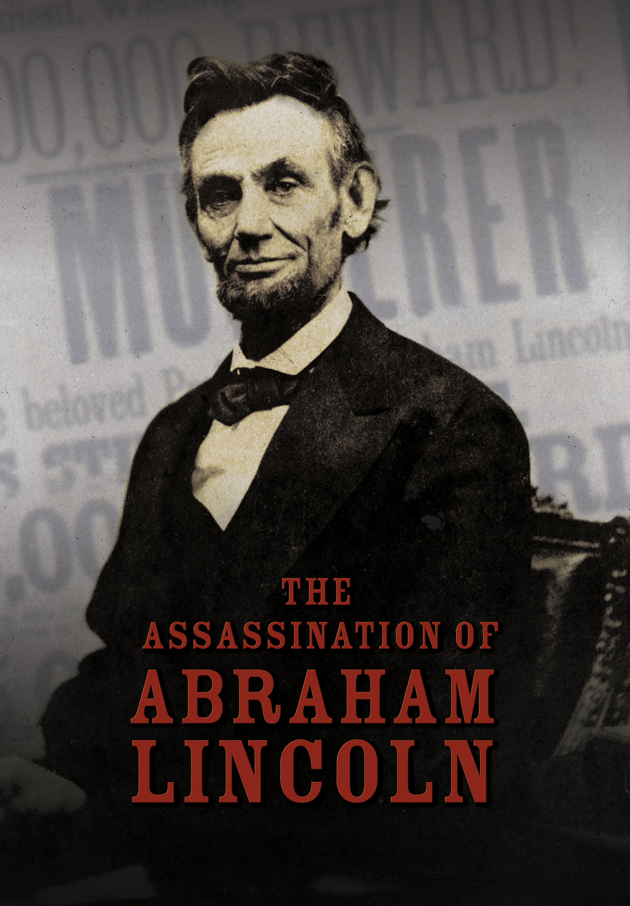
Credit: Courtesy of WGBH Educational Foundation.

“Abraham Lincoln came to power during an exceptionally turbulent time,” said American Experience Executive Producer Mark Samels. “America was, in essence, split in two, and this virtually unknown, untested leader was tasked with solving the worst crisis in our collective history.”

In November 1860, a little-known Republican Congressman from Illinois named Abraham Lincoln was elected President of the United States. A vocal opponent of slavery, Lincoln’s victory enraged millions of Southern sympathizers, including an acclaimed young actor named John Booth, who blamed abolitionists for the growing division of the country.

By 1862, the small skirmish that began the previous year had turned into a full-blown Civil War, a bloody stalemate with no end in sight. As casualties stumbled into Washington, Lincoln haunted the War Department, absorbing the loss of life all around him. Out of all the suffering, he resolved, must come what he would later call a “new birth of freedom.”

In January 1863, President Lincoln issued the Emancipation Proclamation, an order freeing the slaves within the Confederate states and transforming the meaning of the Civil War. By August 1864, a second presidential term seemed improbable, until the Union army broke through Confederate defenses in Atlanta.
It was a victory that allowed Lincoln to win a second term.

For Booth, the news of four more years of Lincoln as President was almost too much to bear. He wanted to contribute to the Southern cause, but not as a soldier in the Confederate Army. He looked for something grander — a single, heroic gesture that would turn the tide of history and catapult him into immortality. In 1864, he started taking assignments from the Confederate underground, a loose network of spies living north of the Mason Dixon Line. With a small band of co-conspirators, he began plotting to kidnap Abraham Lincoln and ransom him for thousands of imprisoned Confederate soldiers.

On April 3, 1865, the Confederate capital in Richmond, Virginia, fell to Union forces. Only six days later, General Robert E. Lee surrendered and the war was effectively over. Booth was overcome with disappointment and bitterness. He resolved to punish the North for what it had done to the South, and his desperation gave rise to a new scheme: to kill the tyrant responsible for the demise of his beloved Confederacy — President Abraham Lincoln.

When Booth arrived at Ford’s Theatre in Washington on the morning of April 14 to pick up his mail, he overheard someone announce that President Lincoln was to be in attendance for that evening’s show. For the next eight hours, the actor made frenzied preparations for what he hoped would be the greatest performance of his life. He quickly reassembled his co-conspirators, and filled them in on his plan to kill the three most powerful men in America: the president, the vice president and the secretary of state.

Later that evening, Booth arrived at Ford’s Theatre and lurked in waiting. As the play reached a climax and the lead actor delivered his biggest laugh line of the evening, a single shot rang out and hit the president in the back of the head. Before anyone could stop him, Booth jumped over the balcony, breaking his ankle, ran across the stage, and escaped into the darkness.

From the Peterson House, where Lincoln lay dying, Secretary of War Edwin Stanton took over control of the government. He interrogated witnesses, ordered bridges and roads closed, and put the Union cavalry on high alert. Outside, panic and disbelief traveled through the streets as word of Lincoln’s death spread. For twelve days, as the killer and one of his accomplices made their way south, Stanton organized a manhunt of unprecedented size and traced the fugitives through thick woods and swampland, and into Virginia’s Confederate stronghold.

Booth was convinced that if he could just make it to Virginia and the deep South beyond, he would be lauded as a hero and a savior. But lying in the woods reading newspaper accounts he was stunned: the entire country — North and South — had denounced him. His visions of triumph and grandeur were shattered.

On April 26, at three in the morning, a search party surrounded Booth and his accomplice David Herold at Garrett’s Farm, just south of Port Royal, Virginia, where they were hiding inside a tobacco barn. Herold surrendered, but Booth refused. After a tense standoff, Union soldiers set the barn ablaze, and a cavalryman fired at Booth, hitting him in the neck. Booth died three hours later.

While the hunt for Booth was ongoing, a funeral train carried the remains of Lincoln on a 1,700-mile journey from Washington to Springfield, Illinois. Along the way, some seven million people lined the tracks or filed past Lincoln’s open casket to pay their respects to their fallen leader.

“When people wept for Lincoln, or when they went to their diaries and they drew black around the pages of those days, they were really weeping for themselves,” said historian David W. Blight. “They were weeping for their own kids. They were weeping for their own losses in the War.”

“It was with the assassination that the myth of Abraham Lincoln was born,” added James L. Swanson, author of Manhunt: The 12-Day Chase for Lincoln’s Killer. “Lincoln was not universally liked or beloved during his presidency. Millions of people hated him. Once he was assassinated, everything changed.”

The Assassination of Abraham Lincoln is available on DVD from PBS Distribution and can be purchased at ShopPBS.org.

About the Filmmakers

An Ark Media Productions film for american experience

Written, Produced and Directed by | Barak Goodman
Edited by | Sari Gilman
Director of Photography | Stephen McCarthy
Music by | Joel Goodman
Narrated by | Chris Cooper

American Experience is a production of WGBH Boston

Senior Producer | Susan Bellows
Executive Producer | Mark Samels

Barak Goodman (Writer/Director/Producer) is co-founder of Ark Media and a principal producer, director and writer with the company. His films for Ark Media have been nominated for an Academy Award and won multiple Emmys, DuPont-Columbia and Peabody Awards, the RFK Journalism Prize, and three times been official selections at the Sundance Film Festival. He was the series director and producer of Cancer: The Emperor of all Maladies, based on the Pulitzer Prize-winning book by Siddhartha Mukherjee, and he directed, produced and wrote Makers, the first comprehensive history of the modern women’s movement. His work for American Experience includes the upcoming Oklahoma City (February 7), about the nation’s deadliest domestic terrorist attack, Ruby Ridge (February 14), about the 1992 FBI siege that helped launch the modern militia movement, Clinton, a four-hour biography of Bill Clinton, My Lai, the story of America's most notorious war crime, and Scottsboro, about the arrest and trials of eight African-American teenagers for rape in Depression-era Alabama.

Mark Samels (Executive Producer)
As executive producer of PBS’ flagship history series, Mark Samels conceives, commissions and oversees all American Experience films. Samels has overseen more than 130 films, expanding both the breadth of subjects and the filmmaking style embraced by the series, allowing for more contemporary topics and more witness-driven storytelling. Beginning his career as an independent documentary filmmaker, he held production executive positions at public television stations in West Virginia and Pennsylvania before joining WGBH. Samels is a founding member of the International Documentary Association and has served as a governor of the Academy of Television Arts & Sciences. A graduate of the University of Wisconsin, Samels holds honorary Doctor of Humane Letters degrees from Emerson College and Elizabethtown College.

About American Experience
For more than 28 years, American Experience has been television’s most-watched history series. The series has been hailed as “peerless” (The Wall Street Journal), “the most consistently enriching program on television” (Chicago Tribune) and “a beacon of intelligence and purpose” (Houston Chronicle). On air and online, the series brings to life the incredible characters and epic stories that have shaped America’s past and present. Acclaimed by viewers and critics alike, American Experience documentaries have been honored with every major broadcast award, including 30 Emmy Awards, four duPont-Columbia Awards and 17 George Foster Peabody Awards; the series received an Academy Award® nomination for Best Documentary Feature in 2015 for Last Days in Vietnam. Visit pbs.org/americanexperience and follow us on Facebook, Twitter, Instagram and YouTube to learn more.

Exclusive corporate funding for American Experience provided by Liberty Mutual Insurance. Major funding provided by the Alfred P. Sloan Foundation, the Corporation for Public Broadcasting and public television viewers. American Experience is produced for PBS by WGBH Boston.

###
Press Contacts:
CaraMar, Inc.
Mary Lugo 770-623-8190 lugo@negia.net
Cara White 843-881-1480 cara.white@mac.com
Abbe Harris 908-244-5516 abbe.harris@caramar.net

For further information and photos visit http://www.pbs.org/pressroom.

