American Experience Roads to Memphis Traces the Fateful Journeys of Dr. Martin Luther King, Jr. and James Earl Ray to
Their Deadly Collision in Memphis

Encore Broadcast on Tuesday, February 26, 2019 as Part of
Black History Month Programming

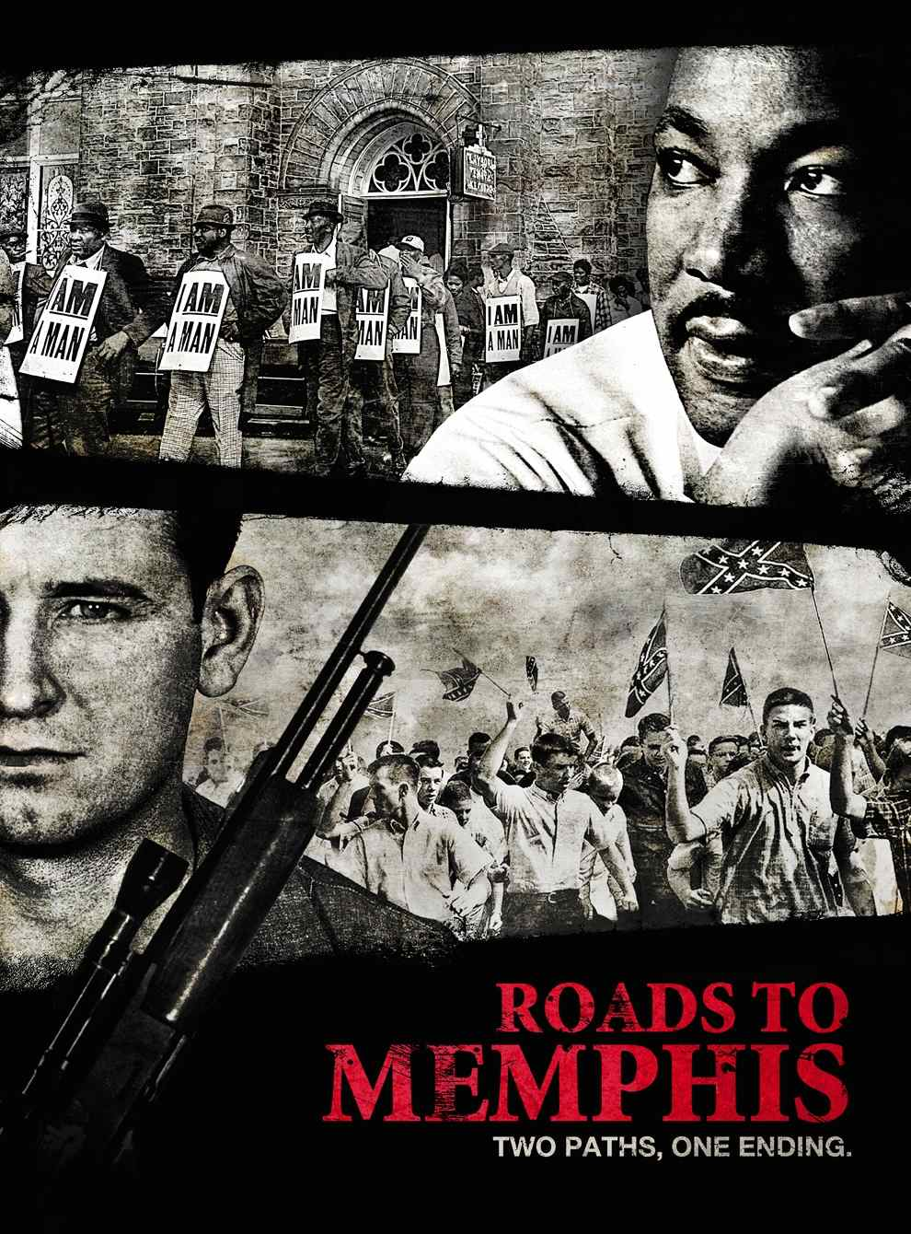
(BOSTON, MA) — A riveting crosscut narrative of a killer and his prey, Roads to Memphis is the fateful story of an assassin and his target set against the seething, turbulent forces in American society that drove two men to their violent and tragic collision on April 4, 1968. Following the inexorably converging paths of James Earl Ray and Dr. Martin Luther King, Jr.,
Roads to Memphis is both an incisive portrait of an America on edge in that crisis-laden year and a cautionary tale of how the course of history can be forever altered by the actions of one individual. Originally broadcast in 2010, the film will have an encore broadcast on American Experience Tuesday, February 26, 9:00-10:00 p.m. ET (check local listings) on PBS.

Roads to Memphis is told through eyewitness testimony from King’s inner circle and the officials involved in Ray’s capture and prosecution following an intense two-month international manhunt. The first film to explore the mind of the elusive assassin, Roads to Memphis is directed by Emmy Award-winning filmmaker Stephen Ives and produced by Amanda Pollak.

When James Earl Ray was arrested in July 1969, he was the most wanted suspect in the world. Who was this “four-time loser” who was able to assassinate Dr. King, the Nobel Prize-winning, charismatic leader of the civil rights movement? How did Ray manage to escape and elude authorities for months? What motivated him to kill? Roads to Memphis reveals a mysterious and misunderstood loner who remains an enigma even today.

About the Participants, in Order of Appearance

Dan Rather was a reporter for CBS when he reported on the King assassination.

John Campbell was a Shelby County Assistant District Attorney in Memphis.

Gerald Posner is the author of best-selling books including, Killing the Dream, about the King assassination.

Harris Wofford (1926-2019) is a former Democratic U.S. Senator from Pennsylvania who served as an attorney for the United States Commission on Civil Rights from 1954-1958 and was also chairman of the Subcabinet Group on Civil Rights.

Joe Sweat is a former reporter for the Memphis Commercial Appeal.

Rev. Samuel “Billy” Kyles (1934-2016) was a Memphis civil rights leader and preacher who worked with Dr. Martin Luther King, Jr. in supporting the sanitation workers strike and witnessed his assassination.

Roger Wilkins (1932-2017) was a civil rights leader who served as assistant attorney general in the Johnson administration.

Hampton Sides, a Memphis native, is the author of several books including Hellhound on His Trail: The Stalking of Martin Luther King, Jr. and the International Hunt for His Assassin.

Wayne Flynt is professor emeritus at Auburn University and the author of Dixie's Forgotten People: The South's Poor Whites.

Dorothy Cotton was the education director for the Southern Christian Leadership Conference for twelve years under the direct supervision of Dr. Martin Luther King, Jr.

Andrew Young was the Executive Director of the Southern Christian Leadership Conference (SCLC) and one of Dr. King's principal lieutenants in 1968. He was with King when he was assassinated.

Benjamin Hooks (1925-2010) was a Memphis-bred civil rights leader, Baptist minister and attorney and close friend of Dr. King.

Elmore Nickelberry and Leslie Moore were Memphis sanitation workers who marched with Dr. King.

Maxine Smith (1929-2013) led the Memphis chapter of the NAACP from 1962 until 1996.

B. Venson Hughes is a retired officer of the Memphis Police Department.

About the Filmmakers

Directed by Stephen Ives
Written by Michelle Ferrari
Produced by Amanda Pollak
Edited by George O’Donnell
Associate Producer Lindsey Megrue
Music by Peter Rundquist

American Experience
Executive Producer Mark Samels
Senior Producer Susan Bellows

An Insignia Films production for American Experience

Stephen Ives (Writer/Director) has established himself as one of the nation’s leading independent documentary directors in his more than 20 years of work in public television. His landmark series THE WEST was one of the most-watched PBS programs of all time. In 1987, Ives began a decade-long collaboration with filmmaker Ken Burns as a co-producer of a history of the United States Congress and as a consulting producer on the groundbreaking series THE CIVIL WAR and BASEBALL.
After the premiere of THE WEST, Ives turned his attention towards contemporary films, producing a profile of the Cornerstone Theater Company, which aired on HBO in the fall of 1999, and Amato: A Love Affair with Opera, which aired on PBS in 2001 and earned Ives a nomination from the Directors Guild of America for Outstanding Directorial Achievement. His profile of 1930s thoroughbred Seabiscuit (American Experience, 2003) won a Primetime Emmy Award, and his PBS series REPORTING AMERICA AT WAR, about American war correspondents, was described by the Los Angeles Times as “television that matters…a visual document of power and clarity.” His other films for American Experience include Lindbergh, Las Vegas, New Orleans, Kit Carson, Panama Canal, Custer’s Last Stand, Grand Coulee Dam, 1964, The Big Burn The Great War, and Sealab.
Amanda Pollak (Producer) has been making highly acclaimed documentaries for public television for more than two decades. As a partner at Insignia Films, she began her tenure by producing the series REPORTING AMERICA AT WAR, and then moved on to create several American Experience films including Las Vegas, New Orleans, Kit Carson, Roads to Memphis, Panama Canal, Custer’s Last Stand, Grand Coulee Dam, 1964, The Big Burn, Edison, Space Men and The Great War.
In addition to her work with Insignia Films for American Experience, Pollak directed the fourth episode of Henry Louis Gates’ PBS series FACES OF AMERICA, and produced CONSTITUTION USA with Peter Sagal, a four-part PBS series that premiered in 2013. More recently, she was part of the founding team for Retro Report, an online series featured on The New York Times website that combines documentary storytelling with shoe-leather reporting to peel back the layers of some of the most intriguing news stories of our past. Her work has been seen by a wide national audience, heralded by the media and recognized with three Emmy Awards, a Cine Golden Eagle Award, and the George Foster Peabody Award.
Mark Samels (Executive Producer) conceives, commissions and oversees all films for the PBS flagship history series American Experience. Samels has overseen more than 130 films, expanding both the breadth of subjects and the filmmaking style embraced by the series, allowing for more contemporary topics and witness-driven storytelling. Beginning his career as an independent documentary filmmaker, he held production executive positions at public television stations in West Virginia and Pennsylvania before joining WGBH. Samels is a founding member of the International Documentary Association and has served as a governor of the Academy of Television Arts & Sciences. A graduate of the University of Wisconsin, Samels holds honorary Doctor of Humane Letters degrees from Emerson College and Elizabethtown College.

About American Experience
For 30 years, American Experience has been television’s most-watched history series. Hailed as “peerless” (The Wall Street Journal), “the most consistently enriching program on television” (Chicago Tribune), and “a beacon of intelligence and purpose” (Houston Chronicle), the series brings to life the incredible characters and epic stories that have shaped America’s past and present. American Experience documentaries have been honored with every major broadcast award, including 30 Emmy Awards, four duPont-Columbia Awards, and 17 George Foster Peabody Awards; the series received an Academy Award® nomination for Best Documentary Feature in 2015 for Last Days in Vietnam. American Experience also creates original digital content that uses new forms of storytelling to connect our collective past with the present. Visit pbs.org/americanexperience and follow us on Facebook, Twitter, Instagram and YouTube to learn more.

Major funding for American Experience provided by Liberty Mutual Insurance, Consumer Cellular and the Alfred P. Sloan Foundation. Additional funding provided by the Robert David Lion Gardiner Foundation, the Documentary Investment Group, the Corporation for Public Broadcasting and public television viewers. American Experience is produced for PBS by WGBH Boston.

* * *
Press Contacts:
CaraMar Publicity
Mary Lugo 770-623-8190 lugo@negia.net
Cara White 843-881-1480 cara.white@mac.com
Abbe Harris 908-244-5516 abbe.harris@caramar.net

For further information and photos visit http://www.pbs.org/pressroom

