American Experience: Jimmy Carter

Encore Broadcast

Monday, August 15, 2016

9:00-11:00 p.m. ET on PBS

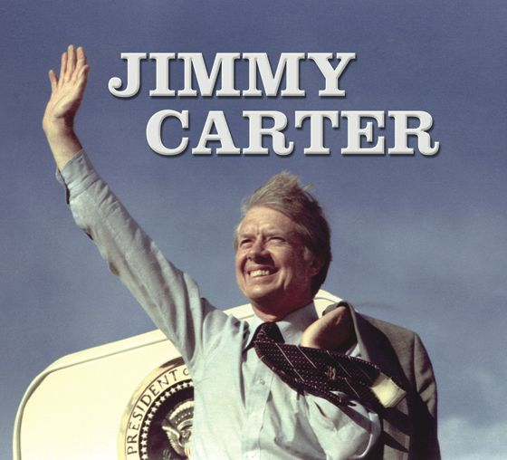
(BOSTON, MA) — Jimmy Carter, part of the Peabody Award-winning American Experience collection The Presidents, will have an encore broadcast on Monday, August 15, 2016, 9:00-11:00 p.m. ET (check local listings) on PBS. Jimmy Carter’s story is one of the greatest dramas in American politics. In 1980, he was overwhelmingly voted out of office in a humiliating defeat, but over the following decades became one of the most admired statesmen and humanitarians in America and the world. Produced, written, and directed by Adriana Bosch, Jimmy Carter traces his rapid ascent in politics, dramatic fall from grace, and unexpected resurrection.

Carter’s story is told by the people who know him best. Wife Rosalynn provides a rare glimpse of the inner life of their marriage, his early career, and political struggles. Son Chip speaks with candor about the president who was his father, and the life of this political family. Others appearing in the film include vice president Walter F. Mondale, press secretary Jody Powell, budget director Bert Lance, pollster Patrick Caddell, U.N. ambassador Andrew Young, congressman Dan Rostenkowski, and Carter’s most important biographers, Douglas Brinkley and Peter Bourne. The program also features Carter family home movies, as well as rare film of Carter’s final hours in the Oval Office, when he and his advisors waited in vain for the release of the Americans who had been held hostage in Tehran for 444 days.

Carter was the first president to confront the challenge of militant Islam, then embodied by the Ayatollah Khomeini, leader of the Iranian revolution. Carter was also the first president to embark on what would prove to be the excruciating road to peace in the Middle East. But in the end, he would be undone by his failure to secure the release of the hostages and by a plummeting economy.

The documentary shows how Carter’s political redemption was accomplished by Carter himself. The memories of his presidency — gas lines, inflation, recession, the Iran hostage crisis, an ineffectual and fractured administration, and the so-called national malaise — would be eclipsed, finally, by his post-presidential successes as a peacemaker in the world’s most troubled areas, and his emergence as a champion for the poor in his own country.

Jimmy Carter is written, produced, and directed by Adriana Bosch. Editor: James Rutenbeck. Co-Producer: David Condon. Associate Producer: Julie Rosenberg. Music: Mason Daring. Narrator: Linda Hunt.

American Experience is a production of WGBH Boston. Senior Producer: Susan Bellows. Managing Director: James E. Dunford. Executive Producer: Mark Samels.

American Experience recently launched The Presidents, an all-new digital portal showcasing more than 750 assets from the Peabody Award-winning collection of films about our nation’s most important leaders. The portal allows viewers to screen full-length films, delve deeper with experts and living witnesses, and examine more than 200 primary source documents. Video galleries on The Presidents site explore how different presidents faced issues including the economy, war, dealing with a crisis, and abuses of power.

The National Endowment for the Humanities (NEH), an independent federal agency, has been a major funder of American Experience’s The Presidents for more than 20 years.

Films from The Presidents series are available on DVD at shopPBS.org or wherever DVDs are sold. Films are also available to download on iTunes.

Exclusive corporate funding for American Experience provided by Liberty Mutual Insurance. Major funding provided by the Alfred P. Sloan Foundation. Major funding for The Presidents provided by the National Endowment for the Humanities: Celebrating 50 Years of Excellence. Additional funding provided by the Corporation for Public Broadcasting and public television viewers. American Experience is produced for PBS by WGBH Boston.

About American Experience
For more than 28 years, American Experience has been the nation’s most-watched television history series. It has been hailed as “peerless” (The Wall Street Journal), “the most consistently enriching program on television” (Chicago Tribune), and “a beacon of intelligence and purpose” (Houston Chronicle). On air and online, the series brings to life the incredible characters and epic stories that have shaped America’s past and present. Acclaimed by viewers and critics alike, American Experience documentaries have been honored with every major industry award, including 30 Emmy Awards, four duPont-Columbia Awards, and 17 George Foster Peabody Awards; the series received an Academy Award® nomination for Best Documentary Feature in 2015 for Last Days in Vietnam.

Press Contacts:
CaraMar, Inc.
Mary Lugo 770-623-8190 lugo@negia.net
Cara White 843-881-1480 cara.white@mac.com
Abbe Harris 908-244-5516 abbe.harris@caramar.net

For further information and photos visit http://www.pbs.org/pressroom

Signature Image Credit: © WGBH Educational Foundation. Image of Jimmy Carter courtesy of the Jimmy Carter Presidential Library.

