American Experience The Poison Squad
Premieres Tuesday, January 28, 2020 on PBS

Meet the Forgotten Chemist and His “Poison Squad,” Whose Fight Against Deadly Chemicals in Food Led to the Establishment of the FDA

(BOSTON, MA) – By the late 19th century, the American food supply was rife with frauds, fakes, and legions of untested and often deadly chemicals that threatened the health of consumers. The Poison Squad, based on the acclaimed book by Deborah Blum, tells the story of a little known government chemist named Dr. Harvey Wiley, who, determined to banish these dangerous substances from the American diet, took on the powerful food manufacturers and their allies in government. To demonstrate the peril lurking in these ubiquitous chemicals — from copper sulfate to borax to formaldehyde — Wiley embarked upon a series of bold and controversial trials on human subjects — a dozen brave young men who would become known as the “Poison Squad.” Following Wiley’s unusual experiments and tireless crusade for food safety, the film charts the path of the forgotten man whose work would become the basis for our consumer protection laws, and ultimately the creation of the FDA. Written, directed and produced by John Maggio and executive produced by Mark Samels and Susan Bellows, The Poison Squad premieres Tuesday, January 28, 2020, 9:00-11:00 p.m. ET (check local listings) on American Experience on PBS, PBS.org and the PBS Video App.
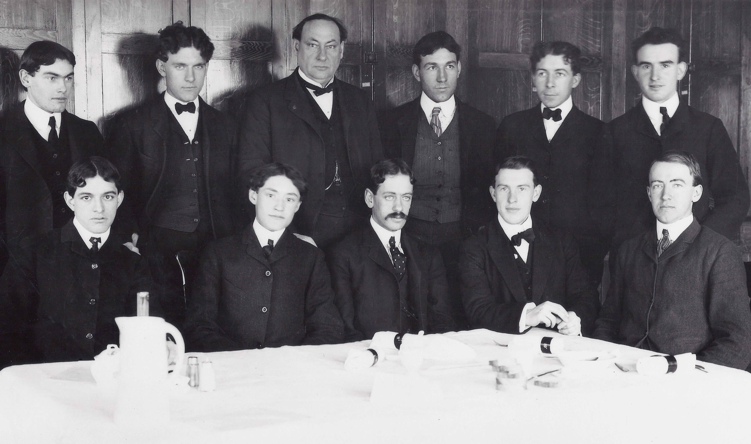
Dr. Harvey Wiley (third from left on back row), surrounded by test subjects who became known as “the Poison Squad.”
Credit: Courtesy of the FDA

At the close of the 19th century, technology and industry were booming. More and more Americans migrated to cities and away from farm life and fresh, homegrown food. Completely unregulated, the burgeoning food manufacturing industry took off as millions of Americans needed access to readily available and affordable food. In this pre-refrigeration world, meatpacking and canning companies sought ways to keep their products fresh at the lowest possible cost, regularly processing products with untested chemical preservatives. Milk was diluted with water and then sometimes whitened with plaster of paris or chalk to get rid of its bluish tint; formaldehyde was often added to sweeten the taste of souring milk, while pureed calf brains could be used to mimic the cream on top. In big cities, tainted milk was a breeding ground for deadly bacteria, outbreaks of scarlet fever, tuberculosis and cholera were common. Since no ingredient labeling was required, other dairy products like oleomargarine made from scraps from meatpackers were sold as butter and corn syrup was marketed as honey and maple syrup. And when the rations shipped to U.S. soldiers fighting the Spanish American war in Cuba were so rancid and reeking of toxic chemicals that troops refused to eat them, New York governor Theodore Roosevelt, who had fought alongside them, said he would rather have eaten his hat.
Dr. Harvey Wiley, a chemist working at the U.S. Department of Agriculture, had been trying for years to raise the alarm about the perils lurking on market shelves. Determined to banish dangerous substances from American dinner tables, Wiley faced enormous opposition from big business and their lobbyists and cronies in Congress. He decided that the only way to prove the toxicity of these chemicals would be through a scientific study using human subjects.
In 1902, Wiley recruited 12 robust young men with brave hearts and strong stomachs and fed them meals tainted with increasing amounts of common chemical additives such as borax, salicylic acid, sodium benzoate and formaldehyde. In exchange for free food and five dollars a month, these volunteers, dubbed the “Poison Squad,” agreed to eat only the meals served by Dr. Wiley, submit to a battery of physical examinations after each meal, and — promise not to sue the federal government if they were injured or sickened in the process.
Soon newspaper reporters were covering the colorful and often stomach-churning exploits of Wiley’s “Poison Squad” and the public was transfixed. Other progressives joined Wiley’s “pure food” movement, including women’s groups and suffragists, the influential cookbook writer Fannie Farmer, and readers of Upton Sinclair’s groundbreaking novel The Jungle, which was filled with shocking revelations about the conditions in America’s meatpacking plants.
Wiley’s experiments became one of the most influential scientific studies of the 19th century. Finally, in 1906, decades after he first sounded the alarm, Congress passed the Meat Inspection Act and the Pure Food and Drug Act — the first consumer protection laws in the nation’s history.
“The Poison Squad reminds us that our current concerns about food safety have a long history,” says Susan Bellows, senior producer, American Experience. “Although he remains mostly forgotten, we can thank Wiley and his brave volunteers whenever we see a ‘certified organic’ label on a package of chicken or read an ingredient list on the side of a box at our local supermarket.”
The Poison Squad will be available on DVD from PBS Distribution and can be purchased at ShopPBS.org.
Explore the rich diversity of America’s culture, food and history through new programs premiering January through March 2020. Discover the mysteries, surprises and revelations hidden in family trees with Dr. Henry Louis Gates, Jr. in FINDING YOUR ROOTS (Tuesdays, January 7-February 25). Get a delicious taste of immigrant traditions and cuisines woven into our nation's food and culture in six different cities with Chef Marcus Samuelsson in NO PASSPORT REQUIRED (Mondays, January 20 - February 17) and take a culinary journey through the American South with Chef Vivian Howard in SOMEWHERE SOUTH (Fridays, March 27-May 1). THE INN AT LITTLE WASHINGTON: A DELICIOUS DOCUMENTARY (Friday, March 27) follows self-taught chef Patrick O’Connell as he chases a third Michelin star, and FOOD. ROOTS. PHILIPPINES travels with Chef Billy Dec to his mother’s native Philippines in search of the recipes of his ancestors.

About the Participants

Mark Bittman is a journalist and the author of 20 acclaimed books, including the How to Cook Everything series and a member of the faculty of Columbia University’s Mailman School of Public Health.

Deborah Blum is the author of The Poison Squad and director of the Knight Science Journalism program at the Massachusetts Institute of Technology.

Kathleen Dalton is the author of Theodore Roosevelt: A Strenuous Life.

Jack High is the co-author of The Politics of Purity: Harvey Washington Wiley and the Origins of Federal Food Policy.

Suzanne Junod is the former FDA Historian at the US Department of Health and Human Services.

Mark Kurlansky is the author of MILK!: A Ten Thousand Year Food Fracas.

Corby Kummer is an award-winning food writer for The Atlantic and author of The Pleasures of Slow Food.

Sarah Lohman is a culinary historian and author of Eight Flavors: The Untold Story of American Cuisine.

Marion Nestle is the author of several books, including Food Politics: How the Food Industry Influences Nutrition and Health and Safe Food: The Politics of Food Safety.

Eric Schlosser is an investigative journalist and bestselling author of books including Fast Food Nation.

Bruce Watson is a journalist who reports on finance, food and culture.

About the Filmmakers

Written and Directed by  Based on the book | JOHN MAGGIO  THE POISON SQUAD BY DEBORAH BLUM
Produced by | JOHN MAGGIO  TOM DENISON
Edited by | NANCY KENNEDY
Music by | GARY LIONELLI

American Experience is a production of WGBH Boston
Senior Producer | SUSAN BELLOWS
Executive Producer | MARK SAMELS

John Maggio (Writer, Director and Producer) is a principal producer, director and writer with Ark Media. His work includes films for FRONTLINE (College Inc., Growing up Online) and American Experience (Bonnie and Clyde, The Boy in the Bubble, Kinsey). Maggio’s films have been honored with the National Emmy Award and Writers Guild Award, multiple nominations for News and Documentary Emmy Awards, and have premiered in competition at the Sundance Film Festival. His film The Newspaperman: The Life and Times of Ben Bradlee for HBO was nominated for 2018 Producers Guild Award for best documentary feature. In January of 2018, his Into The Amazon opened the 30th season of American Experience and his latest feature, Panic: The Untold Story of the 2008 Financial Crisis, for HBO, recently won a 2019 Emmy Award.

Mark Samels (Executive Producer) conceives, commissions and oversees all films for the PBS flagship history series American Experience. Samels has overseen more than 130 films, expanding both the breadth of subjects and the filmmaking style embraced by the series, allowing for more contemporary topics and witness-driven storytelling. Beginning his career as an independent documentary filmmaker, he held production executive positions at public television stations in West Virginia and Pennsylvania before joining WGBH. Samels is a founding member of the International Documentary Association and has served as a governor of the Academy of Television Arts & Sciences. A graduate of the University of Wisconsin, Samels holds honorary Doctor of Humane Letters degrees from Emerson College and Elizabethtown College.

Susan Bellows (Senior Producer) is an award-winning producer and writer with more than 20 years of experience producing national programs for public television. Bellows was the producer and director of the Emmy Award-winning JFK, which premiered on American Experience in 2013, and writer, director and producer for The Bombing of Wall Street, which premiered on the series in 2018. Since joining the series in 2003, she has provided editorial support and guidance to its broadcast and new media work. Previously, Bellows served as senior producer for the Peabody and Emmy Award-winning series Africans in America. Her other producing credits include films for The Great Depression, for which she received an Emmy nomination, and America’s War on Poverty, both productions of Blackside, Inc. Bellows also co-produced New Worlds, New Forms for the WNET-produced series Dancing, an eight-hour landmark series on dance forms around the world.

About American Experience
For over 30 years, American Experience has been television’s most-watched history series. Hailed as “peerless” (The Wall Street Journal), “the most consistently enriching program on television” (Chicago Tribune) and “a beacon of intelligence and purpose” (Houston Chronicle), the series brings to life the incredible characters and epic stories that have shaped America’s past and present. American Experience documentaries have been honored with every major broadcast award, including 30 Emmy Awards, four duPont-Columbia Awards and 17 George Foster Peabody Awards; the series received an Academy Award® nomination for Best Documentary Feature in 2015 for Last Days in Vietnam. American Experience also creates original digital content that uses new forms of storytelling to connect our collective past with the present. Visit pbs.org/americanexperience and follow us on Facebook, Twitter, Instagram and YouTube to learn more.

Major funding for American Experience provided by Liberty Mutual Insurance, Consumer Cellular and by the Alfred P. Sloan Foundation. Additional funding provided by the Robert David Lion Gardiner Foundation, The Documentary Investment Group: Roxanne E. and Michael J. Zak, the Corporation for Public Broadcasting and public television viewers. American Experience is produced for PBS by WGBH Boston.

* * *
Press Contacts:
CaraMar Publicity
Mary Lugo 770-623-8190 lugo@negia.net
Cara White 843-881-1480 cara.white@mac.com
Abbe Harris 908-244-5516 abbe.harris@caramar.net

For further information and photos visit http://www.pbs.org/pressroom

