Amelia Earhart To Have Encore Broadcast
Tuesday, May 7, 2019 on PBS

First of Four “Women in History” Episodes on American Experience in May

(BOSTON, MA) — Amelia Earhart, written, directed and produced by Nancy Porter, will have an encore broadcast on American Experience on Tuesday, May 7, 2019, 9:00-10:00 p.m. ET (check local listings) on PBS. The first in a special “Women in History” four-week series, Amelia Earhart will be followed by encore broadcasts of Annie Oakley (May 14), Emma Goldman (May 21) and Rachel Carson (May 28).
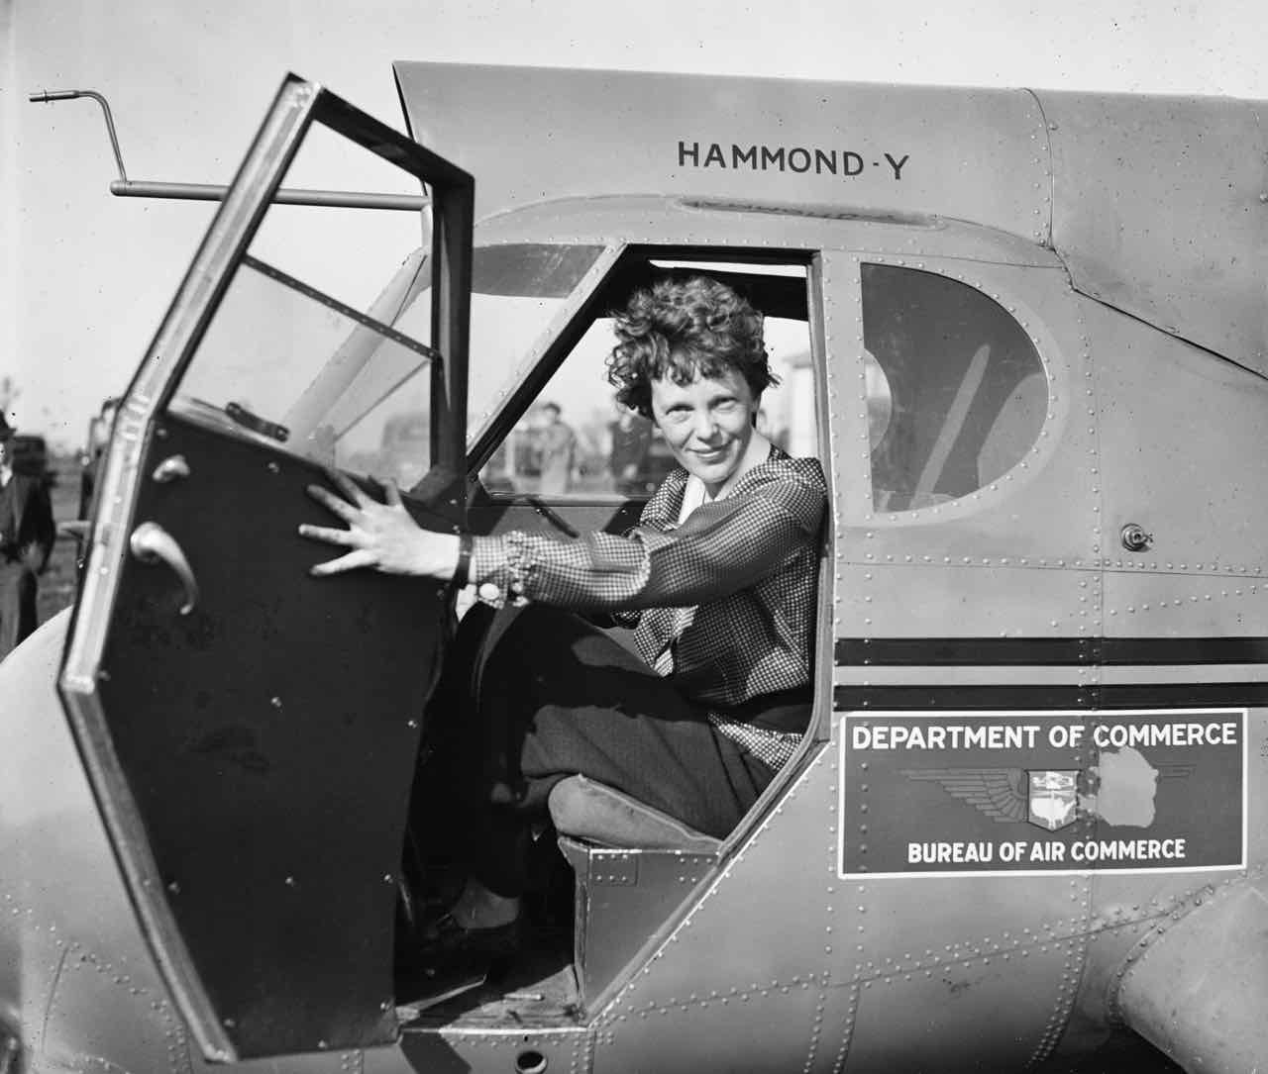
Amelia Earhart circa 1936.
Credit: Courtesy of the Library of Congress

The first woman to fly solo across the Atlantic, Amelia Earhart was one of America’s earliest celebrities. After only a few years as a pilot she became the best-known female flier in America, not only for her daring and determination, but also for her striking looks and outspoken personality. Earhart even had an uncanny resemblance to Charles Lindbergh — the most famous man in America at the time — that publicists seized upon, nicknaming her “Lady Lindy.” Three weeks short of her 40th birthday, Earhart disappeared over the Pacific Ocean, and her story became legend.

Raised to be a proper Victorian woman, Earhart decided early on that role did not suit her. She collected newspaper articles and pictures of women who were successful in male-dominated fields such as film, law, management, and engineering. Unsure of her own direction, Earhart moved between various schools and jobs. At 23, she discovered her passion when she paid $5 for her first ride in a biplane. “As soon as we left the ground,” she later wrote, “I knew I myself had to fly. ‘I think I’d like to fly,’ I told the family casually that evening, knowing full well I’d die if I didn’t.”

To raise money for her own plane — a yellow Kinner Airster biplane she named The Canary — Earhart worked as a truck driver, photographer, and stenographer. In 1921, she passed her pilot's test from the National Aeronautic Association and received her license two years later from the Fédération Aéronautique Internationale, all while flying in races and setting an unofficial altitude record for female pilots.

In 1928, Earhart gained international fame after she became the first female passenger to fly across the Atlantic on the Friendship with pilot Wilmer Stultz and co-pilot Louis Gordon. After writing a bestselling book about the experience Earhart’s celebrity exploded. With publicist George Palmer Putnam — who would become her husband — she planned a nationwide book tour and endorsed dozens of products but did not feel deserving of the acclaim. “I was just baggage, like a sack of potatoes,” she claimed about her famous trip. Only in 1932, after she flew across the Atlantic Ocean solo, did Earhart feel she had earned her lavish praise.

The second person in the world to accomplish this after Lindbergh, Amelia Earhart did not slow down. Through the 1930s she broke more flying records, wrote another book, promoted commercial airlines, and worked as a lecturer, career advisor to female college students, and Aviation Editor at Cosmopolitan Magazine.

In 1937, Earhart decided to go for the one record in aviation that no one — man or woman — had ever attempted before: to fly around the world at the equator. An extremely dangerous and unprecedented flight, it required months of preparation and a lot of luck. In the end, Earhart had neither. Exhausted from a grueling schedule of promotions, speeches and interviews, she took off from Florida, making it all the way to New Guinea. After a few days rest, Amelia continued on, losing radio contact while trying to locate and land on tiny Howland Island in the middle of the Pacific. On July 2, 1937, nearly 22,000 miles into the around-the-world flight, Amelia Earhart and her navigator Fred Noonan disappeared without a trace.

Although her life ended tragically, Earhart’s groundbreaking contributions to flight and women’s struggle for equality made her an enduring American hero.

About the Filmmakers

Written, Directed and Produced By |  | NANCY PORTER
Co-Produced By |  | JANE FEINBERG
Edited By |  | JEAN JORDAN
Narrated By  Associate Producer  Original Music By |  | KATHY BATES  MELANIE PERKINS  MICHAEL BACON
Cinematography |  | PETER HOVING  MICHAEL CHIN  BILL MILLS  JERI SOPANEN

American Experience is a production of WGBH Boston

Senior Producer |  | SUSAN BELLOWS
Executive Producer |  | MARK SAMELS

Mark Samels (Executive Producer) conceives, commissions and oversees all films for the PBS flagship history series American Experience. Samels has overseen more than 130 films, expanding both the breadth of subjects and the filmmaking style embraced by the series, allowing for more contemporary topics and witness-driven storytelling. Beginning his career as an independent documentary filmmaker, he held production executive positions at public television stations in West Virginia and Pennsylvania before joining WGBH. Samels is a founding member of the International Documentary Association and has served as a governor of the Academy of Television Arts & Sciences. A graduate of the University of Wisconsin, Samels holds honorary Doctor of Humane Letters degrees from Emerson College and Elizabethtown College.

About American Experience
For 30 years, American Experience has been television’s most-watched history series. Hailed as “peerless” (The Wall Street Journal), “the most consistently enriching program on television” (Chicago Tribune) and “a beacon of intelligence and purpose” (Houston Chronicle), the series brings to life the incredible characters and epic stories that have shaped America’s past and present. American Experience documentaries have been honored with every major broadcast award, including 30 Emmy Awards, four duPont-Columbia Awards and 17 George Foster Peabody Awards; the series received an Academy Award® nomination for Best Documentary Feature in 2015 for Last Days in Vietnam. American Experience also creates original digital content that uses new forms of storytelling to connect our collective past with the present. Visit pbs.org/americanexperience and follow us on Facebook, Twitter, Instagram and YouTube to learn more.

Major funding for American Experience provided by Liberty Mutual Insurance, Consumer Cellular and the Alfred P. Sloan Foundation. Additional funding provided by the Robert David Lion Gardiner Foundation, the Documentary Investment Group, the Corporation for Public Broadcasting and public television viewers. American Experience is produced for PBS by WGBH Boston.

* * *
Press Contacts
CaraMar Publicity
Mary Lugo 770-623-8190 lugo@negia.net
Cara White 843-881-1480 cara.white@mac.com
Abbe Harris 908-244-5516 abbe.harris@caramar.net

For further information and photos visit http://www.pbs.org/pressroom

