American Experience Annie Oakley To Have Encore Broadcast
Tuesday, March 15, 2022 on PBS and PBS.org

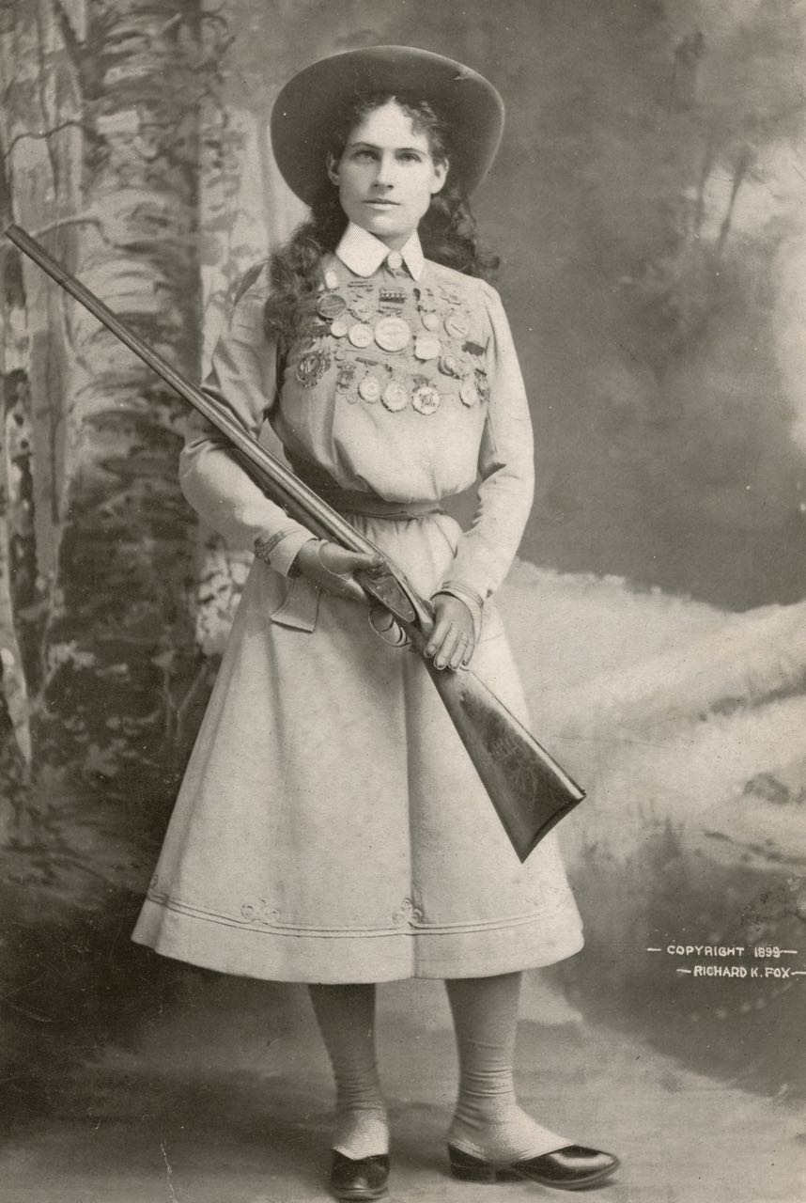
Annie Oakley, circa 1899.
Credit: Library of Congress
(BOSTON, MA) — Annie Oakley, the story of a five-foot, 100-pound sharpshooter who pulled herself out of poverty to become an iconic performer known the world over as a symbol of the Wild West, will have an encore broadcast on American Experience Tuesday, March 15, 2022, 8:00-9:00 p.m. ET (check local listings) on PBS, PBS.org and the PBS Video App.

She was the toast of New York, London, Paris, and eventually the world. “Adopted” in 1884 by Native American Chief Sitting Bull, she charmed the Prince of Prussia and entertained the likes of Oscar Wilde and Queen Victoria. Annie Oakley excelled in a man’s world by doing what she loved and won fame and fortune as “the little lady from Ohio who never missed a shot.”

Phoebe Anne Moses, called Annie, first picked up a gun in 1875 at age 15 not to become a superstar, but to save her family from destitution. Annie taught herself to shoot and took to the woods of Greenville, Ohio, to hunt quail, which she would sell at the general store. Thanks to her prowess with a shotgun, Annie became the family’s primary breadwinner and paid off the mortgage on the family farm.

Annie was soon noticed by Frank Butler, who was making a name for himself on the variety stage. On a trip through Ohio, Butler challenged that he could outshoot anyone around. But the teenager from Greenville didn't just outshoot him, she also won his heart. They married and toured the world as Butler and Oakley, the stage name that Annie adopted.

Annie Oakley dazzled crowds around the world, first on the variety circuit, then with the circus, and eventually with Buffalo Bill's Wild West show. Annie amazed her audiences by splitting playing cards in two, hitting countless moving targets, even once shooting a cigarette out of Prince Wilhelm of Prussia's mouth at 30 paces. She could shoot with her left hand, her right hand, upside down and sideways.

In 1885, Annie entertained crowds in 40 cities across America. By 1895, that number grew to more than 130 cities around the world. She was a star at the Paris Exposition in 1889 and shone again in 1893 when Buffalo Bill set up shop just outside of Chicago’s Columbian Exposition. The self-taught sharpshooter had become a living symbol of the Wild West — a place that was fast disappearing.

The end of Annie’s career was plagued with scandal. Erroneous stories of Annie stealing to pay for cocaine hit the papers in 1903 when Annie was 43 years old. She spent six years entangled in legal battles trying to clear her name and would only perform for a few years more. She retired from public life in 1913.

American Experience Annie Oakley will stream simultaneously with broadcast and be available on all station-branded PBS platforms, including PBS.org and the PBS Video app, available on iOS, Android, Roku, Apple TV, Amazon Fire TV, Android TV, Samsung Smart TV, Chromecast and VIZIO. All titles will be available for streaming with closed captioning in English and Spanish. PBS station members can view many series, documentaries and specials via PBS Passport. For more information about PBS Passport, visit the PBS Passport FAQ website.

American Experience Annie Oakley

A Riva Productions film for American Experience

Produced and Directed by |  | RIVA FREIFELD
Written by |  | KEN CHOWDER
Edited by |  | DAVID ESPAR
Co-Producer  Directors of Photography  Music |  | AMY BROWN  JOEL SHAPIRO, BOYD ESTUS, ROBERT ELFSTROM, MICHAEL CHIN and  JOHN CHATER  SHELDON MIROWITZ
Narrator |  | LAURA LINNEY
American Experience is a production of GBH Boston

Executive Producer |  | CAMEO GEORGE

About American Experience
For more than 30 years, American Experience has been television’s most-watched history series, bringing to life the incredible characters and epic stories that have shaped America’s past and present. American Experience documentaries have been honored with every major broadcast award, including 30 Emmy Awards, five duPont-Columbia Awards and 19 George Foster Peabody Awards. PBS’s signature history series also creates original digital content that innovates new forms of storytelling to connect our collective past with the present. Cameo George is the series executive producer. American Experience is produced for PBS by GBH Boston. Visit pbs.org/americanexperience and follow us on Facebook, Twitter, Instagram and YouTube to learn more.

Major funding for American Experience provided by Liberty Mutual Insurance and by the Alfred P. Sloan Foundation. Major funding for Annie Oakley provided by the National Endowment for the Humanities: Democracy Demands Wisdom. Additional funding for American Experience provided by the Robert David Lion Gardiner Foundation, the Documentary Investment Group, the Corporation for Public Broadcasting and public television viewers.

Press Contacts
CaraMar Publicity
Mary Lugo 770-851-8190 lugo@negia.net
Cara White 843-881-1480 cara.white@mac.com
Abbe Harris 908-244-5516 abbe.harris@caramar.net

For further information and photos visit http://www.pbs.org/pressroom

