American Experience Presents The Amish: Shunned

Premieres Tuesday, February 4, 2014

9:00-11:00 p.m. ET on PBS

TCA Panelists

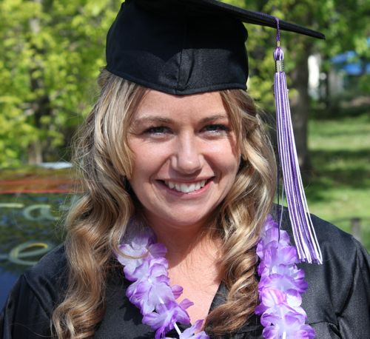
Naomi Kramer (Participant) first left the Old Order Amish at 19, though it took her many years to admit she would not return. Since leaving, she has become a nurse and set up the Amish Descendant Scholarship Fund for other former Amish. They gave out their first awards in 2012.

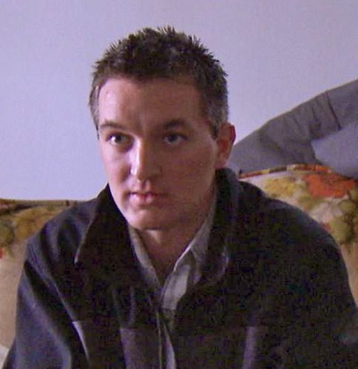

Levi Shetler (Participant) was born and raised in Saint Lawrence County, New York. He left the Swartzentruber Amish when he was 17 and moved to Ohio to work in construction with other former Amish, including his brother. He now lives in Iowa.

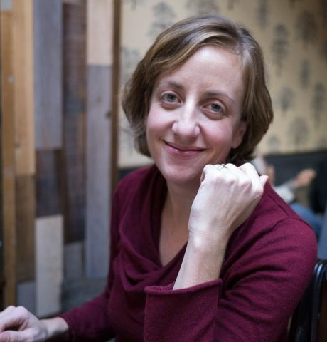
Callie Taintor Wiser (Writer, Producer, Director) was the producer for the Emmy-nominated The Amish, which premiered on American Experience in 2012. She began her career in documentary journalism working on a number of films for FRONTLINE before embarking on a freelance career. Wiser’s other work for American Experience includes producing the three-and-a-half hour documentary George H.W. Bush and co-producing the first two episodes of the six-part series God in America, a co-production of American Experience and FRONTLINE. She has also produced for the web, most notably the first edition of the FRONTLINE Interviews, a web-based oral history initiative launched in April 2012. She is a native of Tennessee and graduated from the University of North Carolina, where she was a Morehead Scholar. She lives with her husband and son in Somerville, Massachusetts.

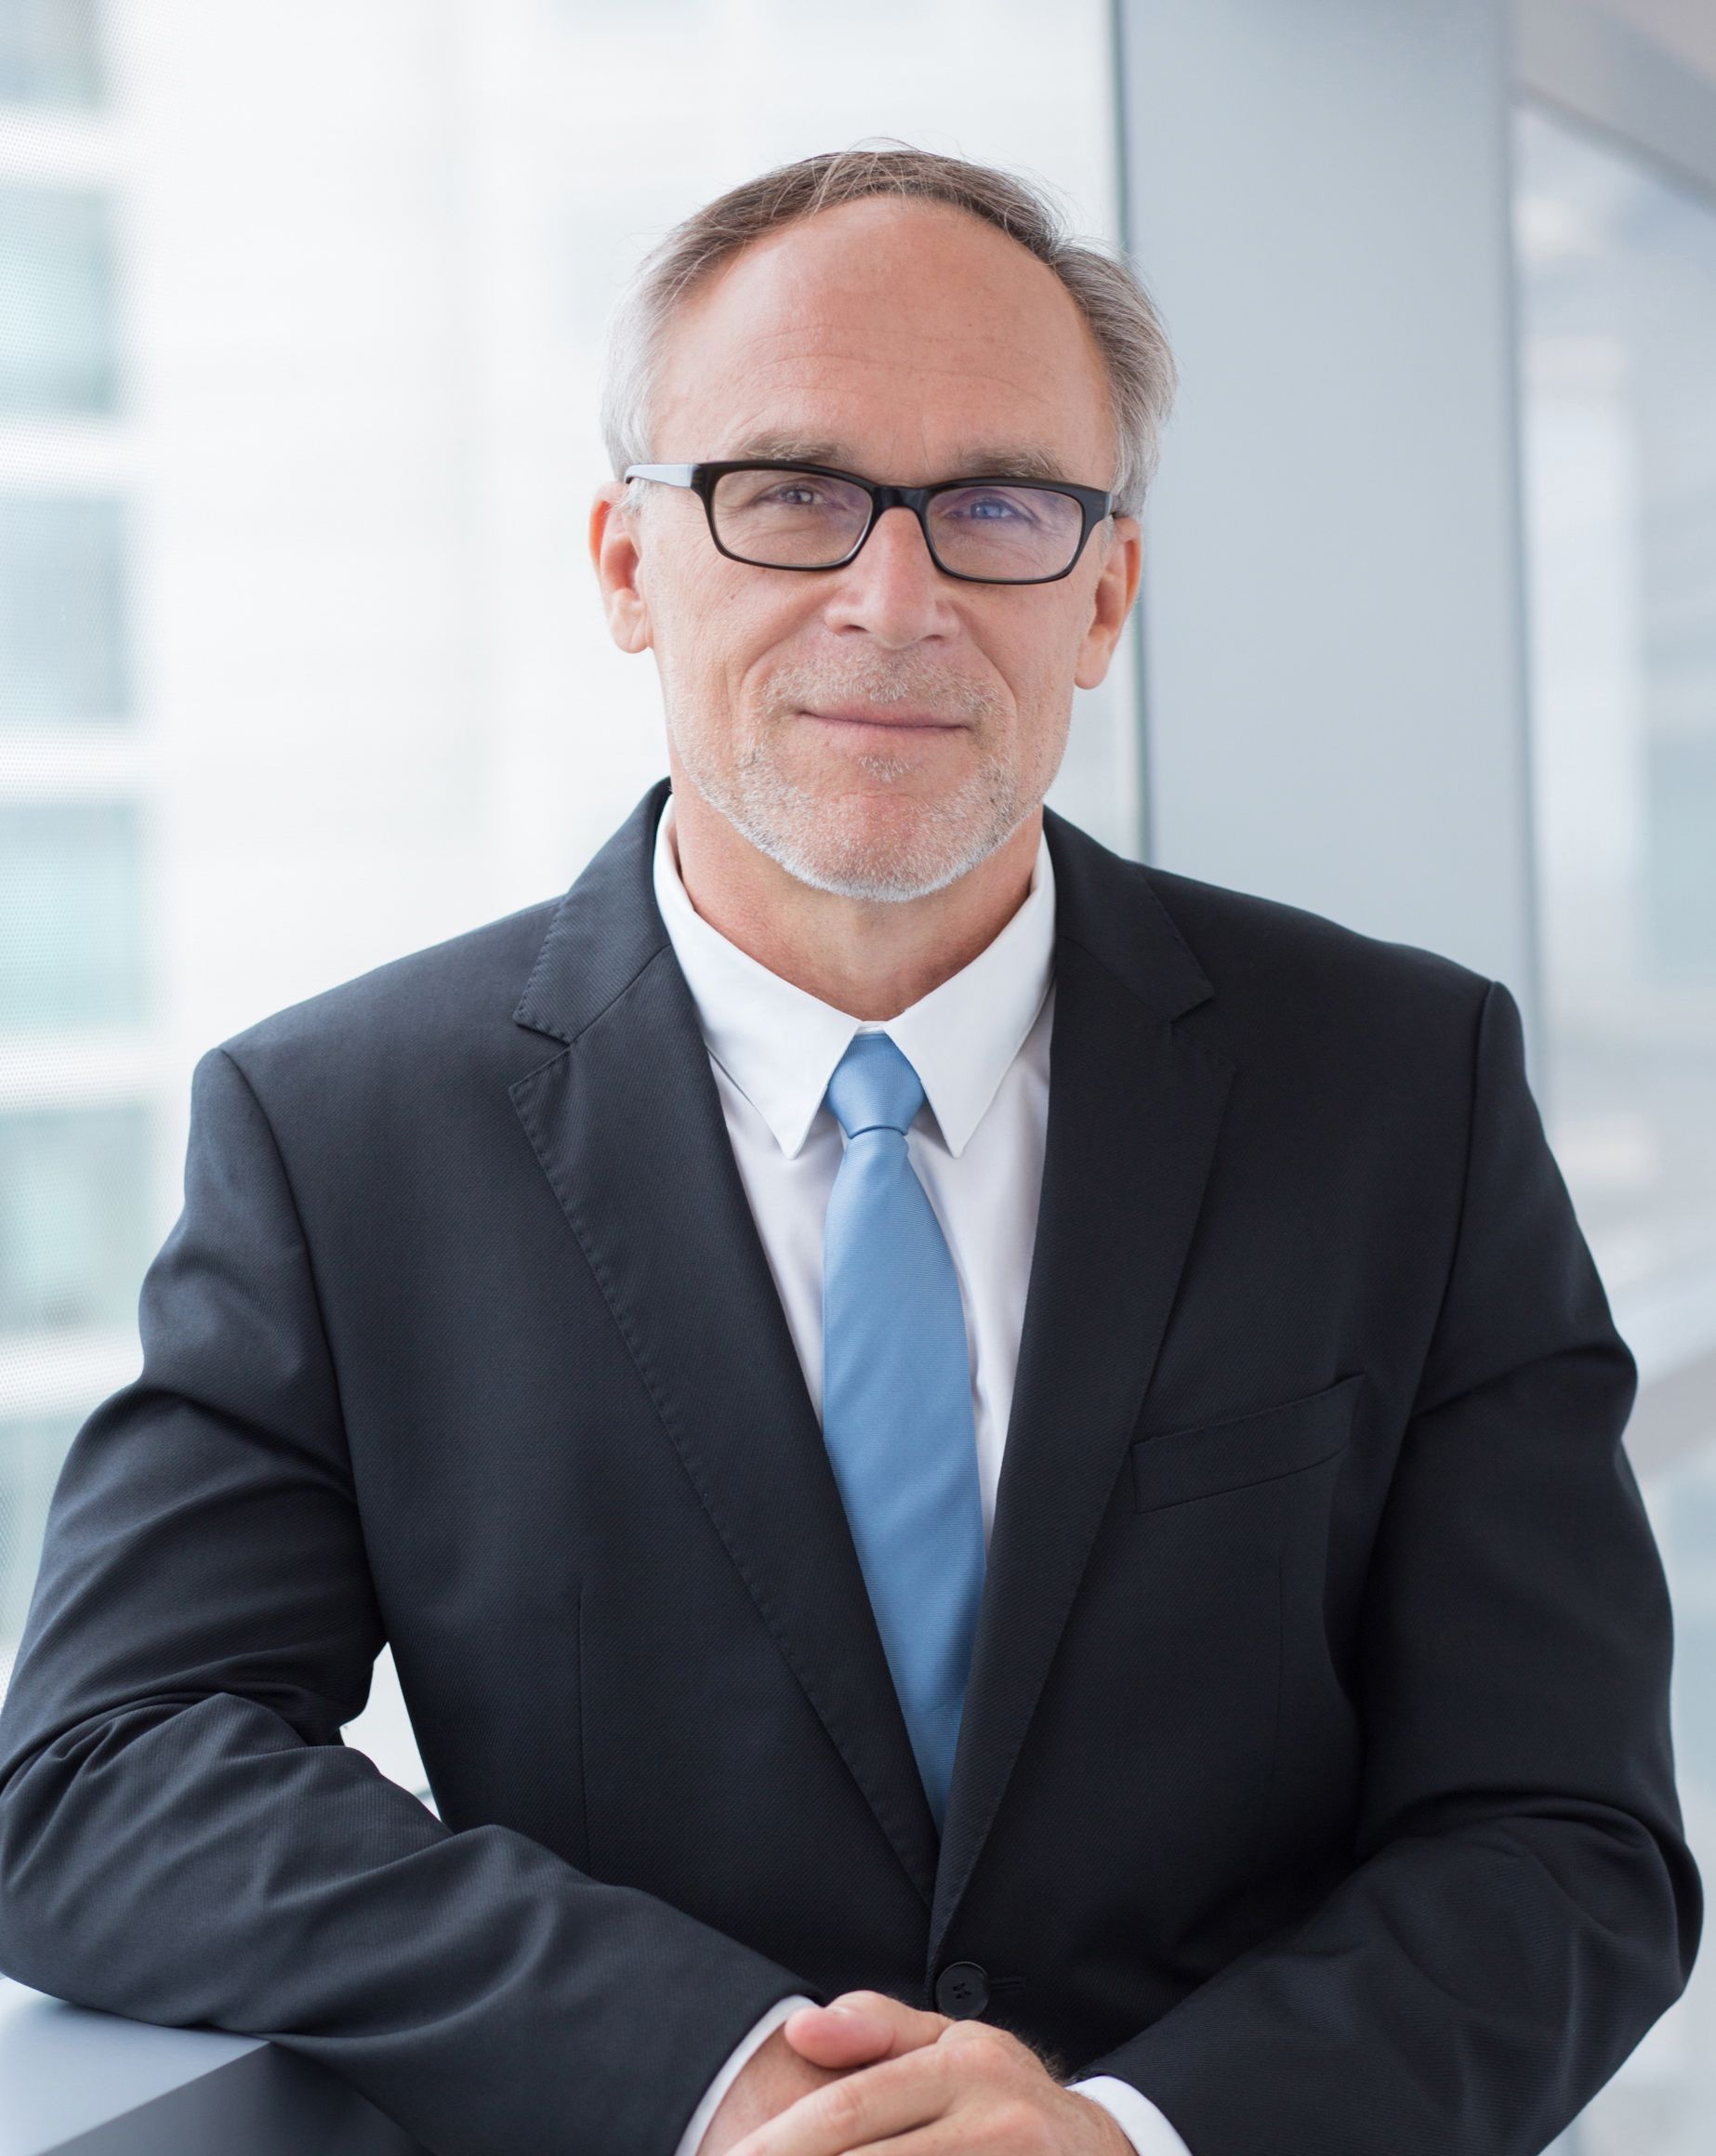
Mark Samels (Executive Producer) was named executive producer of American Experience, PBS’ flagship history series, in 2003. Under Samels’ leadership, the series has been honored with nearly every industry award, including the Peabody, Primetime Emmys, the duPont-Columbia Journalism Award, Writers Guild Awards, Oscar nominations and Sundance Film Festival Audience and Grand Jury Awards. Samels also served on the Board of Governors at the Academy of Television Arts and Sciences. Prior to joining WGBH, Samels worked as an independent documentary filmmaker, an executive producer for several U.S. public television stations and as a producer for the first co-production between Japanese and American television. A native of Wisconsin, he is a graduate of the University of Wisconsin-Madison.

* * *

