American Experience Bombshell
Premieres Tuesday, January 6, 2026
on PBS and Streaming on PBS.org

New Documentary Explores How The U.S. Government Manipulated the Narrative About the Atomic Bombings of Hiroshima and Nagasaki

(Boston, MA) — Eighty years after the devastating atomic bombings that ushered in the nuclear age, Bombshell explores how the U.S. government manipulated the narrative about the atomic bombings of the Japanese cities Hiroshima and Nagasaki. Through propaganda, censorship and the co-opting of the press, the government presented a benevolent picture of atomic power, minimizing the horrific human toll of the bombings. Written and directed by Ben Loeterman, produced by Loeterman and Gaia De Simoni, executive produced by Cameo George, and narrated by Ann Curry, Bombshell sheds light on the efforts of a group of intrepid reporters to let the world know the truth. It premieres Tuesday, January 6, 2026, 9:00-10:30 p.m. ET (check local listings), on American Experience on PBS, PBS.org and the PBS app.
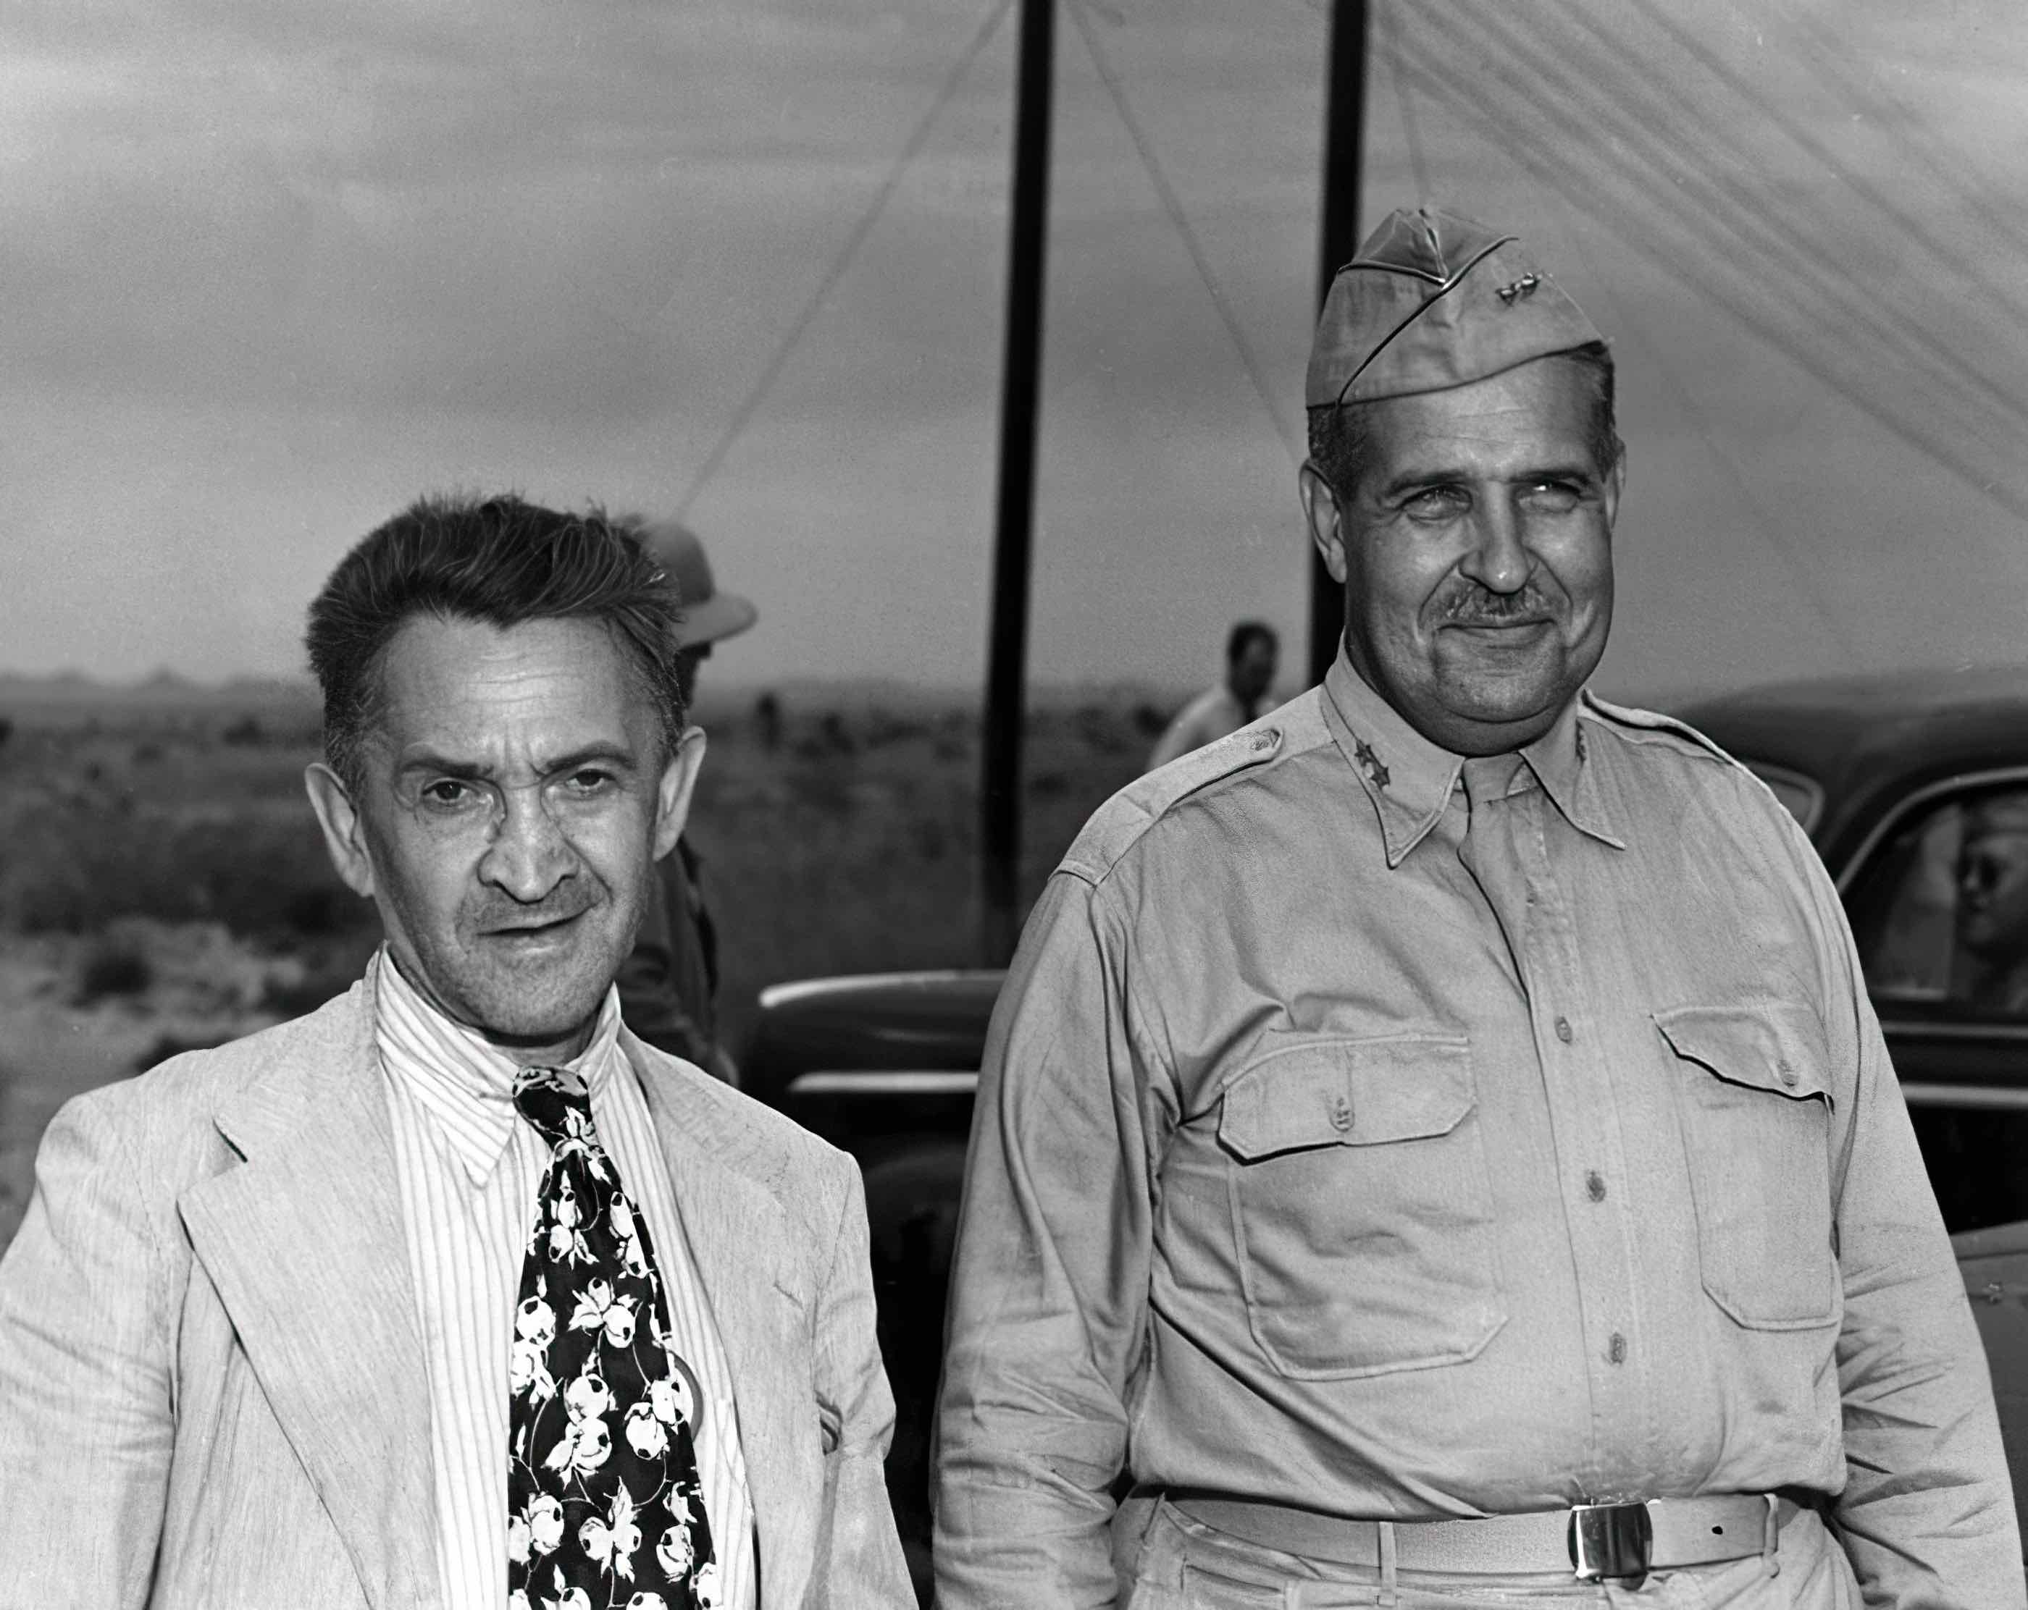
William L. Laurence and General Leslie R. Groves after a press tour at the Trinity test site, September 1945. Credit: U.S. Army Corp of Engineers

On August 6, 1945, a revolutionary new weapon destroyed Hiroshima, a Japanese city of 300,000 inhabitants. Three days later, a second atomic bomb was dropped on Nagasaki. America’s secret superweapon was lauded for bringing about victory in the Pacific and ending World War II. President Truman’s official announcement included half-truths that shaped the government’s official narrative: “Sixteen hours ago, an American airplane dropped one bomb on Hiroshima, an important Japanese army base.” In fact, the bomb was aimed at Hiroshima’s city center for maximum psychological effect; the army base on its outskirts escaped much damage.
The U.S. media became pivotal in promoting — and then piercing — the official narrative. While Truman publicly declared that “it has never been the habit of the scientists of this country or this government to withhold from the world scientific knowledge,” that is precisely what General Groves, leader of the Manhattan Project, insisted upon. His strategy was a PR campaign fueled by press releases written anonymously by William L. Laurence, the science writer for The New York Times and an undercover member of the Manhattan Project team. Laurence’s assignment: downplay the radiation effects from the bomb.
Not every journalist adhered to the official line. First on the ground in Hiroshima was Japanese American Leslie Nakashima, who had worked for the United Press in Tokyo until Pearl Harbor. After the bombing, he rushed to Hiroshima to check on his mother. She was safe, but the devastation stunned him. Although the United Press syndicated his story, many American papers censored it, including The New York Times, which removed all references to radiation poisoning. An accompanying warning by General Groves told readers that all reports out of Japan “are pure propaganda.”
Australian freelancer Wilfred Burchett dodged checkpoints to reach Hiroshima, while Chicago Daily newsman George Weller became the first American reporter into Nagasaki. The radiation poisoning Burchett witnessed was detailed in a front-page story headlined Atomic Plague. It was published in London and reprinted around the world, but Americans did not see it. Meanwhile, George Weller submitted his dispatches to General MacArthur for approval, who instead confiscated them.
Several African American journalists also refused to buy the government’s narrative. Woven through their coverage is the suspicion that the bomb has been deliberately reserved for use against Asians rather than Europeans. Writing in the Chicago Defender, Langston Hughes argued that the bombs were dropped on “Japs,” because the Japs are “colored.” Charles H. Loeb, who wrote for the Black press, reported on the residual effects of radiation poisoning, but there was no follow-up in the mainstream media.
The official narrative finally began to crack in August 1946 when John Hersey’s article on Hiroshima was published as an entire issue of The New Yorker. While Groves and Laurence presented a benevolent spin on atomic power, Hersey’s reporting revealed the enormous moral and human consequences. The issue sold out overnight and the article was reprinted around the world. The Truman administration doubled down on its efforts to sell its official story, including a government-approved Hollywood movie, The Beginning or the End.
The only on-the-ground photos to survive August 6 were taken by Hiroshima news photographer Yoshito Matsushige, but they were confiscated just after Japan formally surrendered. In 1952, after censorship was lifted, LIFE magazine published them, allowing Americans to finally peer under the mushroom cloud for the first time.
Bombshell sheds light on the efforts of courageous journalists to inform the world about the human costs of nuclear weapons, despite government censorship. On the 80th anniversary of the bombings, their long-overlooked but crucial perspective underscores the essential role of journalists in telling the story of the atomic bomb.
Says filmmaker Ben Loeterman: “Bombshell has much to teach us, and the press, about reporting peace and security issues around the world today, from India and Pakistan to North Korea and Japan to Israel and Iran.”
American Experience Bombshell will stream for free simultaneously with broadcast on all station-branded PBS platforms, including PBS.org and the PBS app, available on iOS, Android, Roku, Apple TV, Amazon Fire TV, Android TV, Samsung Smart TV, Chromecast and VIZIO. The film will also be available for streaming with closed captioning in English and Spanish on the American Experience website.
About the Major Subjects in the Film

Wilfred Burchett was an Australian reporter widely credited as being the first Western journalist to report from Hiroshima following the dropping of the bomb, even though he arrived well after Leslie Nakashima.

Gen. Leslie Groves was a United States Army Corps of Engineers officer who directed the Manhattan Project, the secret effort to develop the atomic bomb.

John Hersey was a war correspondent for Time and Life and the author of “Hiroshima,” which appeared in the August 31, 1946, issue of The New Yorker.

William L. Laurence was a New York Times science writer who was hired by Gen. Groves to write government-approved press releases about the atomic project.

Charles Loeb was an editor at the Cleveland Call and Post, an African American newspaper. His syndicated reporting for the National Negro Newspaper Association exposed the truth about radiation casualties from the Hiroshima bomb.

Yoshito Matsushige was a Japanese photojournalist who took the only known photographs in Hiroshima on the day of the bombing.

Leslie Nakashima was the first Western journalist to report from Hiroshima after the atomic bombing. Nakashima, who had personal reasons for being there — to check on the safety of his mother — arrived in Hiroshima on August 22, 1945. His eyewitness account of the devastation, Hiroshima as I Saw It, was widely syndicated by the United Press (now UPI) but many papers heavily censored it because of Nakashima’s Japanese heritage.

George Weller was an American newspaper reporter who investigated the radiation fallout following the bombing of Nagasaki, but his reporting was censored.

About the Participants

Paul Alkebulan is a historian and author of The African American Press in World War II: Toward Victory at Home and Abroad.

Janet Farrell Brodie is professor emerita of history at Claremont Graduate University. Among her publications are The First Atomic Bomb: The Trinity Site in New Mexico (2023) and Radiation Secrecy and Censorship After Hiroshima and Nagasaki (2015).

Kay Callison is the founder and former director of the American Audio Prose Library of Columbia, Missouri. She interviewed John Hersey in his Key West home in 1988.

Matthew Delmont is professor of history at Dartmouth University. An expert on African American history and the Civil Rights Movement, he authored Black Quotidian: Everyday History in African American Newspapers and Half American: The Epic Story of African Americans Fighting World War II at Home and Abroad.

Michael D. Gordin is the Rosengarten Professor of Modern and Contemporary History at Princeton University. He has written two books on nuclear history: Five Days in August: How World War II Became a Nuclear War (2007) and Red Cloud at Dawn: Truman, Stalin, and the End of the Atomic Monopoly (2009).

Philip Gourevitch is a New Yorker staff writer and author. His books include The Ballad of Abu Ghraib (2008) and We Wish to Inform You That Tomorrow We Will Be Killed with Our Families (1998).

Vincent Intondi is a professor, historian and author whose most recent works are African Americans Against the Bomb: Nuclear Weapons, Colonialism, and the Black Freedom Movement (2015) and Saving the World from Nuclear War: The June 12, 1982 Disarmament Rally and Beyond (2023). He is currently Domestic Affiliate Scholar at Cornell University.

Vincent Kiernan is author of Atomic Bill: A Journalist's Dangerous Ambition in the Shadow of the Bomb. A science and medical journalist for more than 20 years, Kiernan has written for publications including New Scientist; he is also a lecturer for the MA in Communication at John Hopkins.

Greg Mitchell is an author and journalist whose most recent work is The Beginning or the End: How Hollywood – and America – Learned to Stop Worrying and Love the Bomb (2020). Among his other works are Atomic Cover-up: Two U.S. Soldiers, Hiroshima & Nagasaki, and the Greatest Movie Never Made (2011) and Hiroshima in America: A Half Century of Denial, with Robert Jay Lifton (1996).

Felecia Ross is associate professor at the School of Communication of The Ohio State University. Her research interest focuses on the relationship between the mass media and traditionally discriminated groups, with a specialty in the history of the African American press.

Mitchell Stephens is a professor of Journalism at New York University.

Crystal Uchino is assistant professor in the Global Communications Department at Kyoto University and author of The Case of Leslie Satoru Nakashima and His Breaking News Dispatch.

Alex Wellerstein is professor at the Stevens Institute of Technology in Hoboken, NJ, where he directs Science and Technology Studies in the College of Arts and Letters. Wellerstein is the author of Restricted Data: The History of Nuclear Secrecy in the United States (2021) and the forthcoming The Most Awful Responsibility: Truman and the Secret Struggle for Control of the Atomic Age.

Ben Yagoda, a professor of English at University of Delaware, is a biographer and the author of About Town: The New Yorker and the World It Made.

About the Filmmakers

American Experience Bombshell

Produced by | BEN LOETERMAN, GAIA DE SIMONI
Written and Directed by | BEN LOETERMAN
Edited by  Narrated by | MATT SHELLEY-READE  PETER RHODES  ANN CURRY

American Experience is a production of WGBH Boston
Executive Producer | CAMEO GEORGE
Ben Loeterman (Writer/Producer/Director) is an award-winning filmmaker of current affairs and history documentaries. He wrote, directed and produced films for the PBS series FRONTLINE over its first 20 years and has contributed to films to the series AMERICAN EXPERIENCE and AMERICAN MASTERS. He produced two PBS specials, The People v. Leo Frank and 1913: Seeds of Conflict, about how things first went wrong in Palestine, with funding from the National Endowment of Humanities. Loeterman has earned national Emmys for investigative reporting (The Triumph of Evil) and directing (Angel on Death Row), a duPont-Columbia award for his film about the 9/11 hijackers and Amnesty International’s Spotlight award for The Triumph of Evil, about the genocide in Rwanda.

Gaia De Simoni (Co-Producer) is a journalist with experience in print, digital and more recently documentary film. For Bombshell, De Simoni served as content producer, combing interview transcripts, oral histories, and researching background material and visual assets. Prior to Bombshell, De Simoni was archival researcher and production assistant on Walter Winchell: The Power of Gossip. Before moving into the documentary world, De Simoni worked as a sports reporter focused on golf in her home country of Italy, where she is considered one of the country’s premiere golf journalists. After receiving a master’s degree in journalism from Boston University, De Simoni worked as a digital editor for NBC’s Regional Sports Network.
Cameo George (Executive Producer, American Experience) is an Emmy Award-winning producer, writer and journalist with more than 25 years of experience in documentary, broadcast television and digital content production. George has produced, developed and commissioned innovative programming at CNN, NBC News and ABC News. She was the senior producer of CNN’s groundbreaking series Black in America and Latino in America and executive producer of the eight-hour PBS documentary series 16 FOR '16: THE CONTENDERS, which was also broadcast on the BBC. George joined American Experience from ABC News, where she was head of development for long-form projects, responsible for creating a pipeline of docuseries and feature documentary films across Walt Disney Television platforms, including ABC News, Hulu, National Geographic and Disney+. She was recently named to The Root’s list of 2024’s 100 Most Influential Black Americans.
About American Experience
For nearly 40 years, American Experience has been television’s most-watched history series, bringing to life the incredible characters and epic stories that have shaped America’s past and present. American Experience documentaries have been honored with every major broadcast award, including 32 Emmy Awards, five duPont-Columbia Awards and 20 George Foster Peabody Awards. PBS’s signature history series also creates original digital content that innovates new forms of storytelling to connect our collective past with the present. Cameo George is the series executive producer. American Experience is produced for PBS by GBH Boston. Listen to the American Experience Presents podcast on Apple, Spotify, Amazon Music and more. Visit pbs.org/americanexperience and follow us on Facebook, Instagram, Threads and YouTube to learn more.

Major funding for American Experience provided by Liberty Mutual Insurance, Carlisle Companies and by the Alfred P. Sloan Foundation. Funding for Bombshell provided by the National Endowment for the Humanities: Democracy demands wisdom. Additional funding for American Experience provided by the Robert David Lion Gardiner Foundation, The American Experience Trust, the Corporation for Public Broadcasting and public television viewers.

Bombshell is distributed internationally by PBS International.

* * *
Contacts: CaraMar Publicity
Mary Lugo 770-851-8190 lugo@negia.net
Cara White 843-881-1480 cara.white@mac.com

For further information and photos visit https://pressroom.pbs.org

