AMERICAN EXPERIENCE Presents

Butch Cassidy & the Sundance Kid

Premieres Tuesday, February 11, 2014
9:00-10:00 p.m. ET on PBS

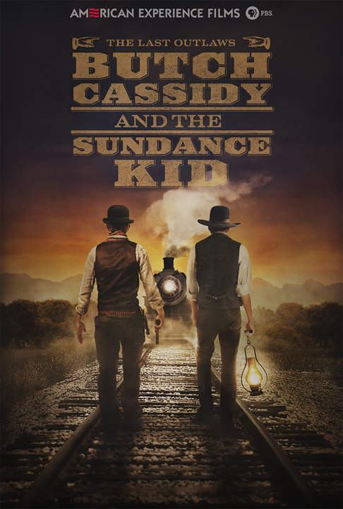
Long before they were immortalized on screen by Paul Newman and Robert Redford, Butch Cassidy and the Sundance Kid captivated Americans from coast to coast. In the 1890s, their thrilling exploits — robbing western banks and trains and then seemingly vanishing into thin air — became front-page news and the basis of rumor and myth. But who were Robert Leroy Parker and Harry Alonzo Longabaugh? What really happened after they formed the Wild Bunch gang? And how did they manage to pull off some of the most spectacular holdups in western history while eluding the Pinkertons, the nation’s largest and most feared private detective force? Separating fact from fiction, the latest installment of the popular American Experience series The Wild West explores the last pair of outlaws to flee on horseback into the setting sun of a vanishing West. Butch Cassidy & the Sundance Kid, produced and directed by John Maggio, premieres on American Experience on Tuesday, February 11, 2014, 9:00-10:00 p.m. ET on PBS (check local listings), preceded by an encore presentation of Billy the Kid, also directed by Maggio, at 8:00 p.m. ET on PBS.

In an era in which cold-blooded killers like Jesse James and the Younger Brothers terrorized the West, Butch Cassidy, the Sundance Kid and their Wild Bunch gang were a new breed of outlaw. Smart and methodical, Cassidy had elevated bank and train robbery to an art form. Born Robert Leroy Parker in 1866, Butch was raised in a devout but poor Mormon family. At age 13, he took a job at a nearby ranch and met a small-time cattle rustler named Mike Cassidy who schooled young Parker on the finer points of larceny. By the time he was 18, Parker was itching to strike out on his own.

Telluride, Colorado was the place for a young man searching for riches and adventure, famed for its saloons, gambling halls and houses of ill repute. Parker soon found work in the mines but quickly tired of the grueling, fruitless labor. Robbing the local bank seemed a much better bet and on June 24th, 1889, he and two new cohorts successfully pulled off the heist. Knowing his crime would break his mother’s heart, Parker changed his name to Butch Cassidy.

Across the country, in the grimy mill town of Phoenixville, Pennsylvania, a young boy named Harry Longabaugh could only dream of a life of adventure on the open range. At age 14, he got his chance when he landed a job on his cousin’s ranch in Cortez, Colorado. He quickly became an admired cowboy but, after a terrible winter that wiped out most of the herds, he turned to crime and was eventually arrested for horse stealing. When Harry emerged from his yearlong stint in jail, he had a new nickname — the Sundance Kid. He retreated to the steep canyons and unforgiving terrain known as the Outlaw Trail that ran from Montana down to New Mexico, and soon met Butch. Says historian Thom Hatch: “They had a lot in common. They both loved horses. They loved to drink. They loved to gamble, and they could talk larceny all day long.”

Boosted by their newly formed gang, the Wild Bunch embarked on a daring and successful spree of bank and train robberies across the West. But their wide-open, freewheeling world was quickly fading into the past. Powerful railroad executives, mining barons and cattle kings were determined to usher in their own modern brand of law and order, and they hired the famed Pinkerton Detective Agency to catch the gang. The Pinkertons had over 2,000 full-time agents and 30,000 paid informants and part-timers and used the most up-to-date crime-fighting techniques. Butch, Sundance and the Wild Bunch were no match for the all-seeing Pinkertons; slowly but surely, members of the gang were captured or killed.

Knowing the only way to elude them was to flee the country, Butch and Sundance escaped to Argentina with Sundance’s companion, the mysterious Etta Place. But even in South America, Butch and Sundance were unable to escape the long arm of the Pinkertons. Forced back into a life of larceny in their attempts to elude old and new enemies, they met their end after a shootout in Bolivia. Yet even in the drama of their deaths, many refused to believe the era of Butch Cassidy and the Sundance Kid had truly come to an end. Says historian Paul Hutton: “We don’t want the outlaws to die. We certainly don’t want them to die the way Butch and Sundance died. As wild as they were, and bad as they were, they still represented something that Americans embrace, that wild freedom. And when they’re gone, the Wild West is gone.”

* * *

About the Participants, in Order of Appearance

Michael Rutter is an author whose books include Wild Bunch Women, Outlaw Tales of Utah, and Myths and Mysteries of the Old West.

Ken Verdoia is a Utah historian, documentarian and journalist based in Salt Lake City.

Thom Ross is a prominent western artist.

Thom Hatch is an award-winning historian and author whose books include The Last Outlaws: The Lives and Legends of Butch Cassidy and the Sundance Kid and Black Kettle: The Cheyenne Chief Who Sought Peace But Found War.

Gerald Kolpan is a Philadelphia-based novelist whose works include Etta, a fictionalized account of the life of Etta Place, purported girlfriend of the Sundance Kid.

Paul A. Hutton is a Professor of History at the University of New Mexico who has written several books on the Old West.

Anne Meadows is the author of Digging Up Butch and Sundance, which recounts the South American adventures of Meadows and her husband, Daniel Buck, while they investigated the question of what really happened to the outlaws once they fled the United States.

About the Filmmakers

Written, Produced and Directed by  Co-Produced by  Edited by  Narrated by  Cinematography by |  | John Maggio  Josh Gleason  Ilya Chaiken  Michael Murphy  Stephen McCarthy  Ben McCoy
Music by |  | Gary Lionelli
An Ark Media and John Maggio Productions film for American Experience

American Experience is a production of WGBH Boston

Senior Producer  Executive Producer |  | Sharon Grimberg  Mark Samels

John Maggio (Producer/Director) is an acclaimed writer, director and producer of documentary films. His work includes several films for FRONTLINE (College, Inc., Growing Up Online) and American Experience (Billy the Kid, The Lobotomist, The Boy in the Bubble, Kinsey, The Fight). Maggio’s films have been honored with the National Emmy Award, Writers Guild Award, an Independent Spirit Award nomination, as well as multiple News and Documentary Emmy Award nominations. His work has premiered at the Sundance Film Festival and has shown at festivals around the world. He most recently completed the four-hour series The Italian Americans, coming to PBS in 2015.

Mark Samels (Executive Producer) was named executive producer of American Experience, PBS’ flagship history series, in 2003. Under Samels’ leadership, the series has been honored with nearly every industry award, including the Peabody, Primetime Emmys, the duPont-Columbia Journalism Award, Writers Guild Awards, Oscar nominations, and Sundance Film Festival Audience and Grand Jury Awards. Samels served on the Board of Governors at the Academy of Television Arts and Sciences. Prior to joining WGBH, Samels worked as an independent documentary filmmaker, an executive producer for several U.S. public television stations, and as a producer for the first co-production between Japanese and American television. A native of Wisconsin, he is a graduate of the University of Wisconsin-Madison.

About American Experience
Television’s most-watched history series, American Experience celebrated its 25th anniversary in 2013. The series has been hailed as “peerless” (The Wall Street Journal), “the most consistently enriching program on television” (Chicago Tribune), and “a beacon of intelligence and purpose” (Houston Chronicle). On air and online, the series brings to life the incredible characters and epic stories that have shaped America’s past and present. Acclaimed by viewers and critics alike, American Experience documentaries have been honored with every major broadcast award, including 30 Emmy Awards, four duPont-Columbia Awards, and 16 George Foster Peabody Awards, one most recently for the series represented by Freedom Riders, Triangle Fire and Stonewall Uprising.

Exclusive corporate funding for American Experience is provided by Liberty Mutual Insurance. Major funding provided by the Alfred P. Sloan Foundation, the Corporation for Public Broadcasting and Public Television Viewers. American Experience is produced for PBS by WGBH Boston.

* * *

Publicity Contacts:

CaraMar Publicity
Mary Lugo 770-623-8190 lugo@negia.net
Cara White 843-881-1480 cara.white@mac.com
Abbe Harris 908-233-7990 abbe@caramar.net

For further information and photos visit http://www.pbs.org/pressroom

