American Experience Casa Susanna
Premieres Tuesday, June 27, 2023, on PBS and Streaming on PBS.org

New Documentary Offers a Fascinating Window Into a Secret Chapter
of LGBTQ+ History

(BOSTON, MA) – In the 1950s and ’60s, an underground network of transgender women and cross-dressing men found refuge at a modest house in the Catskills region of New York. Known as Casa Susanna, the house provided a safe place to express their true selves and live for a few days as they had always dreamed—dressed as and living as women without fear of being incarcerated or institutionalized for their self-expression. Told through the memories of those who visited the house, the film provides a moving look back at a secret world where the persecuted and frightened found freedom, acceptance and, often, the courage to live out of the shadows. A co-production with ARTE, Casa Susanna is directed by the critically acclaimed French filmmaker Sébastien Lifshitz (Wild Side, Little Girl, Bambi) and executive produced by Cameo George. Winner of the Grand Jury Prize at the 2022 DOC NYC Festival, Casa Susanna premieres Tuesday, June 27, 2023, 9:00-11:00 p.m. ET (check local listings) on PBS, PBS.org and the PBS App.
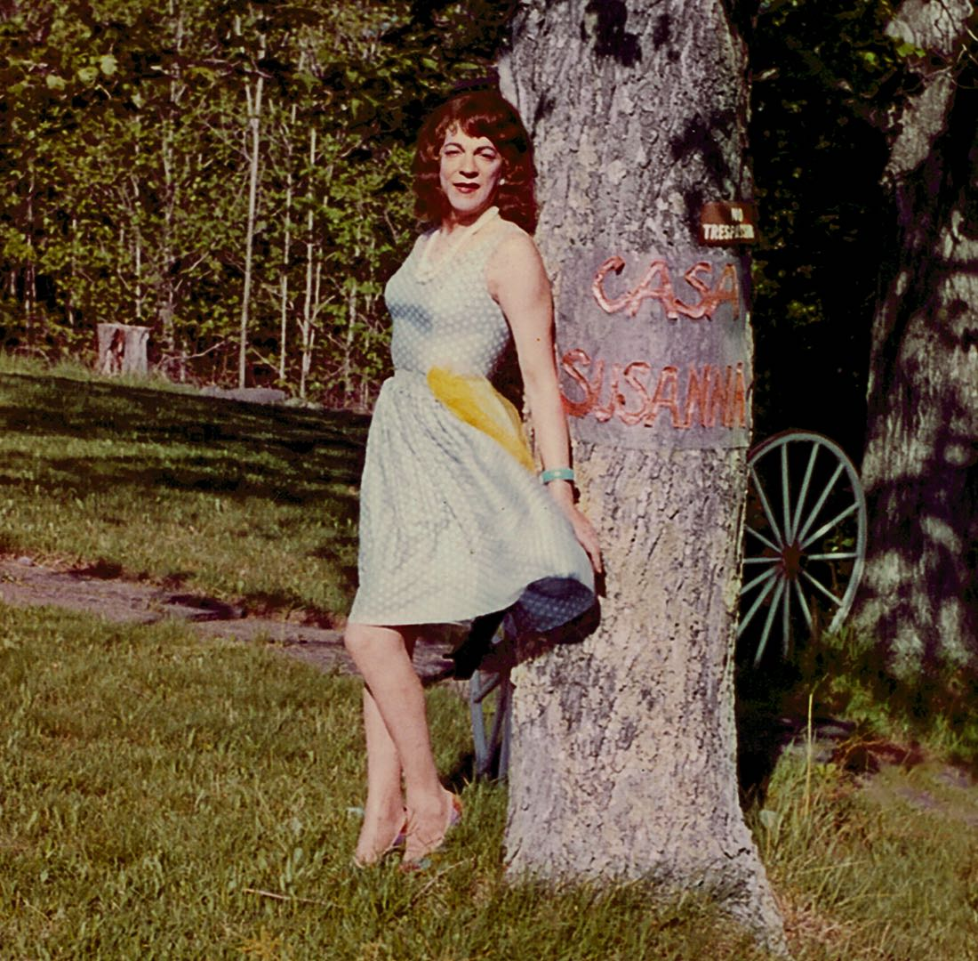
Credit: Collection of Cindy Sherman

Using a rich trove of color photos of Casa Susanna’s guests, archival footage and personal remembrances, the film introduces us to Diana and Kate, two people whose lives were forever changed at Casa Susanna. We join them as they travel back to the now-abandoned site and share their memories of a time when people like them, from all over the country, came to a place where they were free to dress and live as women from morning to night. They found each other and the refuge of Casa Susanna through word-of-mouth and Transvestia, a magazine for and by the trans and cross-dressing community.

The film also recounts the forgotten life of Susanna Valenti, the courageous woman who ran the house. From her enlistment in the army as a man to her marriage to Marie, an eccentric older Italian woman, Susanna led a life that, even today, many would find hard to imagine. Like Susanna, many who came to the Catskills house had ordinary jobs, were in heterosexual marriages and had fathered children.

Also featured is Betsy Wollheim, who discovered that her father was a regular visitor to Casa Susanna after his death. Gregory Bagarozy, Marie’s grandson, shares warm memories of unconventional summers at his grandmother’s home. Together their stories provide a fascinating and moving look at a forgotten moment in queer history.

“I have been lucky enough to be able to bring this secret history, this invisible world, back to life with the help of Kate, Diana, Betsy and Gregory,” says filmmaker Sébastien Lifshitz. “Now their story, the story of this clandestine community, is there for all to see. The unsettled nature of their existences and their bravery ring loud and clear.”

Says Cameo George, American Experience Executive Producer: “People think that the transgender movement is something very new, but that is because queer history has been marginalized and hidden for so long. This film, in a beautiful and touching way, brings an important chapter of that history to light, confirming that this community is and has been a part of the American story.”

American Experience Casa Susanna will stream for free simultaneously with broadcast until July 26 on all station-branded PBS platforms, including PBS.org and the PBS App, available on iOS, Android, Roku, Apple TV, Amazon Fire TV, Android TV, Samsung Smart TV, Chromecast and VIZIO. All titles will also be available for streaming with closed captioning in English and Spanish.

Participants in Order of Appearance

Katherine Cummings (deceased) was born in Scotland in 1935 and realized as a child that she was attracted to feminine attire. In college, she researched scientific literature for a better understanding of what that meant, but the literature gave no clue. Moving to Australia, Kate obtained a copy of the underground magazine called Transvestia, which allowed her to correspond with a network of US-based trans women and cross-dressers. In 1960, she moved to Toronto to continue her English studies and was able to frequent Casa Susanna. Working as a librarian all her life, Kate (then John Cummings) married and had three children before opting for gender affirmation surgery in the late ’80s. She published an autobiography in 1992 and became an activist for transgender people's rights.

Betsy Wollheim (she/her) is the president, co-publisher and co-editor-in-chief of Daw Books, a science-fiction and fantasy publishing house. Her father, Donald Wollheim, was a well-known science fiction writer. After his death, she discovered he had belonged to the Casa Susanna community, with his wife's support. In 1966, under a pseudonym, Wollheim published A Year Among the Girls to tell the story of his life as a cross-dresser at Casa Susanna.

Diana Merry-Shapiro (she/her) was born into an Iowa farming family in 1939. Her mother's religious culture and the general prejudices of the era prevented her from letting anyone know how badly she wanted to be a girl. As a student, she discovered the Transvestia network and subsequently New York's Casa Susanna. There she met Katherine Cummings and Gloria, a well-known benefactress of the Casa Susanna community, who soon enabled a trip to Tijuana, Mexico, for Diana’s gender affirmation surgery. She then embarked on a brilliant career as a computer programmer at the Xerox Company's Palo Alto Research Center. As one of the original co-inventors of the Smalltalk programming language, she helped write the first system for overlapping display windows. Diana lives with Carol, her wife of 30 years, in New York City.

Gregory Bagarozy (he/him) was born in 1951 in New York City and raised in a traditional Italian-American family, whose lynchpin was his grandmother, Marie Tonell. A fiercely independent woman, Marie ran a Fifth Avenue wigmakers shop that soon became a haunt for the city's cross-dressing and transgender community. Tito Arriagada (later known as Susanna Valenti) entered the store in search of a wig, not realizing he would meet the woman who changed his life. Marie and Tito married in 1958, and their Catskills estate became a haven for the cross-dressing and transgender community. Gregory grew up in this unusual ambiance, remaining close to Marie and Tito/Susanna till the day they died.

American Experience Casa Susanna

A Film By
SÉBASTIEN LIFSHITZ

Produced by |  | MURIEL MEYNARD
In Collaboration With |  | ISABELLE BONNET
Editing |  | TINA BAZ
Sound |  | FRANCOIS ABDELNOUR
 |  | FANNY MARTIN
 |  | JEANNE DELPLANCQ
 |  | DANIEL SOBRINO
Cinematography |  | PAUL GUILHAUME, A.F.C.

In Association with BBC Storyville

An Agat Films Production for American Experience
and Arte France

American Experience is a production of GBH Boston
Executive Producer | CAMEO GEORGE

About the Filmmakers

Sébastien Lifshitz (Director) was born in 1968 in Paris, France. After studying art history at the Ecole du Louvre, he decided to devote himself to cinema and directed his first feature film, Come Undone, in 2000, which was acclaimed by critics and distributed worldwide. This was followed by the documentary The Crossing (2001), selected for the Directors’ Fortnight in Cannes, then Wild Side (2004) and Bambi (2016), both of which won awards at the Berlin Film Festival. After The Invisibles (2012), an official selection at the Cannes Film Festival, and The Lives of Thérèse (2017) at the Directors’ Fortnight, he directed two new documentaries: Adolescents, awarded at the Locarno Film Festival, winner of Louis-Delluc Prize for Best Film and of three Césars in 2021, and Little Girl, presented at the Berlin Film Festival in 2020 and distributed worldwide, including in the United States, in 2022.

Cameo George (Executive Producer, American Experience) is an Emmy Award-winning producer, writer and journalist with more than 20 years of experience in documentary, broadcast television and digital content production. George has produced, developed and commissioned innovative programming at CNN, NBC News and ABC News. She was the senior producer of CNN’s groundbreaking series Black in America and Latino in America and executive producer of the eight-hour PBS documentary series 16 FOR '16: THE CONTENDERS, which was also broadcast on the BBC. George joined American Experience from ABC News, where she was head of development for long-form projects, responsible for creating a pipeline of docuseries and feature documentary films across Walt Disney Television platforms, including ABC News, Hulu, National Geographic and Disney+.

About American Experience

For 35 years, American Experience has been television’s most-watched history series, bringing to life the incredible characters and epic stories that have shaped America’s past and present. American Experience documentaries have been honored with every major broadcast award, including 30 Emmy Awards, five duPont-Columbia Awards and 19 George Foster Peabody Awards. PBS’s signature history series also creates original digital content that innovates new forms of storytelling to connect our collective past with the present. Cameo George is the series executive producer. American Experience is produced for PBS by GBH Boston. Visit pbs.org/americanexperience and follow us on Facebook, Twitter, Instagram and YouTube to learn more.

Major funding for American Experience provided by Liberty Mutual Insurance and by the Alfred P. Sloan Foundation. Funding for Casa Susanna provided by members of The Better Angels Society including The Fullerton Family Charitable Fund and Philip I. Kent through the Philip I. Kent Charitable Fund, Brian A. McCarthy Foundation, and Angoa and Procirep – Société Des Producteurs. Additional funding for American Experience provided by the Robert David Lion Gardiner Foundation, The Documentary Investment Group, the Corporation for Public Broadcasting and public television viewers.

* * *
Contacts:
CaraMar Publicity
Mary Lugo 770-851-8190 lugo@negia.net
Cara White 843-881-1480 cara.white@mac.com
Abbe Harris 908-244-5516 abbe.harris@caramar.net

For further information and photos visit http://www.pbs.org/pressroom

