“Chasing the Moon”

Premieres Monday-Wednesday, July 8-10, 2019 on PBS

TCA Panelists

Susan Bellows (Series Producer) is an award-winning producer and writer with more than 20 years of experience producing national programs for public television. Bellows most recently served as the writer, director and producer for The Bombing of Wall Street, which premiered on American Experience in February 2018. She was also the producer and director on the four-hour JFK, which premiered in 2013. Since joining the series in 2003, she has provided editorial support and guidance to its broadcast and new media work. Previously, Bellows served as senior producer for the Peabody and Emmy Award- winning series Africans in America. Her other producing credits include films for The Great Depression, for which she received an Emmy nomination, and America’s War On Poverty, both productions of Blackside, Inc. Bellows also co-produced New Worlds, New Forms for the WNET-produced series Dancing, an eight-hour landmark series on dance forms around the world.
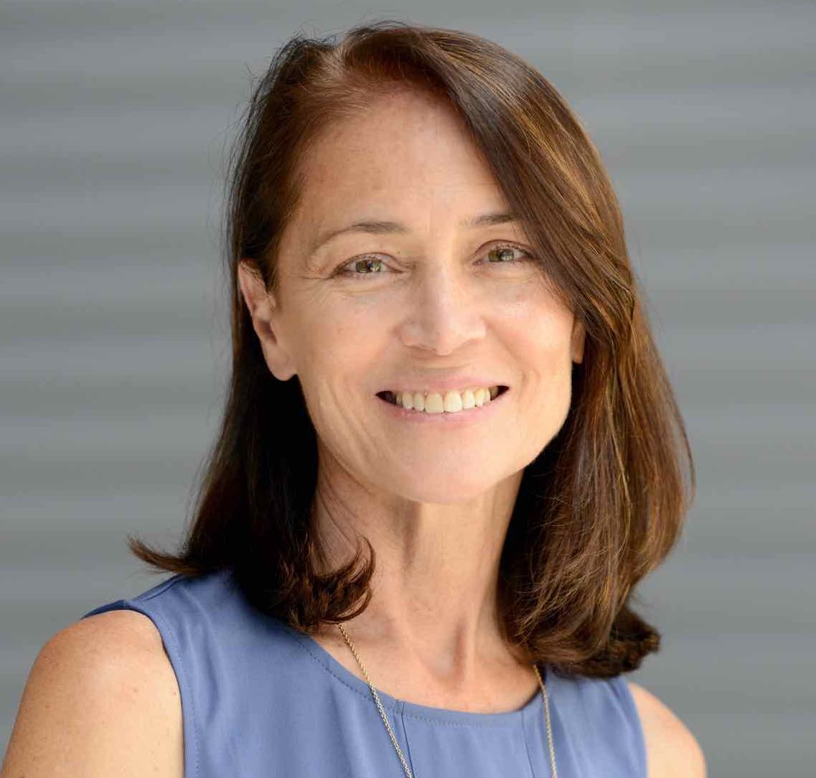

Mark Bloom (Participant), a lifelong journalist, covered his biggest story at the age of 30 — the 1969 Apollo 11 moon landing and safe return to Earth. At the time, he was the science editor of the New York Daily News. Earlier, he had been a correspondent for Reuters in New York where his diverse assignments included the invasion of the Beatles; the visits of Prince Philip, Princess Margaret and the Pope; General Assemblies and Security Council sessions at the United Nations; President Johnson’s gall bladder surgery in Washington; and, from Cape Canaveral and Houston, all 10 Gemini Earth-orbital missions. At The News, he covered the advent of human heart transplantation, Robert Kennedy’s assassination, the Apollo 1 fire and the Congressional hearings that followed, the two unmanned Saturn 5 moon-rocket tests, all 11 Apollo missions, Apollo-Soyuz, the three Skylab missions, and he was a press pool reporter for the Pacific splashdown of the final Apollo. Since his aerospace correspondent days, he has turned to medical writing and editing, working for such physician-oriented news publications as Medical World News, Physician’s Weekly, and the website MedPage Today. Most recently, he has been a freelance contributor to the Post and Courier of Charleston, South Carolina. He lives in New York and Charleston with his partner, Susan Lyons, a retired journalist.
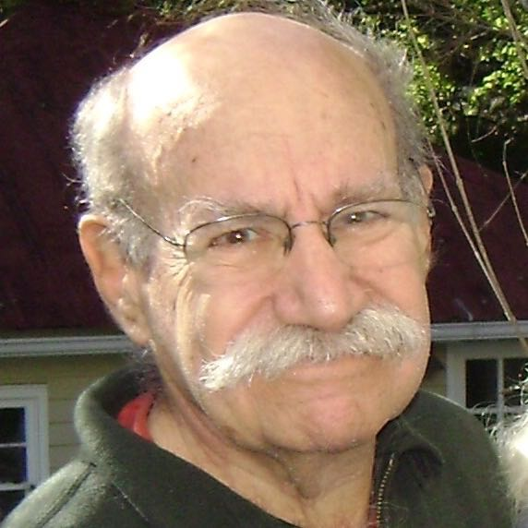

Poppy Northcutt (Participant), a return-to-Earth specialist on the Apollo Program, became the first woman to work in an operational support role in NASA’s Mission Control Center with the flight of Apollo 8. She was a member of the mission operations team that received the Presidential Medal of Freedom for the rescue of Apollo 13. She also received the Apollo Achievement Award and the “Silver Snoopy” flight safety award for her work on Apollo 11.
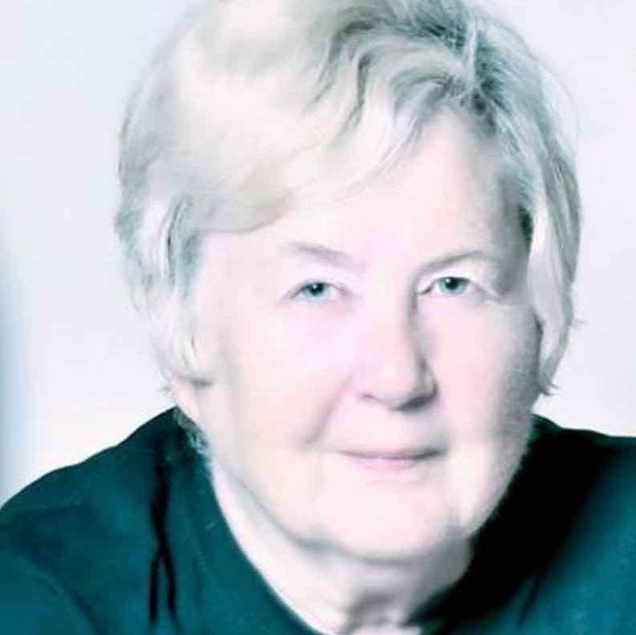

In mid-life, Northcutt attended law school at the University of Houston Law Center, where she
graduated summa cum laude. She clerked for a federal appellate judge, and then prosecuted and
later defended criminal cases. While working as a prosecutor, she was instrumental in starting the Domestic Violence Unit at the Harris County District Attorney’s Office, where she served as the unit's first felony prosecutor. In private practice, she specialized in criminal trial and appellate work, mainly handling serious felonies, including capital murder cases. Now semi-retired, she is a referral lawyer for Jane’s Due Process, a non-profit organization that provides legal services for pregnant teenage girls.

Northcutt is currently the president of both the Houston Area Chapter of the National Organization for Women, Inc. (NOW) and of Texas State NOW. She served on the national board of directors of NOW in the 1970s and was the founding chair of the Harris County Women's Political Caucus, the first Women’s Advocate for the City of Houston, also in the 1970s. She served as a special conference consultant to the U.S. Department of State’s International Women’s Year (IWY) Commission organizing the National Women's Conference, which was held as the U.S. Observance of International Women’s Year. She was the co-coordinator of the Texas Women’s Credentials Challenge during the 1972 Democratic National Convention, part of a national effort on the part of the Women’s Political Caucus to increase the representation of women as delegates at all levels of the Democratic Party. She currently serves as a volunteer deputy voter registrar and as a Democratic Party precinct chair in Harris County.

Northcutt frequently speaks on women’s rights issues and on the role of women in the space
program. She has been featured in numerous magazine and newspaper articles and in several
documentaries about the space program, including “Makers: Women Who Make America” and
NOVA “Apollo’s Daring Mission.”

Robert Stone (Director/Editor/Producer) is a multi-award-winning, Oscar and Emmy-nominated documentary filmmaker. Born in England, he grew up in both Europe and America. After graduating with a degree in history from the University of Wisconsin-Madison, he moved to New York City in 1983 to pursue a career in filmmaking. He gained considerable recognition for his first film, Radio Bikini (1987), which premiered at Sundance, was nominated for an Academy Award for Best Feature Documentary and was the first of his films to premiere on American Experience.
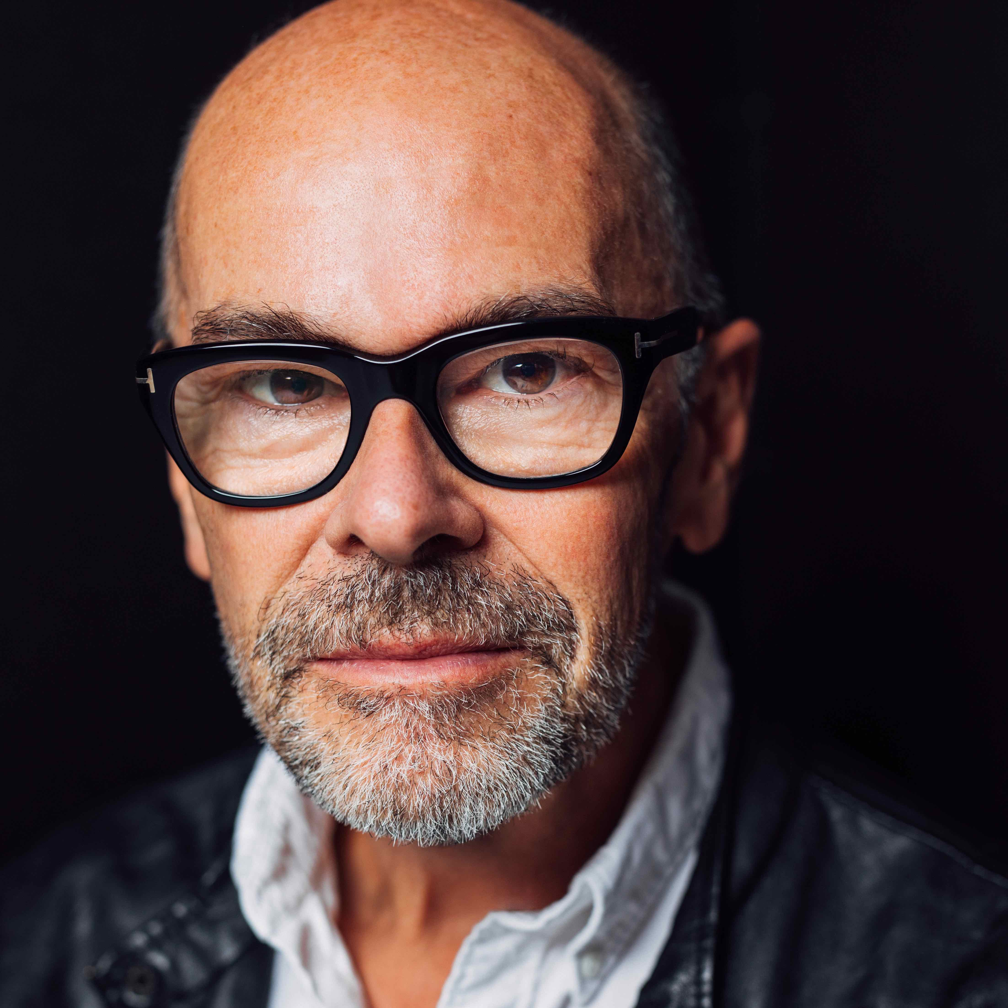

His best-known work includes Guerrilla: The Taking of Patty Hearst (2004), which premiered at Sundance and went on to become one of the most highly acclaimed theatrical documentaries of the year. That was followed by the documentary feature Oswald’s Ghost (2007), for which Stone earned a second Emmy nomination for Outstanding Achievement in Non-Fiction Filmmaking. Earth Days premiered as the Closing Night Film at the 2009 Sundance Film Festival and was released theatrically to wide critical acclaim. His most recent (and most controversial) film, Pandora’s Promise, premiered at the 2013 Sundance Film Festival, won the prestigious Green Award at the Sheffield Documentary Film Festival and was broadcast on CNN in 2013. In addition to Radio Bikini, Guerrilla, Oswald’s Ghost and Earth Days, Stone also produced The Satellite Sky, Civilian Conservation Corps and Cold War Roadshow for American Experience.

