American Experience “Citizen Hearst”
TCA Panelists

Participants

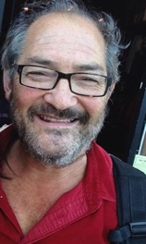
Gary Kamiya (Participant) was born in Oakland, California, grew up in Berkeley and has lived in San Francisco since 1971. He was a culture critic and senior editor at the San Francisco Examiner before co-founding Salon.com, where he was the longtime executive editor and a columnist. He was the executive editor of San Francisco Magazine for five years. His first book, Shadow Knights: The Secret War Against Hitler, was a critically acclaimed dramatic history of Britain’s top-secret World War II organization, the Special Operations Executive. His bestselling second book, Cool Gray City of Love: 49 Views of San Francisco, won the Northern California Book Award in creative nonfiction in 2013. His new book, with artist Paul Madonna, is Spirits of San Francisco: Voyages Through the Unknown City. His award-winning San Francisco history column, “Portals of the Past,” has run for more than eight years in the San Francisco Chronicle.
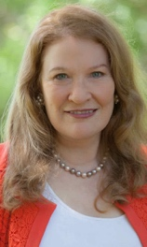

Victoria Kastner (Participant) is the author of the new volume Julia Morgan: An Intimate Biography of the Trailblazing Architect, which reveals the fascinating life of the woman who designed Hearst Castle at San Simeon. Kastner spent decades as its official historian and has also written several books on the history of this glamorous estate.

Filmmakers

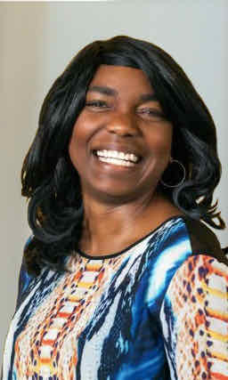
Cameo George (American Experience Executive Producer) is an Emmy Award-winning producer, writer and journalist with more than 20 years of experience in documentary, broadcast television and digital content production. George has produced, developed and commissioned innovative programming at CNN, NBC News, ABC News and digital media startup OZY.com. She was the senior producer of CNN’s groundbreaking series Black in America and Latino in America and the executive producer of the eight-hour PBS documentary series 16 for '16: The Contenders, which was also broadcast on the BBC. George joined American Experience from ABC News, where she was Head of Development for Longform projects, responsible for creating a pipeline of docuseries and feature documentary films across Walt Disney Television platforms including ABC News, Hulu, National Geographic and Disney+.

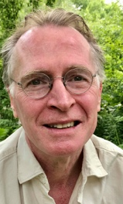
Stephen Ives (Director/Writer) is an Emmy Award-winning writer and director who has established himself as one of the nation’s leading documentary filmmakers. His landmark series The West was one of the most-watched PBS programs of all time. In 1987, Ives began a decade-long collaboration with Ken Burns as a co-producer of a history of the United States Congress and a consulting producer on the groundbreaking series The Civil War and Baseball.

After the premiere of The West, Ives produced a profile of the Cornerstone Theater Company, which aired on HBO in the fall of 1999, and Amato: A Love Affair with Opera, which aired on PBS in 2001 and earned him a nomination from the Directors Guild of America for Outstanding Directorial Achievement. His profile of 1930s thoroughbred Seabiscuit (American Experience, 2003) won multiple Emmy Awards, and his PBS series, Reporting America At War, was described by the Los Angeles Times as “television that matters…a visual document of power and clarity.” His other films for American Experience include Lindbergh, Las Vegas, New Orleans, Kit Carson, Roads to Memphis, Panama Canal, Custer’s Last Stand, Grand Coulee Dam, 1964, The Big Burn, Sealab and The Great War, for which he received a Writers Guild Award.

