“Command and Control”

Premieres Winter 2017

TCA Panelists

Participants

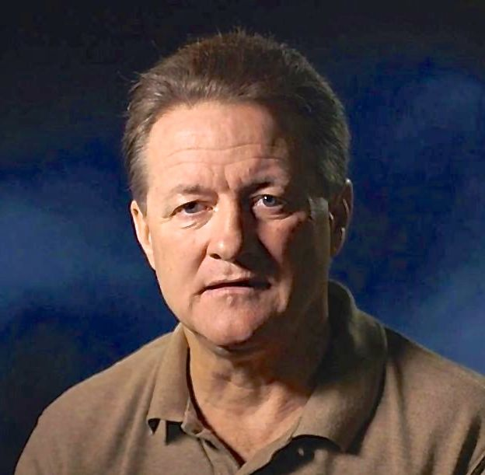
Greg Devlin was a Senior Airman on Propellant Transfer System Team B and part of the volunteer unit that entered the Titan II Missile silo after it was evacuated on September 18, 1980, because of a fuel leak. Born in Cincinnati, Ohio, Devlin joined the U.S. Air Force right out of high school at 17. Soon after completing basic training at Lackland AFB in San Antonio, Texas, he married his childhood sweetheart, to whom he has remained married for almost 39 years. While serving in the Air Force from 1977-1981, he became an Arkansas Golden Gloves Champion. After leaving the Air Force, Devlin worked at the Kennedy Space Center for many years as a life support technician and supervisor. Now retired, Devlin is a resident of Titusville, Florida, and the co-founder of an educational children’s book series called the Neon Tiki Tribe.
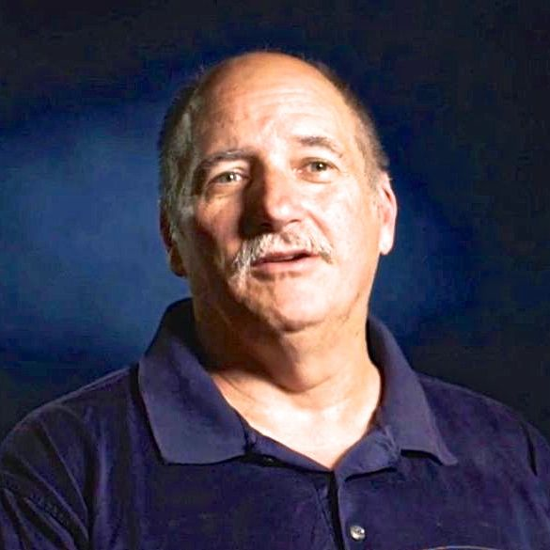

Dave Powell was a 21-year-old Titan II repairman on Propellant Transfer System Team A performing routine maintenance on the afternoon of the Damascus incident. Following his service in the military, Powell spent 23 years in the communications industry wiring commercial buildings for voice, data, security and cable television. After selling his commercial vending company he has been working in express logistics at the Greater Cincinnati Airport. Married for 32 years, Powell lives in Cold Spring, Kentucky, and has three children.

Filmmakers


Robert Kenner (Producer/Director/Co-Writer) has won an array of awards and garnered rave reviews for his documentary work exposing some of today’s least addressed, yet critical social and environmental issues. His film Food, Inc. was nominated for an Academy Award and won two Emmys. His most recent documentary, Merchants of Doubt, inspired by the acclaimed book by Naomi Oreskes and Erik Conway, lifted the curtain on a secretive group of pundits-for-hire who present themselves in the media as scientific authorities — yet whose contrary aim is to spread maximum confusion about well-studied public threats ranging from toxic chemicals to pharmaceuticals to climate change. Kenner received Peabody, Emmy and Grierson Awards for his American Experience film Two Days in October, an examination of two key events during the Vietnam conflict and how they shaped Americans’ views of the war. Other films for American Experience include Influenza 1918, John Brown’s Holy War and War Letters. Kenner was also co-filmmaker with Richard Pearce on The Road to Memphis for Martin Scorsese’s series The Blues. He has directed a number of specials for HBO and National Geographic, including the award-winning Don’t Say Goodbye. Kenner has also directed a number of award-winning commercials and corporate videos for eBay, Hewlett Packard, Hallmark and others.


Mark Samels (Producer/Executive Producer of American Experience). As executive producer of PBS’s flagship history series, Mark Samels conceives, commissions and oversees all American Experience films. Samels has overseen more than 120 films, expanding both the breadth of subjects and the filmmaking style embraced by the series, allowing for more contemporary topics and more witness-driven storytelling. Beginning his career as an independent documentary filmmaker, he held production executive positions at public television stations in West Virginia and Pennsylvania before joining WGBH. Samels is a founding member of the International Documentary Association and has served as a governor of the Academy of Television Arts & Sciences. A graduate of the University of Wisconsin, Samels holds honorary Doctor of Humane Letters degrees from Emerson College and Elizabethtown College.

###

