American Experience Command and Control
Premieres Tuesday, January 10, 2017
9:00-11:00 p.m. ET on PBS

High-Stakes Documentary Thriller Exposes Long-Hidden Story of One of America’s Most Dangerous Nuclear Accidents

“Robert Kenner’s documentary, based on Eric Schlosser's terrifying book of the same name, combines Cold War-era thriller with post-apocalyptic nightmare. And given it’s all true, this one will stay with you for days after viewing.” — Rolling Stone
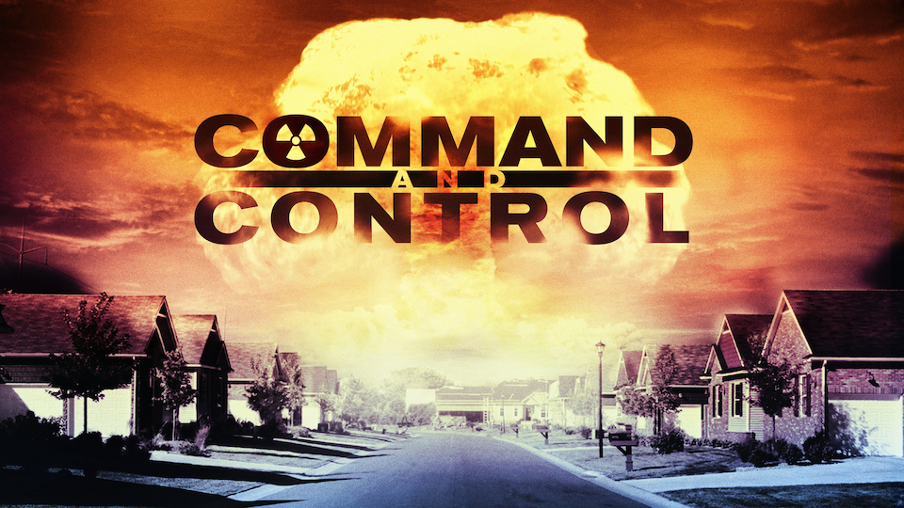
(BOSTON, MA) — A cautionary tale of freak accidents, near misses, human fallibility, and extraordinary heroism, Command and Control exposes the terrifying truth about the management of America’s nuclear arsenal and shows what can happen when the weapons built to protect us threaten to destroy us. The film recounts, in chilling, minute-by-minute detail, the story of a deadly 1980 accident at a Titan II missile complex in Damascus, Arkansas. Through the first-person accounts of Air Force personnel, weapon designers and first responders who were on the scene, the film reveals the unlikely chain of events that caused the accident and the feverish efforts to prevent the explosion of a ballistic missile carrying the most powerful nuclear warhead ever built by the United States — 600 times more powerful than the bomb that destroyed Hiroshima. Directed by Academy Award-nominated filmmaker Robert Kenner (Food Inc.) and based on the critically acclaimed book of the same title by Eric Schlosser (Fast Food Nation), Command and Control premieres on American Experience Tuesday, January 10, 2017, 9:00-11:00 p.m. ET (check local listings) on PBS.
On the evening of September 18, 1980, Airmen David F. Powell and Jeffrey L. Plumb were performing routine maintenance at the Titan II silo in Damascus, Arkansas. At the age of 21, Powell was considered a highly experienced missile technician; Plumb, who had just turned 19, was still in training. As the two stood on a platform near the top of the Titan II, a socket fell from Powell’s wrench, plummeted 70 feet and, shockingly, punctured the missile. A stream of highly explosive rocket fuel began pouring into the silo.

Nothing like this had ever happened to a Titan II before and the Air Force had no procedures in place to deal with the event. For the next eight hours, the leadership of the Strategic Air Command (SAC) frantically struggled to figure out how to prevent a massive explosion and retain control of the thermonuclear warhead — a weapon so powerful that it could destroy much of Arkansas and deposit lethal radioactive fallout across the East Coast.

“The story of the Damascus accident is one that nobody really knows, and in fact, I’m not sure anybody’s supposed to know,” said Mark Samels, producer of Command and Control and American Experience executive producer. “As safe and secure and as well-designed and well-operated as our nuclear weapons system may be, it’s subject to the x-factor. And the x-factor is human fallibility. The most powerful weapons that we’ve ever created as human beings have a threat built into them. And that threat is us.”

“Today the U.S. still has approximately 7,000 nuclear weapons. Command and Control teaches us that these weapons not only pose a threat to our enemies, but also to ourselves,” said Kenner. “After an accident, everyone will be asking why we didn’t do something. We need to be asking these questions before it’s too late.”

Woven through the Damascus story is a riveting history of America’s nuclear weapons program, from World War II through the Cold War, much of it based on recently declassified documents. A cautionary tale filmed in an abandoned Titan II missile silo in Arizona, Command and Control forces viewers to confront the great dilemma that the U.S. has faced since the dawn of the nuclear age: How do we manage weapons of mass destruction without being destroyed by them?

PBS Distribution will release Command and Control on DVD and Digital HD on January 10, 2017. The film can be purchased at ShopPBS.org.

The Participants, in Alphabetical Order

Harold Brown was U.S. Secretary of Defense from 1977 to 1981.

Lieutenant Allan D. Childers was the deputy commander of the Titan II Missile Combat Crew in Damascus, Arkansas.

Senior Airman Greg Devlin was on Propellant Transfer System Team B.

Mona Harper was a Damascus resident at the time of the accident.

Staff Sergeant Rodney L. Holder was the ballistic missile systems analyst technician responsible for keeping the Titan II at Damascus ready to launch.

Sam Hutto is a dairy farmer whose land was across from the Damascus missile site.

Sid King was the 27-year old manager of a local radio station in nearby Clinton, Arkansas.

Bud Laumer was an airman on duty at the Titan II Missile complex in Damascus.

Col. John T. Moser was commander of the 308th Strategic Missile Wing at the Little Rock Command Post.

Bob Peurifoy was an engineer who joined the nuclear weapons-building Sandia Laboratory in 1952 and subsequently became its leading advocate for nuclear weapon safety.

Airman Jeffrey L. Plumb was a 19-year-old on Propellant Transfer System Team A at the Titan II Missile complex in Damascus.

Senior Airman David Powell was a 21-year-old Titan II repairman on Propellant Transfer System Team A in Damascus.

David H. Pryor was a U.S. Senator from Arkansas from 1979 to 1997.

James L. “Skip” Rutherford III was a staffer in the Little Rock office of Arkansas Senator David H. Pryor.

Senior Airman James R. Sandaker was a young missile technician on Propellant Transfer System
Team B.

Col. Ben G. Scallorn was a Titan II expert at the Eighth Air Force at Barksdale Air Force Base in Louisiana.

Eric Schlosser is the author of The New York Times bestseller Command and Control.

Bill Stevens (deceased) was an engineer who became the first head of Sandia’s nuclear safety department.

About the Filmmakers

A Robert Kenner Films production for American Experience

Directed by | Robert Kenner
Screenplay by | Robert Kenner and Eric Schlosser
Story by | Brian Pearle and Kim Roberts
Based on the Book | Command and Control by Eric Schlosser
Produced by | Robert Kenner, Melissa Robledo, Mark Samels, and Eric Schlosser
Edited by  Directors of Photography  Music by | Kim Roberts, A.C.E.  Paul Goldsmith and Jay Redmond  Mark Adler

American Experience is a production of WGBH Boston
Senior Producer | Susan Bellows
Executive Producer | Mark Samels

Robert Kenner (Producer/Director/Co-Writer) has won an array of awards and garnered rave reviews for his documentary work exposing some of today’s least addressed, yet critical social and environmental issues. His film Food, Inc. was nominated for an Academy Award and won two Emmys. His most recent documentary, Merchants of Doubt, inspired by the acclaimed book by Naomi Oreskes and Erik Conway, lifted the curtain on a secretive group of pundits-for-hire who present themselves in the media as scientific authorities — yet whose contrary aim is to spread maximum confusion about well-studied public threats ranging from toxic chemicals to pharmaceuticals to climate change. Kenner received Peabody, Emmy and Grierson Awards for his American Experience film Two Days in October, an examination of two key events during the Vietnam conflict and how they shaped Americans’ views of the war. Other films for American Experience include Influenza 1918, John Brown’s Holy War and War Letters. Kenner was also co-filmmaker with Richard Pearce on The Road to Memphis for Martin Scorsese’s series The Blues. He has directed a number of specials for HBO and National Geographic, including the award-winning Don’t Say Goodbye. Kenner has also directed a number of award-winning commercials and corporate videos for eBay, Hewlett Packard, Hallmark and others.

As an investigative journalist, Eric Schlosser (Producer/Co-Writer) tries to explore subjects ignored by the mainstream media and give voice to people at the margins of society. Schlosser’s first book, Fast Food Nation (2001), helped start a revolution in how Americans think about what they eat. It has been translated into more than 20 languages and remained on The New York Times best-seller list for two years. His second book, Reefer Madness (2003), looked at America’s thriving underground economy and was also a New York Times best-seller. Command and Control (2013) was a finalist for the 2014 Pulitzer Prize (history), a New York Times Notable Book and best-seller, a Time Magazine Top 10 Nonfiction Book and won the Gold Medal Award (nonfiction) from the 2013 California Book Awards. An expanded version of Schlosser’s New Yorker article, “Break-In at Y-12,” was recently published as Gods of Metal (2015) in the United Kingdom, New Zealand and Australia. Gods of Metal explores the risk of nuclear terrorism by telling the story of three Catholic pacifists who broke into one of the most heavily guarded nuclear weapons facilities in the world. His next book is about the American prison system.

Two of Schlosser’s plays, Americans (2003) and We the People (2007), have been produced in London. He served as an executive producer of the films Fast Food Nation (2006), There Will Be Blood (2008), Food Chains (2014) and Hanna Ranch (2014), and as a co-producer of the Oscar-nominated documentary Food, Inc.

Mark Samels (Producer/Executive Producer of American Experience). As executive producer of PBS’ flagship history series, Mark Samels conceives, commissions and oversees all American Experience films. Samels has overseen more than 130 films, expanding both the breadth of subjects and the filmmaking style embraced by the series, allowing for more contemporary topics and more witness-driven storytelling. Beginning his career as an independent documentary filmmaker, he held production executive positions at public television stations in West Virginia and Pennsylvania before joining WGBH. Samels is a founding member of the International Documentary Association and has served as a governor of the Academy of Television Arts & Sciences. A graduate of the University of Wisconsin, Samels holds honorary Doctor of Humane Letters degrees from Emerson College and Elizabethtown College.

About American Experience
For more than 28 years, American Experience has been television’s most-watched history series. The series has been hailed as “peerless” (The Wall Street Journal), “the most consistently enriching program on television” (Chicago Tribune) and “a beacon of intelligence and purpose” (Houston Chronicle). On air and online, the series brings to life the incredible characters and epic stories that have shaped America’s past and present. Acclaimed by viewers and critics alike, American Experience documentaries have been honored with every major broadcast award, including 30 Emmy Awards, four duPont-Columbia Awards and 17 George Foster Peabody Awards; the series received an Academy Award® nomination for Best Documentary Feature in 2015 for Last Days in Vietnam. Visit pbs.org/americanexperience and follow us on Facebook, Twitter, Instagram and YouTube to learn more.

Exclusive corporate funding for American Experience provided by Liberty Mutual Insurance. Major funding provided by the Alfred P. Sloan Foundation. Additional funding for Command and Control provided by the John D. and Catherine T. MacArthur Foundation, the Corporation for Public Broadcasting and public television viewers. American Experience is produced for PBS by WGBH Boston.

Additional funding for a national impact campaign for Command and Control provided by the John D. and Catherine T. MacArthur Foundation and Carnegie Corporation of New York.

* * *
Press Contacts:
CaraMar Publicity
Mary Lugo 770-623-8190 lugo@negia.net
Cara White 843-881-1480 cara.white@mac.com
Abbe Harris 908-244-5516 abbe.harris@caramar.net

For further information and photos, visit pbs.org/pressroom.

Image credit: ©WGBH Educational Foundation

