American Experience Jubilee Singers: Sacrifice and Glory

To Have Encore Broadcast on Tuesday, November 19, 2019 on PBS

A Group of Former Slaves Battle Prejudice and Oppression

to Sing Their Way Into the World’s Heart

(BOSTON, MA) — On November 16, 1871, a group of unknown singers –all but two of them former slaves and many of them still in their teens – arrived at Oberlin College in Ohio to perform before a national convention of influential ministers. After a few standard ballads, the a cappella chorus began to sing spirituals such as “‘Steal Away’ and other songs associated with slavery and the dark past, sacred to our parents,” as soprano Ella Sheppard recalled. It was one of the first public performances of the secret music African Americans had sung in fields and behind closed doors. Jubilee Singers: Sacrifice and Glory, produced by Llewellyn Smith, tells the story of a group of former slaves who battled prejudice and oppression to sing their way into the world’s heart. Eventually, they would perform for presidents and queens, tour the United States and Europe, and establish songs like “Swing Low, Sweet Chariot” and “This Little Light of Mine” as a cherished part of the nation’s musical heritage. Jubilee Singers: Sacrifice and Glory, featuring contemporary Fisk Jubilee Singers and narrated by Dion Graham, will have an encore presentation on American Experience Tuesday, November 19, 2019, 9:00-10:00 p.m. ET (check local listings) on PBS.
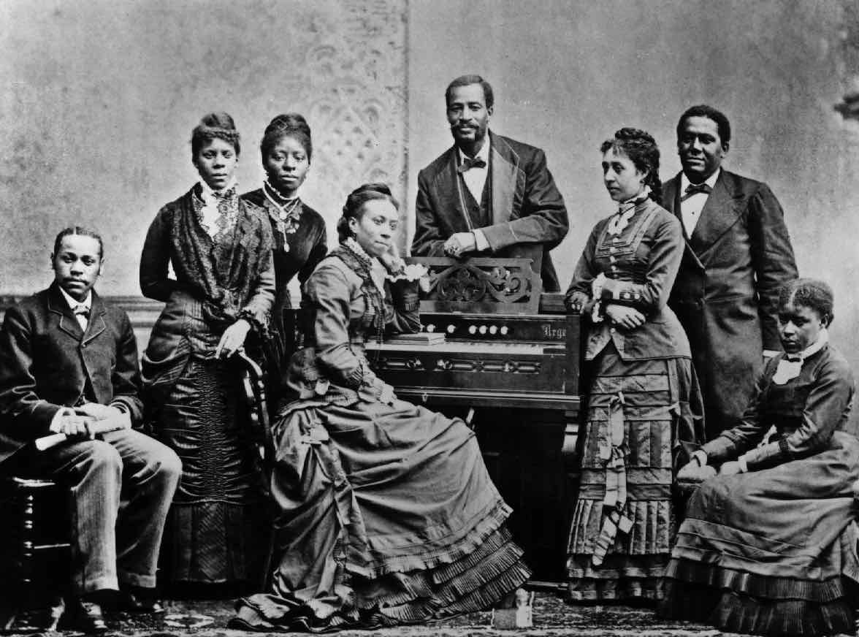
Credit: Fisk University Archives

The concert in Oberlin was the turning point in a daring fundraising experiment for impoverished Fisk University in Nashville, Tennessee, where the singers were students. Established in January 1866, Fisk taught freed slaves how to count their wages, how to write the new names they had chosen for themselves, and read both the ballot and the Bible. Despite emancipation, the South was a dangerous place. Fisk students who dared teach in the countryside were routinely assaulted and whipped by Ku Klux Klan nightriders, including one who one was shot at in his classroom and another who had her school building burned to the ground.
Charged with keeping the financially troubled school afloat, treasurer George Leonard White proposed taking Fisk’s most gifted singers on a fundraising tour of the North. Before they even left town, they encountered resistance: the parents were afraid to let their children go. White’s fellow teachers opposed the tour, and the American Missionary Association — the northern religious organization that operated Fisk — refused to help, worried that the chorus’s appeal for funds would jeopardize their own fundraising activities. But White persevered.
Following the path of the Underground Railway, the group made its debut in Cincinnati. Despite the warm reception, donations totaled less than $50. Night after night, it was the same: crowds loved their singing, but the collection plate yielded barely enough to cover their expenses. Yet no one turned back.
Life on the road took its toll. White and the singers endured rheumatism, bronchitis, chronic coughs. Their clothes ran to rags. But after the triumphant Oberlin performance, word started to spread. In December, the Jubilee Singers appeared at Henry Ward Beecher’s weekly prayer meeting at Brooklyn’s Plymouth Church. “Every church wanted the Jubilee Singers from that time on,” wrote Maggie Porter. They sang for Mark Twain, President Ulysses S. Grant, congressmen, and diplomats.
After less than two weeks of rest, the singers were back on the road, touring the Eastern United States. Eventually they would tour Europe to universal acclaim and sing for the royal families of Holland, Germany, and Britain.
The group raised what today would be millions of dollars, but they paid a terrible price. Worn down by the relentless schedule, an advance man suffered a nervous breakdown. George White lost his wife to typhoid fever. White himself nearly died of a pulmonary hemorrhage. Contralto Minnie Tate’s voice was torn to shreds. Tenor Benjamin Holmes’s nagging cough was a symptom of his tuberculosis. They faced discrimination on the road and from the press. A grueling tour of Germany — 98 days, 41 towns, 68 concerts — brought with it low morale, frayed nerves, and rivalries among the singers.
After almost seven years of touring, the Jubilee Singers returned home. They were honored by Fisk for raising the funds to complete Jubilee Hall and save their school.
But their contributions extended far beyond Fisk University. They had introduced the world to the power of spirituals and challenged racial stereotypes on two continents. “In their wake, hotels, railways, steamship lines, and boards of education integrated their facilities. The Jubilees not only introduced the world to the music of black America, they championed the liberties of all Americans,” says Andrew Ward, co-writer of the documentary and author of Dark Midnight When I Rise: The Story of the Jubilee Singers. More than 125 years later, the Jubilee Singers of Fisk University continue the concert tradition begun by that courageous original chorus of former slaves.

About the Filmmakers

Produced and Directed by | Llewellyn Smith
Written by | Llewellyn Smith & Andrew Ward
Senior Creative Consultant | Andrew Ward
Edited by | Jean Boucicaut
Principal Cinematography | Michael Chin
Original Score by | Tom Phillips
Narrated by | Dion Graham

Produced with the assistance of Nashville Public Television

American Experience is a production of WGBH Boston

Senior Producer  Executive Producer | Susan Bellows  Mark Samels

Mark Samels (Executive Producer) conceives, commissions and oversees all films for the PBS flagship history series American Experience. Samels has overseen more than 130 films, expanding both the breadth of subjects and the filmmaking style embraced by the series, allowing for more contemporary topics and witness-driven storytelling. Beginning his career as an independent documentary filmmaker, he held production executive positions at public television stations in West Virginia and Pennsylvania before joining WGBH. Samels is a founding member of the International Documentary Association and has served as a governor of the Academy of Television Arts & Sciences. A graduate of the University of Wisconsin, Samels holds honorary Doctor of Humane Letters degrees from Emerson College and Elizabethtown College.

About American Experience
For 30 years, American Experience has been television’s most-watched history series. Hailed as “peerless” (The Wall Street Journal), “the most consistently enriching program on television” (Chicago Tribune) and “a beacon of intelligence and purpose” (Houston Chronicle), the series brings to life the incredible characters and epic stories that have shaped America’s past and present. American Experience documentaries have been honored with every major broadcast award, including 30 Emmy Awards, four duPont-Columbia Awards and 17 George Foster Peabody Awards; the series received an Academy Award nomination for Best Documentary Feature in 2015 for Last Days in Vietnam. American Experience also creates original digital content that uses new forms of storytelling to connect our collective past with the present. Visit pbs.org/americanexperience and follow us on Facebook, Twitter, Instagram and YouTube to learn more.

Major funding for American Experience provided by Liberty Mutual Insurance, Consumer Cellular and by the Alfred P. Sloan Foundation. Additional funding for Jubilee Singers provided by the Ford Foundation. Additional funding for American Experience provided by the Robert David Lion Gardiner Foundation, The Documentary Investment Group, the Corporation for Public Broadcasting and public television viewers. American Experience is produced for PBS by WGBH Boston.

* * *
Publicity Contacts
CaraMar Publicity
Mary Lugo 770-623-8190 lugo@negia.net
Cara White 843-881-1480 cara.white@mac.com
Abbe Harris 908-244-5516 abbe.harris@caramar.net

For further information and photos visit http://www.pbs.org/pressroom

