American Experience: Nixon
Encore Broadcast
Thursday, August 11, 2016
8:00-11:00 p.m. ET on PBS

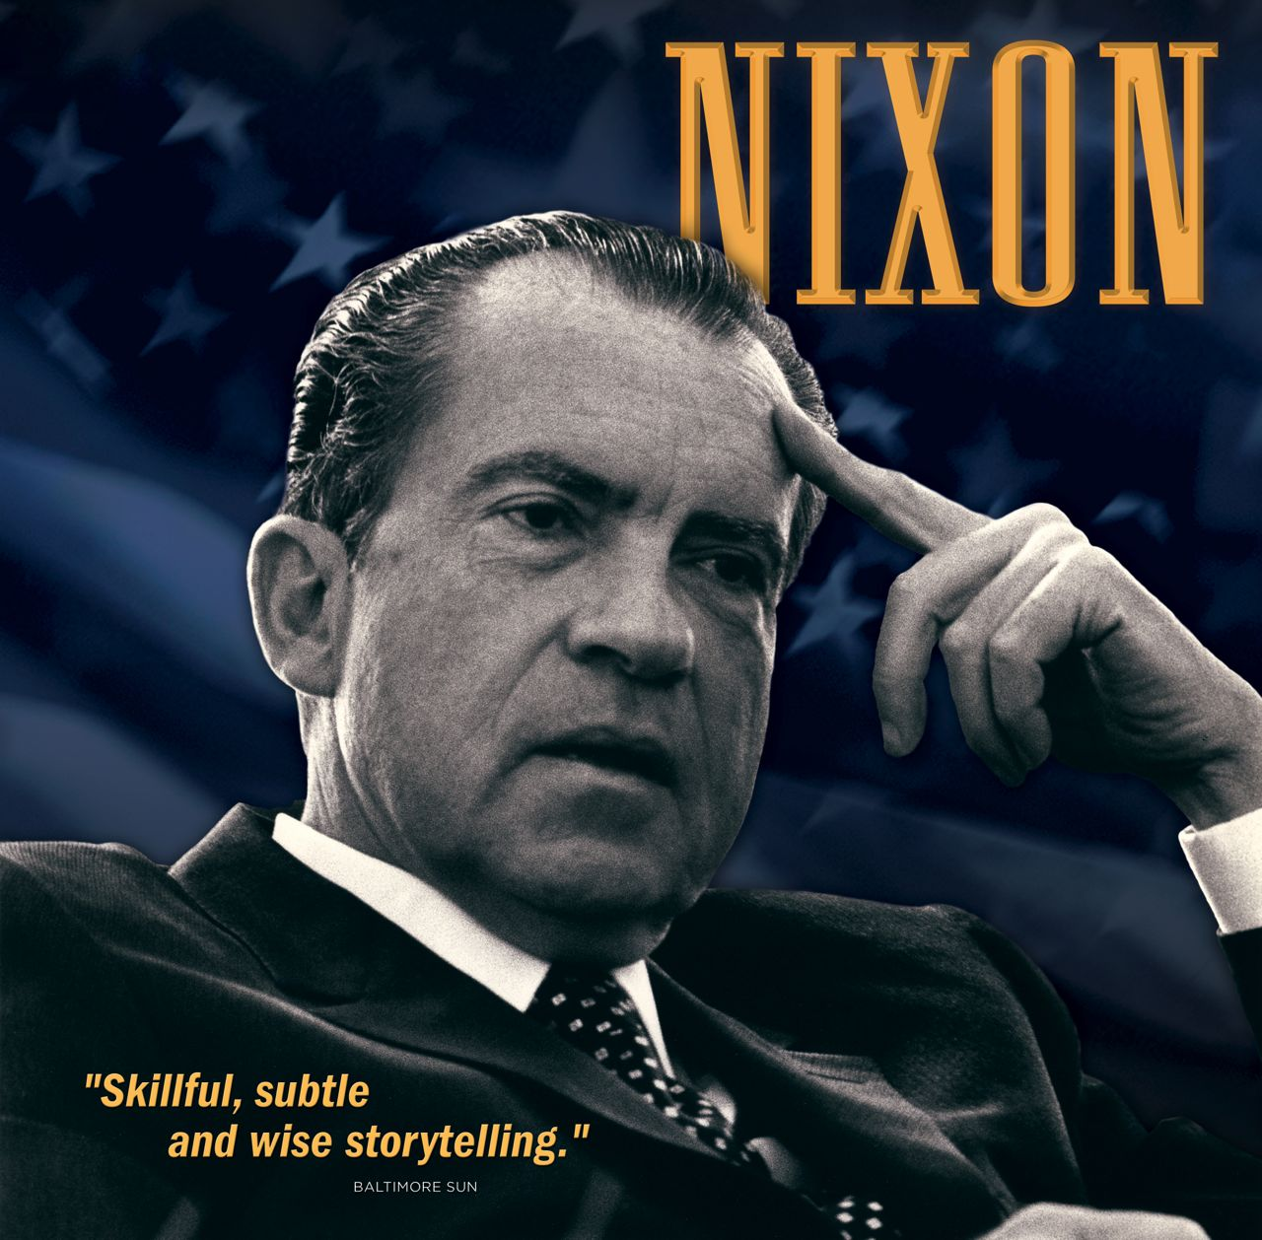
(BOSTON, MA) – Winner of a Writers Guild Award and part of the American Experience Peabody Award-winning collection The Presidents, Nixon explores one of the most controversial and enduring figures on the American political landscape. Featuring interviews with former presidential aides John Ehrlichman, Charles Colson, and John Dean, along with many others, Nixon will have an encore broadcast on Thursday, August 11, 2016, 8:00-11:00 p.m. ET (check local listings) on PBS.

Nixon traces the president’s life from his boyhood in Loma Linda, California, through his resignation from office in the face of likely impeachment in 1974. The film puts his life and career in the context of history to reveal how he shaped, and was shaped by, American politics, and explores the fateful combination of strengths and weaknesses that propelled him to the presidency and then brought him down. Although Nixon does not deal with the post-presidential years, it highlights one of the most distinctive characteristics of his path through American politics — his ability to come back from defeat.

Because Nixon rose to power as television came of age, many of the key moments in his career are also important moments in the history of the medium — moments that remain etched in national memory: the “Checkers” speech in 1952, the Kennedy-Nixon presidential debates in 1960, Nixon’s handshake with Chou En-Lai as he landed in Peking in 1972, and the final wave before the helicopter slowly lifted from the White House lawn after the president’s resignation in August 1974.

Nixon’s story is told by many who were close to him, including former presidential aides Ehrlichman, Colson, and Dean, along with his cousin, Merle West, who grew up with him in California; Duke Law School classmate Lyman Brownfield; early campaign staffers Patrick Hillings and Ted Rogers; Nixon biographer Roger Morris, who served as an aide to Henry
Kissinger in the first Nixon administration; journalist David Broder; and Watergate committee counsel Sam Dash.

Nixon is a production of WGBH Boston in association with Thames Television. The executive producer is Elizabeth Deane. Part 1 is produced and edited by David Espar and written by Geoffrey C. Ward. Associate Producer: Laura Stuchinsky. Part 2 is produced by Elizabeth Deane and written by Geoffrey C. Ward. Editor: Sarah Holt. Associate Producer: Karen Cariani. Consulting Producer: David Espar. Part 3 is produced by Marilyn Mellowes and written by Geoffrey C. Ward. Daniel McCabe is co-producer. Associate Producer: Karen Cariani. Original Music: Todd Boekelheide.

American Experience is a production of WGBH Boston. Senior Producer: Susan Bellows. Managing Director: James E. Dunford. Executive Producer: Mark Samels.

American Experience recently launched The Presidents, an all-new digital portal showcasing more than 750 assets from the Peabody Award-winning collection of films about our nation’s most important leaders. The portal allows viewers to screen full-length films, delve deeper with experts and living witnesses, and examine more than 200 primary source documents. Video galleries on The Presidents site explore how different presidents faced issues including the economy, war, dealing with a crisis, and abuses of power.

The National Endowment for the Humanities (NEH), an independent federal agency, has been a major funder of American Experience’s The Presidents for more than 20 years.

Films from The Presidents series are available on DVD at shopPBS.org or wherever DVDs are sold. Films are also available to download on iTunes.

Exclusive corporate funding for American Experience provided by Liberty Mutual Insurance. Major funding provided by the Alfred P. Sloan Foundation. Major funding for The Presidents provided by the National Endowment for the Humanities: Celebrating 50 Years of Excellence. Additional funding provided by the Corporation for Public Broadcasting and public television viewers. American Experience is produced for PBS by WGBH Boston.

About American Experience
For more than 28 years, American Experience has been the nation’s most-watched television history series. It has been hailed as “peerless” (The Wall Street Journal), “the most consistently enriching program on television” (Chicago Tribune), and “a beacon of intelligence and purpose” (Houston Chronicle). On air and online, the series brings to life the incredible characters and epic stories that have shaped America’s past and present. Acclaimed by viewers and critics alike, American Experience documentaries have been honored with every major industry award, including 30 Emmy Awards, four duPont-Columbia Awards, and 17 George Foster Peabody Awards; the series received an Academy Award® nomination for Best Documentary Feature in 2015 for Last Days in Vietnam.

Press Contacts:
CaraMar, Inc.
Mary Lugo 770-623-8190 lugo@negia.net
Cara White 843-881-1480 cara.white@mac.com
Abbe Harris 908-244-5516 abbe.harris@caramar.net

For further information and photos visit http://www.pbs.org/pressroom

Signature Image Credit: © WGBH Educational Foundation. Image of Richard Nixon courtesy of Richard Nixon Presidential Library.

