American Experience Presents Ripley: Believe It or Not

Premieres Winter 2015 on PBS

TCA Panelists

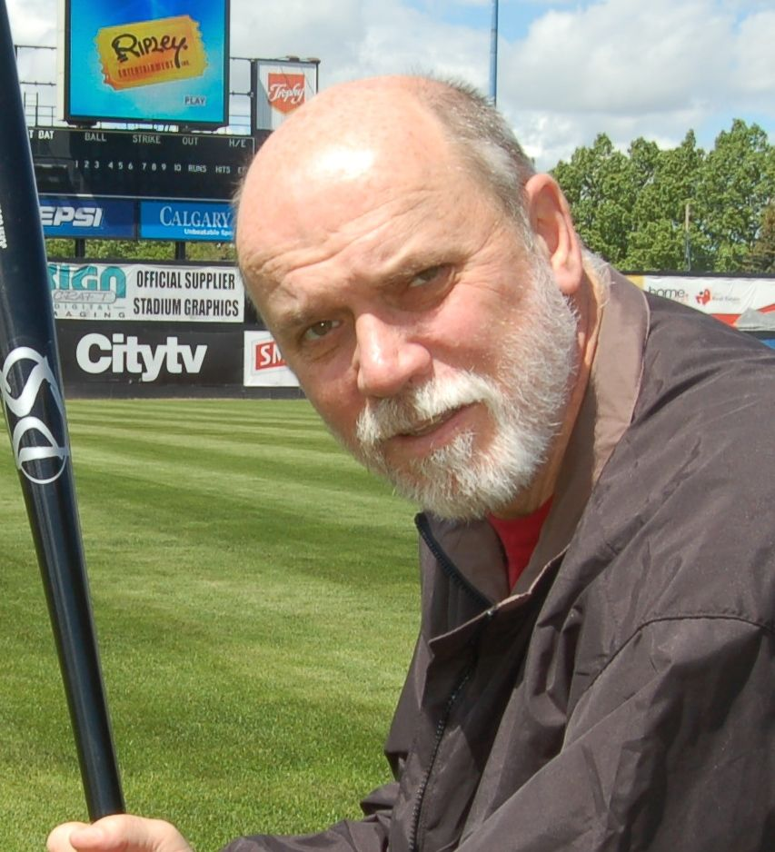Edward Meyer (Panelist) is vice president of Exhibits & Archives for Ripley’s Believe It or Not! For more than 30 years he has traveled around the world collecting unusual stories and unbelievable artifacts to fill Believe It or Not! books and museums. He is a walking encyclopedia of information, some strange, some gross — but all true! He has acquired more than 20,000 different museum artifacts, everything from a pin valued at $1 million dollars to a two-trunked elephant to Marilyn Monroe’s lingerie to Lee Harvey Oswald’s mortuary toe tag to a meteorite from Mars. Editor of the famous Ripley’s Believe It or Not! syndicated cartoon, producer of countless Ripley museum films and a researcher for more than 200 Ripley television shows, Meyer has appeared on radio and television programs around the world as the Ripley historian and raconteur.

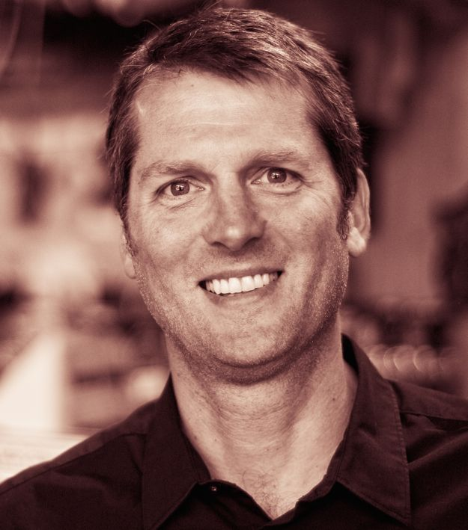Neal Thompson (Panelist) is the author of A Curious Man: The Strange and Brilliant Life of Robert “Believe It or Not!” Ripley, published in June 2013 by Crown, and now out in paperback. He is also the author of three other nonfiction books. A former journalist, Neal has worked at The Philadelphia Inquirer, The St. Petersburg Times and The Baltimore Sun, and has written for Outside, Esquire, Sports Illustrated and Men's Health. He and his books have been featured on NPR, ESPN, the History Channel, Fox, and TNT. Neal lives in Seattle with his wife and two skateboarding sons. Since 2011, he has worked as an editor, reviewer and interviewer on the books team at Amazon.com, where he oversees the Best Books of the Month program.

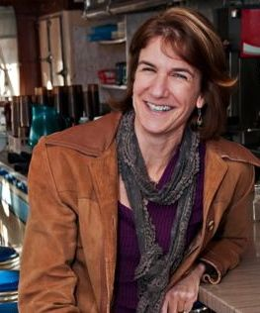Cathleen O’Connell (Producer/Director) has worked in the documentary field for more than 25 years on both nationally broadcast PBS documentaries and independent films. Her previous work for American Experience includes producer/director of War of the Worlds; co-producer for two episodes of God in America, “A New Adam” and “A New Eden” (a coproduction with FRONTLINE); coordinating producer for We Shall Remain, a five-part mini-series that surveyed Native history in America from the 1600s to the 21st century; and re-creations producer for John and Abigail Adams. A recent PBS credit includes re-creations producer for The Latino Americans. In 2013, O’Connell’s independently produced documentary Sousa on The Rez was broadcast nationally on the WORLD Channel and exhibited at the Smithsonian’s National Museum of the American Indian. Her non-broadcast work includes producing videos for the Veteran Administration’s About Face campaign, an initiative designed to educate veterans and their families about PTSD.

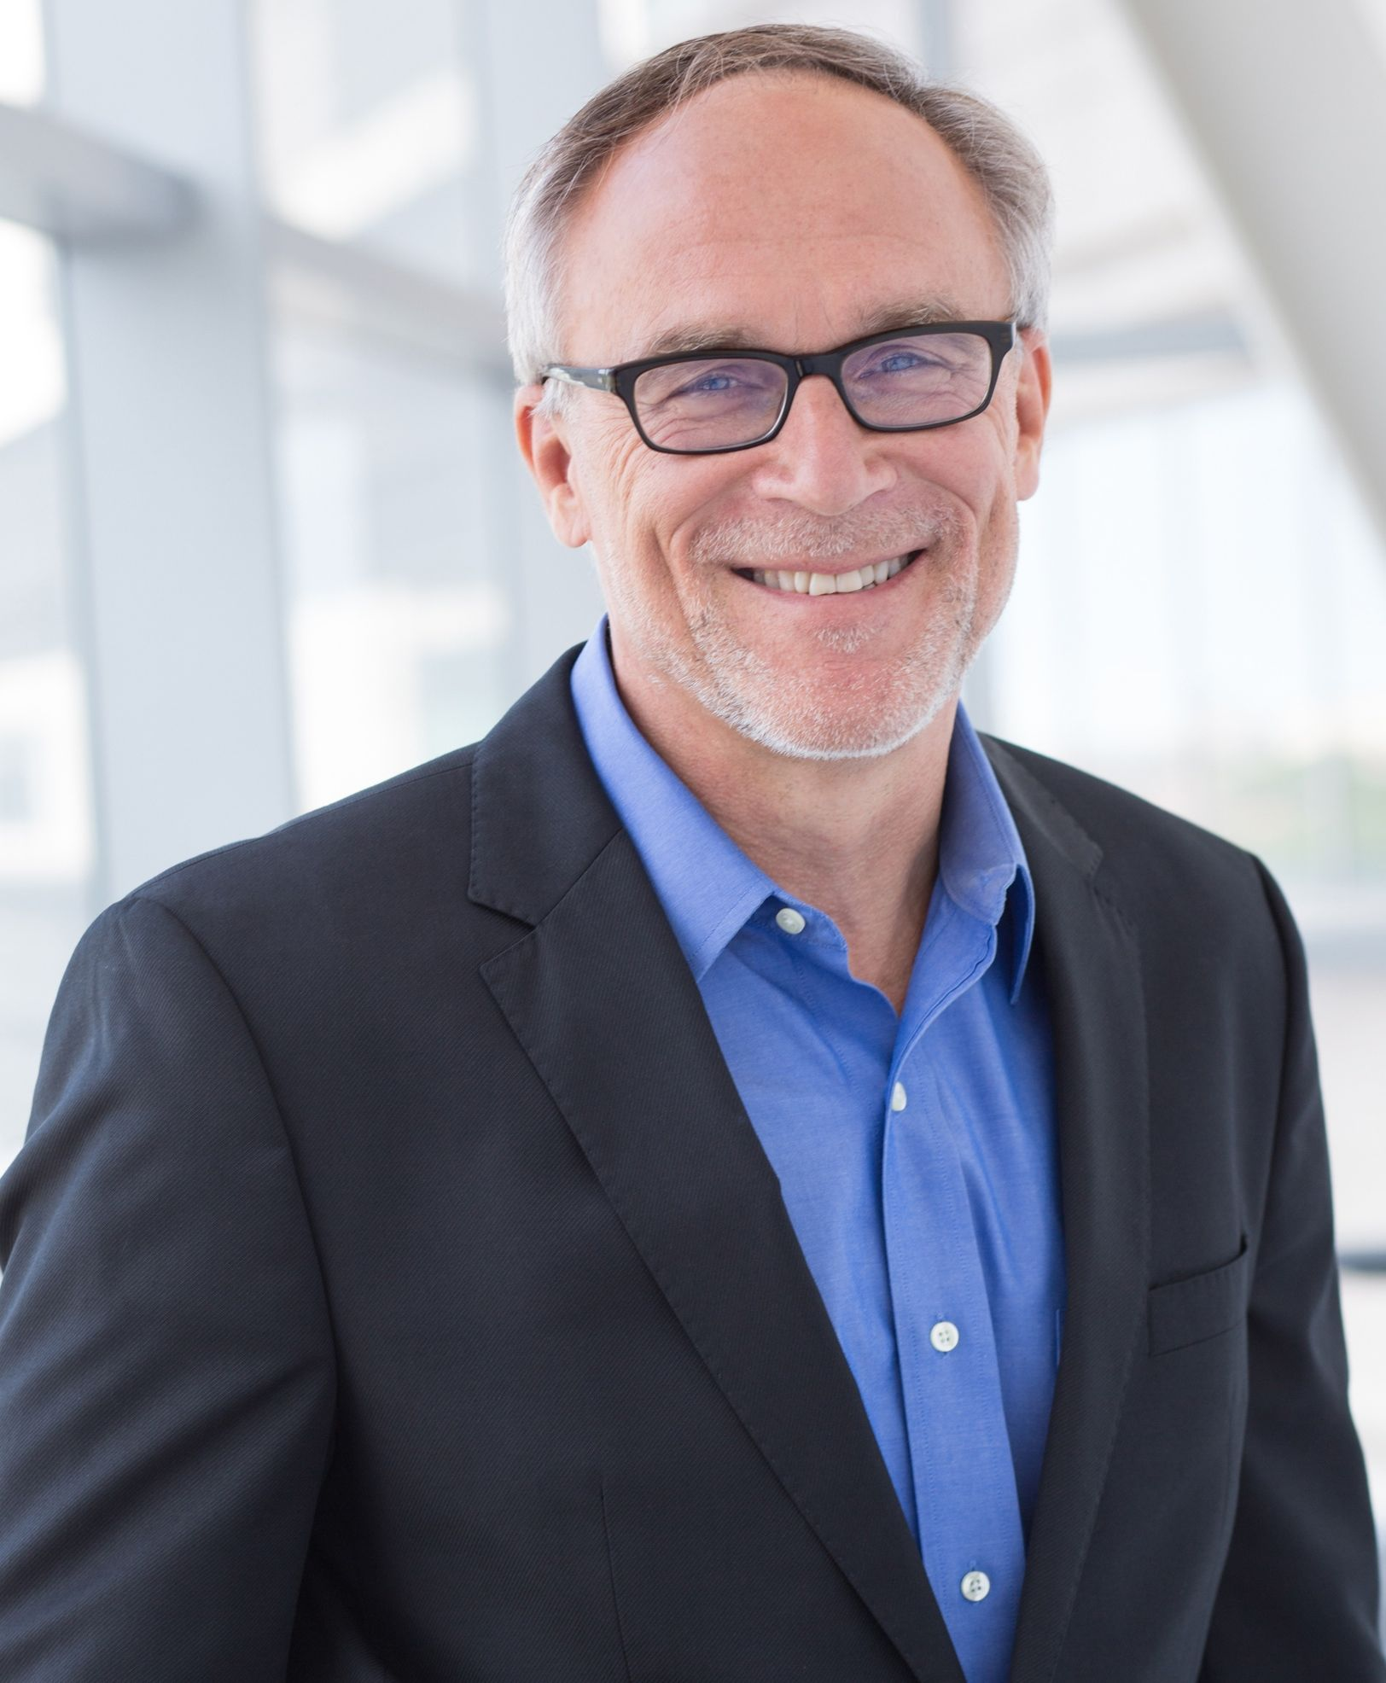Mark Samels (Executive Producer) was named executive producer of American Experience, PBS’ flagship history series, in 2003. Under Samels’ leadership, the series has been honored with nearly every industry award, including the Peabody, Primetime Emmys, the duPont-Columbia Journalism Award, Writers Guild Awards, Oscar nominations, and Sundance Film Festival Audience and Grand Jury Awards. Prior to joining WGBH, Samels worked as an independent documentary filmmaker, an executive producer for several U.S. public television stations and as a producer for the first co-production between Japanese and American television. A native of Wisconsin, he is a graduate of the University of Wisconsin-Madison.

