“Oklahoma City”
Premieres Tuesday, February 7

“Ruby Ridge”
Premieres Tuesday, February 14

TCA Panelists

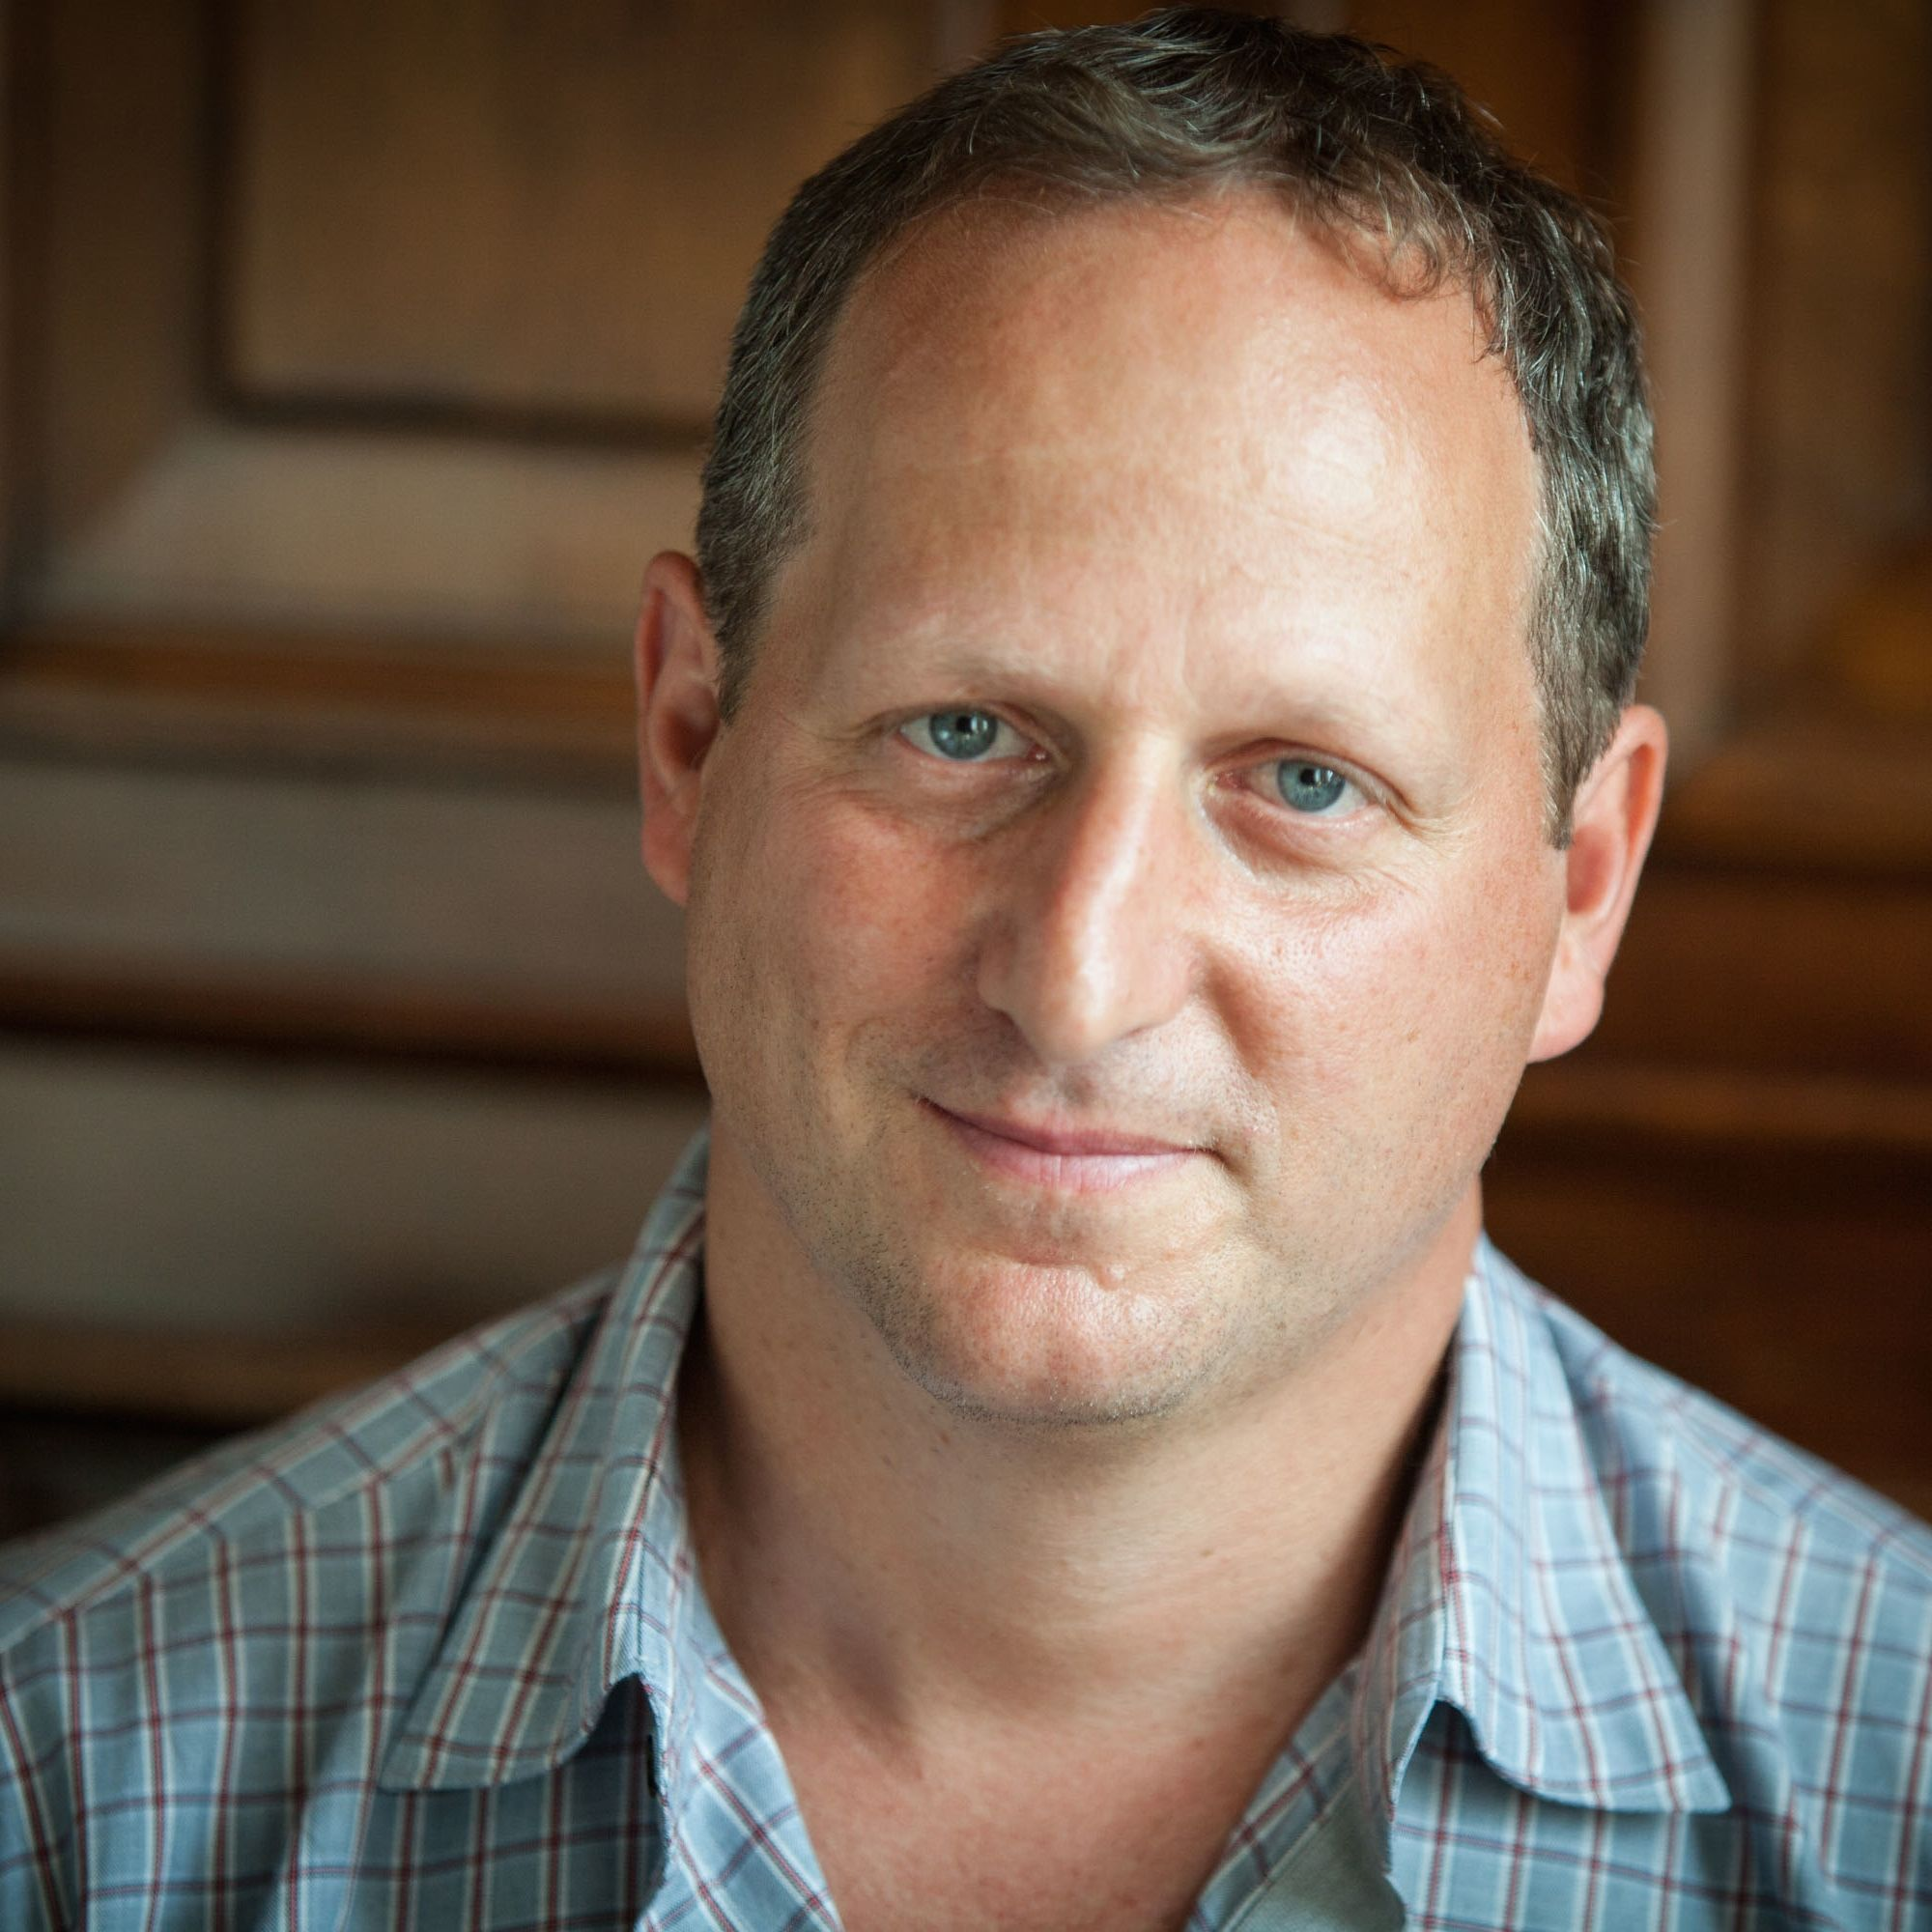
Barak Goodman (Writer/Director/Producer) is co-founder of Ark Media and a principal producer, director and writer with the company. His films for Ark Media have been nominated for an Academy Award and won multiple Emmys, duPont-Columbia and Peabody Awards, the RFK Journalism Prize, and three times been official selections at the Sundance Film Festival. He was the series director and producer of “Cancer: The Emperor of All Maladies,” based on the Pulitzer Prize-winning book by Siddhartha Mukherjee, and he directed, produced and wrote “Makers,” the first comprehensive history of the modern women’s movement. In addition to “Oklahoma City” and “Ruby Ridge,” his work for American Experience includes “Clinton,” a four-hour biography of Bill Clinton, “My Lai,” the story of America's most notorious war crime, and “Scottsboro,” about the arrest and trials of eight African-American teenagers for rape in Depression-era Alabama.
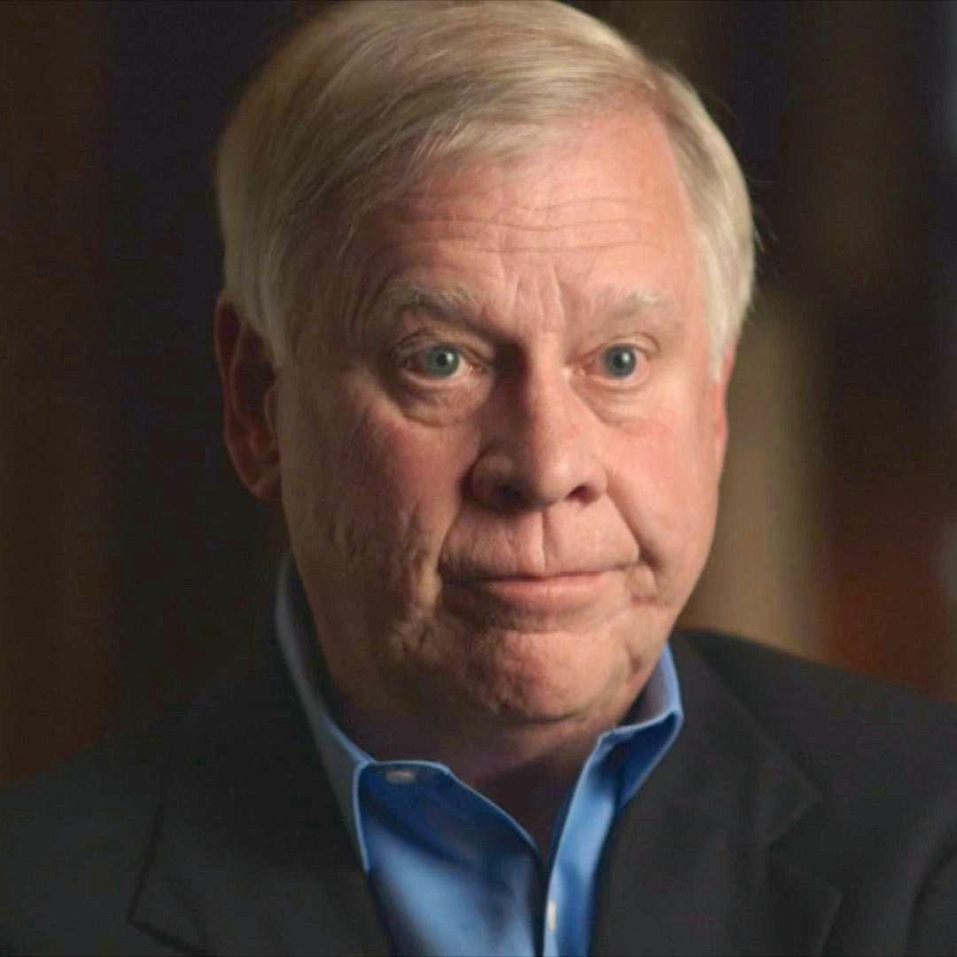
Bill Morlin (Participant) retired in 2009 after a 37-year career
as a newspaper reporter for The Spokane Chronicle and The Spokesman-Review, where he covered extremist groups, including the Aryan Nations. He coined the term “Ruby Ridge” for his first report on Randy Weaver. Morlin now works as a national correspondent for Intelligence Report and Hatewatch, both publications of the Southern Poverty Law Center.

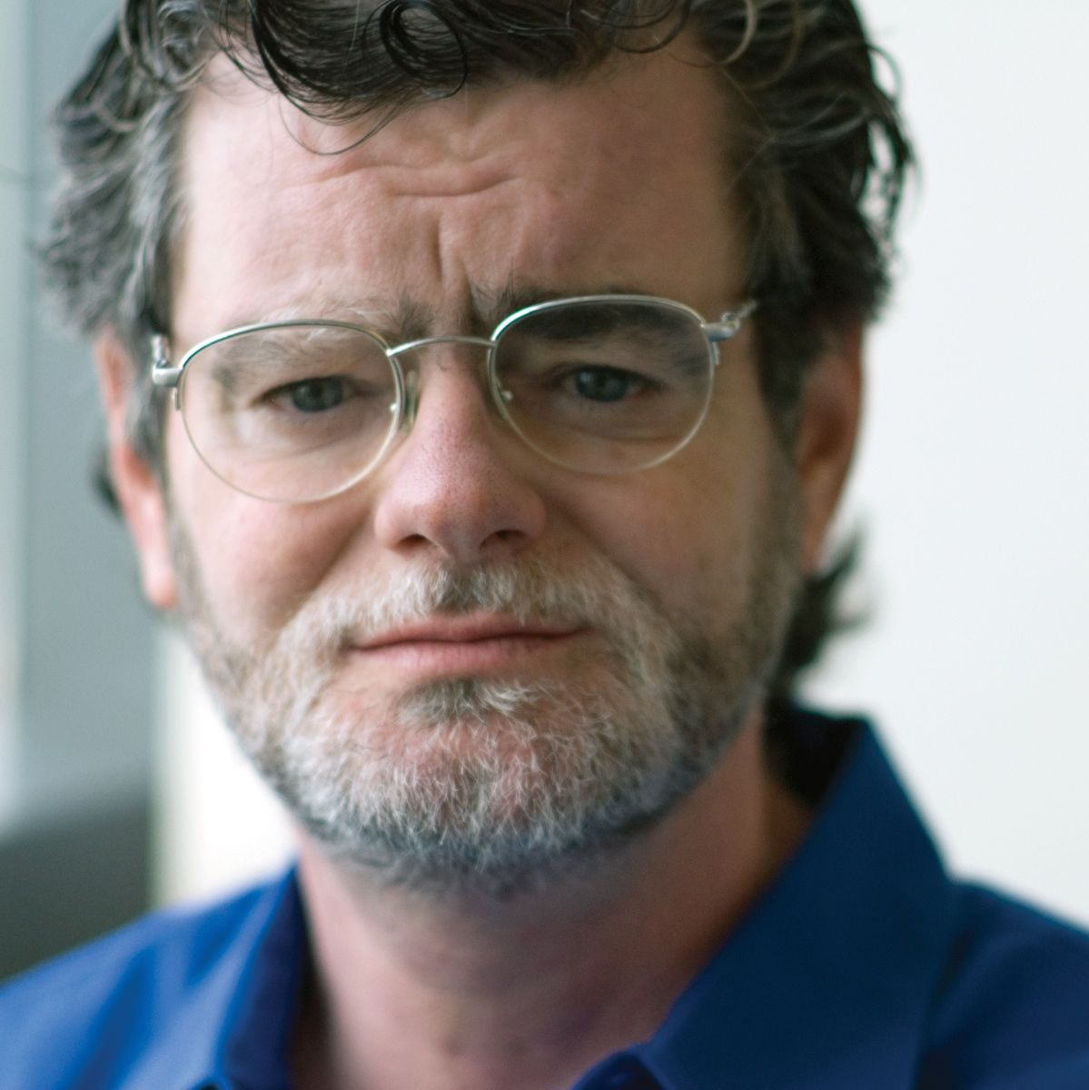
Mark Potok (Participant). As a senior fellow of the Southern Poverty Law Center and editor in chief of its award-winning Intelligence Report magazine, Mark Potok helps lead the premier operation monitoring the extreme right in the United States. In addition to editing the magazine, Potok acts as a key spokesman for the SPLC, a well-known civil rights organization based in Alabama, and has testified before the Senate, the Helsinki Commission, the United Nations High Commission on Human Rights and in other leading venues. Before coming to SPLC in 1997, Potok spent almost 20 years as an award-winning reporter at newspapers including USA Today, the Dallas Times Herald and The Miami Herald. While at USA Today, he covered the 1993 siege in Waco, the rise of militias, the 1995 Oklahoma City bombing and the trial of Timothy McVeigh. In 1996, his editors nominated him for a Pulitzer Prize for a package of stories on racism in Texas public housing. More recently, Potok won a 2010 first-place Green Eyeshade Award for best investigative magazine article from the Society of Professional Journalists. In his current position, Potok is regularly quoted by major media, scholars and book authors in both the United States and abroad.


Mark Samels (Executive Producer). As executive producer of the PBS flagship history series, Mark Samels conceives, commissions and oversees all American Experience films. Samels has overseen more than 130 films, expanding both the breadth of subjects and the filmmaking style embraced by the series, allowing for more contemporary topics and more witness-driven storytelling. Beginning his career as an independent documentary filmmaker, he held production executive positions at public television stations in West Virginia and Pennsylvania before joining WGBH. Samels is a founding member of the International Documentary Association and has served as a governor of the Academy of Television Arts & Sciences. A graduate of the University of Wisconsin, Samels holds honorary Doctor of Humane Letters degrees from Emerson College and Elizabethtown College.

