American Experience “The Blinding of Isaac Woodard”
Premieres Tuesday, March 30, 2021 on PBS

TCA Panelists

Participants

Richard Gergel is a United States District Judge in Charleston, South Carolina. He is a native of Columbia, South Carolina and is a graduate of Duke University and the Duke University School of Law. Judge Gergel practiced law for 30 years before he was nominated to the federal bench by President Barak Obama. His nomination was unanimously approved by the United States Senate in August 2010. He is the author of Unexampled Courage: The Blinding of Sgt. Isaac Woodard and the Awakening of President Harry S. Truman and Judge J. Waties Waring, the book on which “The Blinding of Isaac Woodard” is based, and co-author with his wife, Dr. Belinda Gergel, of In Pursuit of the Tree of Life: The History of the Early Jews of Columbia, South Carolina.

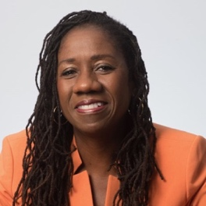
Sherrilyn Ifill is the seventh President and Director-Counsel of the NAACP Legal Defense and Educational Fund, Inc. (LDF), the nation’s premier civil rights legal organization. LDF was founded in 1940 by legendary civil rights lawyer (and later Supreme Court Justice) Thurgood Marshall. Ifill served as an Assistant Counsel for LDF from 1988-1993, litigating voting rights cases. She left LDF to teach at the University of Maryland School of Law in Baltimore, where in addition to teaching in the classroom, she litigated civil rights cases alongside her students for 20 years.

Ifill returned to LDF to lead the organization in 2013 and has emerged as one of the nation’s leading voices in the struggle for racial justice and equality. Under her leadership, LDF has intensified its litigation challenging voter suppression, racial discrimination in the criminal justice system and housing discrimination, and has taken a leadership role in resisting federal efforts to roll back civil rights gains in areas such as affirmative action, employment discrimination and school discipline policies. The organization is at the forefront of civil rights organizations challenging unconstitutional policing practices in cities around the country.

A critically acclaimed author, her scholarly articles and her 2007 book, On the Courthouse Lawn: Confronting the Legacy of Lynching in the 21st Century, reflect Ifill’s lifelong engagement in and analysis of issues of race and American public life. Ifill graduated from Vassar College in 1984 with a B.A. in English and earned her J.D. from New York University School of Law in 1987. She has received honorary doctorates from New York University, Bard College, Fordham Law School and CUNY Law School. In 2019, Ifill was inducted into the American Academy of Arts & Sciences. She serves on the board of the Learning Policy Institute, the Advisory board for the Profiles in Courage Award and the Board of Trustees for the Baltimore Museum of Art. She is a past chair of the U.S. board of the Open Society Foundations, one of the largest philanthropic supporters of civil rights and liberties in the country.

Filmmakers

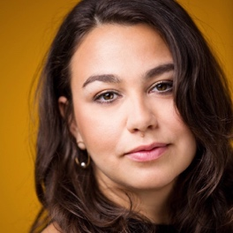
Jamila Ephron (Director/Producer/Co-Writer) has been producing and directing documentary films for more than 15 years. Her most recent film was George W. Bush, which premiered on American Experience in May 2020. Her previous film, Woodstock: Three Days That Defined a Generation, was released theatrically by PBS Distribution and premiered on American Experience in August 2019. Jamila also produced and co-directed Far from the Tree, based on the bestselling book by Andrew Solomon for Participant Media and Sundance Selects. Additional work for American Experience includes My Lai (winner of the Primetime Emmy and Peabody Award), The Assassination of Abraham Lincoln and Clinton. She co-produced Makers: Women Who Make America, a three-hour documentary on second wave feminism, and Cancer: The Emperor of All Maladies, based on the Pulitzer Prize-winning book by Siddhartha Mukherjee.

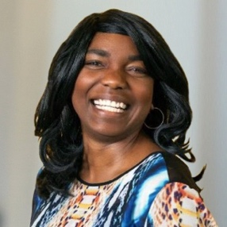
Cameo George (American Experience Executive Producer) is an Emmy Award-winning producer, writer and journalist with more than 20 years of experience in documentary, broadcast television and digital content production. George has produced, developed and commissioned innovative programming at CNN, NBC News, ABC News and digital media startup OZY.com. She was the senior producer of CNN’s groundbreaking series Black in America and Latino in America and the executive producer of the eight-hour PBS documentary series 16 for '16: The Contenders, which was also broadcast on the BBC. George joined American Experience from ABC News, where she was Head of Development for Longform projects, responsible for creating a pipeline of docuseries and feature documentary films across Walt Disney Television platforms including ABC News, Hulu, National Geographic and Disney+.

