American Experience The Bombing of Wall Street

Premieres Tuesday, February 13, 2018 on PBS

New Film Explores the Radical Movement that Led to a Mostly-Forgotten Terror Attack on U.S. Soil and Launched the Career of J. Edgar Hoover

(BOSTON, MA) — On September 16, 1920, as hundreds of Wall Street workers headed out for lunch, a horse-drawn cart packed with dynamite exploded in front of Morgan Bank — the world’s most powerful banking institution. The blast turned the nation’s financial center into a bloody war zone and left 38 dead and hundreds more seriously injured. As financial institutions around the country went on high alert, many wondered if this was the strike against American capitalism that radical agitators had threatened for so long. A mostly forgotten act of terror that remains unsolved today, the bombing helped launch the career of a young J. Edgar Hoover and sparked a bitter national debate about how far the government should go to protect the nation from acts of political violence. Based on Beverly Gage’s The Day Wall Street Exploded: A Story of America in its First Age of Terror, The Bombing of Wall Street is executive produced by Mark Samels, written and directed by Susan Bellows, and produced by Michael Rossi and Susan Bellows. The film premieres on American Experience Tuesday, February 13, 2018, 9:00-10:00 p.m. ET (check local listings) on PBS.
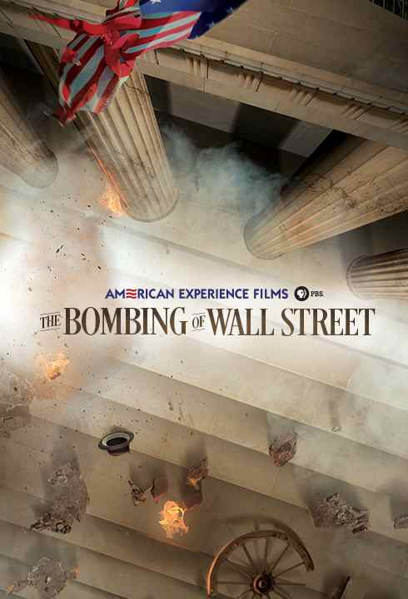

The brutal Wall Street attack struck at a moment in history when millions of people around the globe were challenging capitalism as an economic system. The Bolshevik revolution in Russia spurred similar workers movements around the globe, including in the U.S. While the so-called Gilded Age had produced great wealth, it had also created great poverty, fracturing the U.S. into the haves and the have-nots. World War I, which had just concluded a year earlier, had been enormously profitable for capitalists, but had created economic and political divisions that would prove fertile ground for revolt.

The bombing came on the heels of a series of violent labor battles from Seattle to Boston. In April and May of 1919, 30 bombs targeting bankers and government officials were mailed to arrive on May Day. Attorney General A. Mitchell Palmer, an ambitious man with his eye on the White House, ordered the Justice Department’s Bureau of Investigation to draw up a list of possible suspects. When, a month later, a bomb — and the bomber — exploded on Palmer’s very own doorstep, followed by similar attacks in six other cities, he retaliated with a broad campaign targeting anyone connected to revolutionary organizations.

Palmer created “The Radical Division” at the Bureau and appointed an ambitious 24-year-old, J. Edgar Hoover, to run it. In its first year of operation, the unit amassed more than 200,000 files on radical activities but, to Palmer’s critics, it was not enough. He silenced them on November 7, 1919, the second anniversary of the Bolshevik Revolution, with a massive raid that resulted in the deportation of 249 Russian immigrants, including the anarchist Emma Goldman. Additional “Palmer Raids” struck across the country and suspected radicals were sent to detention centers and many more were deported.

While the raids were praised by some, many church, labor and business groups questioned Palmer’s tactics; the negative publicity quashed any chances Palmer had of winning the Democratic nomination for president at the July 1920 convention. Three months later, Palmer would oversee the investigation of the Wall Street bombing. Although there were suspects, no one was ever charged or convicted of the bombing.

“During this period, America was grappling with the some of the same difficult quandaries in which we find ourselves now,” said American Experience Executive Producer Mark Samels. “How do we protect ourselves from violent extremists who wish to harm us without violating the civil liberties of those who may have different political beliefs? There was no easy answer in 1920 and no easy answer now.”

The Bombing of Wall Street will be available on DVD from PBS Distribution and can be purchased at ShopPBS.org. Online viewing begins on February 14, 2018 at pbs.org.

* * *

About the Participants (in alphabetical order)

Kenneth Ackerman is an attorney and author whose books include Young J. Edgar: Hoover and the Red Scare, 1919-1920, Boss Tweed: The Corrupt Pol who Conceived the Soul of Modern New York, and The Gold Ring: Jim Fisk, Jay Gould, and Black Friday 1869.

Steve Fraser is a historian, writer, and editor. His books include Wall Street: America's Dream Palace (2008), Every Man a Speculator: A History of Wall Street in American Life (2005) and Age of Acquiescence: The Life and Death of American Resistance to Organized Wealth and Power (2015). He has taught at Columbia University, Princeton University, the University of Pennsylvania, and New York University.

Beverly Gage is professor of 20th-century American history at Yale University and author of The Day Wall Street Exploded: A Story of America in its First Age of Terror. Her next book, G-Man: J. Edgar Hoover and the American Century, will be a biography of former FBI director J. Edgar Hoover.

James Green was a professor of history and labor studies at University of Massachusetts, Boston and the author of six books on American labor and radical movements, including Death in the Haymarket: A Story of Chicago, the First Labor Movement and the Bombing that Divided Gilded Age America.

Charles McCormick is Professor of History Emeritus at Fairmont State University and author of Hopeless Cases: The Hunt for the Red Scare Terrorist Bombers.

Bruce Watson is the author of several books including Sacco & Vanzetti: The Men, the Murders, and the Judgment of Mankind and Bread and Roses: Mills, Migrants, and the Struggle for the American Dream.

About the Filmmakers

Written and Directed by | SUSAN BELLOWS
Narrated by | OLIVER PLATT
Edited by | GLENN FUKUSHIMA
Produced by | MICHAEL ROSSI  SUSAN BELLOWS
Original Music by | JOEL GOODMAN
Cinematography | STEPHEN McCARTHY
Associate Producer | PAMELA GAUDIANO

American Experience is a production of WGBH Boston
Senior Producer | SUSAN BELLOWS
Executive Producer | MARK SAMELS

Susan Bellows (Writer, Director and Producer) is an award-winning producer and writer with more than 20 years of experience producing national programs for public television. Bellows is currently the series producer for American Experience and most recently served as producer/director on the four-hour JFK, which premiered in 2013. Since joining the series in 2003, she has provided editorial support and guidance to its broadcast and new media work. Previously, Bellows served as senior producer for the Peabody and Emmy-Award winning series Africans in America. Her other producing credits include films for The Great Depression, for which she received an Emmy nomination, and America’s War On Poverty, both productions of Blackside, Inc. Bellows also co-produced New Worlds, New Forms for the WNET-produced series Dancing, an eight-hour landmark series on dance forms around the world.

Mark Samels (Executive Producer). As executive producer of the PBS flagship history series, Samels conceives, commissions and oversees all American Experience films. Samels has overseen more than 120 films, expanding both the breadth of subjects and the filmmaking style embraced by the series, allowing for more contemporary topics and more witness-driven storytelling. Beginning his career as an independent documentary filmmaker, he held production executive positions at public television stations in West Virginia and Pennsylvania before joining WGBH. Samels is a founding member of the International Documentary Association and has served as a governor of the Academy of Television Arts & Sciences. A graduate of the University of Wisconsin, Samels holds honorary Doctor of Humane Letters degrees from Emerson College and Elizabethtown College.

About American Experience
For 30 years, American Experience has been television’s most-watched history series. Hailed as “peerless” (The Wall Street Journal), “the most consistently enriching program on television” (Chicago Tribune), and “a beacon of intelligence and purpose” (Houston Chronicle), the series brings to life the incredible characters and epic stories that have shaped America’s past and present. American Experience documentaries have been honored with every major broadcast award, including 30 Emmy Awards, four duPont-Columbia Awards, and 17 George Foster Peabody Awards; the series received an Academy Award® nomination for Best Documentary Feature in 2015 for Last Days in Vietnam. American Experience also creates original digital content that uses new forms of storytelling to connect our collective past with the present. Visit pbs.org/americanexperience and follow us on Facebook, Twitter, Instagram and YouTube to learn more.

Major funding for American Experience provided by Liberty Mutual Insurance and by the Alfred P. Sloan Foundation. Additional funding for The Bombing of Wall Street provided by The Documentary Investment Group: Gretchen Stone Cook Charitable Foundation. Additional funding for American Experience provided by The Robert David Lion Gardiner Foundation, the Corporation for Public Broadcasting and public television viewers. American Experience is produced for PBS by WGBH Boston.

* * *
Press Contacts:
CaraMar Publicity
Mary Lugo 770-623-8190 lugo@negia.net
Cara White 843-881-1480 cara.white@mac.com
Abbe Harris 908-244-5516 abbe.harris@caramar.net

For further information and photos visit http://www.pbs.org/pressroom

